Supplementary figures
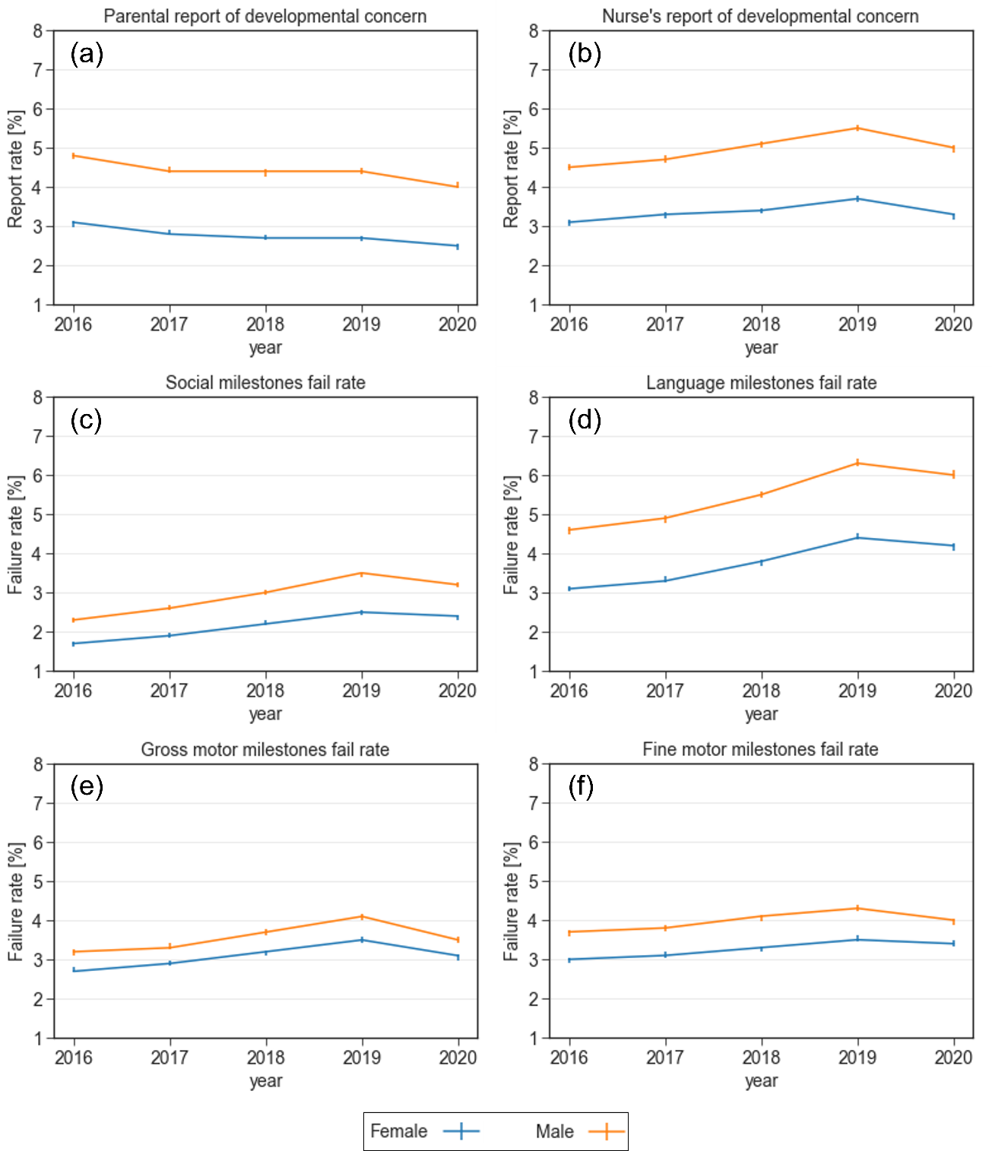
Supplementary Figure 1. Reports of concern and failure rates in various developmental domains stratified by child’s sex between 2016-2020. (a) Parental report of developmental concern (b) Nurse's report of developmental concern (c) Failure rate in the social domain (d) Failure rate in the language domain (e) Failure rate in the gross motor domain (f) Failure rate in the fine motor domain

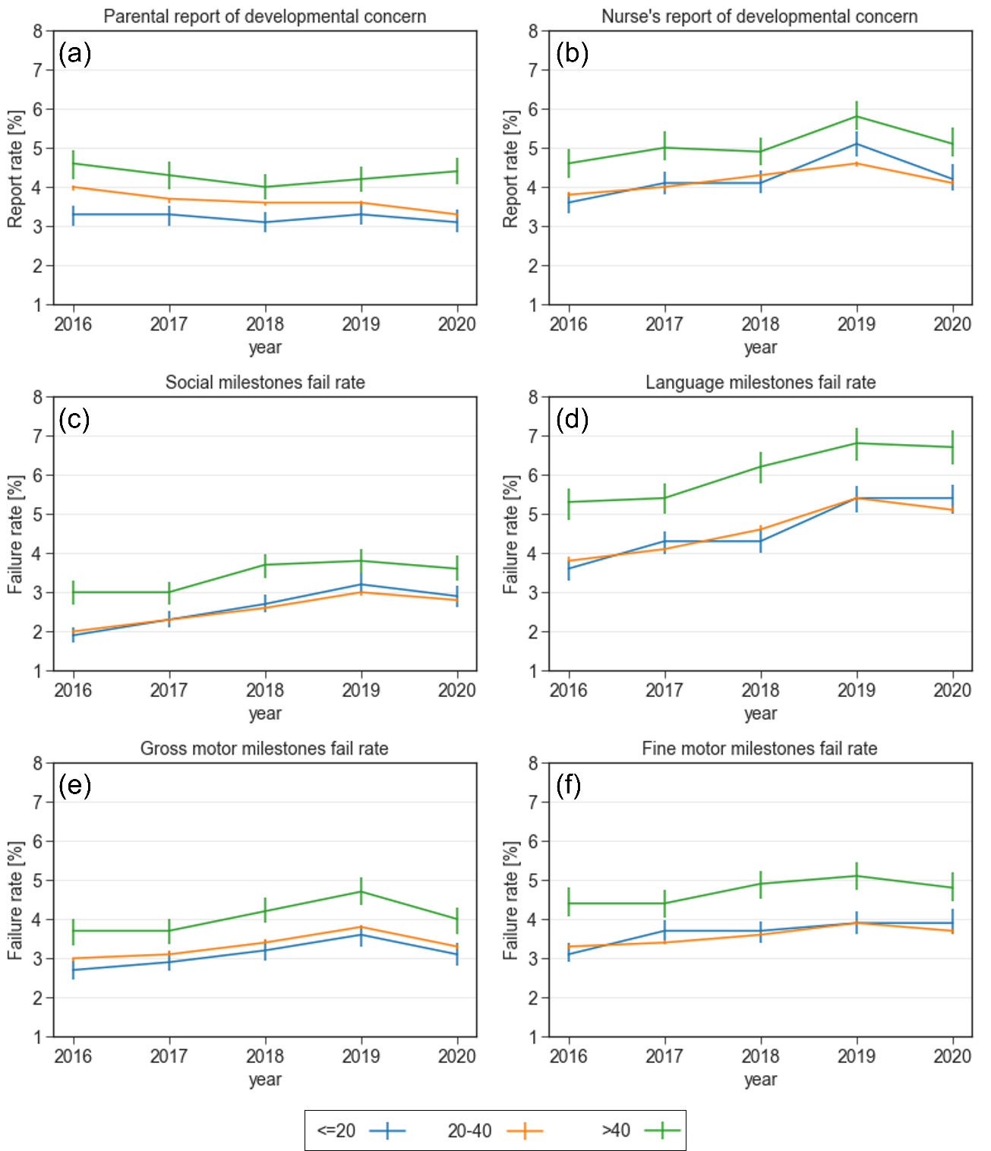
Supplementary Figure 2. Reports of concern and failure rates in various developmental domains stratified by maternal age between 2016-2020. (a) Parental report of developmental concern (b) Nurse's report of developmental concern (c) Failure rate in the social domain (d) Failure rate in the language domain (e) Failure rate in the gross motor domain (f) Failure rate in the fine motor domain

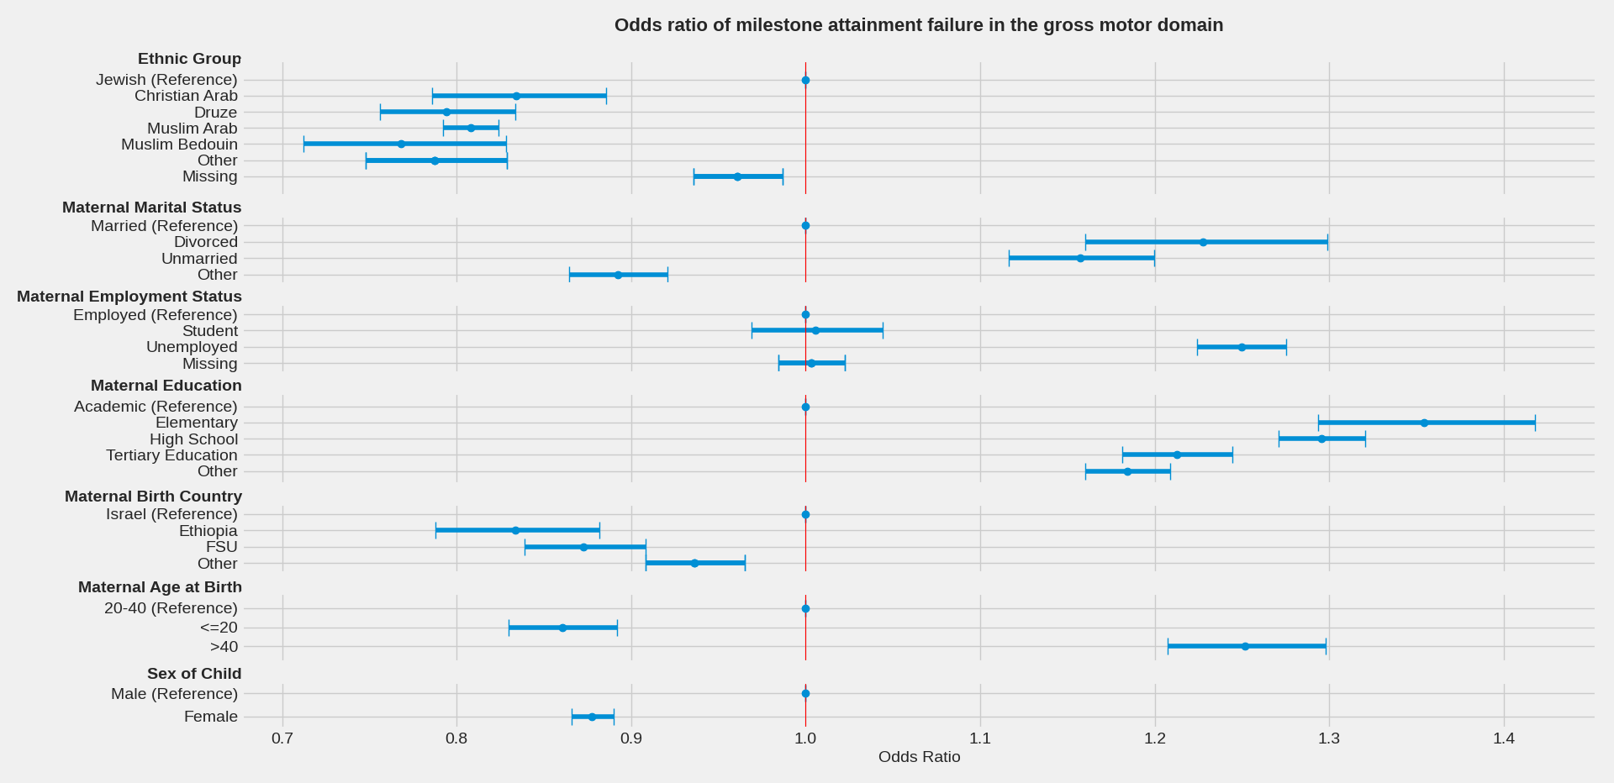
Supplementary Figure 3. Mutually adjusted odds ratios of milestone attainment failure in the gross motor domain, by demographic factors

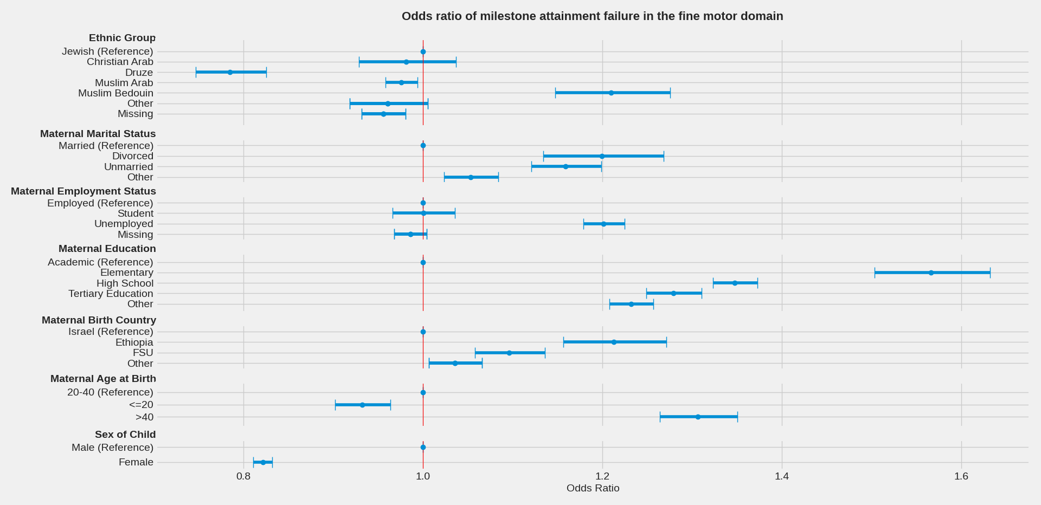
Supplementary Figure 4. Mutually adjusted odds ratios of milestone attainment failure in the fine motor domain, by demographic factors
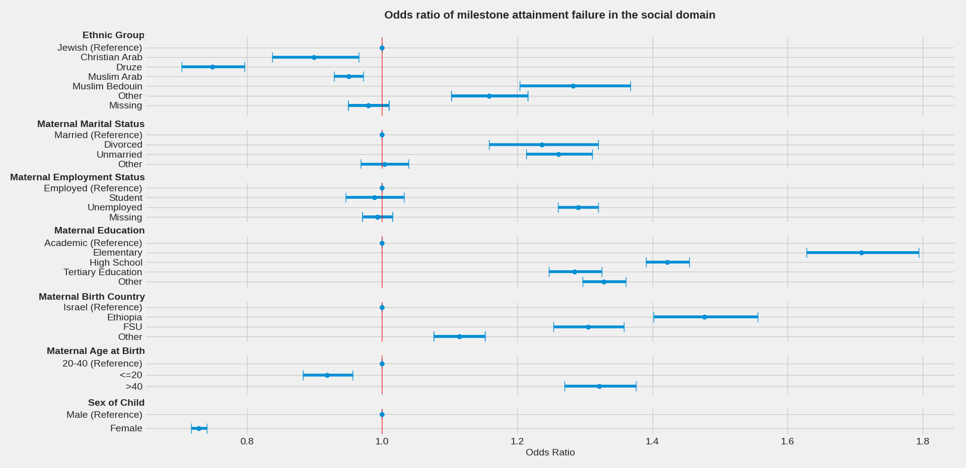
Supplementary Figure 5. Mutually adjusted odds ratios of milestone attainment failure in the social domain, by demographic factors

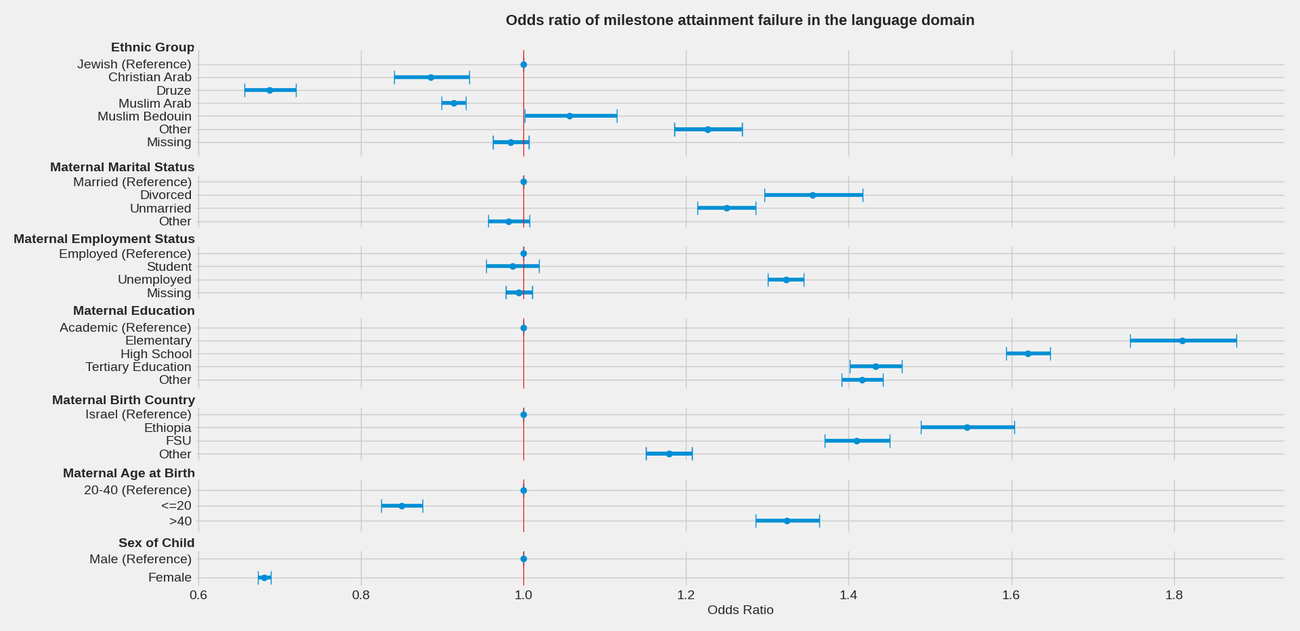
Supplementary Figure 6. Mutually adjusted odds ratios of milestone attainment failure in the language domain, by demographic factors

