SUPPLEMENTARY MATERIAL
Agentic, Communal, and Spiritual Traits are Related to the Semantic Representation of Written Narratives of Positive and Negative Life Events
Danilo Garcia^{1, 2*}, Henrik Anckarsäter¹, Oscar N. E. Kjell^{2, 3}, Trevor Archer ^{2, 4}, Patricia Rosenberg², C. Robert Cloninger⁵, Sverker Sikström^{2, 3}
¹ Institute of Neuroscience and Physiology, Centre for Ethics, Law and Mental Health (CELAM), University of Gothenburg, Gothenburg, Sweden
²Network for Empowerment and Well-Being, Sweden
³Department of Psychology, Lund University, Lund, Sweden
⁴Department of Psychology, University of Gothenburg, Gothenburg, Sweden
⁵Departments of Psychiatry & Genetics, Washington University School of Medicine in St. Louis, Missouri, USA

Reliability analysis on the TCI traits with regard to age
There is evidence of reduced reliability for both personality instruments used here among adolescents, especially for those below 17 years of age which made about 51% of the sample studied here (e.g., Brändström, Sigvardsson, Nylander & Richter, 2008; De Fruyt, Mervielde, Hoekstra & Rolland, 2000; Moreira, Oliveira, Cloninger, Azevedo, Souza, Castro & Cloninger, 2012). Although never tested, this drop in reliability is often attributed to lower reading or comprehension ability among adolescents below 17 years of age. The Cronbach’s alphas, however, were acceptable for both instruments and in the whole sample in the present study. Nevertheless, we conducted reliability analysis of each personality scales for different age groups: adolescents below 17 years of age and adolescents aged 17 or more. Only two scales demonstrated a dramatic drop in reliability: Reward Dependence (from .77 for adolescents aged 17 or older to .70 for those below 17 years of age) and Persistence (from .75 for those aged 17 or older to .62 for those below 17 years of age). See Table S1 for further details.

Table S1. Showing Cronbach’s α for each personality model’s scales divided in age groups: adolescents below 17 years of age and adolescents aged 17 years or above.
Personality Model | Personality trait | < 17 (n = 40) | ≥ 17 (n = 39)
Big Five | Openness | .87 | .82
Big Five | Conscientiousness | .92 | .93
Big Five | Extraversion | .88 | .90
Big Five | Agreeableness | .88 | .90
Big Five | Neuroticism | .91 | .92
Temperament  and Character | Novelty Seeking | .79 | .74
Temperament  and Character | Harm Avoidance | .89 | .89
Temperament  and Character | Reward Dependence | .70 | .77
Temperament  and Character | Persistence | .62 | .75
Temperament  and Character | Self-directedness | .84 | .81
Temperament  and Character | Cooperativeness | .82 | .86
Temperament  and Character | Self-transcendence | .84 | .76

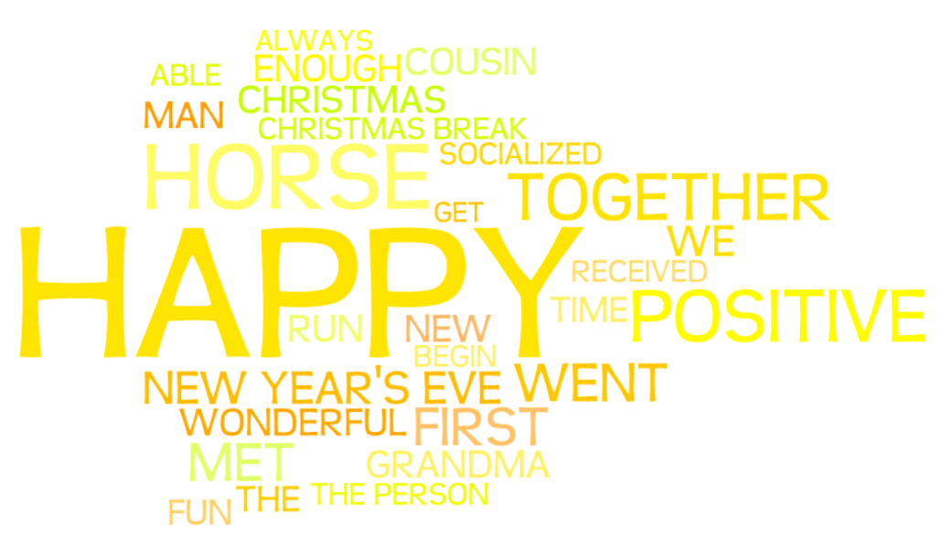
Figure S1. Participants’ (N = 40) positive life narratives depicted as a word cloud (created with wordle.net). The words are translated from Swedish to English. The font size is proportional to the Q-value in a Chi-2 test where the word frequencies of narratives are compared with the word frequencies in Google n-grams.
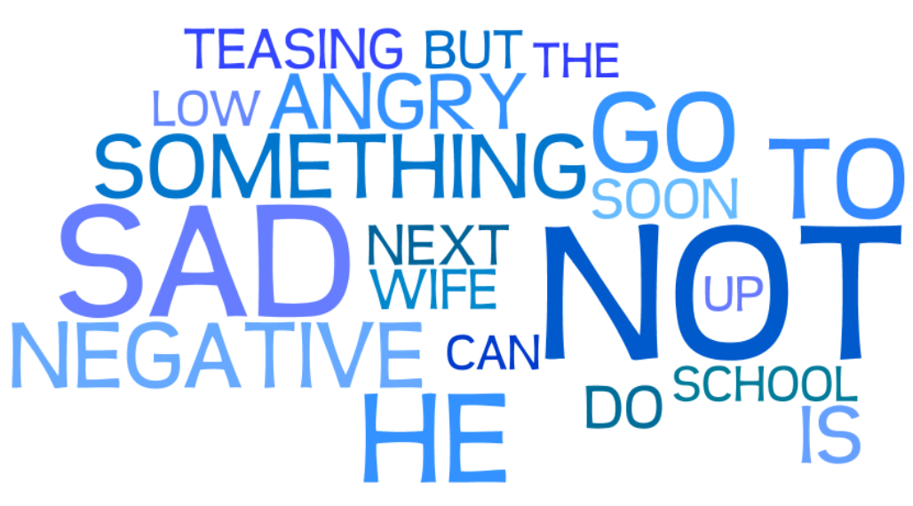
Figure S2. Participants’ (N = 39) negative life narratives depicted as a word cloud (created with wordle.net). The words are translated from Swedish to English. The font size is proportional to the Q-value in a Chi-2 test where the word frequencies of narratives are compared with the word frequencies in Google n-grams.
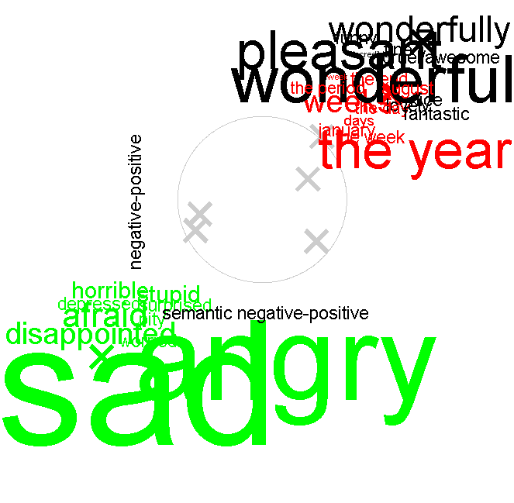
Figure S3. Cluster of words significantly overrepresented in written narratives of negative and positive life events (created with semanticexcel.com).
Note: The axes were created by first dividing the data set into participants that were instructed to write about positive or negative life events (y-axis), or on a median split of the predicted value of positive or negative life events (x-axis). Words (duplicates removed) were then clustered (using the k-means algorithm) into eight clusters based on their semantic representation. Three clusters included words that where significantly (chi-square test, not corrected for multiple comparisons) over-represented (duplicates included) in data sets defining the x and y-axis. These clusters were included and color-coded in the figure. For each cluster, words that are significantly over-represented (chi-square test, not corrected for multiple comparisons) in either condition are included. The grey circle constitutes the distance from origin where significance is reached. The font size of the word reflects the 'q' value in the chi-square test.

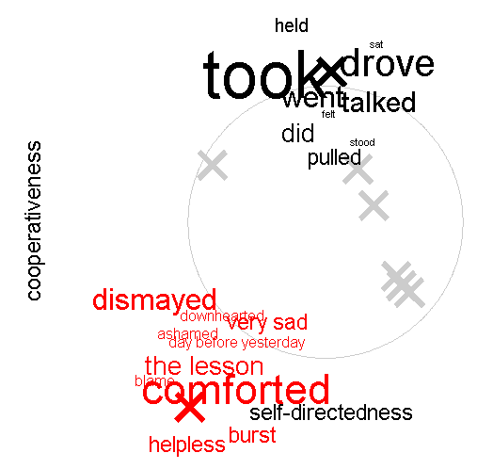

Figure S4. Cluster of words significantly overrepresented in written narratives in relation to high/low levels of Self-directedness and Cooperativeness.
Note: The axes were created by first dividing the data in median split categories based on individuals scores in Self-directedness (x-axis) and Cooperativeness (y-axis). Words (duplicates removed) were then clustered (using the k-means algorithm) into eight clusters based on their semantic representation. Two clusters included words that where significantly (chi-square test, not corrected for multiple comparisons) over-represented (duplicates included) in data sets defining the x and y-axes respectively. These clusters were included and color-coded in the figure. For each cluster, words that are significantly over-represented (chi-square test, not corrected for multiple comparisons) in either condition are included. The grey circle constitutes the distance from origin where significance is reached. The font size of the word reflects the 'q' value in the chi-square test.

