Additional file 6: Figure S2. Correlation between CI and GEDVI changes between T₁ and T₃.
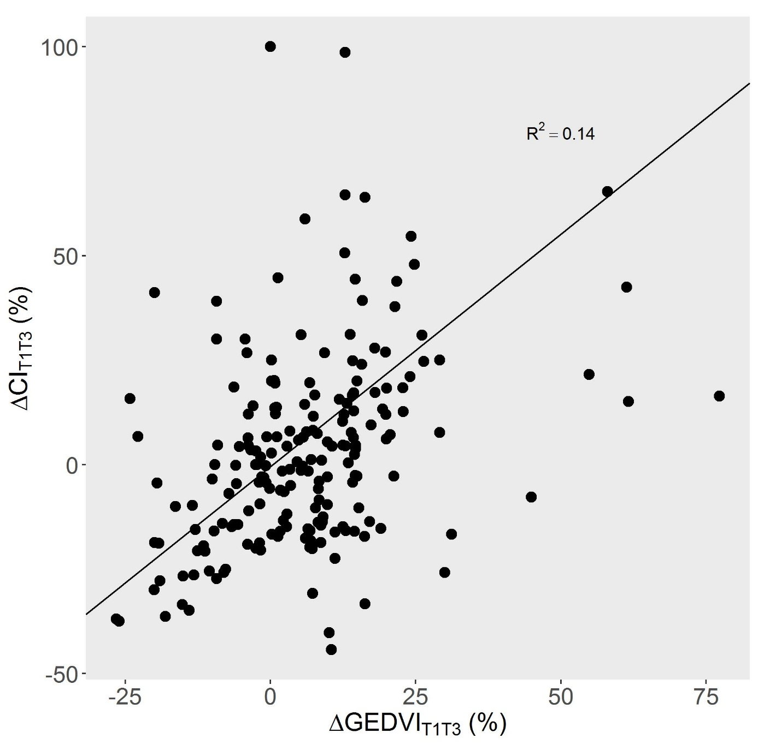

Dot are individual datapoints. Line is regression line with corresponding R². Correlation is statistically significant with p values < 0.001.
ΔCI_{T1T3} = change in cardiac index between T₁ and T₃; ΔGEDVI_{T1T3} = change in global end-diastolic volume index between T₁ and T₃.

Supplementary figure 3. Correlation between CI and GEDVI changes between T₁ and T₃ as a function of changes in cardiac function index.

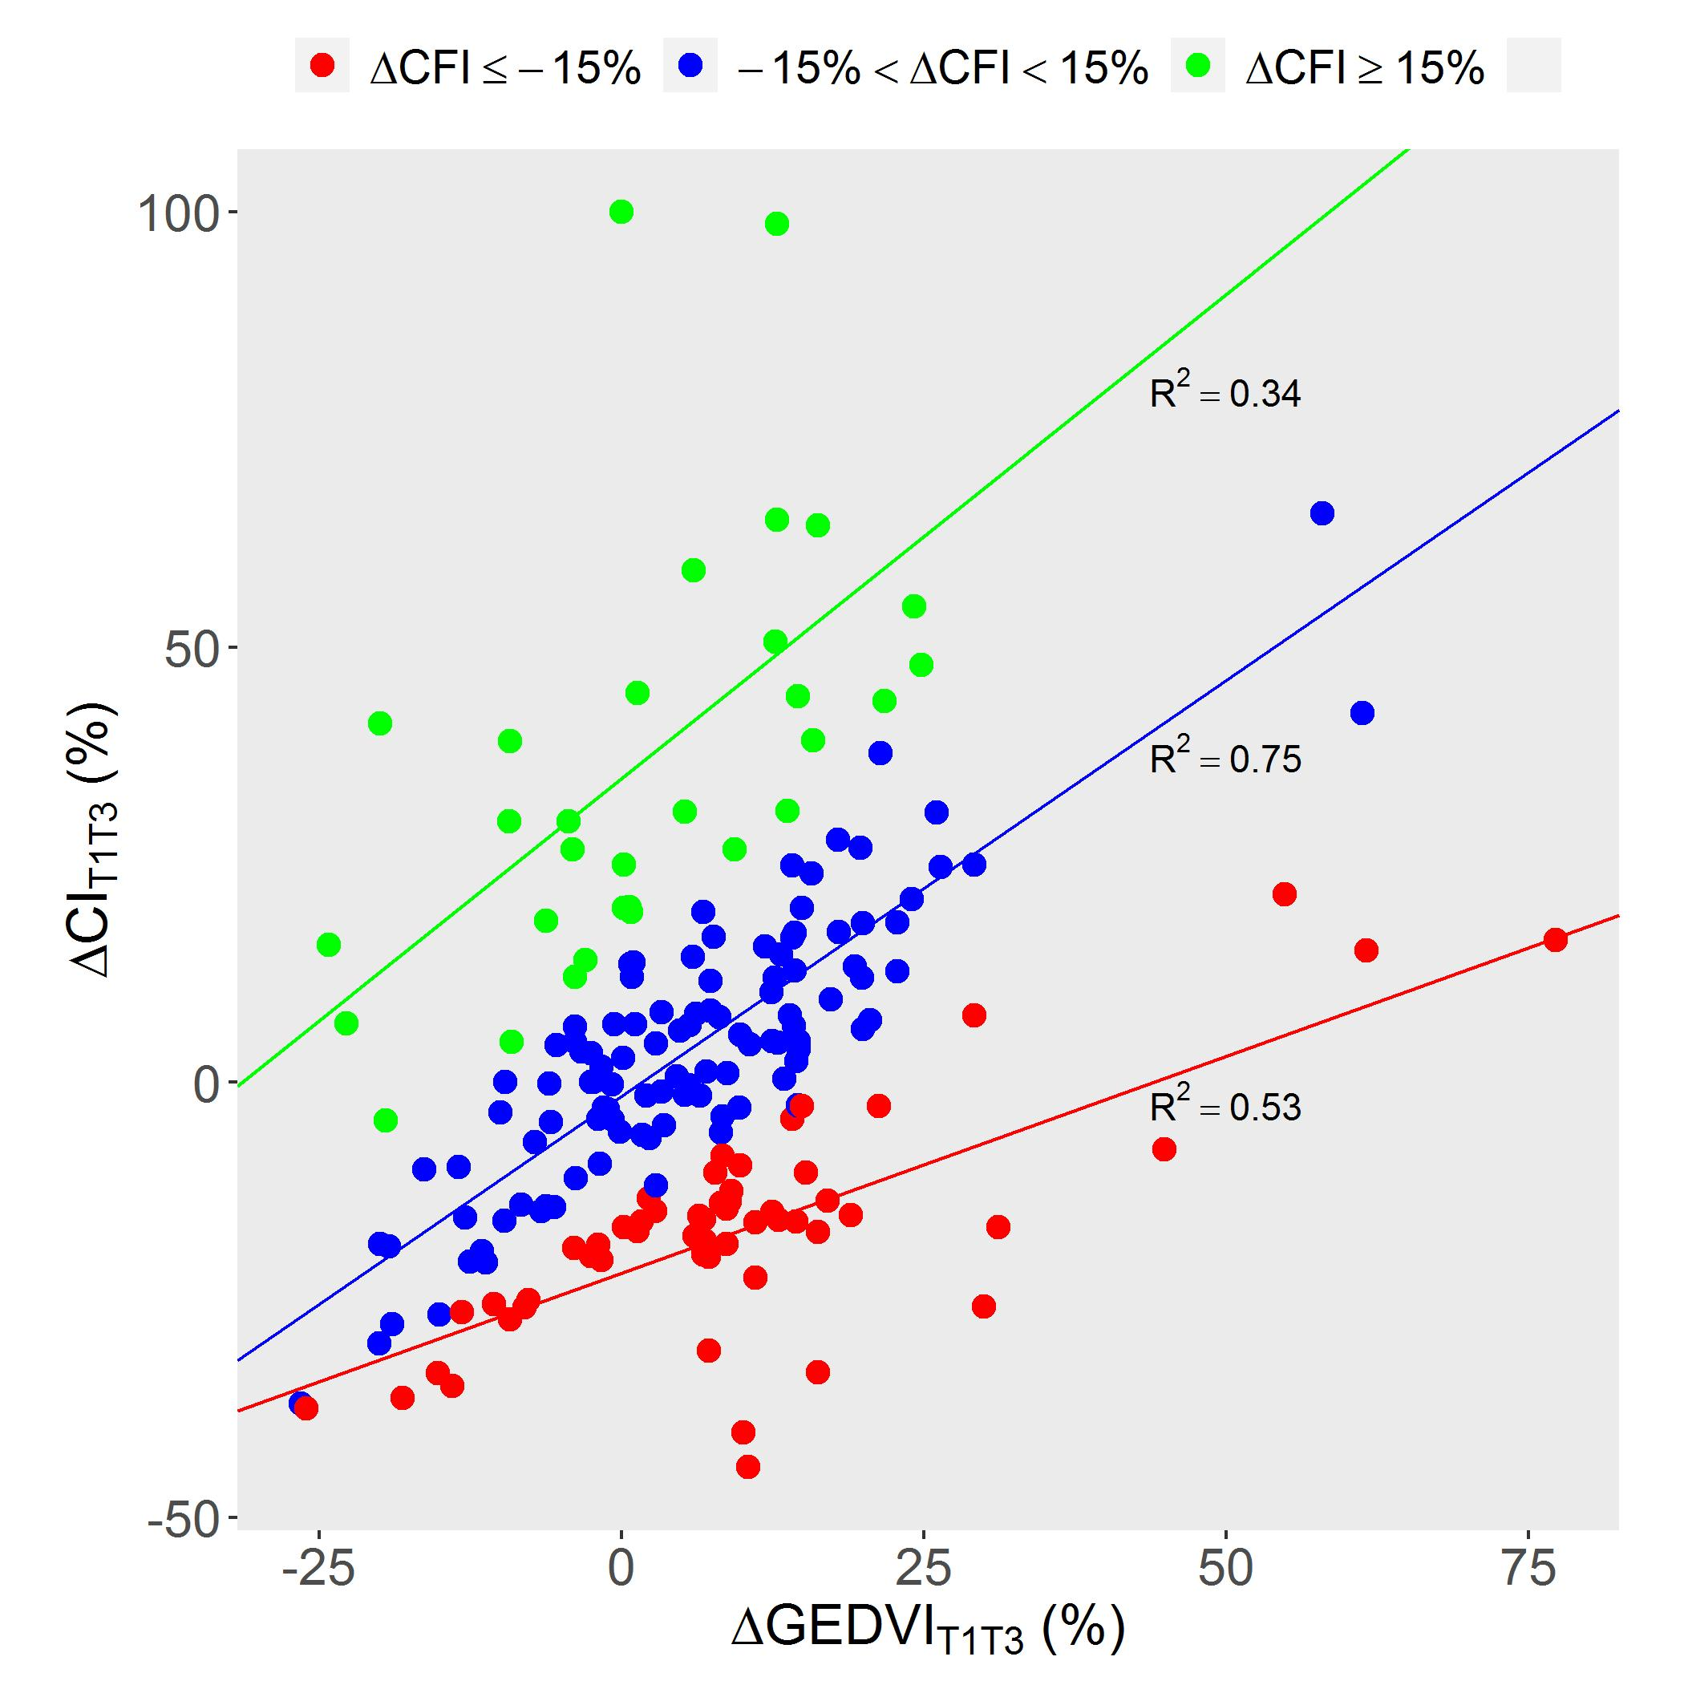
Dot are individual datapoints. Green dots refer to sessions with significant increase in CFI (≥15%) between T₁ and T₃ suggesting a change in CI not fully related to GEDVI change. Blue dots refer to sessions without significant increase in CFI between T1 and T3. Red dots refer to sessions with significant decrease in CFI (≤-15%) between T1 and T3. Lines are regression lines in each subgroup with corresponding R². All correlations are statistically significant with p values < 0.001.
ΔCFI = change in cardiac function index between T₁ and T₃; ΔCI_{T1T3} = change in cardiac index between T₁ and T₃; ΔGEDVI_{T1T3} = change in global end-diastolic volume index between T₁ and T₃

