Additional file 7: Figure S3. Change in cardiac index and global end-diastolic volume between T₁ and T₃ and between T₃ and T₄.
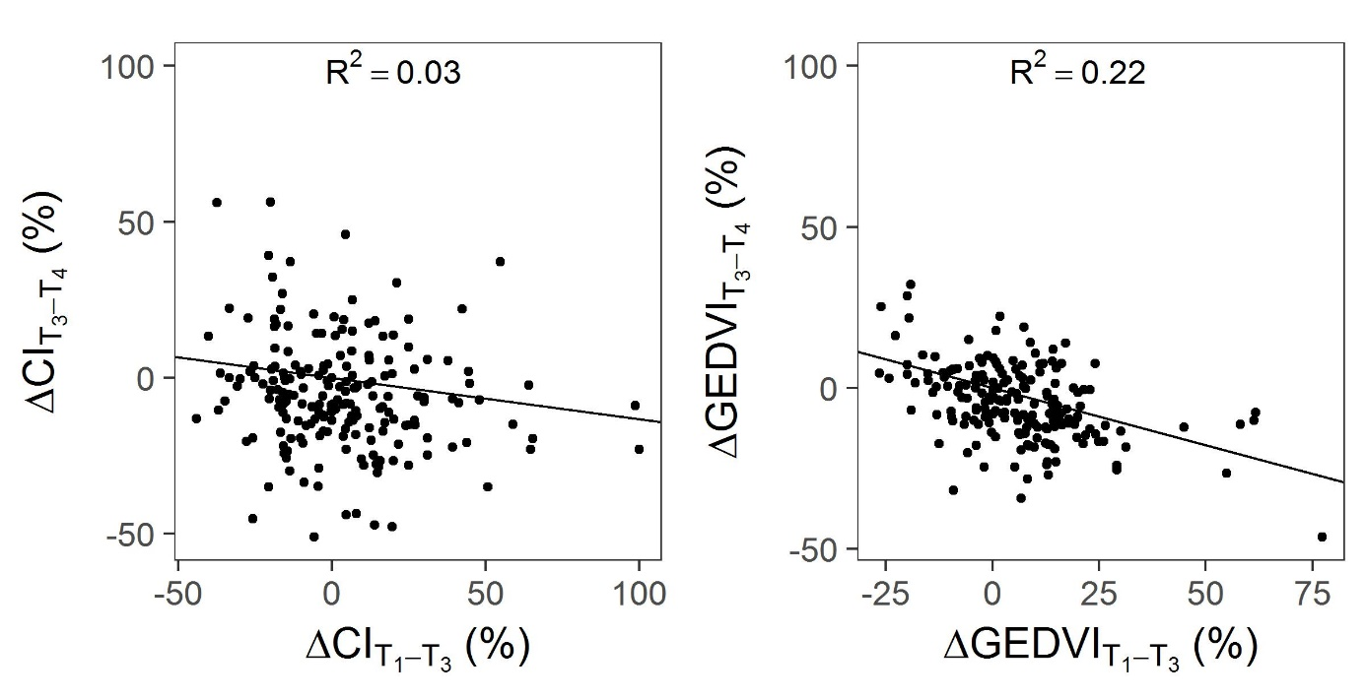
Symbols are individual values for each prone position session. Solid lines are regression lines.
ΔCI_{T1-T3} = change in cardiac index between T₁ and T₃, ΔCI_{T3-T4}= change in cardiac index between T₃ and T₄, ΔGEDVI_{T1-T3}= change in global-end diastolic volume between T₁ and T₃, ΔGEDVI_{T3-T4}= change in global-end diastolic volume between T₃ and T₄; R² = coefficient of determination; T₁ = before prone position; T₃ = end of prone position session; T₄ = after prone position session.

