Figure S1. Funnel plot for CAT on mortality in non-HIV PCP patients.

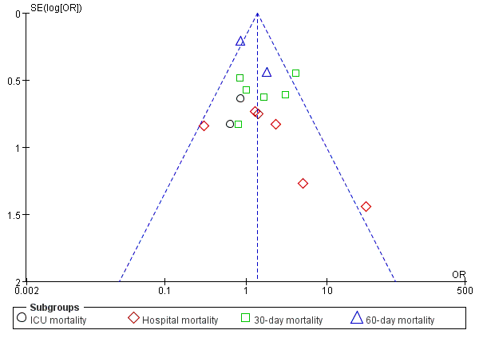

Figure S2. Funnel plot for CAT on mortality in non-HIV PCP patients with hypoxia or respiratory failure.

