Additional file 1

Search strategies for each topic

Topics: LV systolic function and RV function
Given that LV systolic function and RV function can be reported separately or together [i.e. LVSF ∪ RVF ∪ (LVSF ∩ RVF)], these two topics were combined in the search strategy, but were separated during the screening and appraisal process.

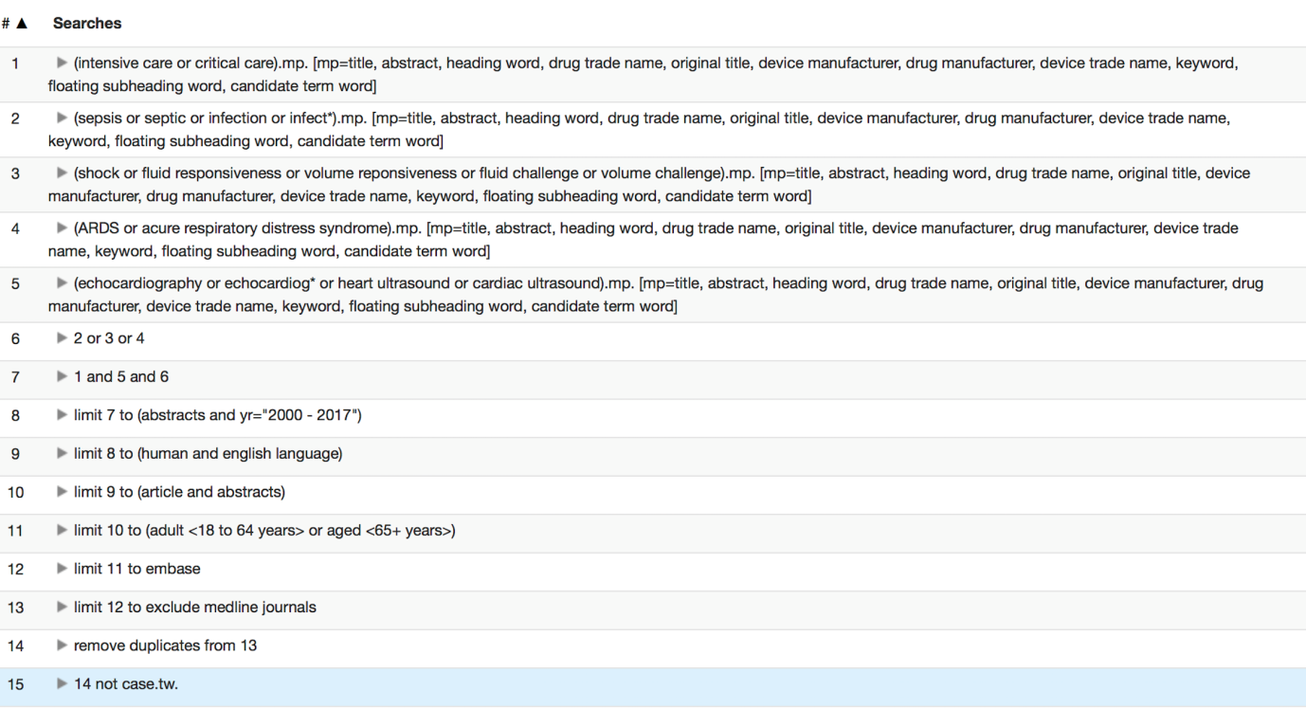

Topics: LV diastolic function and fluid management
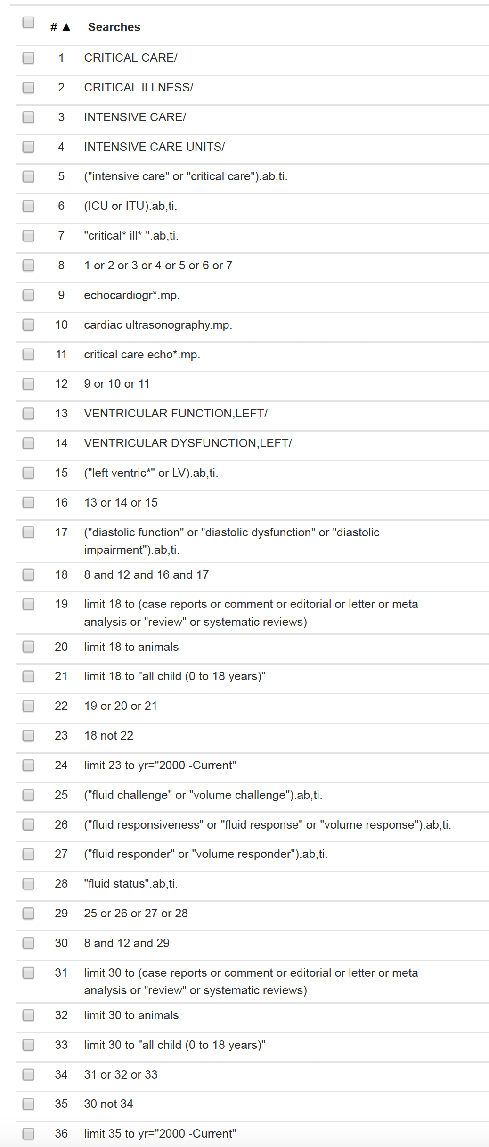

Topic: Advanced echocardiography techniques
