table S1. ADVOS treatment parameters during the first ADVOS treatment in each patient. Subgroup analysis. Median (IQR25, IQR75).
 | All (n=34) | ARDS (n=10) | Severe metabolic acidosis (n=11)
Duration (h) | 18.5  (8.25, 22.0) | 22.5  (16.5, 23.75) | 17.0  (7.5, 20.0)
Blood flow (ml/min) | 100  (100, 150) | 150  (113, 225) | 100  (100, 160)
Concentrate flow (ml/min) | 160  (160, 320) | 160  (160, 160) | 320  (160, 320)
Dialysate pH setting | 8.3  (7.5, 8.7) | 8.8  (8.2, 8.9) | 8.5  (8.4, 8.8)
UF rate (ml/h) | 0  (0, 168) | 105  (0, 213) | 0  (0, 165)
Dialysate Temperature (°C) | 28.0  (28.0, 29.5) | 28.5  (28.0, 30.0) | 28.0  (28.0, 28.5)

table S2. Bilirubin elimination in each ADVOS-session depending on bilirubin-levels prior to treatment. Median (IQ25, IQ75).
Bilirubin before ADVOS (mg/dl) | Relative elimination for each ADVOS treatment (%) | Treatments were level reduction occurred (%)
<6 | 0.0 (-20.0, 28.8) | 38 %
6-12 | -10.8 (-19.7, -4.7) | 86 %
>12 | -23.0 (-30.5, -17.4) | 97 %

table S3. Ventilation, hemodynamic and electrolytes directly before and after the first ADVOS treatment in each patient. Subgroup analysis: All, respiratory failure and severe metabolic acidosis. Median (IQ25, IQ75). Non-parametric paired Wilcoxon test. *p<0.05, **p<0.01
 | All (n=34) |  | ARDS (n=10) |  | Severe metabolic acidosis (n=11)
 | before | after | before | after | before | after
Ventilation
FiO₂ (%) | 45  (30, 60) | 50  (30, 65) | 70  (60, 85) | 60  (50, 80) | 40  (30, 58) | 60  (45, 85)**
PaO₂/FiO₂ | 170  (103, 327) | 155  (114, 256) | 102  (84, 120) | 130  (114, 244) | 136  (105, 244) | 122  (76, 153)
PEEP (mbar) | 10  (8, 14) | 10  (9, 14) | 14  (9, 15) | 11  (8, 15) | 11  (9, 14) | 14  (10, 15)
Pinsp (mbar) | 26  (25, 31) | 26  (25, 29)* | 34  (31, 36) | 28  (27, 30)** | 26  (25, 28) | 28  (25, 30)
Driving Pressure (mbar) | 16  (13, 18) | 15  (14, 17) | 20  (18, 23) | 16  (15, 17)** | 17  (16, 17) | 15  (14, 17)
TV (ml/min/kg) | 5.8  (4.8, 6.3) | 5.7  (4.5, 6.1) | 5.7  (4.1, 5.9) | 4.8  (4.4, 6.0) | 6.0  (4.9, 6.5) | 5.9  (4.3, 6.1)
Respiratory rate  (breath/min) | 24  (21, 27) | 24  (21, 27) | 27  (24, 29) | 28  (23, 29) | 24  (24, 25) | 24  (22, 26)
Minute Ventilation  (l/min) | 10.5  (8.2, 12.0) | 10.0  (7.7, 12.5) | 10.4  (9.2, 11.1) | 9.0  (7.7, 11.7) | 11.1  (9.6, 12.6) | 10.1  (10.0, 12.6)
Vital signs
MAP (mmHg) | 69  (59, 82) | 74  (60, 82) | 67  (63, 72) | 69  (66, 73) | 66  (57, 90) | 68  (60, 83)
Heart Rate (bpm) | 86  (71, 110) | 93  (71, 99) | 91  (85, 96) | 87  (64, 94) | 84  (77, 131) | 84  (75, 98)
Noradrenalin max. dose (µg/kg/min) | 0.444  (0.180, 0.800) | 0.375  (0.141, 0.750)** | 0.444  (0.320, 0.629) | 0.170  (0.142, 0.375)** | 0.600  (0.317, 0.836) | 0.480  (0.342, 0.830)
Electrolytes
Na⁺  (mmol/l) | 141  (136, 143) | 138  (135, 140)** | 142  (139, 143) | 139  (135, 143) | 139  (138, 142) | 138  (135, 140)
Cl⁻  (mmol/l) | 110  (106, 114) | 106  (103, 110)** | 108  (103, 109) | 102  (97, 105)** | 110  (109, 116) | 107  (104, 109)**
K⁺  (mmol/l) | 4.1  (3.9, 4.4) | 4.4  (4.0, 4.6) | 4.5  (4.2, 4.7) | 4.1  (4.0, 4.2) | 4.3  (3.9, 4.8) | 4.5  (4.2, 5.0)
Calcium total (mmol/l) | 2.12  (1.98, 2.21) | 2.01  (1.94, 2.20)* | 1.98  (1.97, 2.03) | 2.06  (1.98, 2.26) | 2.05  (2.01, 2.15) | 2.04  (1.87, 2.18)
Ca²⁺  (mmol/l) | 1.20  (1.13, 1.25) | 1.18  (1.09, 1.21)** | 1.13  (1.09, 1.23) | 1.14  (1.08, 1.21) | 1.14  (1.05, 1.27) | 1.10  (1.02, 1.21)
Mg²⁺  (mmol/l) | 0.84  (0.73, 0.98) | 0.87  (0.84, 0.92) | 0.81  (0.74, 0.87) | 0.86  (0.85, 0.87) | 0.97  (0.75, 1.00) | 0.90  (0.83, 0.97)
Phosphate  (mmol/l) | 1.11  (0.73, 1.69) | 1.06  (0.76, 1.47) | 1.28  (0.93, 1.91) | 0.79  (0.77, 1.08)** | 1.12  (0.86, 2.30) | 1.38  (0.91, 2.40)

table S4. Driving pressure variation in each treatment depending on the value before ADVOS treatment among mechanically ventilated patients. Median (IQ25, IQ75).
Driving pressure before treatment (mbar) | Relative driving pressure variation for each ADVOS treatment (%) | Number of treatments | Treatments with reduction of driving pressure (%)
<15 | 0.0 (-1.4, 8.33) | 29 | 27.6 %
15-20 | -6.3 (-17.1, 0.0) | 35 | 57.1 %
≥20 | -17.7 (-31.8, -6.8) | 8 | 75.0 %

table S5. Norepinephrine (NE) dose variation in each treatment depending on the dose before ADVOS treatment among patients requiring vasopressors. Among patients not requiring vasopressors patient before ADVOS treatment, only one needed it after it. Median (IQ25, IQ75).
NE dose before treatment (µg/kg/min) | Relative NE dose variation for each treatment (%) | NE dose reduction during treatment (%) | No NE requirement following treatment (%)
≥ 0.001 - 0.100 | -95 (-100, -41) | 100 % | 43 %
≥ 0.100 - 0.500 | -25 (-48, -0.0) | 68 % | 3 %
≥ 0.500 | -20 (-53, 0.0) | 73 % | 6 %

table S6. Spearman rank correlation of ADVOS blood flow rate and ADVOS pH setting to patients´ delta pH, pCO₂ and HCO₃⁻ . Delta means the difference of patients´ blood parameters of pH, pCO₂ and HCO₃⁻ between the inlet and the outlet of the ADVOS system. r, Spearman correlation coefficient.
Parameter | ADVOS blood flow rate (ml/min) | p-value | ADVOS pH setting | p-value
delta pH | r = 0.421 | <0.001 | r = 0.763 | <0.001
delta pCO₂ | r = -0.633 | <0.001 | r = -0.862 | <0.001
delta HCO₃⁻ | r = 0.293 | 0.008 | r = 0.915 | <0.001

table S7. Adverse events (AE) in 102 albumin dialysis sessions.
Complication | AE present prior to ADVOS | AE onset during ADVOS
Hemorrhage | 0 | 3
Thrombocytopenia | 68 | 1
Thrombosis | 0 | 0
Hypokalemia | 0 | 0
Hyperkalemia | 7 | 2
Hypophosphatemia | 22 | 0
Hyperphosphatemia | 17 | 0
Hypocalcemia | 43 | 5
Hypercalcemia | 4 | 0
Hypomagnesemia | 9 | 4
Hypermagnesemia | 7 | 0
Cardiac rhythm disorders | 5 | 0
Seizures | 0 | 0
Air embolism | 0 | 0
Catheter insertion complication | 0 | 0
Table S8. Blood gas parameters prior to and immediately after each ADVOS treatment. Apart from the summary of all treatment sessions, this table illustrates the blood gas parameters of two subgroups (i.e. patients with ARDS and patients with metabolic acidosis immediately prior to ADVOS. Median (IQ25, IQ75). Non-parametric paired Wilcoxon test. *p<0.05, **p<0.01
 | All (n=102) |  | ARDS (n=26) |  | Severe metabolic acidosis (n=12)
 | before | after | before | after | before | after
Blood gas
Blood pH | 7.36  (7.28, 7.41) | 7.41  (7.36, 7.46)** | 7.30  (7.22, 7.34) | 7.40  (7.33, 7.48) | 7.19  (7.10, 7.19) | 7.40**  (7.35, 7.45)
HCO₃⁻ (mmol/l) | 24.4  (18.9, 27.1) | 25.4  (21.6, 29.5) | 28.8  (25.3, 32.2) | 32.2  (28.5, 39.6)** | 14.9  (13.7, 16.5) | 20.9**  (18.2, 24.1)
PaCO₂ (mmHg) | 43.6  (35.1, 57.9) | 38.9 **  (32.6, 49.1) | 63.9  (58.6, 74.3) | 54.3  (48.8, 61.5) | 37.0  (31.1, 42.4) | 36.9  (32.5, 39.7)
PaO₂ (mmHg) | 78.6  (70.9, 92.0) | 78.9  (71.3, 89.4) | 72.9  (65.4, 83.3) | 77.0  (72.2, 92.4) | 89.6  (61.6, 102.8) | 78.4  (68.2, 83.4)
Base Excess (mmol/l) | 0.2  (-6.8, 3.4) | 1.4 **  (-3.7, 6.1) | 3.5  (0.8, 8,8) | 9.1  (4.7, 17.3)** | -13.1  (-15.0, -11.1) | -3.4**  (-8.0, 0.8)
Lactate mmol/l) | 2.15  (1.23, 5.38) | 1.90  (1.33, 5.15) | 1.50  (0.75, 2.60) | 1.65  (0.95, 2.98) | 10.40  (6.8, 12.3) | 6.95  (4.18, 9.28)
SID (mEq/l) | 35.3  (30.2, 39.8) | 35.1  (29.9, 40.0) | 40.5  (38.6, 43.7) | 42.5  (40.1, 49.0) | 23.0  (21.4, 25.1) | 28.8**  (24.7, 33.8)

Table S9. Impact of session duration of ADVOS on several parameters. The median duration of ADVOS treatment (17.5 hours) was chosen as cut-off.
Parameter | ADVOS > 17.5 hours | ADVOS ≤ 17.5 hours | p-value
Delta bilirubin (mg/dl) | -0.07 ± 0.36 | -0.10 ± 0.42 | 0.899
Delta creatinine (mg/dl) | -0.44 ± 0.88 | -0.13 ± 0.42 | 0.053
Delta NH3 (µmol/l) | -11.8 ± 25.5 | -5.3 ± 24.6 | 0.121
Delta INR | -0.0 ± 0.7 | 0.0 ± 0.37 | 0.202
Delta lactate (mmol/l) | -0.16 ± 3.72 | 0.39 ± 3.16 | 0.949
Delta sodium (mmol/l) | -1.4 ± 3.2 | -1.3 ± 2.4 | 0.900
Delta chloride (mmol/l) | -3.0 ± 5.2 | -0.6 ± 4.0 | 0.028
Delta potassium (mmol/l) | 0.1 ± 0.6 | -0.0 ± 0.5 | 0.498
Delta heart rate (per min) | -7.2 ± 14.9 | -3.3 ± 18.3 | 0.187
Delta MAP (mmHg) | 1.8 ± 14.0 | -0.4 ± 21.5 | 0.668
Delta norepinephrine (µg/kg/min) | -0.17 ± 0.31 | -0.03 ± 0.21 | 0.012
Delta PEEP (mbar) | 0.1 ± 2.7 | -0.2 ± 1.3 | 0.800
Delta respiratory rate (per min) | -1.8 ± 4.2 | 0.5 ± 2.9 | 0.011
Delta driving pressure (mbar) | -1.6 ± 4.0 | -0.3 ± 2.2 | 0.162
Delta tidal volume (ml) | -21 ± 112 | -7 ± 66 | 0.630
Delta P/F ratio | 6.4 ± 77.6 | -31 ± 170 | 0.745
Delta pH | 0.07 ± 0.13 | 0.05 ± 0.09 | 0.524
Delta CO₂ (mmHg) | -3.6 ± 11.7 | - 5.4 ± 8.0 | 0.232
Delta HCO₃⁻ (mmol/l) | 4.0 ± 7.2 | 1.4 ± 6.4 | 0.049

figure S1. Variation in pCO2 and HCO3- between the inlet and the outlet of the dialyzer at different dialysate pH settings during ADVOS treatments. Data are stratified according to the ADVOS pH setting being employed at the time of blood sampling.
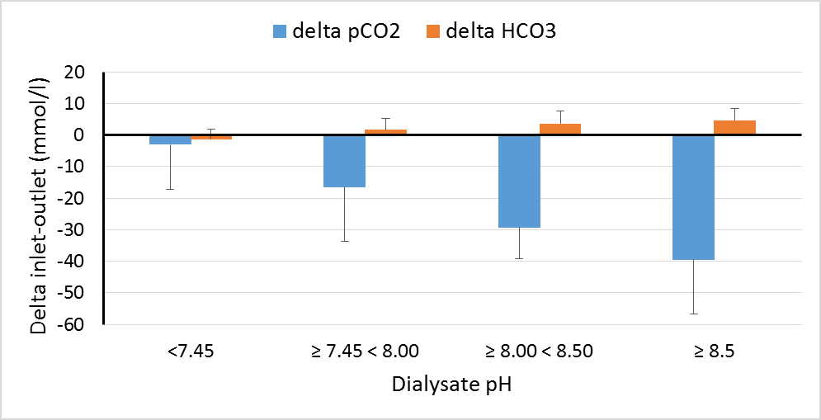

figure S2. Variation in blood pH between the inlet and the outlet of the dialyzer at different dialysate pH settings during ADVOS treatments. Data are stratified according to the ADVOS pH setting being employed at the time of blood sampling.
