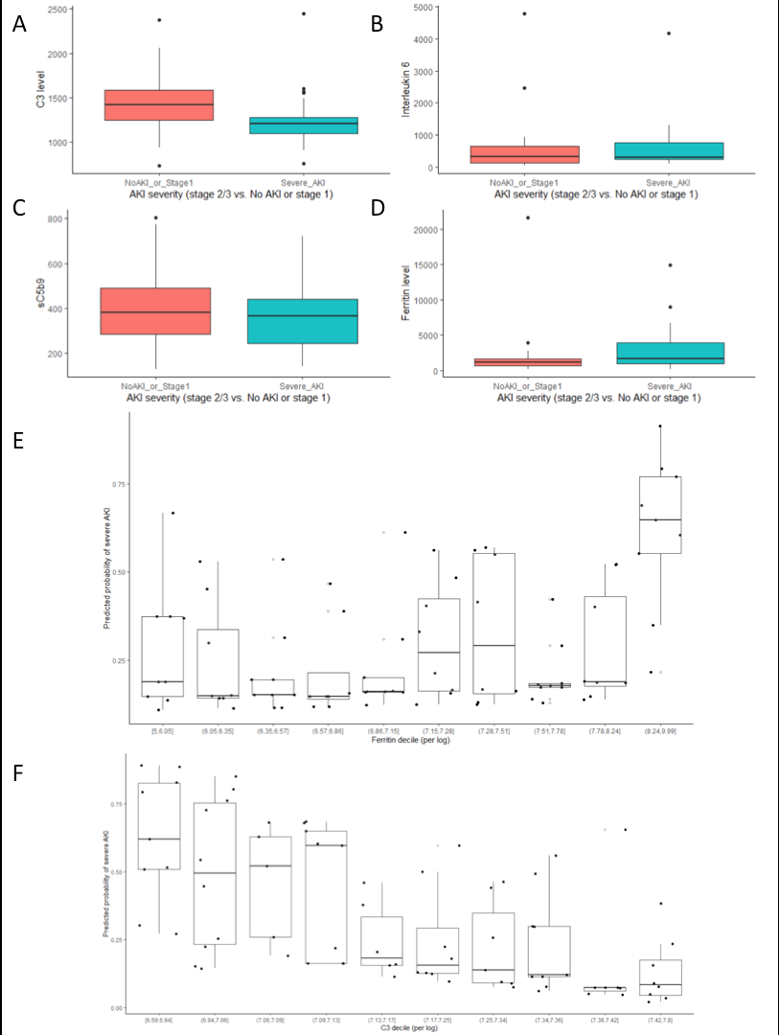
Figure S1. Boxplots depicting relationship between AKI stage 2 and 3 and C3 [ng/mL] (A), IL-6 [ng/mL] (B), sC5b9 [ng/mL] (C) and ferritin levels [mg/L] (D) levels, and predicted probabilities of severe AKI according to ferritin (E) and C3 (F) deciles (per log).
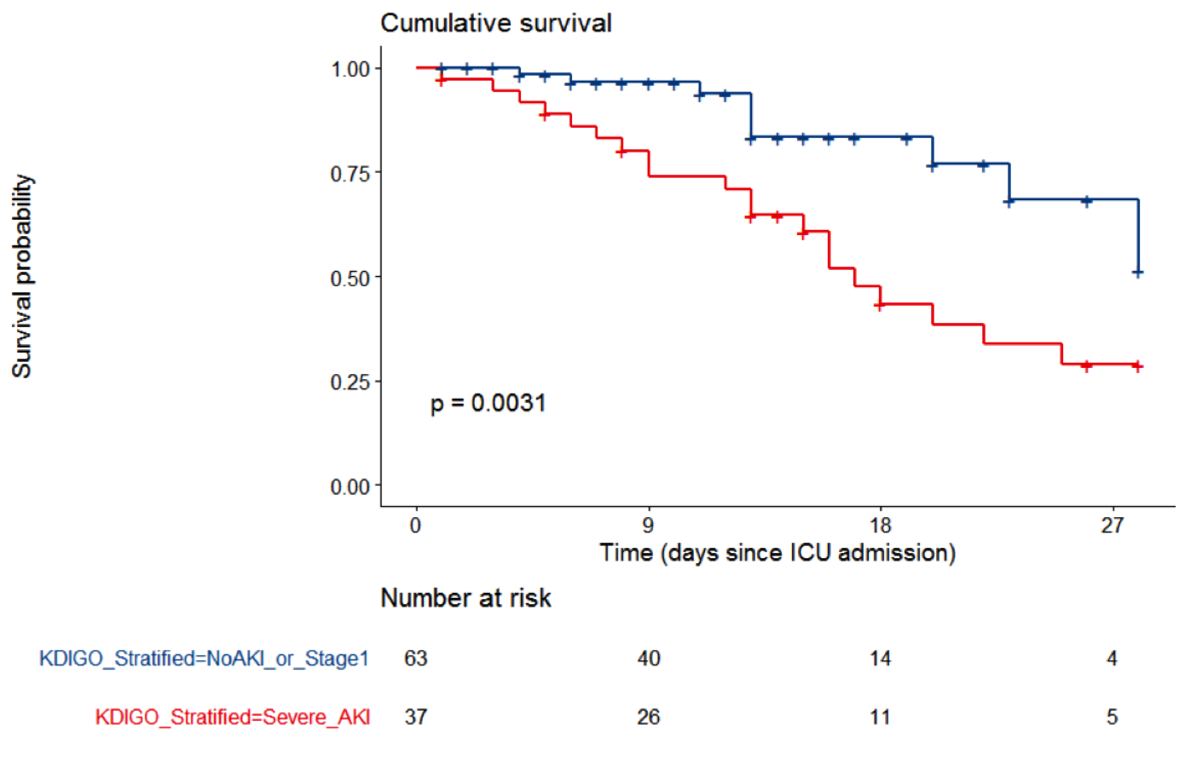
Figure S2. Kaplan-Meier curve for day-28 survival in patients without AKI or with AKI stage 1 (n=63) compared to AKI stage 2 or 3 (n= 37).

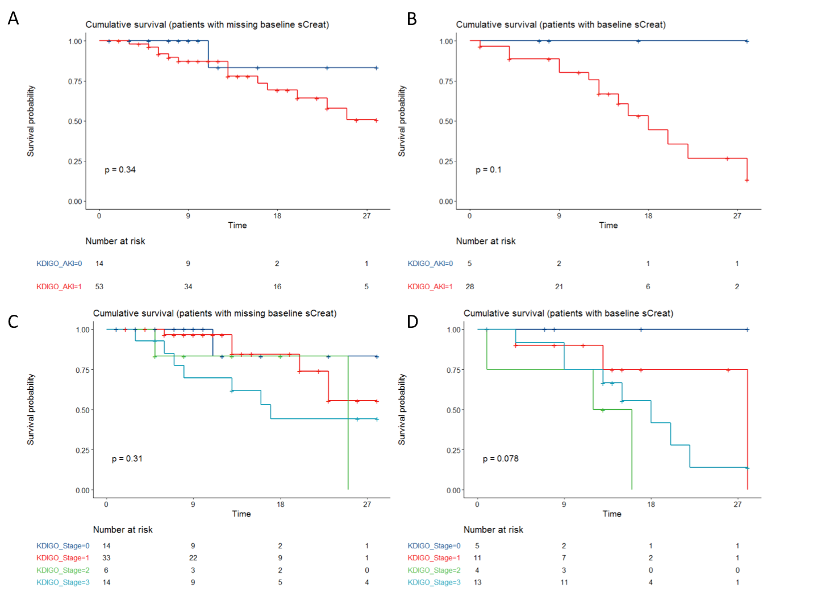

Figure S3. Kaplan-Meier curves for day-28 survival according to AKI (A and B) and AKI stages (C and D) in patients with (n=33, B and D) and without (n= 67, A and C) baseline creatinine value.

Table S1. Factors associated with risk of AKI stage 2 and 3, compared to no AKI or AKI stage 1, after adjustment for modified SOFA and chronic kidney disease (logistic regression)
 | Odds ratio | 95%CI | P Value
IL-6 at day 0 (per log increase) | 1.54 | 0.94-2.63 | 0.097
Ferritin at day 0 (higher than median) | 2.64 | 0.94-7.94 | 0.072
C3 at day 0 (higher than median) | 0.17 | 0.05-0.54 | 0.004
sC5b9 at day 0 (per ng/mL) | 0.999 | 0.994-1.000 | 0.492
PEEP at day 1 (per mmHg) | 0.993 | 0.884-1.11 | 0.906

Table S2. Interaction between missing baseline serum creatinine and reported results

Variable | Model | P-value for interaction
AKI | Mortality (univariate analysis) | 0.37
AKI stage | Mortality (univariate analysis) | 0.96
SOFA | AKI (logistic regression) | 0.10
CKD | AKI (logistic regression) | 0.99
IL-6 | AKI (logistic regression – Se analysis) | 0.23
sC5b9 | AKI (logistic regression – Se analysis) | 0.09
Ferritin | AKI (logistic regression – Se analysis) | 0.60
PEEP at day 1 | AKI (logistic regression – Se analysis) | 0.30
AKI | Mortality (Cox model) | 0.93
SOFA | Mortality (Cox model) | 0.29

