Appendix

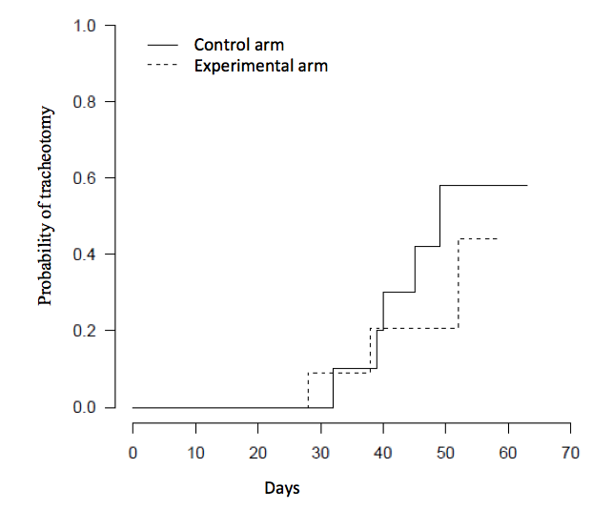

Figure S1. Cumulative incidence of tracheostomy

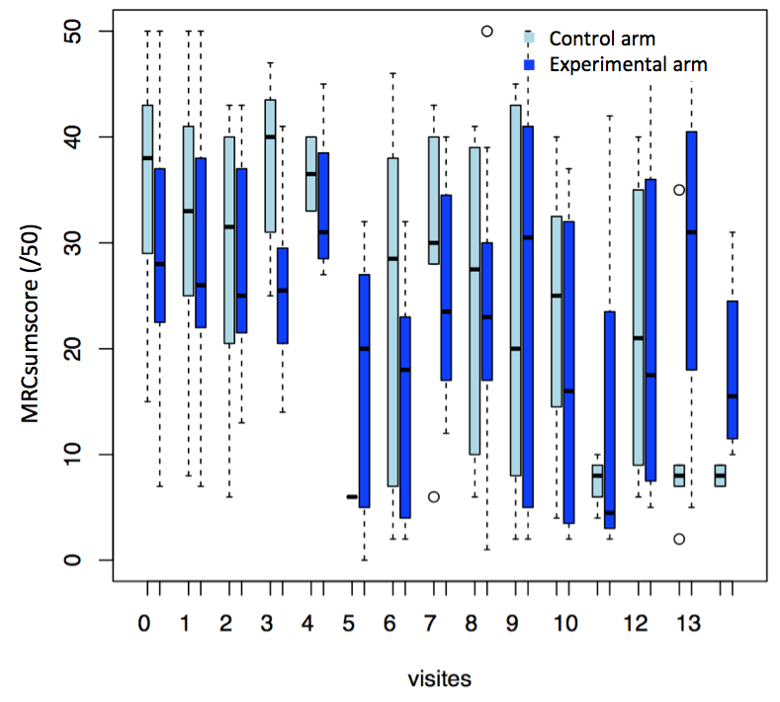

Figure S2. Neurological scores during the entire following period

Table S1: Predominant organisms in early and late-onset pneumonia*
 |  | Early-onset pneumonia | Late-onset pneumonia
Type of respiratory sample | Polymicrobien | 9 (41%) | 14 (64%)
Type of respiratory sample | Monomicrobien | 9 (41%) | 7 (32%)
Type of respiratory sample | Negative | 4 (18%) | 1 (4%)
Culture of respiratory sample | Haemophilus influenzae | 8 (36%) | 3 (14%)
Culture of respiratory sample | methicillin-susceptible Staphylococcus aureus | 8 (36%) | 14 (63%)
Culture of respiratory sample | Streptococcus pneumonia | 4 (18%) | -
Culture of respiratory sample | Other Streptococci | 3 (14%) | -
Culture of respiratory sample | Pseudomonas aeruginosa | 3 (14%) | 13 (60%)
Culture of respiratory sample | Klebsiella pneumoniae | - | 4 (18%)
Total |  | 22 | 22

*Data are expressed as number (percentage).

Table S2. Secondary outcomes *

 | All patients  n=50 | Experimental group  N=25 | Control group  N=25 | p value
Mechanical ventilation -yes | 41 (82) | 25 (100) | 16 (64) | <0.001
Invasive ventilation- yes | 33 (66) | 17 (68) | 16 (64) | <0.001
Non invasive ventilation- yes | 8 (16) | 8 (32) | 0 (0) | <0.001
NIV failure- yes | 6 (12) | 6 (24) | - | -
Time on mechanical ventilation- days |  | 14 |7-29] | 22 |18- 36] | 0.095
Tracheostomy - yes | 10 (20) | 4 (16) | 6 (24) | 0.79
Hospital length of stay - days |  | 27 [16-48] | 26 [16-54] | 0.5

*Data are expressed as number (percentage) for categorical variables and as median [interquartile range] for continuous variables.

Table S3. Distribution of serious adverse events across randomization groups*
 | All patients  n=50 | Experimental group  N=25 | Control group  N=25 | p
In hospital death- yes† | 3 (6) | 1 (4) | 2 (8) | 1.00
Septic shock- yes | 11 (22) | 6 (30) | 5 (25) | 1.00
Acute renal failure- yes | 2 (4) | 0 (0) | 2 (11) | 0.22
Acute hepatic failure-yes | 3 (6) | 1 (5) | 2 (10) | 1.00
Acute respiratory distress syndrome- yes | 13 (26) | 7 (35) | 6 (35) | 1.00

*Data are expressed as number (percentage).
†at 90-days post randomization there were 4 deaths, with one patient who died after being discharge alive from hospital

