Electronic Supplementary Material

Characteristics and outcomes of Acute Respiratory Distress Syndrome related to COVID-19 in Belgian and French Intensive Care Units according to antiviral strategies.
The COVADIS multicenter observational study.

Authors
David Grimaldi¹, MD; Nadia Aissaoui², MD; Gauthier Blonz³, MD; Giuseppe Carbutti⁴, MD; Romain Courcelle⁵, MD; Stephane Gaudry⁶, MD; Aurelie Gaultier⁷, MSc; Alain D’hondt⁸, MD; Julien Higny⁹, MD; Geoffrey Horlait¹⁰, MD; Sami Hraiech^{11,12}, MD; Laurent Lefebvre¹³, MD; Francois Lejeune¹⁴, MD; Andre Ly¹⁵, MD; Michael Piagnerelli¹⁶, MD; Bertrand Sauneuf¹⁷, MD; Nicolas Serck¹⁸, MD; Thibaud Soumagne¹⁹, MD; Piotr Szychowiak^{20,21,22}, MD; Julien Textoris^{23,24}, MD; Benoit Vandenbunder²⁵, MD; Christophe Vinsonneau²⁶, MD; Jean-Baptiste Lascarrou^{22,27}, MD for the COVADIS study group.

Table S1: Antiviral standard procedure in the participating centers

 | Hydroxychloroquine |  | Lopinavir/Ritonavir |  | Remsedivir
 | Dose and duration | Rules for stopping | Dose and duration | Rules for stopping | Dose and duration | Rules for stopping
1 | 400mg/day during 5 days | prolonged QTc, arythmia | NA | NA | NA | NA
2 | 600mg/day during 10 days | prolonged QTc | 800mg/day during 6 days | GFR<30ml/min or ASAT/ALAT>5N | NA | NA
3 | NA | NA | NA | NA | NA | NA
4 | 400mg/day during 5 days | prolonged QTc | NA | NA | NA | NA
5 | 800mg day 1 then 400mg during 9 days | prolonged QTc | 800mg/day during 14 days | GFR<30ml/min or ASAT/ALAT>5N | 200mg day 1 then 100mg during 9 days | GFR<30ml/min or ASAT/ALAT>5N
6 | 400mg/day during 5 days | prolonged QTc | NA | NA | NA | NA
7 | NA | NA | 800mg/day during 14 days | GFR<30ml/min or ASAT/ALAT>5N | NA | NA
8 | 400mg/day during 5 days | prolonged QTc | NA | NA | 100mg/day during 7 days | None
9 | 600mg/day during 10 days | prolonged QTc | NA | NA | NA | NA
10 | 800mg day 1 then 400mg during 4 days | None | 800mg/day during 14 days | None | 200mg day 1 then 100mg during 9 days | None
11 | 600mg/day during 10 days | prolonged QTc, RRT | 800mg/day during 14 days | GFR<30ml/min or ASAT/ALAT>5N | 200mg day 1 then 100mg during 9 days | None
12 | 400mg/day during 5 days | ICU admission | NA | NA | NA | NA
13 | 400mg/day during 5 days | prolonged QTc | 800mg/day during 10 days | None | 200mg day 1 then 100mg during 9 days | Needs for RRT
14 | 400mg/day during 5 days | none | 800mg/day during 14 days | None | 200mg day 1 then 100mg during 9 days | None
15 | 400mg/day during 5 days | prolonged QTc, arythmia | 800mg/day during 5 days | None | NA | NA
16 | 600mg/day during 7 days | prolonged QTc, arythmia | 800mg/day during 7 days | Diarrhea,  GFR<30ml/min | NA | NA
17 | 800mg day 1 then 400mg during 9 days | prolonged QTc | 800mg/day during 14 days | GFR<30ml/min or ASAT/ALAT>5N | 200mg day 1 then 100mg during 9 days | None
18 | NA | NA | NA | NA | NA | NA
19 | 800mg day 1 then 400mg during 5 days | arythmia | NA | NA | NA | NA
20 | 400mg/day during 5 days | prolonged QTc | NA | NA | NA | NA
21 | 600mg/day during 10 days | ICU admission | 800mg/day during 7 days* | None | NA | NA
RRT: Renal Replacement Therapy
* Cease L/R administration after RCT publication (doi 10.1056/NEJMoa2001282)

Table S2: Associated factors with ICU survival

 | Non survivors  N=166 | survivors  N=240 | P value¹
Age, mean±SD | 66 ±10 | 62 ±10 | <0.001
Gender, men, n (%) | 131 (79) | 182 (76) | 0.55
BMI, kg/m², mean±SD | 29.5 ±5 | 29.9 ±5 | 0.39
Hypertension, n (%) | 99 (60) | 130 (54) | 0.31
Uncomplicated diabetis mellitus, n (%) | 33 (20) | 45 (19) | 0.80
Complicated diabetis mellitus, n (%) | 22 (13) | 11 (5) | 0.003
Chronic kidney disease, n (%) | 22 (13) | 10 (4) | 0.001
Periphereal artery disease, n (%) | 14 (8) | 11 (5) | 0.14
History of myocardial infarction, n (%) | 16 (10) | 20 (8) | 0.72
Charlson Comorbidity index, median [IQR]  = 0  = 1  ≥ 2 | 1 (0-3)  58 (35)  34 (21)  74 (45) | 1 (0-2)  110 (46)  70 (29)  60 (25) | < 0.001  < 0.001
PEEP (cmH₂O), mean±SD | 11.5 ±3 | 11.5 ±3 | 0.99
Plateau pressure (cmH₂O), mean±SD  N=159/207 | 24.4 ±4 | 23.0 ±4 | 0.001
P/F, mean±SD | 121 ±48 | 131 ±51 | 0.07
NO, n (%) | 27 (16) | 24 (10) | 0.07
Hydroxychloroquine, n (%) | 110 (66) | 148 (62) | 0.40
Lopinavir/ritonavir, n (%) | 37 (22) | 48 (20) | 0.62
Remdesivir, n (%) | 8 (5) | 13 (5) | 0.82
Corticosteroids², n (%)  N=221/171 | 41 (25) | 40 (18) | 0.10
Macrolides | 106 (64) | 149 (62) | 0.76
Co-infection | 23 (14) | 26 (11) | 0.36
Day 14 Ventilatory mode  Death  Controlled or VV-ECMO  Pressure support  Extubated | 94 (57)  58 (35)  13 (8)  1 (1) | 0 (0)  80 (33)  73 (30)  87 (36) | <0.001
Acute kidney injury, n (%)  - No  - Yes without RRT  - Yes with RRT | 45 (27)  72 (43)  49 (30) | 136 (57)  73 (30)  31 (13) | <0.001
Peak Creatinine until Day 28, median [IQR]  n= 164/205 | 210 [112-429] | 103 [77-175] | < 0.001
Cardiac injury, n (%) | 37 (22) | 18 (8) | < 0.001
Pulmonary embolism, n (%) | 23 (14) | 35 (15) | 0.89
Alive at D28, n (%) | 26 (16) | 240 (100) | < 0.001

AKI: acute kidney injury, see definition in the method section
BMI: body mass index; SD: standard deviation; P/F: PaO2/FiO2 ratio; NO: Inhaled nitric oxide;
¹ P-value was calculated by Fisher exact test, t-test or Mann Whitney test as appropriate
² some patients were included in a double blind RCT steroids vs placebo and are considered as missing data, most of the treated patients received steroids lately

Figure S1: Flow chart of the study

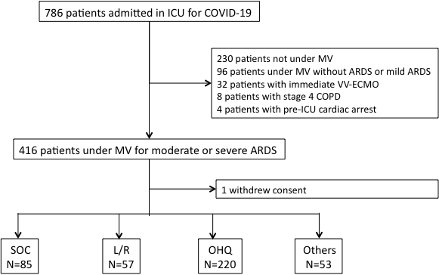

MV: mechanical ventilation, SOC: standard of care, L/R: Lopinavir/ritonavir, OHQ: hydroxychloroquine, Others: OHQ + L/R N= 32; OHQ + Remdesivir N= 10; Remdesivir N=11

Figure S2: Forest plot of antiviral strategies effect on ICU survival in a mixed multivariate model

OR (CI95%) were obtained through a generalized linear mixed model including antiviral strategies, age, sexe, Charlson comorbidity index, plateau pressure and P/F with centre as random effect. (N= 361). L/R: lopinavir/ritonavir ; OHQ: hydroxychloroquine.

Figure S3: Forest plot of variables associated with AKI in a mixed multivariate model

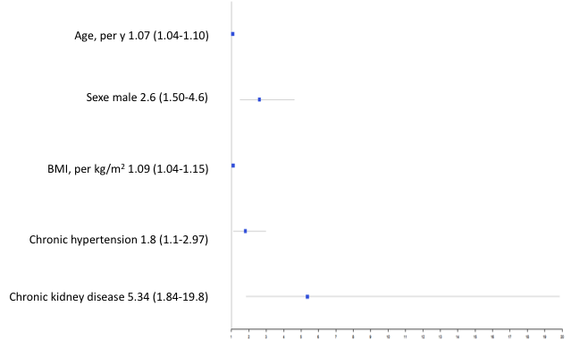
OR (CI95%) were obtained through a generalized linear mixed model including lopinavir, hydroxychloroquine, age, sexe, BMI, chronic hypertension and moderate to severe chronic renal failure with centre as random effect. (N= 410). N= 410. AKI: acute kidney injury. Chronic kidney disease: moderate to severe chronic renal failure

