ROX index to predict invasive mechanical ventilation in immunocompromised patients with acute respiratory failure?
Virginie Lemiale, MD⁽¹⁾, Guillaume Dumas, MD⁽¹⁾, Alexandre Demoule, MD, PhD⁽²⁾, Frederic Pène, MD, PhD⁽³⁾; Achille Kouatchet, MD⁽⁴⁾; Magali Bisbal, MD⁽⁵⁾; Saad Nseir, MD, PhD⁽⁶⁾; Laurent Argaud, MD, PhD⁽⁷⁾; Loay Kontar, MD⁽⁸⁾; Kada Klouche, MD, PhD⁽⁹⁾; Francois Barbier, MD, PhD⁽¹⁰⁾; Amelie Seguin, MD⁽¹¹⁾; Guillaume Louis, MD⁽¹²⁾; Jean-Michel Constantin, MD, PhD⁽¹³⁾; Julien Mayaux, MD⁽²⁾; Florent Wallet, MD⁽¹⁴⁾; Vincent Peigne, MD⁽¹⁵⁾; Christophe Girault, MD⁽¹⁶⁾; Johanna Oziel, MD⁽¹⁷⁾; Martine Nyunga, MD⁽¹⁸⁾; Nicolas Terzi, MD, PhD⁽¹⁹⁾; Lila Bouadma, MD, PhD⁽²⁰⁾; Alexandre Lautrette, MD, PhD⁽²¹⁾; Naike Bige, MD, PhD⁽²²⁾; Jean-Herle Raphalen, MD⁽²³⁾; Laurent Papazian, MD, PhD⁽²⁴⁾, Fabrice Bruneel, MD⁽²⁵⁾; Christine Lebert, MD⁽²⁶⁾; Dominique Benoit, MD, PhD⁽²⁷⁾; Anne-Pascale Meert, MD, PhD⁽²⁸⁾; Samir Jaber, MD, PhD⁽²⁹⁾; Djamel Mokart, MD, PhD ⁽⁵⁾, Michael Darmon, MD, PhD⁽¹⁾; Elie Azoulay, MD, PhD⁽¹⁾. The Groupe de Recherche en Reanimation Respiratoire du patient d’Onco-Hématologie (GRRR-OH)

Additional material

Figures and Tables legends

figure S1: ROC curve for ROX index 6 hours after HFNC onset
Area under the curve (AUC) : 0.623 (0.557-0.689)

Figure S2 : Probability of intubation according to the multivariable model including ROX index.
Figure S3: ROC curve of adjusted ROX index 6 hours after HFNC onset

Area under the curve (AUC) : 0.663 (0.596-0.729).

Figure S4: Comparison between ROC curves of adjusted ROX index and modified model without ROX index

ROC curve for adjusted ROX index 6 h after HFNC onset

ROC curve for modified model without ROX index

Likelihood ratio test p=0.002

Figure S5: Probability of intubation according to ROX index quartile.

For each ROX index quartile the probability of intubation was calculated including IC 95%.

Figure S1

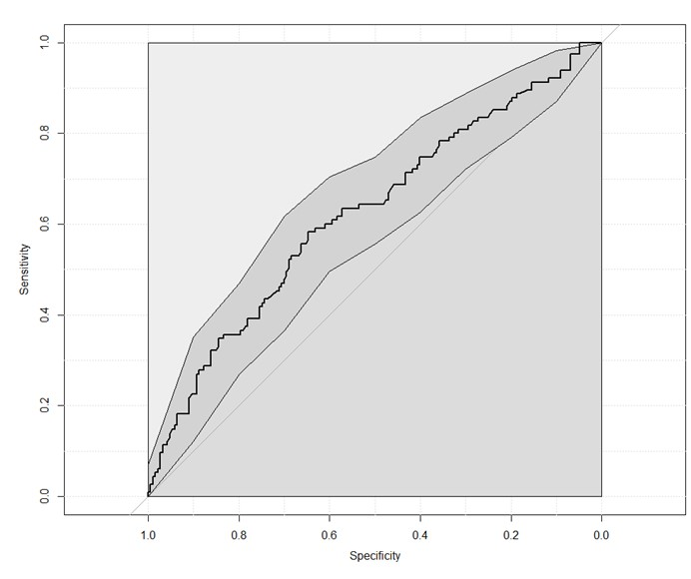

Figure S2

Adjusted ROX index

Figure S3

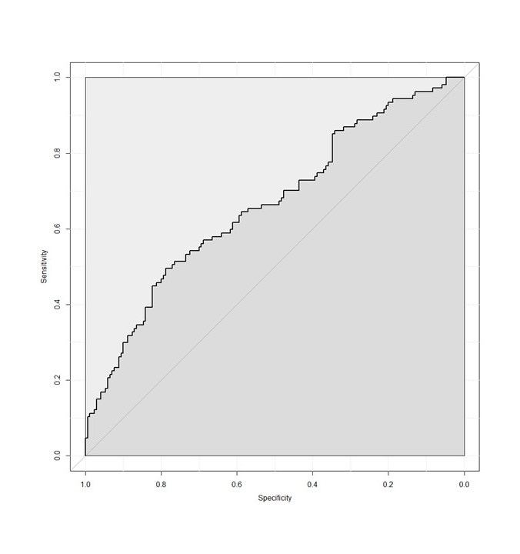

Figure S4

Figure S5

