Additional file 1
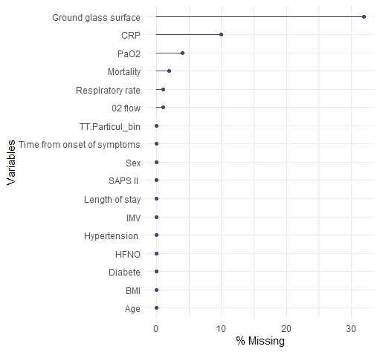
Immunomodulatory treatment
*CRP denotes C-reactive protein, IMV invasive mechanical ventilation, HFNO high flow nasal canula, BMI body mass index, PaO2 Artery partial pressure oxygen, SAPS 2 Simplified Acute Physiology Score
Figure S1 Plot - missing data for each variables*

