Additional file 6: Linear regression between CK and myoglobin

Slope=2.46, R²=0.19, p<0.001. 2 outliers are not reported in the graph because of myoglobin levels of 17000 and 121000 µg/L respectively.

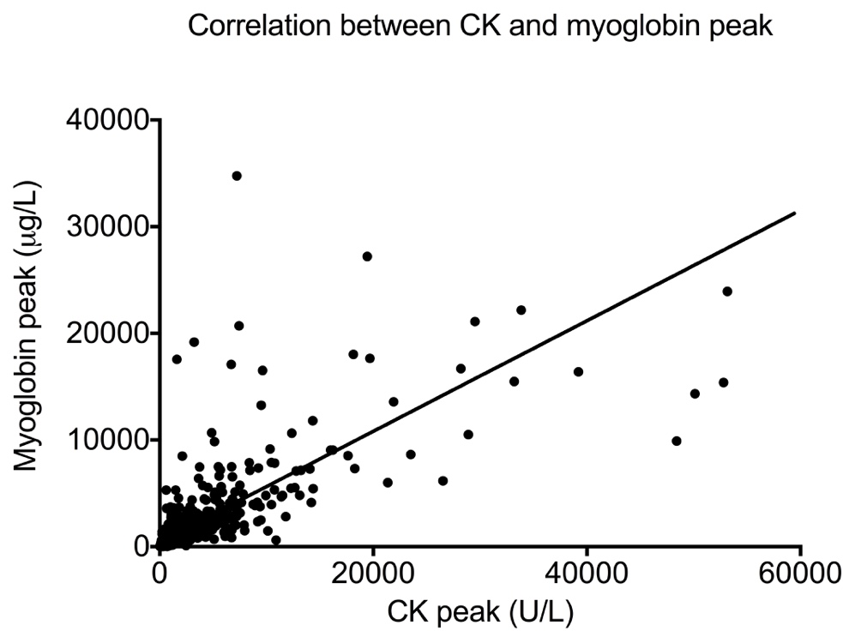

Slope=0.518, R²=0.34, p<0.001. 2 outliers are not reported in the graph because of CK level of 10000 U/L and myoglobin level of 121000 µg/L respectively.

