Figure S1. Kaplan-Meier cumulated survival curves at day 90 since ICU admission according to obesity grades: non obese (blue curve), obesity grade 1 (green curve), obesity grade 3 (red curve).
Non obese patients were defined by BMI < 30 kg/m2, obesity grade 1 by BMI ≥ 30 kg/m2 and < 35 kg/m2, obesity grade ≥ 2 by BMI ≥ 35 kg/m2.

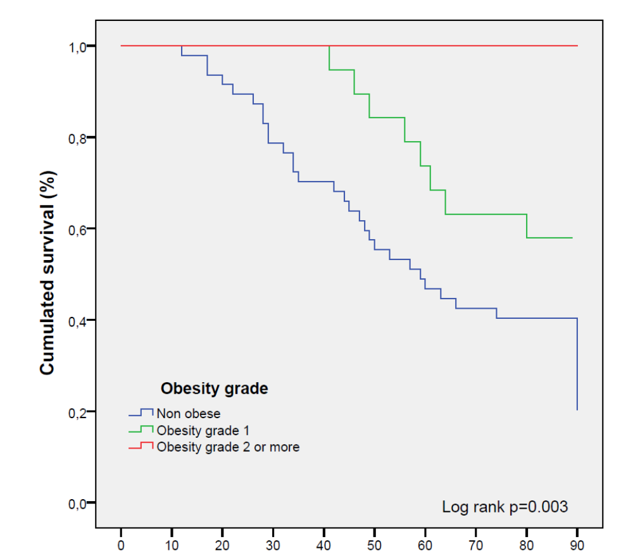

N at Risk
Non obese
Obesity grade 1
Obesity grade ≥2
47
19
10
43
19
10
33
19
10
22
14
10
19
11
10

