Additional File 1
Supplemental Table 1. Baseline characteristics, complications, and outcomes stratified by the two study sites
Clinical Characteristics and Premedical History | IBK  N=39 | BRU  N=21 | p-value*
Age in years | 58 (48-66) | 52 (46-64) | 0.876
Female sex | 28 (72) | 9 (43) | 0.050
Chronic heart failure | 0 (0) | 0 (0) | -
Previous myocardial infarction | 1 (3) | 2 (10) | 0.278
Pre-existing hypertension | 14 (36) | 8 (38) | 1.000
Smoking history | 17 (44) | 7 (33) | 0.582
Admission H&H grade | 5 (3-5) | 3 (2-5) | 0.073
GCS at ICU admission | 3 (3-8) | 7 (3-13) | 0.059
LOC at ictus | 22 (56) | 14 (67) | 0.582
Admission Radiological Characteristics
Modified Fisher Scale | 4 (3-4) | 4 (3-4) | 0.867
ICH present on admission CT-scan | 17 (44) | 13 (62) | 0.279
Hydrocephalus requiring EVD placement | 34 (87) | 8 (38) | <0.001
Global cerebral edema | 14 (36) | 10 (48) | 0.418
Aneurysm Treatment
Endovascular coiling | 16 (41) | 15 (71) | 0.053
Neurosurgical clipping | 22 (56) | 5 (24) | 0.053
Non-aneurysmal SAH | 1 (3) | 1 (5) | 0.053
Complications and Treatments
Neurogenic myocardial stunning | 15 (39) | 8 (38) | 1.00
Pneumonia | 28 (72) | 14 (67) | 0.771
Ventriculitis | 6 (15) | 1 (5) | 0.404
Vasospasm | 34 (87) | 14 (67) | 0.090
Delayed cerebral ischemia | 14 (36) | 11 (52) | 0.276
Noradrenaline, daily dose in mg** | 9 (3-15) | 41 (11-93) | <0.001
Dobutamine, daily dose in mg** | 155 (0-322) | 0 (0-14) | 0.461
Phenylephrine, daily dose in mg** | 0 (0-37) | 0 (0-0) | <0.001
P_{bt}O₂ in mmHg** | 26±11 | 26±9 | 0.611
BTH, percent of monitoring time** | 24 | 21 | 0.786
Outcome Characteristics
Length of ICU stay in days | 30 (24-44) | 19 (11-30) | 0.002
In-hospital mortality | 5 (13) | 9 (43) | 0.012
3-month mRS | 4 (2-5) | 5 (3-6) | 0.080
SAH - subarachnoid hemorrhage, H&H - Hunt and Hess, LOC - loss of consciousness, ICH - intracerebral hemorrhage, EVD - external ventricular drain, BTH – brain tissue hypoxia, mRS - modified Rankin Scale. Data are given in mean±SD, median (IQR) and counts (%).
*Differences across patients from the two sites were assessed with the T-test, Mann-Whitney U test, Qui square test, Fishers exact test, and GEE models in repeated measurements.
** within the first 10 days

Supplemental Table 2. Association between CI and P_{bt}O₂ (GEE model)
Variable | Wald | p-value*
CI | 6.8 | 0.009
MAP | 3.5 | 0.063
ICP | 0.5 | 0.474
Age | 3.4 | 0.067
H&H | 0.4 | 0.550
PaO2 | 8.3 | 0.004
CI*CPP (interaction) | 2.7 | 0.098
Dependent variable: P_{bt}O₂
P_{bt}O₂ – brain tissue oxygenation, CI – continuous cardiac index, MAP – mean arterial pressure, CPP – cerebral perfusion pressure, ICP – intracerebral pressure, PaO2 - partial pressure of oxygen, H&H - Hunt and Hess

Supplemental Table 3. Changes of variables pre- during and post fluid administration in a total of 198 infusions stratified by brain tissue hypoxia vs. normal brain oxygenation at baseline
 | Brain tissue hypoxia at baseline, n=49 |  |  |  | Normal brain oxygenation at baseline, n=149
Variable | Pre infusion | During infusion | Post infusion | p-value** | Pre infusion | During infusion | Post infusion | p-value**
P_{bt}O₂, mmHg | 13±6 | 14±10 | 16±11 | 0.002 | 30±7 | 30±8 | 30±8 | 0.154
BTH, percent | 49 (100) | 43 (88) | 32 (64) | <0.001 | 0 (0) | 7 (5) | 11 (7) | <0.001***
CI, L/min/m² | 3.6±1.0 | 3.7±1.0 | 3.7±1.0 | 0.036 | 4.0±1.1 | 4.0±1.2 | 4.1±1.2 | 0.004
SVV, percent | 9±5 | 10±5 | 8±4 | 0.002 | 12±6 | 12±6 | 9±5 | <0.001
MAP, mmHg | 106±20 | 105±21 | 107±21 | 0.164 | 104±14 | 104±16 | 105±14 | 0.283
CPP*, mmHg |  |  |  | 0.785 |  |  |  | 0.059
IBK | 73±10 | 70±11 | 73±12 |  | 73±9 | 72±9 | 74±10
BRU | 105±35 | 105±37 | 101±42 |  | 112±18 | 111±20 | 114±17
ICP, mmHg | 15±13 | 15±13 | 16±16 | 0.229 | 11±6 | 11±6 | 11±6 | 0.202
HR, bpm | 82±16 | 84±16 | 84±22 | 0.832 | 87±14 | 87±15 | 87±15 | 0.625
P_{bt}O₂ – brain tissue oxygenation, BTH – brain tissue hypoxia; CI – continuous cardiac index, SVV- stroke volume variation, MAP – mean arterial pressure, CPP – cerebral perfusion pressure, ICP – intracerebral pressure, HR – heart rate.
*IBK: zeroed at the level of the Monroe foramen, BRU: zeroed at the heart level
Data are given in mean±SD or counts (%).
** P-values indicate the difference between pre (one hour before) and post (one hour after) fluid administration.
*** Mean P_{bt}O₂ levels decreased from 22±4 mmHg before fluid administration to 18±2 mmHg post fluid administration.

Supplemental Table 4. Changes of variables pre- during and post fluid administration in a total of 198 infusions stratified by CI responders and non-responders.
 | Cardiac responders (∆CI ≥10%), n=50 |  |  |  | Cardiac non-responders (∆CI <10%), n=148
Variable | Pre infusion | During infusion | Post infusion | p-value** | Pre infusion | During infusion | Post infusion | p-value**
P_{bt}O₂, mmHg | 25±11 | 25±11 | 25±10 | 0.917 | 26±10 | 27±11 | 27±11 | 0.999
BTH, percent | 14 (29) | 14 (28) | 12 (24) | 0.513 | 34 (25) | 36 (24) | 29 (20) | 0.432
CI, L/min/m² | 3.5±1.2 | 3.9±1.5 | 4.4±1.6 | <0.001 | 4.0±1.2 | 3.9±1.0 | 3.9±1.0 | 0.126
SVV, percent | 12±7 | 11±7 | 9±6 | 0.001 | 11±5 | 11±5 | 9±5 | <0.001
MAP, mmHg | 103±16 | 105±19 | 107±17 | 0.125 | 105±16 | 104±16 | 105±16 | 0.788
CPP*, mmHg |  |  |  | <0.001 |  |  |  | 0.447
IBK | 70±8 | 72±10 | 76±11 |  | 74±9 | 72±10 | 73±10
BRU | 101±24 | 97±30 | 99±39 |  | 112±26 | 112±27 | 112±26
ICP, mmHg | 14±9 | 13±12 | 13±12 | 0.589 | 12±8 | 12±7 | 12±9 | 0.460
HR, bpm | 82±13 | 83±13 | 84±13 | 0.014 | 87±15 | 87±16 | 87±18 | 0.579
P_{bt}O₂ – brain tissue oxygenation, BTH – brain tissue hypoxia; CI – continuous cardiac index, SVV- stroke volume variation, MAP – mean arterial pressure, CPP – cerebral perfusion pressure, ICP – intracerebral pressure, HR – heart rate.
*IBK: zeroed at the level of the Monroe foramen, BRU: zeroed at the heart level
Data are given in mean±SD or counts (%).
** P-values indicate the difference between pre (one hour before) and post (one hour after) fluid administration.

Supplemental Table 5. Changes of variables pre- during and post fluid administration in a total of 198 infusions stratified by crystalloids vs colloids.
 | Colloids, n=72 |  |  |  | Crystalloids, n=126
Variable | Pre infusion | During infusion | Post infusion | p-value** | Pre infusion | During infusion | Post infusion | p-value**
P_{bt}O₂, mmHg | 27±10 | 28±10 | 28±11 | 0.107 | 25±11 | 25±11 | 25±10 | 0.468
BTH, percent | 14 (20) | 16 (22) | 13 (18) | 0.530 | 34 (30) | 34 (27) | 28 (22) | 0.215
CI, L/min/m² | 3.8±1.2 | 3.8±1.1 | 4.1±1.4 | <0.001 | 3.9±1.0 | 4.0±1.2 | 4.0±1.1 | 0.053
SVV, percent | 12±7 | 11±6 | 8±5 | <0.001 | 11±6 | 11±6 | 10±5 | <0.001
MAP, mmHg | 100±12 | 99±14 | 103±14 | 0.031 | 107±17 | 107±18 | 107±17 | 0.884
CPP*, mmHg |  |  |  | 0.012 |  |  |  | 0.941
IBK | 73±9 | 70±9 | 76±10 |  | 73±9 | 73±10 | 74±11
BRU | - | - | - |  | 109±26 | 108±28 | 109±29
ICP, mmHg | 11±5 | 11±5 | 11±5 | 0.940 | 13±10 | 13±10 | 13±11 | 0.778
HR, bpm | 84±14 | 84±14 | 83±14 | 0.213 | 87±15 | 87±15 | 88±18 | 0.471
P_{bt}O₂ – brain tissue oxygenation, BTH – brain tissue hypoxia; CI – continuous cardiac index, SVV- stroke volume variation, MAP – mean arterial pressure, CPP – cerebral perfusion pressure, ICP – intracerebral pressure, HR – heart rate.
*IBK: zeroed at the level of the Monroe foramen, BRU: zeroed at the heart level
Data are given in mean±SD or counts (%).
** P-values indicate the difference between pre (one hour before) and post (one hour after) fluid administration.

Supplemental Figure 1. Institutional protocol to treat brain tissue hypoxia in IBK.
BRAIN TISSUE HYPOXIA (PbtO2 <20mmHg)

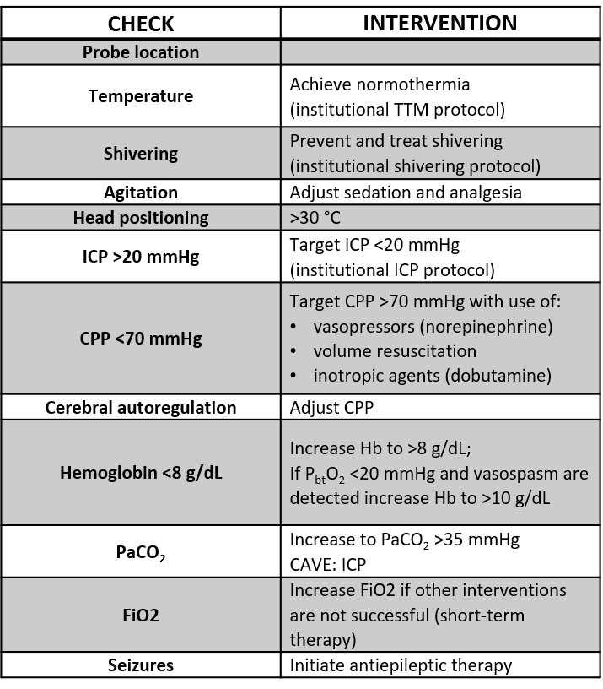

Supplemental Figure 2. Institutional protocol to treat brain tissue hypoxia in BRU.
The order of which intervention to be started first is dependent on patients’ condition and treating physician

A = Suspected low oxygen delivery
a if ICP is between 20-25 mmHg and patient is awakening, no specific therapy could be considered.
c if ICP remains below 20 mmHg
d if ICP is between 15 and 20 mmHg with tissue hypoxia

B = Suspected increased oxygen consumption (i.e. agitation; seizures; inadequate sedation on EEG monitoring)

C = Suspected delayed cerebral ischemia (DCI): diagnosis of DCI is based on a combination of parameters (i.e. clinical deterioration when clinical examination is available or EEG monitoring, PbtO2 and trans-cranial Doppler for unconscious patients) and the demonstration of altered cerebral perfusion on CT-perfusion $±$narrowing of intracranial vessels (angiography or angio-CT scan).

#These includes: a) induced hypertension; b) intra-arterial vasodilators; c) cerebral angioplasty; d) rescue therapies (i.e. intra-carotid catheter for continuous infusion of vasodilators; therapeutic hypothermia; steroids; high-dose magnesium)

