Additional file 1
This appendix has been provided by the authors to give readers additional information about their work.

Supplement to: Janssens GN, Daemen J, Lemkes JS, et al. The influence of timing of coronary angiography on acute kidney injury in out-of-hospital cardiac arrest patients: a retrospective cohort study. Annals of Intensive Care.
Acute kidney injury according to Acute Kidney Injury Network criteria
Creatinine/glomerular filtration rate criteria
Stage 1: Increase in serum creatinine of more than or equal to 0.3 mg/dL (≥26.4 μmol/L) or increase to more than or equal to 150% to 200% (1.5- to 2-fold) from baseline.
Stage 2: Increase in serum creatinine to more than 200% to 300% (>2- to 3-fold) from baseline.
Stage 3*: Increase in serum creatinine to more than 300% (>3-fold) from baseline (or serum creatinine of more than or equal to 4.0 mg (≥354 μmol/L) with an acute increase of at least 0.5 mg/dl (44 μmol/L).
Urine output criteria
Stage 1: Urine output <0.5 ml/kg/h x 6 h
Stage 2: Urine output <0.5 ml/kg/h x 12 h
Stage 3: Urine output <0.3 ml/kg/h x 24 h or anuria x 12 h
* Patients who received renal replacement therapy (RRT) were considered to have met the criteria for stage 3 irrespective of the stage they were in at the time of RRT.
Additional statistical analysis
Univariable and logistic regression analysis was used to identify predictors of AKI. A multivariable model was subsequently determined using backward multivariable logistic regression analysis. Predictors with p-value <0.1 in univariable analysis, were included as candidate predictors in multivariate analysis.
Statistical analyses were performed using SPSS Statistics, version 26 (IBM Corp, Armonk, New York).

Table S1. Creatinine values
Medians and means of creatinine values throughout hospital admission, stratified by early and non-early CAG
Creatinine value | Early CAG group  (N=1148) | Deferred CAG/no CAG group  (N=1227) | p-value
Creatinine at t=0, µmol/L | 96 [81-114] | 100 [82-120] | 0.001
Creatinine at day 1, µmol/L | 78 [62-108] | 90 [68-130] | <0.001
Creatinine at day 2, µmol/L | 82 [67-108] | 86 [67-137] | 0.008
Creatinine at day 3, µmol/L | 79 [65-102] | 84 [67-126] | <0.001
Last creatinine before hospital discharge | 79 [66-100] | 83 [66-117] | 0.08
Peak creatinine during hospitalization, µmol/L | 105 [87-133] | 112 [89-170] | <0.001
Creatinine 1 month after discharge (n=135), µmol/L | 78 [69-87] | 88 [68-102] | 0.05
Creatinine 1 year after discharge (n=91), µmol/L | 84 [74-100] | 88 [74-105] | 0.68

Values are expressed as median and interquartile ranges (IQR).
CAG denotes coronary angiography, PCI percutaneous coronary intervention, CABG coronary artery bypass graft, CRP C-reactive protein, CK creatine kinase.

Table S2. Characteristics in matched patients
Characteristics | Early CAG  (N=125) | Deferred/ no CAG  (N=125) | P value | SD/agreement
Patient characteristics
Male sex | 98/125 (78.4) | 92/125 (73.6) | 0.37 | 95.2
Age in years | 62.0±12.2 | 61.5±15.0 | 0.77 | 0.04
Hypertension | 42/125 (33.6) | 39/125 (31.2) | 0.69 | 97.6
Diabetes mellitus | 19/125 (15.2) | 19/125 (15.2) | 1.00 | 100.0
Previous cardiac arrest | 3/125 (2.4) | 5/125 (4.0) | 0.72 | 98.4
Previous myocardial infarction | 29/125 (23.2) | 26/125 (20.8) | 0.65 | 97.6
Previous CVA or TIA | 18/247 (7.3) | 13/235 (5.5) | 0.46 | 97.3
Chronic kidney disease | 3/125 (2.4) | 2/125 (1.6) | 1.00 | 99.2
Previous renal replacement therapy | 0/125 (0.0) | 0/125 (0.0) | NA | 100.0
Pre-hospital characteristics
Arrest witnessed | 102/125 (81.6) | 109/125 (87.2) | 0.22 | 94.4
First rhythm |  |  | 0.29 | 96.0
VF/VT | 100/125 (80.0%) | 105/125 (84.0)
PEA | 7/125 (5.6) | 2/125 (1.6)
Asystole | 18/125 (14.4) | 18/125 (14.4)
Time from arrest to BLS in minutes | 4 [2-7] | 3 [2-7] | 0.91 | 0.22
Time from arrest to ROSC in minutes | 18 [15-25] | 20 [15-25] | 0.14 | 0.17
Characteristics on hospital arrival
Glasgow coma scale <8 | 118/125 (94.4) | 123/125 (98.4) | 0.17 | 96.0
Signs of STEMI on ECG | 43/125 (34.4) | 36/125 (28.8) | 0.34 | 94.4
CT scan performed | 45/125 (36.0) | 78/125 (62.4) | <0.001 | 73.6
Laboratory values upon admission
pH | 7.2 [7.1-7.3] | 7.2 [7.1-7.3] | 0.43 | 0.00
Lactate, mmol/L | 6.0 [3.4-9.6] | 6.7 [4.4-9.9] | 0.22 | 0.17
Hemoglobin, mmol/L | 8.6±0.89 | 8.7±1.2 | 0.36 | 0.12
Hematocrit | 0.40±0.05 | 0.41±0.06 | 0.27 | 0.14
Leukocytes, ∙10⁹/L | 13.2 [10.4-16.8] | 12.5 [10.2-16.5] | 0.61 | 0.13
CRP, mg/L | 2.6 [2.5-6.3] | 2.5 [2.5-9.0] | 0.33 | 0.004
Creatinine, µmol/L | 90 [74-110] | 98 [81-120] | 0.18 | 0.20
Creatinine >130 µmol/L | 18/125 (14.4) | 19/125 (15.2) | 0.86 | 99.2

All data are expressed in proportions of the population with known data and percentages (%). Plus-minus (±) values are classified as mean and standard deviation. Brackets are classified as median and interquartile ranges (IQR). For continuous variables standardized difference is shown, for dichotomous variables agreement in percentage is shown.
CAG denotes coronary angiography, CVA cerebrovascular accident, ECG electrocardiogram, NA not applicable, TIA transient ischemic attack, VF ventricular fibrillation, VT ventricular tachycardia, PEA pulseless electrical activity, STEMI ST-segment elevation myocardial infarction, CT computed tomography, CRP C-reactive protein, SD standardized difference.

Table S3. Acute kidney injury in patients according to creatinine levels and urine output
AKI outcome | Early CAG (n=1128) | Delayed/no CAG (n=1178) | p-value
AKI present | 310/1028 (30.2) | 402/1100 (36.5) | 0.002
AKI stage |  |  | <0.001
No AKI | 718/1028 (69.8) | 698/1100 (63.5)
1 | 74/1028 (7.2) | 102/1100 (9.3)
2 | 144/1028 (14.0) | 150/1100 (13.6)
3 | 92/1028 (8.9) | 150/1100 (13.6)

All data are expressed in proportions of the population with known data and percentages (%).
AKI denotes acute kidney injury, CAG coronary angiography.
Table S4. Sensitivity analysis of acute kidney injury in patients without a history of RRT or chronic kidney disease (possible confounders for AKI)

AKI outcome | Early CAG (n=1128) | Delayed/no CAG (n=1178) | p-value
AKI present | 173/960 (18.0) | 246/1018 (24.2) | 0.001
AKI stage |  |  | 0.01
No AKI | 787/960 (82.0) | 772/1018 (75.8)
1 | 100/960 (10.4) | 143/1018 (14.0)
2 | 32/960 (3.3) | 44/1018 (4.3)
3 | 41/960 (4.3) | 59/1018 (5.8)

All data are expressed in proportions of the population with known data and percentages (%).
AKI denotes acute kidney injury, CAG coronary angiography.

Table S5. Acute kidney injury in patients according to creatinine levels (application of RRT not taken into account)
AKI outcome | Early CAG (n=1128) | Delayed/no CAG (n=1178) | p-value
AKI present | 160/957 (16.7) | 236/1015 (23.3) | 0.001
AKI stage |  |  | 0.001
No AKI | 797/957 (83.3) | 779/1015 (76.7)
1 | 108/957 (11.3) | 153/1015 (15.1)
2 | 40/957 (4.2) | 51/1015 (5.0)
3 | 12/957 (1.3) | 32/1015 (3.2)

All data are expressed in proportions of the population with known data and percentages (%).
AKI denotes acute kidney injury, CAG coronary angiography.
Table S6. Acute kidney injury in patients with or without coronary angiography and CT scan.
AKI outcome | Early angiography + CT scan (N=161) | Early angiography, no CT scan (N=185) | Delayed angiography + CT scan (N=81) | Delayed angiography, no CT scan (N=50) | No angiography, CT scan (N=156) | No angiography or CT scan (N=48) | p-value
 |  |  |  |  |  |  | 0.003
AKI present | 34 (21.1) | 42 (22.7) | 13 (16.0) | 12 (24.0) | 58 (37.2) | 13 (27.1)
No AKI | 127 (78.9) | 143 (77.3) | 68 (84.0) | 38 (76.0) | 98 (62.8) | 35 (72.9)

All data are expressed in numbers and percentages (%).
AKI denotes acute kidney injury, CT computed tomography,

Table S7. Patient characteristics according to development of acute kidney injury
Characteristics | AKI all stages  (N=374) | No AKI  (N=1523) | p-value
Male sex | 265 (70.9) | 1059 (69.5) | 0.62
Age in years | 64 ± 14 | 63 ± 14 | 0.038
Hypertension | 136/337 (40.4) | 536/1303 (41.1) | 0.80
Diabetes mellitus | 73/359 (20.3) | 222/1429 (15.5) | 0.029
Hypercholesterolemia | 42/175 (24.0) | 176/755 (23.3) | 0.15
Previous cardiac arrest | 7/185 (3.8) | 14/669 (2.1) | 0.19
Previous myocardial infarction | 90/360 (25.0) | 296/1404 (21.1) | 0.11
Previous CVA or TIA | 6/69 (8.7) | 25/417 (6.0) | 0.08
Chronic kidney disease | 15/188 (8.0) | 36/752 (4.8) | 0.08
Previous renal replacement therapy | 4/185 (2.2) | 7/674 (1.0) | 0.26
Arrest witnessed | 146/197 (74.1) | 618/752 (82.2) | 0.012
First rhythm |  |  | <0.001
VF/VT | 141/194 (72.7) | 635/729 (87.1)
PEA | 14/194 (7.2) | 28/729 (3.8)
Asystole | 39/194 (20.1) | 66/729 (9.1)
Time from arrest to BLS in minutes | 5 [2-7] | 3 [1-5] | <0.001
Time from arrest to ROSC in minutes | 20 [10-30] | 15 [10-20] | <0.001
Targeted temperature management | 220/248 (88.7) | 783/976 (80.2) | 0.002
Hypotension | 153/259 (59.1) | 269/804 (33.5) | <0.001
Use of inotropic or vasopressors | 210/252 (83.3) | 446/777 (57.4) | <0.001
Use of intra-aortic balloon pump | 23/352 (6.5) | 82/1266 (6.5) | 0.97
Heart failure <45% | 67/137 (48.9) | 218/561 (38.9) | 0.032
Need for RRT | 68/247 (27.5) | 0 (0.0) | <0.001
Major bleeding* | 10/146 (6.8) | 18/457 (3.9) | 0.15

All data are expressed in proportions of the population with known data and percentages (%). Plus-minus (±) values are classified as mean and standard deviation (SD). Brackets are classified as median and interquartile ranges (IQR).
AKI denotes acute kidney injury, BLS basic life support, CVA cerebrovascular accident, PCI percutaneous coronary intervention, CABG coronary artery bypass graft, CRP C-reactive protein, CK creatine kinase, PEA pulseless electrical activity, ROSC return of spontaneous circulation, RRT renal replacement therapy, TIA transient ischemic attack VF ventricular fibrillation, VT ventricular tachycardia.

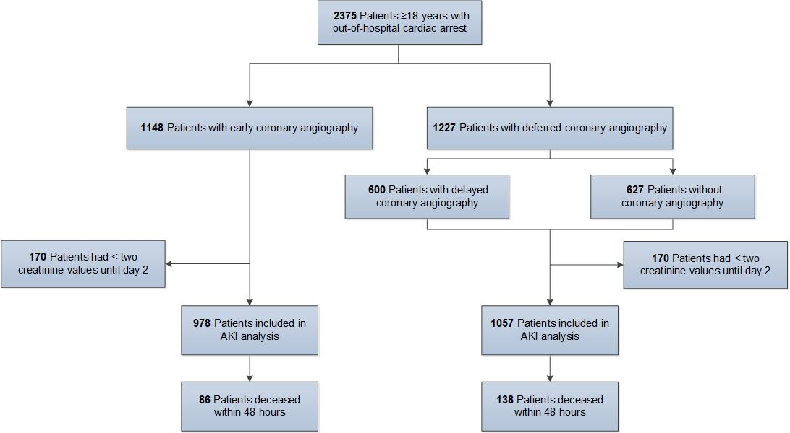
Figure S1. Study flowchart

