Supplemental data


Figure S1. Physician prediction : Visual Likert Scale (ICU = Intensive Care Unit ; RRT = Renal Replacement Therapy)
0 : the physician is certain that the patient will not receive RRT
10 : the physician is certain that the patient will receive RRT

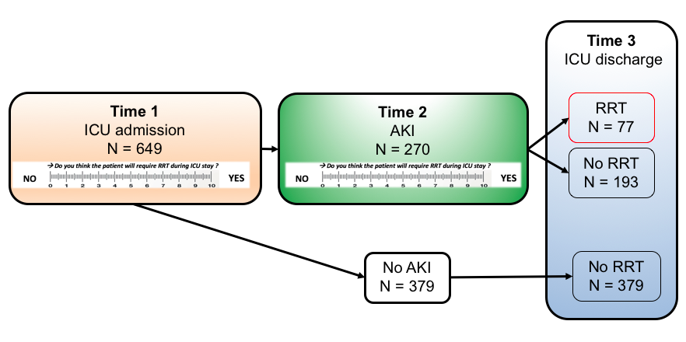
Table S1. Delays between ICU admission/AKI diagnosis/RRT initiation
Figure S2. PresagEER study timeline (ICU = Intensive Care Unit ; AKI = Acute Kidney Injury ; RRT = Renal Replacement Therapy)
 |  | AKI without RRT  (n=193) | AKI with RRT  (n=77) | AKI patients  (n=270) | P value
Delay between ICU admission and AKI diagnosis (n (%)) | Days
 | 0 | 107 (55.4) | 39 (50.6) | 146 (54.1) | 0,14
 | 1 | 37 (19.2) | 12 (15.6) | 49 (18.1)
 | 2 | 19 (9.8) | 7 (9.1) | 26 (9.6)
 | 3 | 4 (2.1) | 4 (5.2) | 8 (3.0)
 | 4 | 5 (2.6) | 2 (2.6) | 7 (2.6)
 | 5 | 3 (1.6) | 2 (2.6) | 5 (1.9)
 | >5 | 18 (9.3) | 11 (14.2) | 29 (19.8)
Delay between AKI diagnosis and RRT initiation (n (%)) | Days
 | 0 |  | 29 (37.7)
 | 1 |  | 14 (18.2)
 | 2 |  | 3 (3.9)
 | 3 |  | 5 (6.5)
 | 4 |  | 1 (1.3)
 | 5 |  | 11 (14.3)
 | >5 |  | 14 (18.2)

Table S2. RRT characteristics
n (%) or Median (IQR) | RRT  (n=77)
Total duration of RRT | 4 [2, 10]
Initial RRT method  CRRT  IHD  SLED | 41 (53.2)  35 (45.5)  1 (1.3)
RRT dependency at ICU discharge | 49 (63.6)
Reasons for need of RRT  Hyperkalemia  Fluid overload  Uremic symptoms  Drug toxin  Electrolyte disorders  Metabolic acidosis  Tumor lysis  Hyperazotemia, oligo-anuria phase  Hyperthermia refractory | 20 (27.0)  30 (39.5)  9 (12.2)  7 (9.3)  13 (17.6)  31 (40.8)  4 (5.4)  41 (53.9)  0 (0)
Biological data at RRT initiation  Blood pH  Serum creatinine - µmol/l  Serum kalemia - mmol/l  Urinary output - ml/d  Urinary creatinine - mmol/l  Serum lactate - mmol/l  Serum bicarbonate - mmol/l  Serum phosphatemia - mmol/l | 7.29 [7.20, 7.36]  274 [202, 412]  4.6 [4.1, 5.6]  295 [3.15, 886]  4.6 [2.5, 6.5]  2.3 [1.2, 5.9]  19 [16, 23]  1.8 [1.2, 2.5]
Fluid balance - ml/d (RRT initiation) | 1250 [381, 3068]
RRT = Renal Replacement Therapy ; CRRT = Continuous Renal Replacement Therapy ; IHD = Intermittent Hemodialysis ; SLED = Sustained Low-Efficiency Dialysis ; ICU = Intensive Care Unit

Table S3. Characteristics and outcomes of AKI patients (n (%) or median (IQR))
Characteristics | AKI without RRT  (n=193) | AKI with RRT  (n=77) | AKI patients  (n=270) | P value
Age years | 66 [57, 74] | 64 [55, 71] | 66 [56, 73] | 0.14
Gender | 44 (22.8) | 20 (26.0) | 64 (23.7) | 0.69
BMI | 26 [23, 30] | 28 [24, 34] | 27 [23, 31] | 0.008
CCI | 4 [3, 7] | 4 [3, 6] | 4 [3, 6] | 0.87
SOFA score at AKI diagnosis | 8 [4, 11] | 10 [6, 13] | 8 [5, 11] | 0.001
Comorbidity  CKD  Congestive heart failure  Myocardial infarction  Diabetes mellitus  Peripheral vascular disease  Chronic pulmonary disease  Connective tissue disease  Liver disease  Hematological disease  Metastatic solid tumor  AIDS | 39 (20.2)  33 (17.1)  36 (18.7)  58 (30.1)  25 (13.9)  40 (20.7)  2 (1.1)  27 (14.0)  11 (5.7)  9 (5.0)  5 (2.8) | 18 (23.4)  15 (19.7)  9 (11.7)  27 (35.1)  13 (17.6)  10 (13.0)  3 (4.1)  16 (20.8)  8 (10.4)  3 (4.1)  3 (4.1) | 57 (21.1)  48 (17.8)  45 (16.7)  85 (31.5)  38 (15.0)  50 (18.5)  5 (2.0)  43 (15.9)  19 (7.0)  12 (4.7)  8 (3.2) | 0.68  0.74  0.23  0.51  0.58  0.19  0.30  0.23  0.27  1.00  0.90
ICU : reasons for admission  Medical  Elective surgery  Emergency surgery | 184 (95.3)  3 (1.6)  6 (3.1) | 71 (92.2)  1 (1.3)  5 (6.5) | 255 (94.4)  4 (1.5)  11 (4.1) | 0.44
Physician’s ICU experience  <2 years  [2-5] years  [5-10] years  >10 years | 49 (25.4)  51 (26.4)  48 (24.9)  45 (23.3) | 29 (37.7)  13 (16.9)  15 (19.5)  20 (26.0) | 78 (28.9)  64 (23.7)  63 (23.3)  65 (24.1) | 0.12
Physician’s ICU seniority  Fellows  Attendings | 100 (51.8)  93 (48.2) | 42 (54.5)  35 (45.5) | 142 (52.6)  128 (47.4) | 0.79
KDIGO score staging  I  II  III | 93 (48.2)  54 (28.0)  46 (23.8) | 21 (27.3)  21 (27.3)  35 (45.5) | 114 (42.2)  75 (27.8)  81 (30.0) | 0.001
Time from admission to AKI diagnosis – days | 0 [0, 2] | 0 [0, 3] | 0 [0, 2] | 0.36
Data’s at AKI diagnosis  Serum creatinine  Urinary Output - mlkgh  Fluid balance - ml/d  Fluid balance - ml/kg/h | 151 [119, 212]  0.5 [0.3, 0.8]  507 [-189, 1876]  0.1 [0, 0.7] | 209 [120, 261]  0.3 [0.1, 0.6]  884 [88, 2543]  0.3 [0, 1] | 160 [119, 233]  0.4 [0.2, 0.8]  596 [-35, 2000]  0.1 [0, 0.8] | 0.03  <0.001  0.07  0.03
Renal ultrasonography | 67 (34.9) | 25 (32.5) | 92 (34.2) | 0.81
AKI causes  Nephrotoxic use  Obstructive cause  Prerenal causes  Intrinsic renal causes | 52 (26.9)  7 (3.6)  154 (79.8)  50 (25.9) | 38 (49.4)  0 (0.0)  62 (80.5)  42 (54.5) | 90 (33.3)  7 (2.6)  216 (80.0)  92 (34.1) | 0.001  0.20  1.00  <0.001
Events week before AKI  Coronary angiography  Mechanical ventilation  Vasopressor use  CT scan  ECMO  Sepsis | 5 (2.6)  80 (41.7)  84 (43.5)  85 (44.3)  2 (1.0)  90 (46.9) | 4 (5.3)  47 (61.8)  46 (60.5)  30 (39.5)  4 (5.3)  45 (59.2) | 9 (3.4)  127 (47.4)  130 (48.7)  115 (42.9)  6 (2.2)  135 (50.4) | 0.48  0.004  0.02  0.56  0.10  0.09
Physician's prediction to need of RRT | 3 [1, 6] | 9 [6, 10] | 4 [2, 8] | <0.001
Outcomes  ICU Mortality  COVID (%)  ICU duration (median [IQR]) | 52 (26.9)  64 (33.2)  5 [3, 11] | 48 (62.3)  30 (39.0)  13 [5, 21] | 100 (37.0)  94 (34.8)  7 [3, 15] | <0.001  0.446  <0.001
AKI = Acute Kidney Injury ; BMI = Body Mass Index ; CCI = Charlson Comorbidity Index ; SOFA = Sequential Organ Failure Assessment ; CKD = Chronic Kidney Disease ; AIDS = Acquired Immuno Deficiency Syndrome ; ICU = Intensive Care Unit ; RRT = Renal Replacement Therapy , KDIGO = Kidney Disease: Improving Global Outcomes ; CT scan = Computed Tomography scanner ; ECMO = Extracorporeal Membrane Oxygenation

Table S4. Multivariate analysis including variables associated with the risk of requiring RRT (without physician prediction)
Variables | OR [95% CI] | P value
SOFA score at ICU admission | 1.16 [1.09-1.24] | < 0.001
Serum Creatinine - per 100µmol/l | 1.48 [1.17-1.87] | <0.01
Urinary Output at ICU admission - mg/kg/h | 0.74 [0.54-1.03] | 0.07
SOFA = Sequential Organ Failure Assessment ; AKI = Acute Kidney Injury ; RRT = Renal Replacement Therapy ; OR = Odds Ratio

