Outcomes in participants with ventilated nosocomial pneumonia and organ failure treated with ceftolozane/tazobactam versus meropenem
– subset analysis of the phase 3 randomized, controlled ASPECT-NP trial
Ignacio Martin-Loeches, MD, et al.
Supplement

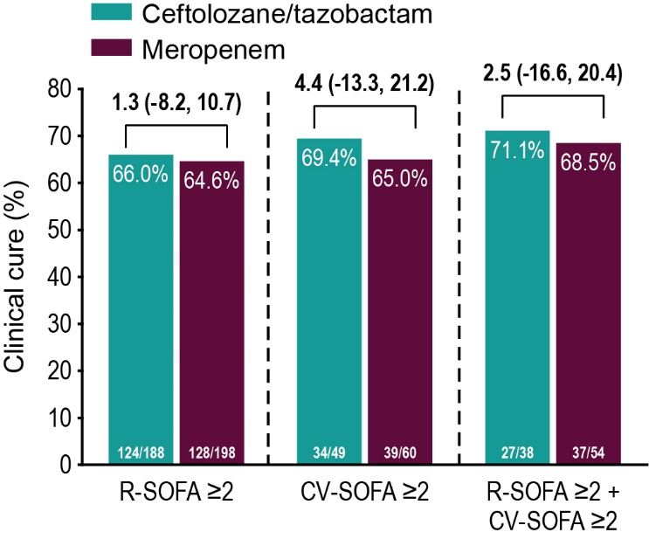
Fig. S1. Clinical cure at TOC by SOFA component score (CE population). Treatment differences were calculated as unstratified Newcombe 95% CIs; positive differences are in favor of ceftolozane/tazobactam, negative differences are in favor of meropenem. Participants with clinical failure at the EOT visit were counted as failures at the TOC visit. CE clinically evaluable, CI confidence interval, CV-SOFA cardiovascular, EOT end-of-therapy, R-SOFA respiratory SOFA component score, SOFA Sequential Organ Failure Assessment, TOC test-of-cure

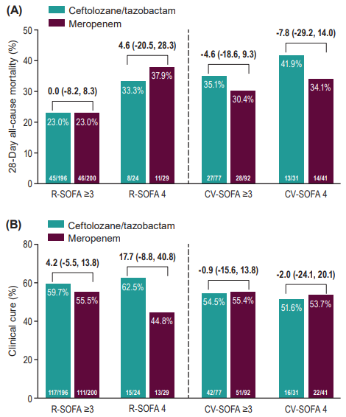
Fig. S2. Mortality (upper panel A) and clinical cure at TOC (bottom panel B) by SOFA component score ≥3 and 4 (ITT population). Treatment differences were calculated as unstratified Newcombe 95% CIs; positive differences are in favor of ceftolozane/tazobactam, negative differences are in favor of meropenem. Participants whose 28-day mortality outcome was missing or unknown were analyzed as deceased. Participants with clinical failure at the EOT visit were counted as failures at the TOC visit. CI confidence interval, CV-SOFA cardiovascular SOFA component score, EOT end-of-therapy, R-SOFA respiratory SOFA component score, SOFA Sequential Organ Failure Assessment, TOC test-of-cure

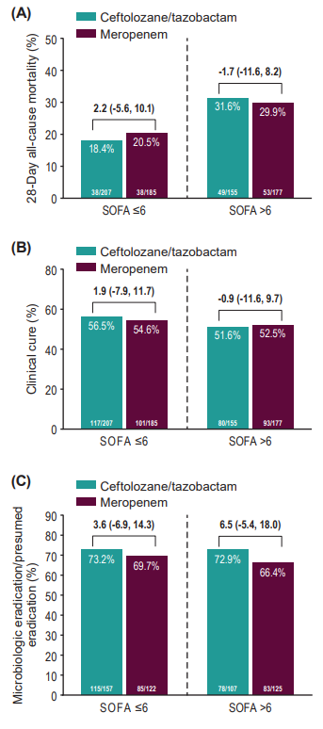
Fig. S3. Outcomes by SOFA ≤6 and >6. Mortality (ITT population) (upper panel A), clinical cure at TOC (ITT population) (middle panel B), microbiologic eradication at TOC (mITT population) (bottom panel C). Treatment differences were calculated as unstratified Newcombe 95% CIs; positive differences are in favor of ceftolozane/tazobactam, negative differences are in favor of meropenem. Participants whose 28-day mortality outcome was missing or unknown were analyzed as deceased. Participants with clinical failure at the EOT visit were counted as failures at the TOC visit. Participants with missing culture and clinical responses that were failure, indeterminate, or missing were counted as microbiologic failures. CI confidence interval, EOT end-of-therapy, SOFA Sequential Organ Failure Assessment, TOC test-of-cure

