MACHINE LEARNING PREDICTS LUNG RECRUITMENT IN ACUTE RESPIRATORY DISTRESS SYNDROME USING SINGLE LUNG CT SCAN

Francesca Pennati MS¹, Andrea Aliverti MS¹, Tommaso Pozzi MD², Simone Gattarello MD³, Fabio Lombardo MD³, Silvia Coppola MD⁴ and Davide Chiumello MD^{2,4,5}

¹Dipartimento di Elettronica, Informazione e Bioingegneria, Politecnico di Milano, Milan, Italy
Department of Anesthesia and Intensive Care, ASST Santi Paolo e Carlo, San Paolo University Hospital, Via Di Rudini 9 Milan, Italy
Department of Health Sciences, University of Milan, Milan, Italy
Coordinated Research Center on Respiratory Failure, University of Milan, Milan, Italy

Corresponding Author
Prof. Davide Chiumello
Department of Anesthesia and Intensive Care, ASST Santi Paolo e Carlo, San Paolo University Hospital, Via Di Rudini 9 Milan, Italy
E-mail address: davide.chiumello@unimi.it

Section 1. Study enrolment process additional details.
Figure S1. Study protocol flow chart.
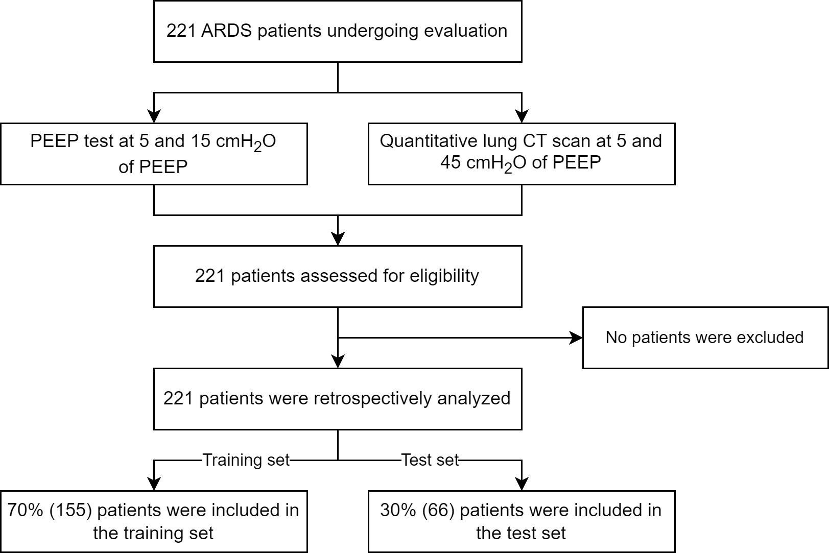

Section 2. Clinical differences in radiologically-defined recruiters and non recruiters in terms of the PEEP test response.
PEEP test (Table S1)
From PEEP 5 to 15 cmH₂O the improvement in oxygenation (Δ₁₅₋₅PaO₂/FiO₂) was significantly higher in recruiters (57 [28 – 101] vs 37 [8 – 79] mmHg).
Table S1. Changes in respiratory mechanics and gas exchange at 5 and 15 cmH₂O of PEEP in patients divided according to lung potential recruitment (LPR). Continuous data are expressed as mean ± SD or median (interquartile range), while categorical data are expressed as %. Student t test or Mann–Whitney rank-sum tests were used as appropriate.
Variables | Recruiters (LPR>15%) | Non-recruiters (LPR≤15%) | p-value
Respiratory mechanics
Δ₁₅₋₅ Driving pressure (cmH₂O) | 0.2 (-1.4, 2.3) | 0.0 (-2.0, 1.1) | 0.092
Δ₁₅₋₅ Respiratory system elastance (cmH₂O/L) | 0.1 (-2.8, 4.5) | -0.6 (-4.0, 2.0) | 0.101
Δ₁₅₋₅ Mechanical Power (J/min) | -6.7 (-8.4, -5.0) | -7.1 (-9.7, -5.6) | 0.050
Respiratory partitioned mechanics
Δ₁₅₋₅ Lung elastance (cmH₂O/L) | -0.4 (-3.3, 4.5) | -0.2 (-3.1, 3.1) | 0.905
Δ₁₅₋₅ Chest wall elastance (cmH₂O/L) | -0.5 (-2.1, 0.9) | -0.7 (-2.9, 1.9) | 0.713
Gas exchange
Δ₁₅₋₅ PaCO₂ (mmHg) | 0.1 (-1.9, 2.2) | 0.6 (-1.2, 2.7) | 0.253
Δ₁₅₋₅ PaO₂ (mmHg) | 32 (17, 58) | 18 (3, 32) | <0.001
Δ₁₅₋₅ PaO₂/FiO₂ | 57 (28, 101) | 37 (8, 79) | <0.001

Section 3. Additional material and methods.
Figure S2. Demographic, mechanical, gas exchange and radiological variable considered in during feature selection according to type of variable (M = respiratory system mechanics, G = gas exchange, CT = radiological data, MPR = partitioned respiratory mechanics) and to the measuring condition (5 = 5 cmH₂O of PEEP, 15 = 15 cmH₂O of PEEP).
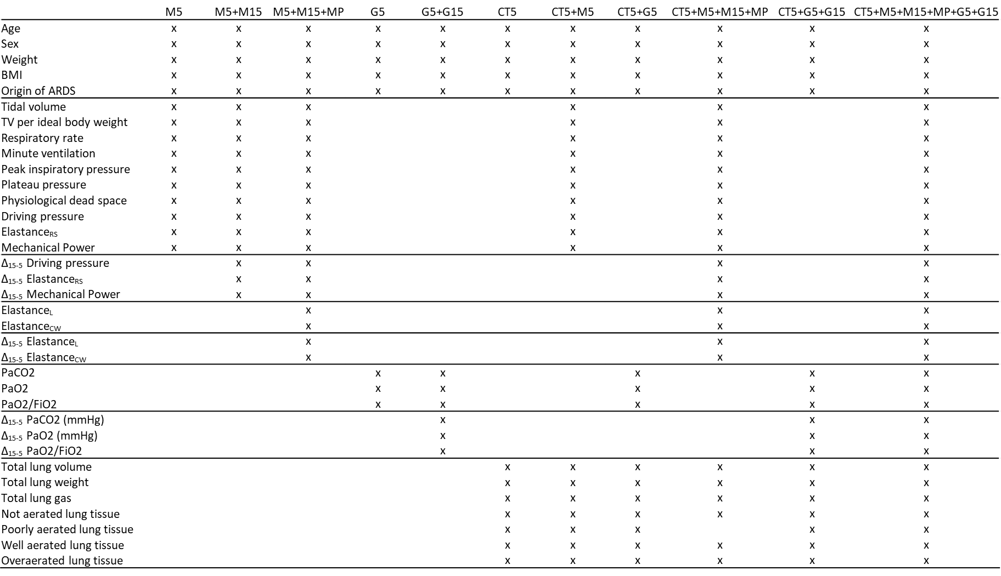

LASSO algorithm details. In the training set, the least absolute shrinkage and selection operator (LASSO) was repeatedly applied. A grid search strategy with a stratified five-fold cross validation repeated 10 times was performed to optimize the regularization parameter λ. The maximum number of features accepted in a model was set to be lower than 10% of the sample size (1). The features selected were then used to train the final model on the entire training set. To generate parsimonious algorithms with higher potential for clinical use, sequential models were generated with increased values of the tuning parameter λ and selecting the smallest value of λ that gave a model with fewer than 5 variables. After repeating this procedure ten times, each time with a different random data split, features were retained according to the frequency with which they were chosen, maintaining the features that had been selected in more than 50% of the cases. For comparison an unsupervised method based on correlation was evaluated. The results are shown in figure S2.

Development of classification models with LASSO-processed sets of variables. When lung recruitability was defined according to radiologically scan as the percent change in not aerated tissue between 5 cmH₂O and 45 cmH₂O, ARDS origin (pulmonary/extra-pulmonary) was the feature retained in all the dataset. Tidal volume, airway plateau pressure and driving pressure were the most frequent selected features when the model included only respiratory system mechanics measured at PEEP 5 cmH₂O, whereas if lung mechanics at PEEP 15 cmH₂O was included (dataset M5+M15), the Δ₁₅₋₅ Mechanical Power was also retained. If respiratory partitioned mechanics was included (dataset M5+M15+RPM), also lung elastance was retained. When the model included only gas exchange parameters (G5), PaO₂/FiO₂ was the most frequent selected feature, whereas if gas exchange at PEEP 15 cmH₂O was considered (G5+G15), Δ₁₅₋₅PaO₂ was also retained. Age, well and not aerated tissue were always selected when the model included only CT parameters (CT5). PaO₂/FiO₂, Δ₁₅₋₅ Mechanical Power and Δ₁₅₋₅ PaO₂ were the features retained when mechanical and gas exchange features were added to CT5 (CT5+G5+G15).
When lung recruitability was defined based on gas exchange (Δ₁₅₋₅PaO₂), ARDS origin was again retained in all the models. If respiratory system mechanics parameters measured at PEEP 5 cmH₂O (M5) were included, BMI and mechanical power were the most frequently selected features. When lung mechanics at PEEP 15 cmH₂O (M5+M15) and respiratory partitioned mechanics (M5+M15+RPM) were added, Δ₁₅₋₅ Driving Pressure and chest wall elastance were respectively retained. When the model included only gas exchange parameters (G5), BMI and PaO₂ were the most frequently selected feature. When the model included only CT parameters (CT5), total, well and poorly aerated tissue were always selected. PaO₂, Δ₁₅₋₅ Driving Pressure and chest wall elastance were retained when mechanical and gas exchange features were added to CT5 (CT5+G5+M5+M15+RPM).

Section 4. Model performances.
Figure S3. Validation AUCs for each pair of dataset and ML algorithm. Lung recruitability is defined both from CT (left, recruiters: Δ₄₅₋₅non-aerated tissue > 15%) and from gas exchange data (right, recruiters: Δ₁₅₋₅PaO₂ > 24mmHg). The feature selection method applied is marked as _no (no feature selection was applied), corr (feature selection based on correlation was applied), _lasso (the least absolute shrinkage and selection operator was applied once).

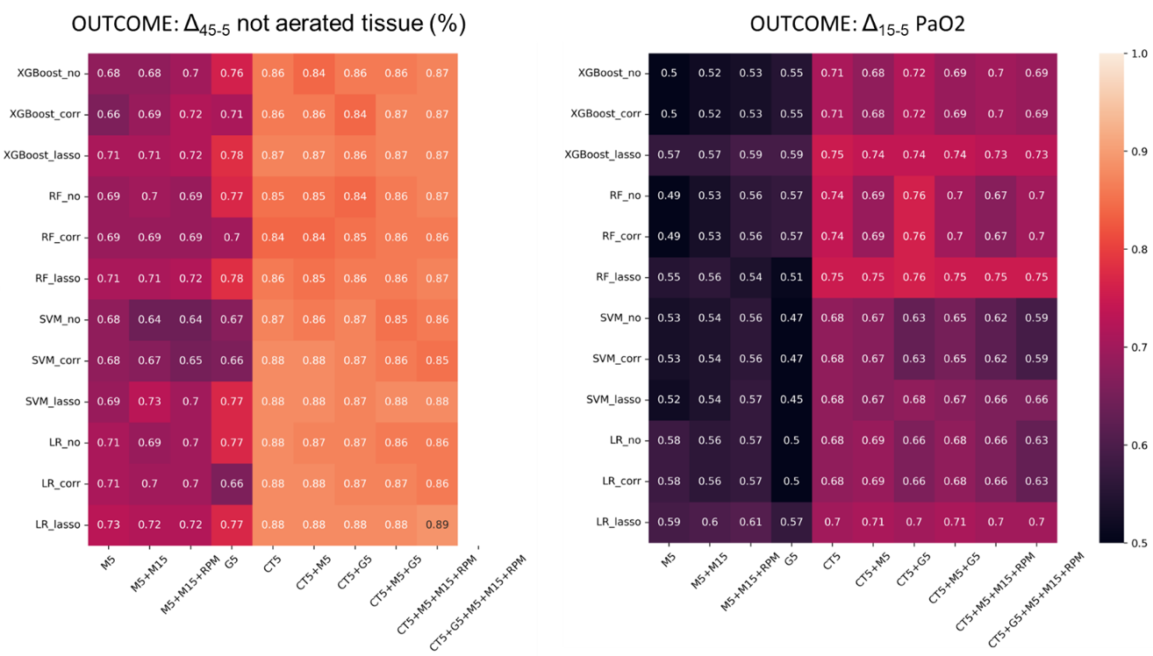

Section 4. Model performances
Radiologically-defined lung recruitability: ML algorithm selection
When lung recruitability was defined from CT, the Cochran test reported a statistically significant difference between the classifiers on mechanical models (M5 _{LASSO}, p=0.02; M5 _{LASSO} +M15 _{LASSO}, p<0.001; M5 _{LASSO} +M15 _{LASSO} +RPM _{LASSO}, p<0.001), with McNemars test indicating significant differences between logistic regression and random forest and between logistic regression and gradient-boosted tree. No statistically significant difference was reported between classifiers based on gas exchange parameters. On CT models, logistic regression reported the highest validation AUCs. However, statistically significant differences were found only on two models including CT data (CT5 _{LASSO} +G5 _{LASSO}, p=0.023 and GT5 _{LASSO} +G5 _{LASSO} +M5 _{LASSO}, p=0.041), with McNemars test indicating significant differences between logistic regression and gradient-boosted tree in both the models.
Gas exchange-defined lung recruitability: ML algorithm selection
When lung recruitability was defined based on gas exchange (Recruiting patients: Δ₁₅₋₅PaO₂ > 24mmHg) (Figure 3), random forest resulted in the highest validation AUCs on gas exchange and CT models. The Cochran test reported statistically significant difference between the classifiers based on gas exchange parameters (p<0.001) and CT parameters (p<0.001), with McNemars test indicating significant differences between random forest and logistic regression and between random forest and support vector machine in all the models.

Table S2. Additional metrics on validation and test set of the logistic regression classifier, when lung recruitability was radiologically-defined (recruiters: Δ₄₅₋₅non-aerated tissue > 15%). AUC, area under the receiver operating characteristic curve; acc, accuracy; sens, sensitivity; spec, specificity. M5: lung mechanics at PEEP 5 cmH₂O; M15: lung mechanics at PEEP 15 cmH₂O; RPM: respiratory partitioned mechanics; G5: gas exchange measured at PEEP 5 cmH₂O; G15: gas exchange measured at PEEP 15 cmH₂O; CT5: CT imaging acquired at PEEP 5 cmH₂O.

 | VALIDATION |  |  |  | TEST
 | AUC | acc | Sens | Spec | AUC | acc | Sens | Spec
M5 | 0.72(0.09) | 0.66(0.08) | 0.70(0.11) | 0.63(0.10) | 0.67 | 0.66 | 0.71 | 0.58
M5+M15 | 0.72(0.08) | 0.65(0.07) | 0.67(0.12) | 0.64(0.09) | 0.66 | 0.63 | 0.66 | 0.58
M5+M15+RPM | 0.73(0.10) | 0.67(0.09) | 0.69(0.13) | 0.65(0.11) | 0.65 | 0.63 | 0.66 | 0.58
G5 | 0.77(0.07) | 0.66(0.08) | 0.71(0.12) | 0.62(0.12) | 0.69 | 0.66 | 0.78 | 0.46
G5+G15 | 0.78(0.07) | 0.68(0.07) | 0.71(0.11) | 0.64(0.11) | 0.75 | 0.72 | 0.78 | 0.62
CT5 | 0.89(0.04) | 0.81(0.06) | 0.79(0.09) | 0.82(0.09) | 0.88 | 0.84 | 0.88 | 0.77
CT5+M5 | 0.88(0.07) | 0.81(0.07) | 0.80(0.12) | 0.82(0.07) | 0.88 | 0.84 | 0.90 | 0.73
CT5+G5 | 0.88(0.06) | 0.81(0.05) | 0.79(0.10) | 0.82(0.07) | 0.88 | 0.84 | 0.88 | 0.77
CT5+M5+G5 | 0.88(0.06) | 0.81(0.07) | 0.79(0.11) | 0.82(0.08) | 0.88 | 0.84 | 0.90 | 0.81
CT5+G5+G15 | 0.89(0.05) | 0.81(0.06) | 0.79(0.11) | 0.83(0.09) | 0.89 | 0.87 | 0.90 | 0.81
CT5+M5+M15+MP | 0.89(0.05) | 0.81(0.06) | 0.79(0.10) | 0.82(0.07) | 0.87 | 0.81 | 0.83 | 0.77
CT5+M5+M15+RPM G5+G15 | 0.90(0.05) | 0.80(0.05) | 0.79(0.11) | 0.82(0.10) | 0.89 | 0.82 | 0.85 | 0.77

Table S3. Additional metrics on validation and test set, reported for the random forest classifier, when lung recruitability was gas exchange-defined (recruiters: Δ₁₅₋₅PaO₂ > 24mmHg).
AUC, area under the receiver operating characteristic curve; acc, accuracy; sens, sensitivity; spec, specificity. M5: lung mechanics at PEEP 5 cmH₂O; M15: lung mechanics at PEEP 15 cmH₂O; RPM: respiratory partitioned mechanics; G5: gas exchange measured at PEEP 5 cmH₂O; G15: gas exchange measured at PEEP 15 cmH₂O; CT5: CT imaging acquired at PEEP 5 cmH₂O.

 | VALIDATION |  |  |  | TEST
 | AUC | acc | Sens | Spec | AUC | acc | Sens | Spec
M5 | 0.55(0.10) | 0.53(0.08) | 0.46(0.12) | 0.59(0.17) | 0.49 | 0.51 | 0.22 | 0.84
M5+M15 | 0.56(0.09) | 0.56(0.08) | 0.58(0.17) | 0.60(0.13) | 0.59 | 0.52 | 0.25 | 0.84
M5+M15+RPM | 0.57(0.10) | 0.56(0.09) | 0.52(0.12) | 0.60(0.13) | 0.60 | 0.48 | 0.25 | 0.74
G5 | 0.59(0.08) | 0.56(0.08) | 0.48(0.15) | 0.62(0.14) | 0.50 | 0.43 | 0.28 | 0.61
CT5 | 0.77(0.07) | 0.71(0.08) | 0.73(0.12) | 0.70(0.15) | 0.81 | 0.79 | 0.75 | 0.84
CT5+M5 | 0.76(0.06) | 0.69 (0.07) | 0.71(0.12) | 0.68(0.13) | 0.81 | 0.76 | 0.75 | 0.77
CT5+G5 | 0.78(0.07) | 0.71(0.07) | 0.73(0.12) | 0.70(0.13) | 0.80 | 0.76 | 0.72 | 0.81
CT5+M5+G5 | 0.78(0.07) | 0.71(0.07) | 0.74(0.13) | 0.68(0.12) | 0.80 | 0.79 | 0.78 | 0.81
CT5+M5+M15+RPM | 0.76(0.06) | 0.69(0.07) | 0.72(0.12) | 0.66(0.13) | 0.81 | 0.76 | 0.72 | 0.81
CT5+M5+M15+RPM+G5 | 0.78(0.07) | 0.70(0.08) | 0.73(0.12) | 0.68(0.12) | 0.79 | 0.73 | 0.67 | 0.81

References
1. Jain AK, Duin PW, Jianchang Mao. Statistical pattern recognition: a review. IEEE Trans Pattern Anal Mach Intell. 2000;22(1):4–37.

