Additional data

Figure S1: Clinical Frailty Scale by Rockwood

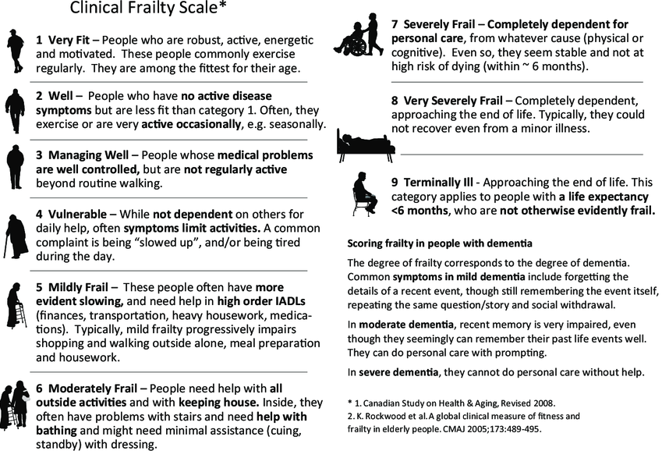

Table S1 : The modified 5-item Frailty Index (mFI)

Factors included in mFI-5
1 | Functional health status before surgery (either partially or totally dependent)
2 | Diabetes mellitus (noninsulin or insulin)
3 | History of COPD
4 | Congestive heart failure within 30 days before surgery
5 | Hypertension requiring medication

Table S2. A summary of important tests and examination to be performed at/during admission in the critical ill elderly patients.

Testing | Test/examination
Frailty | Clinical Frailty Scale
Polypharmacy | Summary of daily prescription drug used
Co-morbidity | Charlson Comorbidity Score
Malnutrition | Body Mass Index
Functional status | Activity of daily life (ADL)
Muscle strength/mass | Hand Grip Dynamometry (if co-operable). Ultrasound: rectus femoris

