Supplementary figure 1
Forrest plot of included studies reporting prevalence of drowning associated pneumonia, depending on the salinity of the water

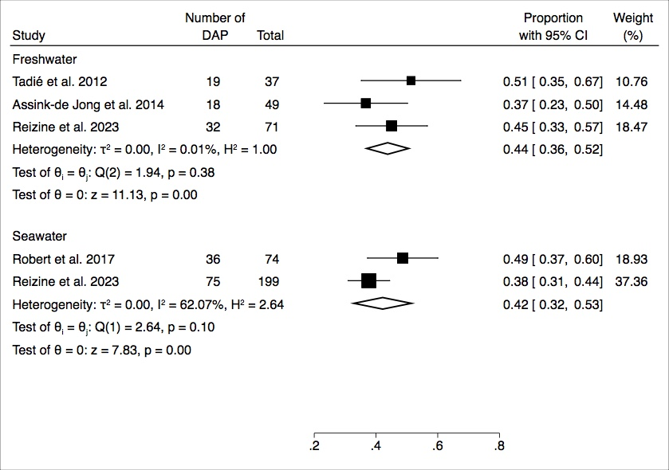

DAP drowning associated pneumonia

