Additional file 11. Cumulative incidence curve for successful extubation or death per group

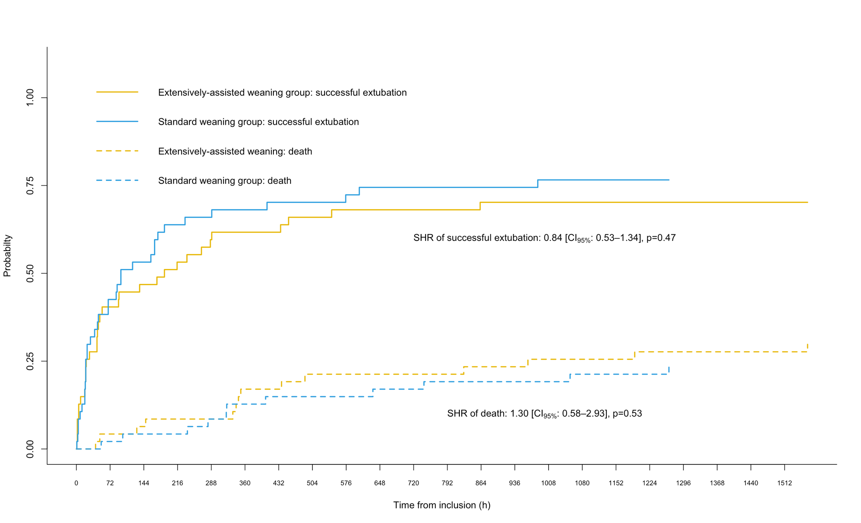
SHR denotes subdistribution hazard ratio; and CI_{95%}, 95% confidence interval

