Additional file 14. Rate of succesful extubation according to study group and spontaneous breathing trial results

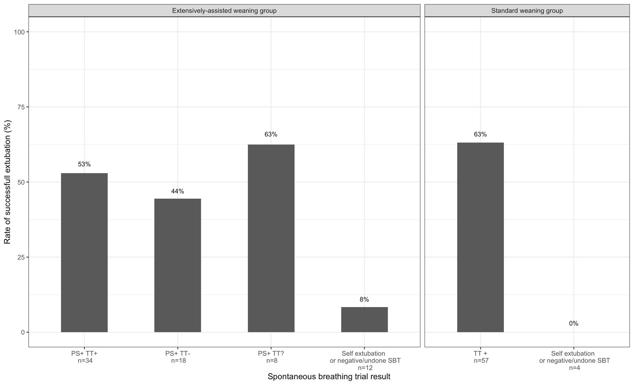
This analysis was unplanned and post hoc.
PS+ TT+ denotes success of spontaneous breathing trial (SBT) with pressure support (PS) followed by the success of a SBT with T-piece (TP); PS+ TT- , success of SBT with PS then failure of SBT with TP; PS+ TT? : success of the SBT with PS but SBT with TP not performed; and TT+, success of SBT with TP

