Additional file 16. Weaning group according to randomization

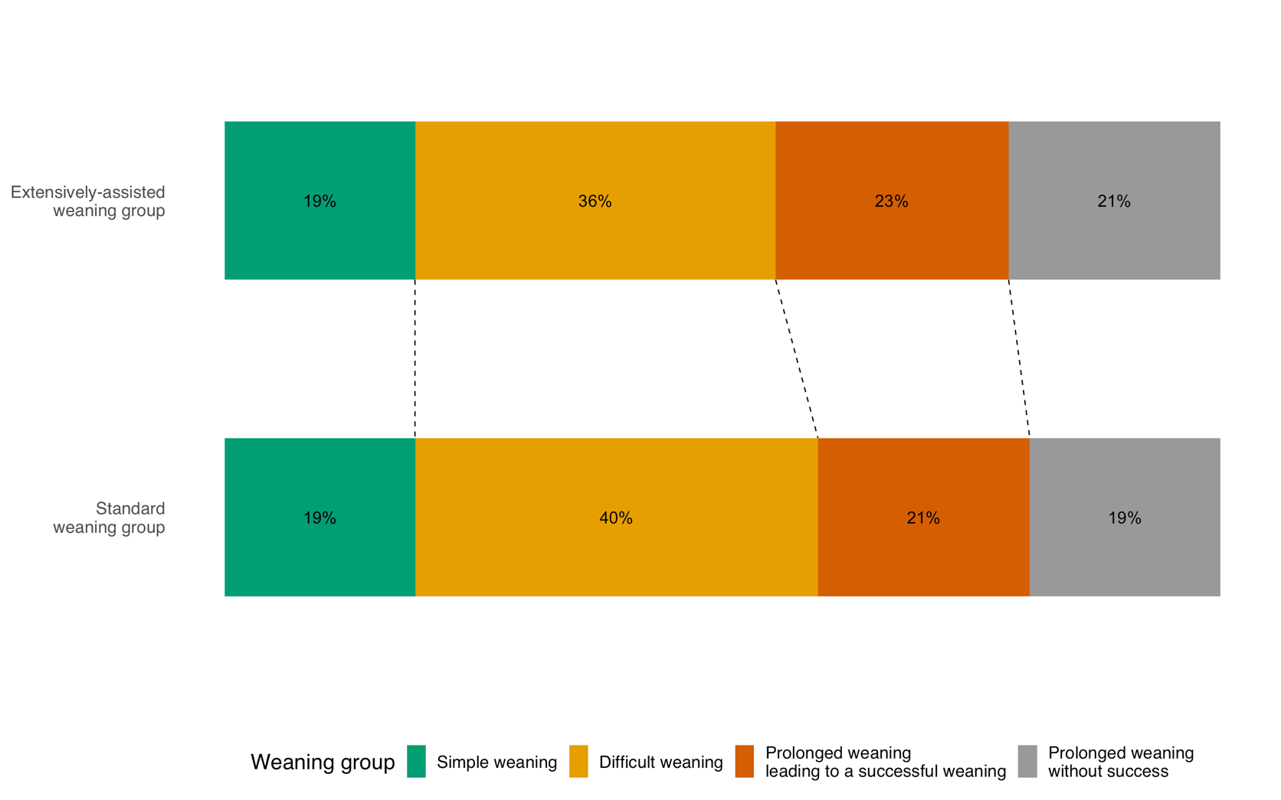

Weaning group were defined according to Béduneau G et al. Epidemiology of weaning outcome according to a new definition. The WIND study. American Journal of Respiratory and Critical Care Medicine, 2017;195:772-783.
Patients classified as simple weaning were either successfully extubated after a first successful SBT on the day of randomization, or on the following day if successful extubation occurred within 24 hours of their first separation attempt from the ventilator.

