Adjusted mortality risk in AKI patients versus no AKI patients by AKI stage
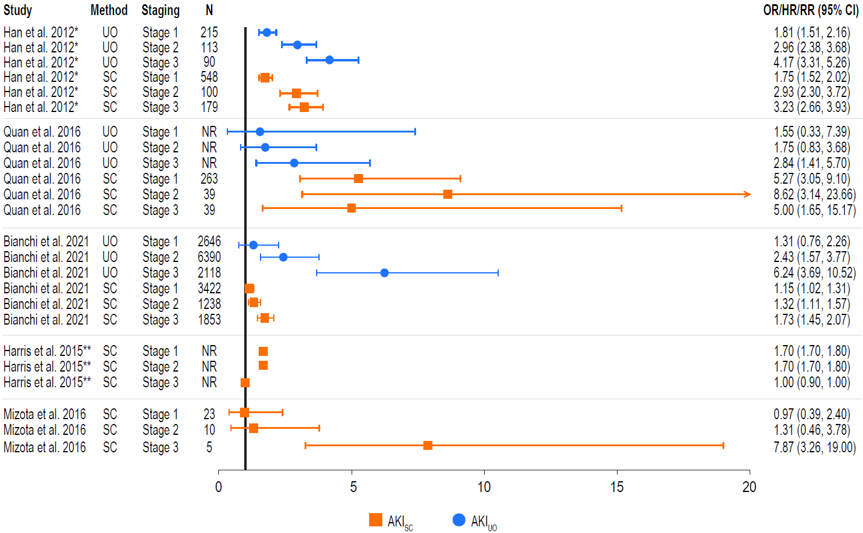
* Data presented as HR (95% CI) where no OR (95% CI) was reported. Error bars correspond to the 95% CI and may extend past visible axis.
** Data presented as RR (95% CI) where no OR (95% CI) was reported. Error bars correspond to the 95% CI and may extend past visible axis.
Boxplots comparing AKI incidence based on diagnostic criteria used. The error bars are the 95% confidence interval, the bottom and top of the box are the 25th and 75th percentiles, the line inside the box is the 50th percentile (median).
Abbreviations: AKI = acute kidney injury; CI = confidence interval; HR = hazard ratio; OR = odds ratio; RR = risk ratio; SC = serum creatinine; UO = urine output.

