Hospital length of stay among patients with AKI
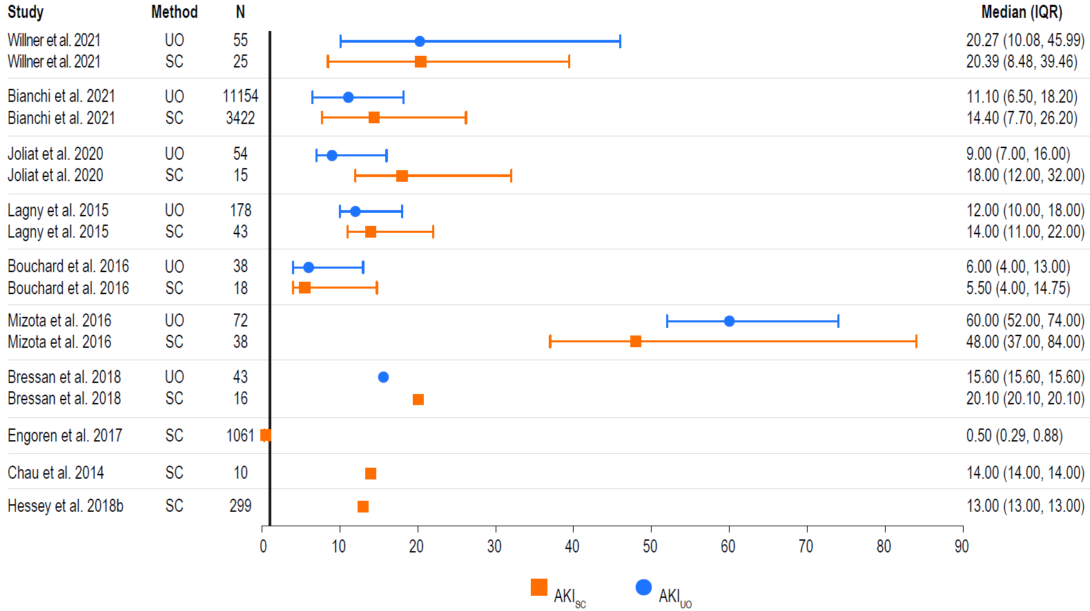
The median ICU length of stay is graphically represented per study and method as a point, with error bars as the IQR. Median values with the associated IQR are listed to the right of the figure. Note that unadjusted results are presented.
Abbreviations: AKI = acute kidney injury; IQR=interquartile range; SC = serum creatinine; UO = urine output.

