The trajectory of sleep after critical illness: a 24-month follow-up study

Mario Henríquez-Beltrán^{1,2,3*}, Ms.C.; Iván D. Benítez^{1,2*}, Ph.D.; Rafaela Vaca^{1,2}, Ms.C.; Sally Santisteve¹, Ms.C.; Maria Aguilà¹, Ms.C.; Anna Vila¹, Ms.C.; Olga Minguez^{1,2}, Ms.C.; Carlos Rodríguez-Muñoz^{1,2}, Ms.C.; Anna Galan Gonzalez¹, Ms.C.; Sulamita Carvalho-Brugger⁴, M.D.; Paula González⁵, M.D.; Paula Rodríguez⁴, M.D.; Jesús Caballero⁴, M.D.; Carme Barberà⁵, M.D.; Gerard Torres^{1,2}, M.D.; Gonzalo Labarca^{6,7}, M.D.; Mar Malla-Banyeres¹, Ms.C.; Anna Moncusí-Moix^{1,2}, Ms.C.; Antoni Torres^{2,8}, M.D.; David de Gonzalo-Calvo^{1,2}, Ph.D.; Ferran Barbé^{1,2}, M.D.; Jessica González^{1,2}, M.D.; Adriano D. S. Targa^{1,2#}, Ph.D.

¹ Translational Research in Respiratory Medicine, Hospital Universitari Arnau de Vilanova-Santa Maria, Biomedical
Research Institute of Lleida (IRBLleida), Lleida, Spain.
² CIBER of Respiratory diseases (CIBERES), Institute of Health Carlos III, Madrid, Spain.
³ Núcleo de Investigación en Ciencias de la Salud, Universidad Adventista de Chile, Chillán, Chile.
⁴ Intensive Care Department, Hospital Universitari Arnau de Vilanova, Lleida, Spain.
⁵ Intensive Care Department, Hospital Universitari Santa Maria, Lleida, Spain.
⁶ Department of Respiratory Diseases, School of Medicine, Pontificia Universidad Católica de Chile, Santiago, Chile.
⁷ Division of Pulmonary and Critical Care Medicine, Beth Israel Deaconess Medical Center and Harvard Medical School, Boston, United States.
⁸ Servei de Pneumologia, Hospital Clinic, Universitat de Barcelona, IDIBAPS, Barcelona, Spain.

*Co-first authors. MHB and IB contributed equally to this study.

#Corresponding author:
Adriano D. S. Targa (atarga@irblleida.cat)
Biomedical Research Institute of Lleida (IRBLleida), Rovira Roure, 80, 25198, Lleida, Spain.

eFigure 1. Trajectory of sleep along the 24-month follow-up.
eFigure 2. Trajectory of sleep quality subdomains (PSQI) along the 24-month follow-up.
eFigure 3. Radar plot illustrating the scores for each component of the PSQI at the short-term for each study group.
eFigure 4. Trajectory of sleep quality along the 24-month follow-up.
eFigure 5. Radar plot illustrating the mean values for each marker of the distinct sequelae at the short-term for each study group.
eFigure 6. Trajectories of other sequelae based on the observed sleep trajectories.

eTable 1. Baseline characteristics of the included and non-included patients.
eTable 2. Baseline characteristics of the cohort.
eTable 3. Sleep quality at the short-term.

eFigure 1. Trajectory of sleep along the 24-month follow-up.
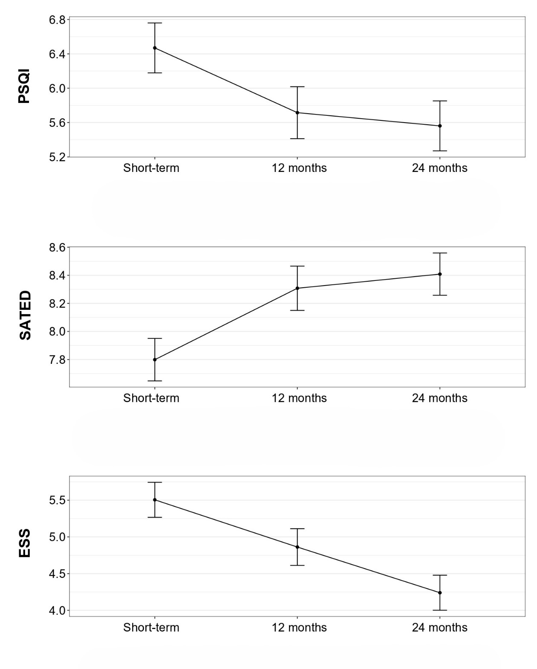
Data are represented as least square means (±SEM). The p-value threshold defining statistical significance was set at less than 0.05. ESS, Epworth Sleepiness Scale; PSQI, Pittsburgh Sleep Quality Index; SATED, Satisfaction Alertness Timing Efficiency Duration; SEM, standard error of the mean.

eFigure 2. Trajectory of sleep quality subdomains (PSQI) along the 24-month follow-up.

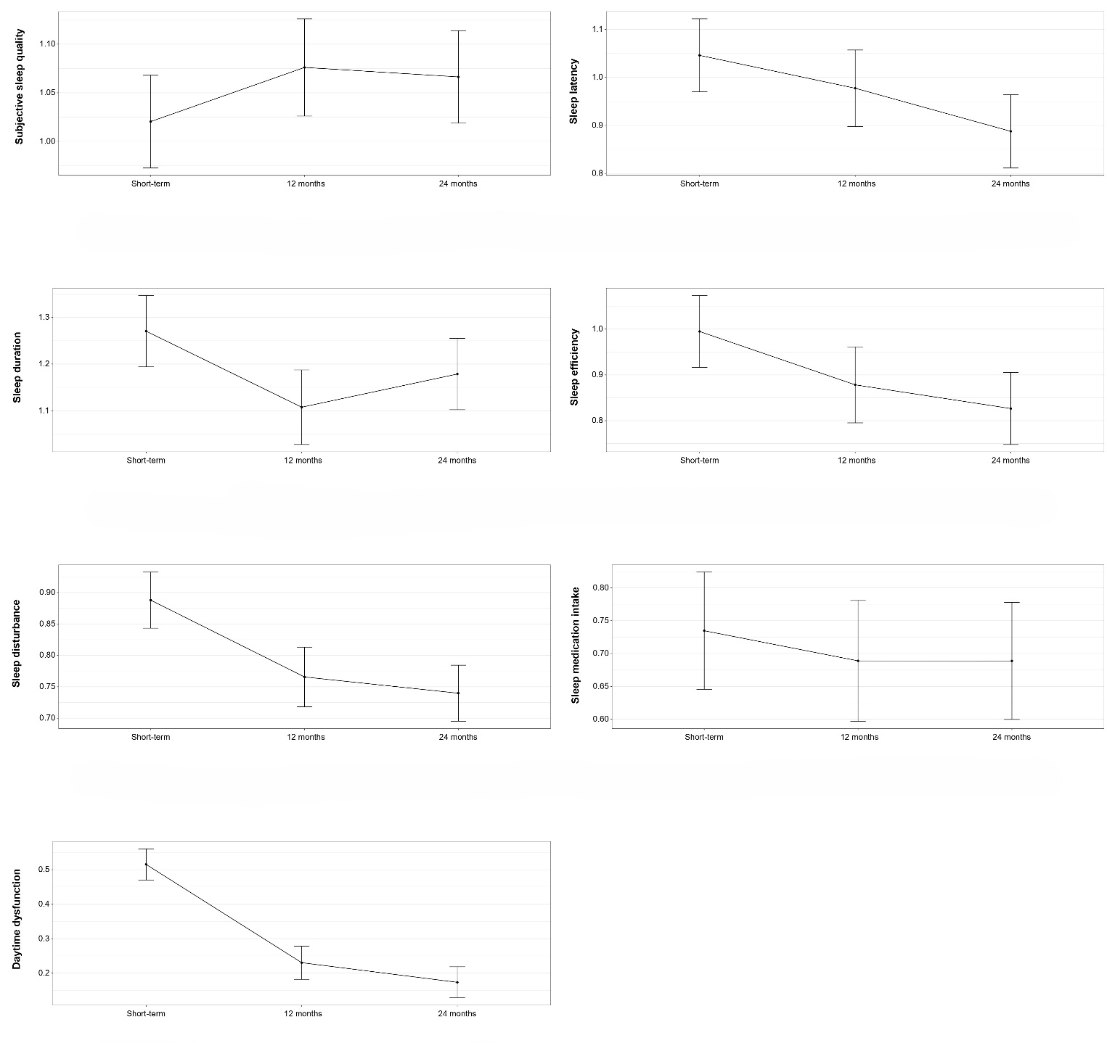
Data are represented as least square means (±SEM). The p-value threshold defining statistical significance was set at less than 0.05. PSQI, Pittsburgh Sleep Quality Index; SEM, standard error of the mean.

eFigure 3. Radar plot illustrating the scores for each component of the PSQI at the short-term for each study group.
MCII, minimal clinically important improvement. PSQI, Pittsburgh Sleep Quality Index.

eFigure 4. Trajectory of sleep quality along the 24-month follow-up.

MCII, minimal clinically important improvement; PSQI, Pittsburgh Sleep Quality Index.

eFigure 5. Radar plot illustrating the mean values for each marker of the distinct sequelae at the short-term for each study group.
Variables were homogenized rescaling values from 0 to 1. 6MWD, 6-minute walked distance; DLCO, diffusing lung capacity for carbon monoxide; HADS, Hospital Anxiety and Depression Scale; MCII, minimal clinically important improvement; PP-6MWD, percent predicted 6MWD; PSQI, Pittsburgh Sleep Quality Index; SF-12, 12-item Short Form Survey.

eFigure 6. Trajectories of other sequelae based on the observed sleep trajectories.
Data are represented as least square means (±SEM). The p-value threshold defining statistical significance was set at less than 0.05. 6MWD, 6-minute walked distance; 6MWT, 6-minute walking test; DLCO, diffusing lung capacity for carbon monoxide; MCII, minimal clinically important improvement; PP-6MWD, percent predicted 6MWD; SEM, standard error of the mean.

eTable 1. Baseline characteristics of the included and non-included patients.
 |  | All | Included | Not included | p-value
 |  | n=332 | n=196 | n=136 | p-value
 |  | n (%), mean (SD) or median [p25;p75]
Sociodemographic and anthropometric data
Sex, male |  | 222 (66.9%) | 137 (69.9%) | 85 (62.5%) | 0.197
Age, years |  | 61.0 [51.0;67.0] | 62.0 [53.0;67.2] | 59.0 [49.0;66.0] | 0.030
Body mass index, kg·m² |  | 30.1 [26.7;34.5] | 29.8 [26.7;33.6] | 30.5 [27.0;35.2] | 0.153
Habits
Tobacco |  |  |  |  | 0.685
Former use |  | 153 (47.8%) | 91 (48.4%) | 62 (47.0%)
Never used |  | 156 (48.8%) | 92 (48.9%) | 64 (48.5%)
Current use |  | 11 (3.44%) | 5 (2.66%) | 6 (4.55%)
Chronic alcohol |  |  |  |  | 0.500
Former consumption |  | 5 (1.55%) | 2 (1.06%) | 3 (2.26%)
Never consumed |  | 303 (94.1%) | 180 (95.2%) | 123 (92.5%)
Current consumption |  | 14 (4.35%) | 7 (3.70%) | 7 (5.26%)
Comorbidities
Obesity |  | 169 (50.9%) | 93 (47.4%) | 76 (55.9%) | 0.162
Hypertension |  | 147 (44.3%) | 90 (45.9%) | 57 (41.9%) | 0.542
Diabetes mellitus type 2 |  | 73 (22.0%) | 43 (21.9%) | 30 (22.1%) | 1.000
Asthma |  | 18 (5.42%) | 13 (6.63%) | 5 (3.68%) | 0.356
Chronic obstructive pulmonary disease |  | 15 (4.52%) | 8 (4.08%) | 7 (5.15%) | 0.849
Hospitalization
Duration, days |  | 19.0 [13.0;32.0] | 22.0 [14.0;36.2] | 15.0 [11.0;26.0] | <0.001
Before ICU admission, days |  | 1.00 [0.00;2.00] | 1.00 [0.00;2.00] | 1.00 [0.00;2.00] | 0.792
After ICU discharge, days |  | 7.00 [4.00;10.2] | 8.00 [5.00;12.0] | 6.00 [4.00;9.00] | <0.001
ICU stay
Duration, days |  | 10.0 [6.00;19.0] | 13.0 [7.00;22.0] | 8.00 [4.00;15.0] | <0.001
APACHE-II score |  | 10.0 [8.00;13.0] | 11.0 [9.00;13.0] | 9.00 [7.00;11.5] | 0.040
Arterial blood-related information
pH |  | 7.45 [7.41;7.48] | 7.45 [7.40;7.48] | 7.45 [7.41;7.47] | 0.985
Partial pressure of oxygen (PaO₂), mmHg |  | 69.0 [55.0;91.5] | 70.0 [56.0;91.0] | 65.0 [54.0;93.0] | 0.513
Partial pressure of carbon dioxide (PaCO₂), mmHg |  | 36.0 [32.0;40.5] | 36.0 [32.2;41.0] | 35.0 [31.0;40.0] | 0.490
Fractional inspired oxygen (FiO₂), % |  | 70.0 [50.0;85.0] | 65.0 [50.0;84.5] | 70.0 [50.0;85.8] | 0.731
PaO₂ to FiO₂ ratio |  | 126 [86.6;181] | 129 [90.1;172] | 104 [83.0;210] | 0.576
Oxygen saturation (SaO₂), % |  | 95.0 [92.0;96.9] | 95.0 [91.3;96.9] | 94.8 [92.0;96.7] | 0.735
Hydrogen carbonate (HCO₃⁻), mmol/L |  | 24.7 (3.79) | 24.6 (3.61) | 24.9 (4.12) | 0.559
Procedures
Invasive mechanical ventilation |  | 170 (51.2%) | 108 (55.1%) | 62 (45.6%) | 0.111
Duration, days |  | 13.0 [7.00;25.0] | 13.0 [8.00;25.0] | 10.0 [6.00;24.0] | 0.097
Non-invasive mechanical ventilation |  | 264 (79.8%) | 147 (75.4%) | 117 (86.0%) | 0.026
Duration, days |  | 3.00 [1.25;5.00] | 3.00 [1.00;5.00] | 3.00 [2.00;6.00] | 0.559
Prone position |  | 166 (50.3%) | 111 (56.9%) | 55 (40.7%) | 0.005
Duration, hours |  | 37.5 [22.0;72.2] | 41.0 [24.0;78.8] | 27.5 [14.2;47.0] | 0.020
Pharmacotherapy
Corticosteroids |  | 309 (93.4%) | 180 (91.8%) | 129 (95.6%) | 0.267
Antibiotics |  | 244 (73.5%) | 157 (80.1%) | 87 (64.0%) | 0.002
Tocilizumab |  | 241 (72.6%) | 135 (68.9%) | 106 (77.9%) | 0.090
Hydroxychloroquine |  | 62 (18.7%) | 48 (24.5%) | 14 (10.3%) | 0.002
Remdesivir |  | 35 (10.5%) | 25 (12.8%) | 10 (7.35%) | 0.163
APACHE-II, acute physiology and chronic health evaluation; FiO2, fractional inspired oxygen; ICU, intensive care unit; n, number; p, percentile; PaO2, partial pressure of oxygen; SD, standard deviation. Missings: tobacco, 12; chronic alcohol, 10.

eTable 2. Baseline characteristics of the cohort.
 | Healthy | Non-MCII | MCII | p-value
 | n=95 | n=63 | n=38 | p-value
 | n (%) or median [p25;p75]
Sociodemographic and anthropometric data
Sex, male | 76 (80.0%) | 38 (60.3%) | 23 (60.5%) | 0.011
Age, years | 62.0 [54.5;69.5] | 61.0 [53.5;66.0] | 60.0 [50.0;65.0] | 0.191
Body mass index, kg·m² | 29.4 [26.7;34.3] | 31.2 [27.7;34.0] | 28.2 [25.1;30.8] | 0.095
Habits
Tobacco |  |  |  | 0.369
Former use | 48 (52.7%) | 29 (48.3%) | 14 (37.8%)
Never used | 42 (46.2%) | 29 (48.3%) | 21 (56.8%)
Current use | 1 (1.10%) | 2 (3.33%) | 2 (5.41%)
Chronic alcohol |  |  |  | 0.366
Former consumption | 0 (0.00%) | 1 (1.61%) | 1 (2.78%)
Never consumed | 86 (94.5%) | 60 (96.8%) | 34 (94.4%)
Current consumption | 5 (5.49%) | 1 (1.61%) | 1 (2.78%)
Comorbidities
Obesity | 41 (43.2%) | 37 (58.7%) | 15 (39.5%) | 0.087
Hypertension | 51 (53.7%) | 20 (31.7%) | 19 (50.0%) | 0.022
Diabetes mellitus type 2 | 22 (23.2%) | 12 (19.0%) | 9 (23.7%) | 0.796
Asthma | 4 (4.21%) | 3 (4.76%) | 6 (15.8%) | 0.048
Chronic obstructive pulmonary disease | 5 (5.26%) | 1 (1.59%) | 2 (5.26%) | 0.562
Hospitalization
Duration, days | 22.0 [15.0;34.0] | 23.0 [15.5;33.0] | 20.0 [13.0;43.0] | 0.988
Before ICU admission, days | 1.00 [0.00;3.00] | 1.00 [0.00;2.00] | 0.00 [0.00;2.00] | 0.596
After ICU discharge, days | 8.00 [5.00;13.0] | 8.00 [5.00;11.0] | 6.00 [4.00;12.8] | 0.468
ICU stay
Duration, days | 13.0 [7.00;20.0] | 13.0 [7.00;23.0] | 12.0 [6.25;30.0] | 0.987
APACHE-II score | 12.0 [9.00;14.0] | 11.0 [9.25;12.0] | 9.00 [7.50;9.50] | 0.024
Arterial blood-related information
pH | 7.44 [7.37;7.48] | 7.45 [7.41;7.48] | 7.45 [7.42;7.47] | 0.900
Partial pressure of oxygen (PaO₂), mmHg | 70.0 [54.5;90.0] | 68.5 [58.5;89.5] | 74.0 [64.2;95.5] | 0.527
Partial pressure of carbon dioxide (PaCO₂), mmHg | 36.5 [32.0;43.2] | 36.0 [32.2;39.0] | 36.0 [34.8;42.0] | 0.691
Fractional inspired oxygen (FiO₂), % | 75.0 [50.0;90.0] | 60.0 [50.0;80.0] | 60.0 [50.0;80.0] | 0.134
PaO₂ to FiO₂ ratio | 118 [81.2;147] | 140 [97.1;190] | 134 [102;186] | 0.090
Oxygen saturation (SaO₂), % | 94.9 [91.0;96.6] | 95.0 [92.5;97.0] | 94.9 [91.0;97.0] | 0.850
Hydrogen carbonate (HCO₃⁻), mmol/L | 24.7 [21.9;27.4] | 24.9 [21.8;28.5] | 24.6 [22.6;27.0] | 0.470
Procedures
Invasive mechanical ventilation | 54 (56.8%) | 31 (49.2%) | 23 (60.5%) | 0.484
Duration, days | 11.5 [7.00;18.0] | 17.0 [9.50;25.5] | 17.0 [10.0;27.5] | 0.247
Non-invasive mechanical ventilation | 71 (74.7%) | 48 (77.4%) | 28 (73.7%) | 0.896
Duration, days | 3.00 [1.00;5.00] | 3.00 [2.00;5.00] | 2.00 [1.00;4.50] | 0.661
Prone position | 58 (61.1%) | 32 (51.6%) | 21 (55.3%) | 0.493
Duration, hours | 48.0 [23.0;78.0] | 38.0 [24.0;76.0] | 40.0 [24.5;116] | 0.832
Pharmacotherapy
Corticosteroids | 88 (92.6%) | 57 (90.5%) | 35 (92.1%) | 0.940
Antibiotics | 76 (80.0%) | 46 (73.0%) | 35 (92.1%) | 0.067
Tocilizumab | 64 (67.4%) | 50 (79.4%) | 21 (55.3%) | 0.037
Hydroxychloroquine | 23 (24.2%) | 14 (22.2%) | 11 (28.9%) | 0.745
Remdesivir | 15 (15.8%) | 5 (7.94%) | 5 (13.2%) | 0.355
APACHE-II, acute physiology and chronic health evaluation; FiO2, fractional inspired oxygen; ICU, intensive care unit; MCII, minimal clinically important improvement; n, number; p, percentile; PaO2, partial pressure of oxygen. Missings: tobacco, 8; chronic alcohol, 7.

eTable 3. Sleep quality at the short-term.

 | Healthy | Non-MCII | MCII |  | Healthy vs. Non-MCII | Healthy vs. MCII | MCII vs. Non-MCII
 | n=95 | n=63 | n=38 |  | Healthy vs. Non-MCII | Healthy vs. MCII | MCII vs. Non-MCII
 | median (p25;p75) | median (p25;p75) | median (p25;p75) | p-value | p-value | p-value | p-value
PSQI total score | 2.93 [2.63;3.22] | 9.08 [8.33;9.83] | 11.0 [9.82;12.2] | <0.001 | <0.001 | <0.001 | 0.001
Subjective sleep quality | 0.63 [0.53;0.73] | 1.24 [1.08;1.40] | 1.63 [1.37;1.89] | <0.001 | <0.001 | <0.001 | 0.005
Sleep latency | 0.36 [0.25;0.47] | 1.59 [1.32;1.85] | 1.87 [1.53;2.20] | <0.001 | <0.001 | <0.001 | 0.229
Sleep duration | 0.65 [0.49;0.82] | 1.65 [1.39;1.91] | 2.18 [1.87;2.50] | <0.001 | <0.001 | <0.001 | 0.013
Sleep efficiency | 0.35 [0.23;0.47] | 1.37 [1.07;1.66] | 2.00 [1.64;2.36] | <0.001 | <0.001 | <0.001 | 0.002
Sleep disturbance | 0.68 [0.58;0.79] | 1.02 [0.84;1.19] | 1.18 [0.97;1.40] | <0.001 | 0.002 | <0.001 | 0.359
Sleep medication intake | 0.06 [-0.03;0.15] | 1.43 [1.05;1.80] | 1.26 [0.80;1.73] | <0.001 | <0.001 | <0.001 | 0.740
Daytime dysfunction | 0.19 [0.10;0.28] | 0.79 [0.55;1.03] | 0.87 [0.58;1.16] | <0.001 | <0.001 | <0.001 | 0.872

MCII, minimal clinically important improvement; n, number; p, percentile; PSQI, Pittsburgh sleep quality index.

