Supplemental digital file content of: Hemodynamic effects of adjunct arginine vasopressin to norepinephrine in septic shock, insights from a prospective multicentre registry study

Supplemental Figure 1: Flowchart as a guideline to initiate, titrate, and taper AVP in patients with septic shock in the intensive care unit. 2
Supplemental Figure 2: Expanded flowchart of the study population, including distribution among the participating centers in the study 3
Supplemental Figure 3: Heatmap of missing baseline data 4
Supplemental Table 1: Distribution of continuous baseline characteristics after multiple imputation 5
Supplemental Table 2: Associations between baseline characteristics and AVP-responsiveness 6
Supplemental Table 3: Sensitivity analysis for a decrease in NE 2 hours after AVP initiation 7
Supplemental Figure 6: NE infusion rates in responders, non-responders and the whole cohort 8
Supplemental Figure 5: NEE infusion rates in responders, non-responders and the whole cohort. 9
Supplemental Figure 6: Dynamics of NEE delta, lactate, MAP and Net Fluid Balance comparing patients with NE reduction to non-responders and those with a stabilization of NE at two hours after start of AVP. 10
Supplemental Figure 7: NE infusion rates (% of baseline) in responders, non-responders and the whole cohort. 11
Supplemental Figure 8: NEE (% of baseline) in responders, non-responders and the whole cohort. 12
Supplemental Figure 9: Arterial pH levels at baseline and after start of AVP. 13
Supplemental Table 4: Probability of longer shock duration in 140 shock survivors 14
Supplemental Table 5: Associations between clinical characteristics and rebound hypotension in 129 shock survivors 15

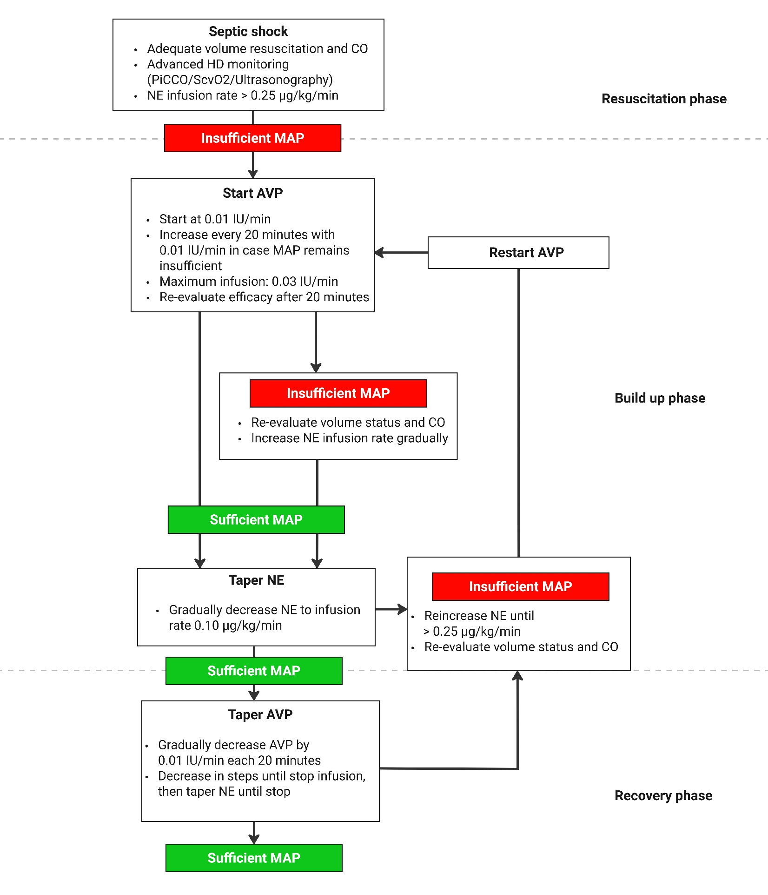
Supplemental Figure 1: Flowchart as a guideline to initiate, titrate, and taper AVP in patients with septic shock in the intensive care unit.
This flowchart was distributed to all participating centers as a guideline for treating septic shock patients with AVP as an adjunct vasopressor.
|Abbreviations: PiCCO = Pulse Contour Cardiac Output; ScVO₂ = Central Venous Oxygen Saturation; CO = Cardiac Output; AVP = Arginine vasopressin; MAP = Mean Arterial Pressure

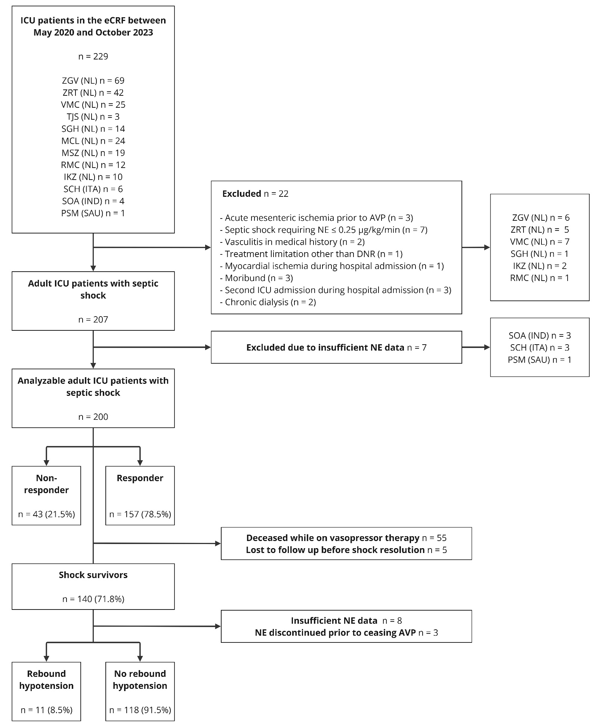
Supplemental Figure 2: Expanded flowchart of the study population, including distribution among the participating centers in the study
Abbreviations: SOA = Siksha ‘O’ Anusandhan Hospital; SCH = San Carlo Hospital; MCL = Medical Centre Leeuwarden; MSZ = Maasstad Hospital; RMC = Radboud University Medical Center; SGH = Spaarne Gasthuis Hospital; TJS = Tjongerschans Hospital; VMC = Viecuri Medical Centre; ZGV = Gelderse Vallei Hospital; ZRT = Rivierenland Hospital; PSM = Prince Sultan Medical Centre; NL = the Netherlands; ITA = Italy, IND = India; SAU = Saudi Arabia; DNR = Do-not-resuscitate; RRT = Renal Replacement Therapy; ICU = Intensive Care Unit; NE = Norepinephrine; AVP = Arginine Vasopressin

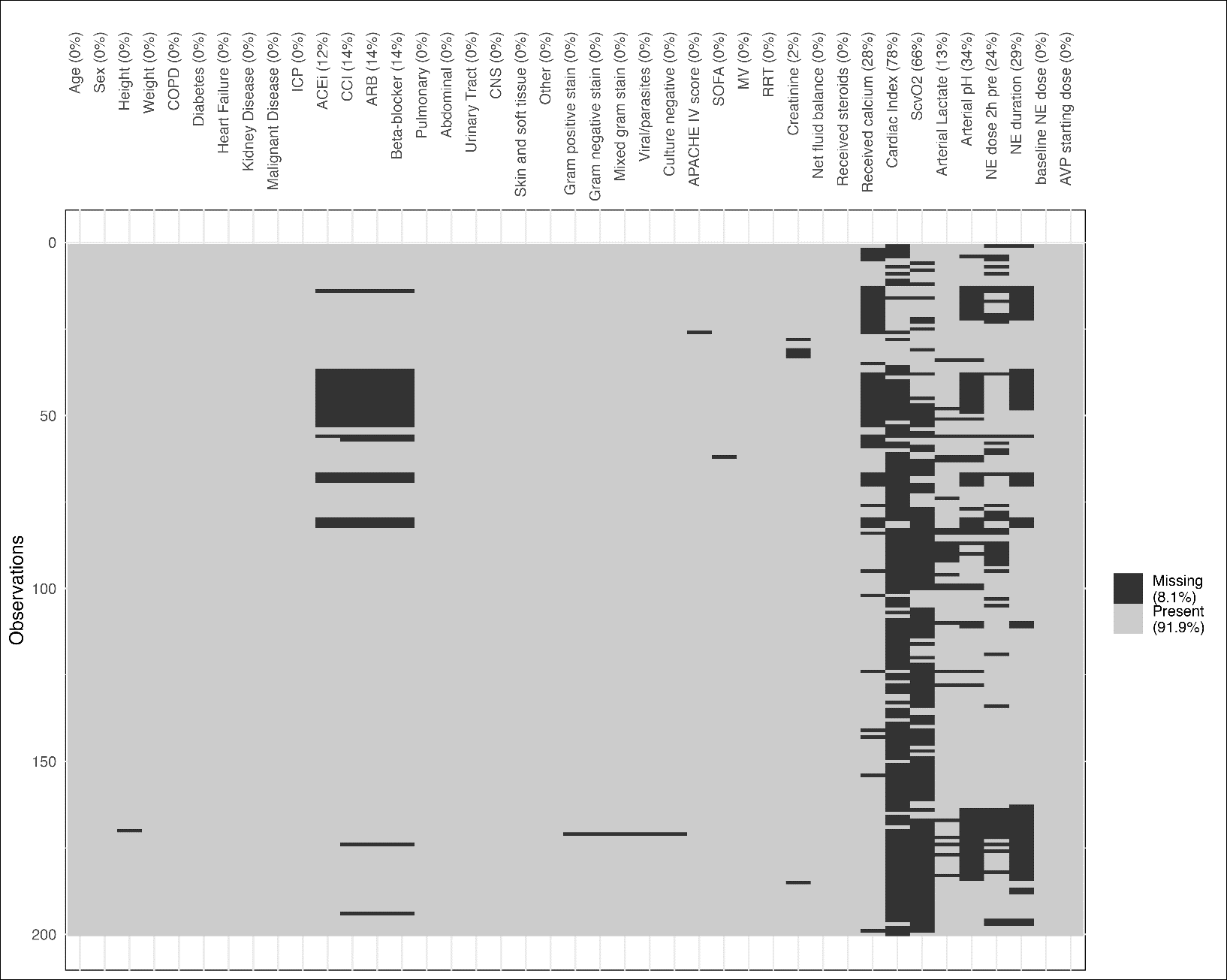
Supplemental Figure 3: Heatmap of missing baseline data
Hawkin’s non-parametric test for continuous missing data was non-significant (p = 0.260), indicative of MCAR among continuous missing data with missing rates less than 40%. Abbreviations: MCAR = Missing Completely At Random; COPD = Chronic Obstructive Pulmonary Disease; ACEi = Angiotensin Converting Enzyme inhibitor; CCI = Calcium Channel inhibitor; ARB = Angiotensin Receptor Blocker; CNS = Central Nerve System; APACHE = Acute Physiological and Chronic Health Evaluation; SOFA = Sequential Organ Failure; MV = Mechanical Ventilation; RRT = Renal Replacement therapy; ScvO2 = Central Venous Oxygen Saturation ; NE = Norepinephrine; AVP = Arginine Vasopressin
Characteristics | Total  n = 200 | Non-responder ⁵  n = 43 | Responder ⁵  n = 157 | p-value
BMI on admission, kg/m² | 27.0 [24.0 – 32.0] | 30.4 [26.8 – 34.8] | 26.2 [23.7 – 31.0] | <0.001
IBW, kg | 58.5 [47.9 – 66.9] | 59.2 [50.8 – 71.0] | 58.2 [7.0 – 66.6] | 0.128
Shock related characteristics
APACHE IV score | 92 [75 – 112] | 93 [77 – 117] | 92 [75 – 111] | 0.575
SOFA score | 10 [8 – 12] | 10 [8 – 12] | 10 [8 – 12] | 0.930
Creatinine, µmol/L | 102 [74 – 166] | 98 [72 – 177] | 105 [76 – 166] | 0.919
Arterial lactate, mmol/L | 3.2 [2.1 – 5.2] | 3.7 [2.4 – 6.6] | 2.9 [2.1 – 4.5] | 0.096
Arterial pH | 7.29 [7.22 – 7.34] | 7.28 [7.23 – 7.32] | 7.29 [7.22 – 7.35] | 0.735
NE duration, hours | 7 [4 – 16] | 6 [3 – 9] | 8 [4 – 17] | 0.183
NEE delta 2 h prior to baseline, % | 18 [5 – 45] | 20 [6 – 51] | 17 [5 – 44] | 0.418

Supplemental Table 1: Distribution of continuous baseline characteristics after multiple imputation
Baseline variables | Univariate Logistic Regression |  | Multivariable Logistic Regression ¹
Baseline variables | OR (95% CI) | p-value | OR (95% CI) | p-value
Age (years) | 1.012 (0.988 – 1.037) | 0.331
Sex (male) | 1.010 (0.512 – 1.992) | 0.978
Weight (kg) | 0.981 (0.967 – 0.995) | 0.009
IBW (kg) ² | 0.981 (0.957 – 1.006) | 0.144
BMI (kg/m²) | 0.941 (0.899 – 0.984) | 0.008
Obesity ³ | 0.310 (0.154 – 0.623) | <0.001 | 0.303 (0.142 – 0.646) | 0.002
Diabetes | 0.685 (0.302 – 1.556) | 0.367
Immunocompromised ⁴ | 0.955 (0.297 – 3.064) | 0.938
Anti-hypertensive medication ⁵ | 1.726 (0.776 – 3.840) | 0.181
Abdominal sepsis | 0.637 (0.323 – 1.256) | 0.193
Pulmonary sepsis | 1.634 (0.748 – 3.571) | 0.218
SOFA-score | 1.007 (0.904 – 1.122) | 0.901
APACHE IV score | 0.999 (0.987 – 1.010) | 0.799
Mechanical Ventilation | 1.334 (0.572 – 3.110) | 0.505
RRT | 4.766 (0.614 – 37.001) | 0.135 | 7.987 (0.933 – 68.365) | 0.058
Creatinine (µmol/L) | 1.000 (0.996 – 1.003) | 0.832
Net Fluid balance (L) | 0.979 (0.905 – 1.059) | 0.598
Net Fluid balance (per 100 ml/kg IBW) | 0.999 (0.952 – 1.048) | 0.961
Received steroids | 1.025 (0.514 – 2.043) | 0.944
Received calcium intravenous | 1.546 (0.419 – 5.705) | 0.513
ScVO₂ (%) | 0.971 (0.909 – 1.039) | 0.394
Arterial lactate (per mmol/L) | 0.910 (0.801 – 1.033) | 0.145 | 0.861 (0.746 – 0.994) | 0.041
Arterial pH (per 0.1) | 1.040 (0.719 – 1.503) | 0.837
NE duration, hours | 1.001 (0.989 – 1.014) | 0.841
NE dosage, per 0.1 mcg/kg/min | 1.172 (0.989 – 1.389) | 0.066
NE dosage, mcg/min | 1.002 (0.985 – 1.02-) | 0.795
NE dosage ≥ 0.30 mcg/kg/min | 3.012 (1.444 – 6.284) | 0.003 | 2.331 (1.058 – 5.137) | 0.036
NEE delta 2 h prior to baseline | 0.996 (0.987 – 1.006) | 0.426
AVP dosage (IU/min) | 1.003 (0.566 – 1.775) | 0.993

Supplemental Table 2: Associations between baseline characteristics and AVP-responsiveness
¹ Variables in multivariable model selected using Least Absolute Shrinkage and Selection Operator (LASSO) regression at λ_{min}. 200 patients were included in the multivariable model; ² Obtained using the Gallagher formula (23); ³ BMI ≥ 30 kg/m²; ⁴ Long-term use of immunosuppressive therapy or use of corticosteroids (e.g. >5 days 1mg/kg prednisone or 20 days ≥0.1mg/kg) or active chemo-or radiation therapy last year, or treatment for a lymphoma any time before ICU admission or documented humoral or cellular deficiencies; ⁵ includes the use of calcium channel inhibitor, angiotensin-converting-enzyme inhibitor and/or angiotensin receptor blocker within 48 hours from ICU admission
Abbreviations: IBW = Ideal Body Weight; BMI = Body Mass Index; SOFA = Sequential Organ Failure Assessment; APACHE = Acute Physiology and Chronic Health Evaluation; RRT = Renal Replacement Therapy; NE = Norepinephrine; NEE = Norepinephrine Equivalent; AVP = Arginine-Vasopressin
Supplemental Table 3: Sensitivity analysis for a decrease in NE 2 hours after AVP initiation

¹ Variables in multivariable model selected using Least Absolute Shrinkage and Selection Operator (LASSO) regression at λ_{min}. 200 patients were included in the multivariable model; ² Obtained using the Gallagher formula (23); ³ BMI ≥ 30 kg/m²; ⁴ Long-term use of immunosuppressive therapy or use of corticosteroids (e.g. >5 days 1mg/kg prednisone or 20 days ≥0.1mg/kg) or active chemo-or radiation therapy last year, or treatment for a lymphoma any time before ICU admission or documented humoral or cellular deficiencies; ⁵ includes the use of calcium channel inhibitor, angiotensin-converting-enzyme inhibitor and/or angiotensin receptor blocker within 48 hours from ICU admission
Abbreviations: IBW = Ideal Body Weight; BMI = Body Mass Index; SOFA = Sequential Organ Failure Assessment; APACHE = Acute Physiology and Chronic Health Evaluation; RRT = Renal Replacement Therapy; NE = Norepinephrine; NEE = Norepinephrine Equivalent; AVP = Arginine-Vasopressin
Baseline variables | Univariate Logistic Regression |  | Multivariable Logistic Regression ¹
Baseline variables | OR (95% CI) | p-value | OR (95% CI) | p-value
Age (years) | 1.038 (1.014 – 1.062) | 0.002 | 1.034 (1.008 – 1.061) | 0.011
Sex (male) | 1.003 (0.573 – 1.758) | 0.991
Weight (kg) | 0.981 (0.968 – 0.995) | 0.008
IBW (kg) ² | 0.982 (0.960 – 1.003) | 0.096
BMI (kg/m²) | 0.944 (0.903 – 0.987) | 0.011
Obesity ³ | 0.410 (0.219 – 0.767) | 0.005 | 0.573 (0.289 – 1.137) | 0.111
Diabetes | 1.744 (0.848 – 3.584) | 0.130
Immunocompromised ⁴ | 0.429 (0.147 – 1.254) | 0.122
Anti-hypertensive medication ⁵ | 1.917 (1.017 – 3.612) | 0.044
Abdominal sepsis | 1.198 (0.686 – 2.093) | 0.526
Pulmonary sepsis | 0.892 (0.488 – 1.631) | 0.710
SOFA-score | 0.924 (0.843 – 1.013) | 0.093
APACHE IV score | 0.996 (0.986 – 1.005) | 0.361
Mechanical Ventilation | 1.517 (0.716 – 3.214) | 0.276
RRT | 0.629 (0.223 – 1.773) | 0.380
Creatinine (µmol/L) | 0.993 (0.989 – 0.997) | <0.001
Net Fluid balance (L) | 1.010 (0.944 – 1.081) | 0.766
Net Fluid balance (per 100 ml/kg IBW) | 1.018 (0.979 – 1.059) | 0.381
Received steroids | 0.633 (0.356 – 1.124) | 0.118
Received calcium intravenous | 1.228 (0.457 – 3.298) | 0.684
ScVO₂ (%) | 1.044 (0.990 – 1.100) | 0.110
Arterial lactate (per mmol/L) | 0.925 (0.823 – 1.039) | 0.190 | 0.888 (0.783 – 1.008) | 0.066
Arterial pH (per 0.1) | 0.988 (0.728 – 1.341) | 0.938
NE duration, hours | 0.997 (0.986 – 1.007) | 0.516
NE dosage, per 0.1 mcg/kg/min | 1.159 (1.028 – 1.306) | 0.016
NE dosage, mcg/min | 1.007 (0.993 – 1.021) | 0.343
NE dosage ≥ 0.30 mcg/kg/min | 6.423 (2.702 – 15.267) | <0.001 | 5.126 (2.096 – 12.533) | <0.001
NEE delta 2 h prior to baseline | 1.010 (0.998 – 1.023) | 0.095
AVP dosage (IU/min) | 0.674 (0.415 – 1.093) | 0.110

Supplemental Figure 6: NE infusion rates in responders, non-responders and the whole cohort.
In the LMM evaluating NE trajectory five hours prior to AVP initiation, the interaction between response and time was significant (p=0.024), indicating a larger increase in NE requirement in non-responders. However, this was no longer significant after applying robust standard errors for substantial heteroscedasticity (p=0.073). In the whole cohort, the NE infusion rate was significantly lower two and five hours after the start of AVP (0.42 µg/kg/min [0.31 – 0.55] vs. 0.38 µg/kg/min [0.29 – 0.53], p < 0.001, and 0.36 µg/kg/min [0.25 – 0.50], p < 0.001, respectively). Medians alongside interquartile ranges are presented. Abbreviations: AVP = Arginine Vasopressin; NE = Norepinephrine

Supplemental Figure 5: NEE infusion rates in responders, non-responders and the whole cohort.
Within the whole cohort, NEE was not significantly lower compared to baseline at two hours after AVP initiation (0.46 µg/kg/min [0.34 – 0.60] vs. 0.44 µg/kg/min [0.35 – 0.59], p = 0.718), while NEE at five hours it was significantly lower (0.42 µg/kg/min [0.29 – 0.55], p < 0.001). Medians alongside interquartile ranges are presented. Abbreviations: AVP = Arginine Vasopressin; NEE = Norepinephrine Equivalent

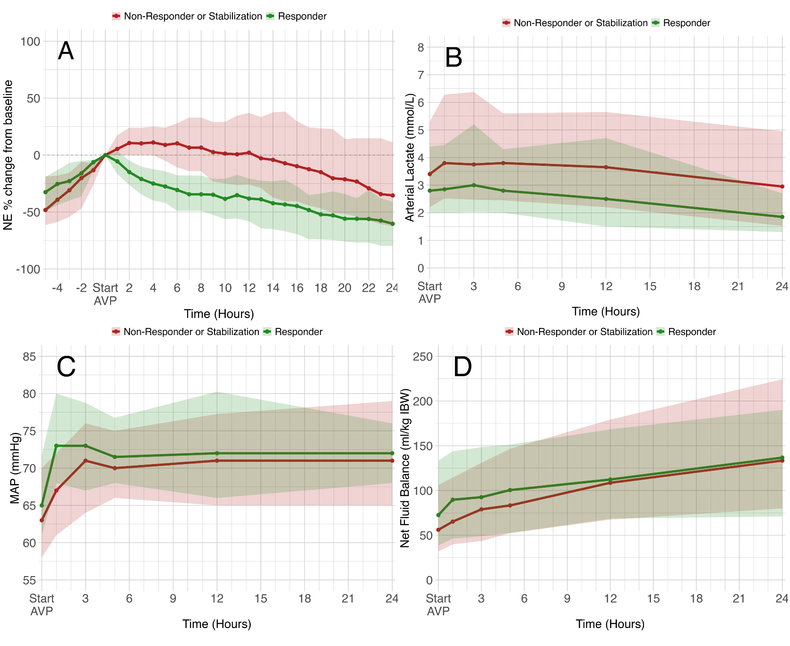
Supplemental Figure 6: Dynamics of NEE delta, lactate, MAP and Net Fluid Balance comparing patients with NE reduction to non-responders and those with stabilization of NE at two hours after the start of AVP.
A. NEE dynamics before and after the start of AVP. An LMM showed no significant differences in NEE at five hours before the start of AVP between those with NE reduction two hours after start of AVP compared to others (p=0.588), nor was there a significant difference in trajectory five hours prior to AVP start (p=0.702)
B. Arterial lactate levels at baseline and after the start of AVP. An LMM showed no significant baseline differences in arterial lactate in patients with NE reduction compared to others (p=0.094) but a higher lactate increase than others (p=0.030). After applying robust standard errors due to heteroscedasticity, the interaction between NE reduction and time was no longer significant (p=0.069).
C. Mean Arterial Pressure (MAP) at baseline and after the start of AVP. An LMM showed a significantly higher baseline in patients with NE reduction compared to non-responders and those with a stabilization of NE (average 4.5 mmHg higher, p<0.001) with a higher increase in MAP over time in patients with NE reduction (average increase 0.21 mmHg, p=0.016).
D. Net fluid balance at baseline and after the start of AVP An LMM showed no significant baseline differences between patients with NE reduction at two hours compared to others (p=0.345), but this increased less over time (average 0.92 ml/kg IBW per hour less, p=0.016) which remained significant after applying robust standard errors (p=0.015).

In all figures, medians alongside interquartile ranges are presented. Abbreviations: NEE = Norepinephrine Equivalent; AVP = Arginine vasopressin; MAP = Mean Arterial Pressure; IBW = Ideal Body Weight; LMM = Linear Mixed Model

Supplemental Figure 7: NE infusion rates (% of baseline) in responders, non-responders and the whole cohort.
Within the whole cohort, the NE percentage of baseline at two hours and five hours was significantly lower compared to baseline (0% [-18 – 0], p = 0.008, and -14% [-35 – 0], p < 0.001, respectively). Medians alongside interquartile ranges are presented. Abbreviations: AVP = Arginine Vasopressin; NE = Norepinephrine

Supplemental Figure 8: NEE (% of baseline) in responders, non-responders and the whole cohort.
Within the whole cohort, the NEE percentage of baseline was not lower at two hours after AVP initiation (0% [-13 – 11], p = 0.933), while at five hours, it was significantly lower than baseline (-9% [-31 – 11], p = 0.001). Medians alongside interquartile ranges are presented. Abbreviations: AVP = Arginine Vasopressin; NEE = Norepinephrine Equivalent

Supplemental Figure 9: Arterial pH levels at baseline and after the start of AVP.
An linear mixed-effects model was conducted to test the change in arterial pH over time. While arterial pH did not significantly decrease over time overall (p=0.123), nor were there significant differences at baseline in arterial pH between responders and non-responders (p=0.553), arterial pH decreased 0.01 per hour faster in non-responders than responders (p=0.005) which remained significant after applying robust standard errors (p=0.05) due to heteroscedasticity; Abbreviation: AVP = Arginine Vasopressin

Baseline variables | Univariate Cox Regression |  | Multivariable Cox Regression ¹
Baseline variables | OR (95% CI) | p-value | OR (95% CI) | p-value
Age (years) | 1.004 (0.982, 1.101) | 0.636
Sex (male) | 1.120 (0.801, 1.565) | 0.509
Weight (kg) | 1.009 (1.001, 1.017) | 0.024
IBW (kg) ² | 1.009 (0.978, 1.004) | 0.170
BMI (kg/m²) | 1.032 (1.007, 1.057) | 0.010 | 1.060 (1.017, 1.105) | 0.006
Obesity ³ | 1.426 (0.999, 2.037) | 0.051
Diabetes | 1.277 (0.820, 1.988) | 0.278
Immunocompromised ⁴ | 1.596 (0.878, 2.899) | 0.126
Congestive Heart failure | 0.738 (0.374, 1.458) | 0.381
Anti-hypertensive medication ⁵ | 0.866 (0.584, 1.282) | 0.472
Abdominal sepsis | 0.765 (0.547, 1.068) | 0.116
Pulmonary sepsis | 1.117 (0.772, 1.616) | 0.557
Urinary tract sepsis | 0.754 (0.382, 1.491) | 0.417
SOFA-score | 1.066 (0.999, 1.138) | 0.054
APACHE IV score | 1.003 (0.997, 1.008) | 0.343
Mechanical Ventilation | 1.001 (0.647, 1.548) | 0.997
RRT | 1.776 (0.930, 3.401) | 0.082
Creatinine (µmol/L) | 1.002 (0.999, 1.004) | 0.146
Net fluid balance (L) | 1.061 (1.015, 1.107) | 0.008 | 1.025 (0.972, 1.080) | 0.369
Net fluid balance (per 100 ml/kg IBW¹) | 1.003 (1.001, 1.006) | 0.016
Received steroids | 1.852 (0.981, 3.485) | 0.446
Received calcium intravenous | 1.852 (0.981, 3.485) | 0.057
ScVO₂ (%) | 1.004 (0.970, 1.041) | 0.808
Arterial lactate (mmol/L) | 1.028 (0.950, 1.112) | 0.500
Arterial pH (per 0.1) | 0.725 (0.588, 0.893) | 0.002 | 0.799 (0.640, 0.999) | 0.049
NE duration (per hour) | 1.017 (1.006, 1.029) | 0.003 | 1.013 (1.000, 1.026) | 0.050
NE duration ≥ 7 hours | 1.524 (1.082, 2.146) | 0.016
NE dosage (per 0.1 mcg/kg/min) | 1.059 (0.970, 1.156) | 0.202 | 1.122 (1.009, 1.248) | 0.033
NE dosage (mcg/min) | 1.017 (1.004, 1.029) | 0.008
NE dosage ≥ 0.30 mcg/kg/min | 1.168 (0.800, 1.707) | 0.419
NEE delta 2 h prior to baseline | 0.999 (0.994 – 1.006) | 0.697
AVP dosage (IU/min) | 1.147 (0.830, 1.582) | 0.406
AVP responsiveness ⁶ | 0.862 (0.565, 1.314) | 0.488

Supplemental Table 4: Probability of longer shock duration in 140 shock survivors
¹ Variables in multivariable model selected using Least Absolute Shrinkage and Selection Operator (LASSO) regression at λ_{min.} 140 shock survivors were included in the multivariable model; ² Obtained using the Gallagher formula (23); ³ BMI ≥ 30 kg/m²; ⁴ Long-term use of immunosuppressive therapy or use of corticosteroids (e.g. >5 days 1mg/kg prednisone or 20 days ≥0.1mg/kg) or active chemo-or radiation therapy last year, or treatment for a lymphoma any time before ICU admission or documented humoral or cellular deficiencies; ⁵ includes use of calcium channel inhibitor, angiotensin-converting-enzyme inhibitor and/or angiotensin receptor blocker within 48 hours from ICU admission; ⁶ Decrease or stabilization of NE-requirement 2 hours after initiation of AVP. Abbreviations: IBW = Ideal Body Weight; BMI = Body Mass Index; SOFA = Sequential Organ Failure Assessment; APACHE = Acute Physiology and Chronic Health Evaluation; RRT = Renal Replacement Therapy; NE = Norepinephrine; NEE = Norepinephrine Equivalent; AVP = Arginine-Vasopressin
Characteristics | Univariate Logistic Regression
Characteristics | OR (95% CI) | p-value
Age (years) | 1.067 (1.002, 1.137) | 0.044
Sex (male) | 0.482 (0.134, 1.735) | 0.264
Weight (kg) | 0.996 (0.967, 1.026) | 0.778
IBW (kg) ¹ | 0.971 (0.921, 1.024) | 0.275
BMI (kg/m²) | 1.005 (0.924, 1.094) | 0.900
Obesity ² | 1.158 (0.320, 4.192) | 0.824
Diabetes | 3.395 (0.896, 12.857) | 0.072
Immunocompromised ³ | - | -
Heart failure | 1.867 (0.204, 17.078) | 0.581
Anti-hypertensive medication ⁴ | 1.544 (0.439, 5.433) | 0.498
Abdominal sepsis | 1.937 (0.538, 6.972) | 0.311
Pulmonary sepsis | 0.549 (0.113, 2.674) | 0.458
SOFA-score at baseline | 0.934 (0.727, 1.201) | 0.596
APACHE IV score | 1.013 (0.990, 1.037) | 0.260
Shock-related characteristics
AVP-responsiveness ⁵ | 0.544 (0.133, 2.232) | 0.398
AVP tapered ⁶ | 0.446 (0.047, 4.203) | 0.481
NE dosage (per 0.1 mcg/kg/min) ⁷ | 0.916 (0.589, 1.420) | 0.169
NE dosage (mcg/min) ⁷ | 0.970 (0.897, 1.049) | 0.443
NE dosage ≥ 0.10 mcg/kg/min ⁷ | 0.482 (0.134, 1.735) | 0.264
NE dosage ≥ 0.20 mcg/kg/min ⁷ | 0.413 (0.050, 3.392) | 0.410
AVP duration (hours) | 0.968 (0.934, 1.003) | 0.071
AVP duration > 24 h | 0.215 (0.054, 0.854) | 0.029
AVP cumulative dosage (IU) | 0.994 (0.979, 1.009) | 0.440

Supplemental Table 5: Associations between clinical characteristics and rebound hypotension in 129 shock survivors

¹ Obtained using Gallagher formula (23); ² BMI ≥ 30 kg/m²; ³Long term use of immunosuppressive therapy or use of corticosteroids (e.g. >5 days 1mg/kg prednisone or 20 days ≥0.1mg/kg) or active chemo-or radiation therapy last year, or treatment for a lymphoma any time before ICU admission or documented humoral or cellular deficiencies; ⁴ includes use of calcium channel inhibitor, angiotensin-converting-enzyme inhibitor and/or angiotensin receptor blocker within 48 hours from ICU admission; ⁵ Decrease or stabilization of NE-requirement 2 hours after initiation of AVP; ⁶ stepwise decrease in AVP dosage one hour before ceasing AVP; ⁷ on the moment AVP is stopped.
Abbreviations: IBW = Ideal Body Weight; BMI = Body Mass Index; SOFA = Sequential Organ Failure Assessment; APACHE = Acute Physiology and Chronic Health Evaluation; RRT = Renal Replacement Therapy; NE = Norepinephrine; NEE = Norepinephrine Equivalent; AVP = Arginine-Vasopressin

