Do diabetes and acute stress-related hyperglycemia increase the risk of ICU-acquired infections? A retrospective assessment in patients with septic shock
Alice Friol, Clément Devautour, Anna Semenov, Juliette Pelle, Marie Renaudier,
Sarah Benghanem, Alain Cariou, Jean-Paul Mira, Julien Charpentier, Frédéric Pène

Supplementary materials
Table S1: Protocol for insulin therapy in the ICU
Table S2: Multivariate competing-risk cause-specific hazard models for risk factors associated with ICU-acquired infections.
Table S3: Multivariate competing-risk cause-specific hazard model for risk factors associated with ICU-acquired infections with regard to preexisting diabetes.
Table S4: Multivariate competing-risk cause-specific hazard models for risk factors associated with ICU-acquired infections – Landmark sensitive analysis starting after the initial 72-hour period of glycemic control
Figure S1: Flowchart of the study
Figure S2: Cumulative incidences of ICU-acquired infections in non-diabetic (n=701) and diabetic patients (n=200) according to 72-hour glycemic control.

Subcutaneous fast-acting insulin administration protocol
Based on 6-hour glucose measurements.
Glycemia
< 8 mmol/L |  | No insulin
8 – 10 mmol/L |  | 4 IU
10 – 15 mmol/L |  | 6 IU
- – 20 mmol/L |  | 8 IU
> 20 mmol/L |  | 10 IU
Continuous intravenous fast-acting insulin infusion: initiation protocol (when blood glucose sustains ≥ 10 mmol/L)
Monitor blood glucose after 1 hour and adjust accordingly.
Glycemia | First i.v. injection |  | Continuous i.v. infusion
10 - 12 mmol/L | 2 IU |  | 2 IU/h
12 - 14 mmol/L | 3 IU |  | 3 IU/h
14 - 16 mmol/L | 4 IU |  | 4 IU/h
Continuous intravenous fast-acting insulin infusion: maintenance protocol
Blood glucose monitoring 1 hour after any change in infusion rate, and every 3 hours otherwise.
Glycemia | Infusion rate adjustment |  | Maximum dosage rate
5 - 6 mmol/L | 0 IU/h |  | 1 IU/h
6 - 7 mmol/L | 0 IU/h |  | 1.5 IU/h
7 - 8 mmol/L | 0 IU/h |  | 2 IU/h
8 - 10 mmol/L | 1 IU/h |  | 3 IU/h
10 - 12 mmol/L | 1.5 IU/h |  | 4 IU/h
12 - 15 mmol/L | 2 IU/h |  | 6 IU/h
> 15 mmol/L | 2.5 IU/h |  | 8 IU/h
Table S1: Protocol for insulin therapy in the ICU

IU: international units

Table S2: Multivariate competing-risk cause-specific hazard models for risk factors associated with ICU-acquired infections.
 | aCSH | 95% confidence interval |  | p
Model 1
Age (+ 1 year) | 0.99 | 0.99 | 1.00 | 0.148
Admission SOFA (+1 point) | 1.03 | 1.00 | 1.06 | 0.085
Preexisting diabetes | 0.98 | 0.71 | 1.36 | 0.918
Pneumonia on admission | 1.63 | 1.26 | 2.11 | <0.001
Hydrocortisone therapy | 1.22 | 0.93 | 1.59 | 0.15
Intubation one given day | 2.45 | 1.38 | 4.35 | 0.002
Arterial catheter one given day | 1.22 | 0.65 | 2.31 | 0.538
Central venous catheter one given day | 1.10 | 0.47 | 2.59 | 0.831
Dialysis catheter one given day | 1.03 | 0.77 | 1.38 | 0.848
Transfusion of blood products one given day | 1.94 | 1.40 | 2.68 | <0.001
Caloric intake (+1 kcal/kg/day) one given day | 1.02 | 1.01 | 1.03 | 0
Median blood glucose level (+1 mmol/L) | 1.09 | 1.01 | 1.18 | 0.021
Model 2
Age (+ 1 year) | 0.99 | 0.99 | 1.00 | 0.203
Admission SOFA (+1 point) | 1.02 | 1.00 | 1.05 | 0.095
Preexisting diabetes | 1.03 | 0.76 | 1.41 | 0.834
Pneumonia on admission | 1.63 | 1.26 | 2.11 | <0.001
Hydrocortisone therapy | 1.22 | 0.93 | 1.59 | 0.15
Intubation one given day | 2.51 | 1.40 | 4.48 | 0.002
Arterial catheter one given day | 1.21 | 0.64 | 2.29 | 0.548
Central venous catheter one given day | 1.11 | 0.47 | 2.59 | 0.814
Dialysis catheter one given day | 1.02 | 0.76 | 1.37 | 0.876
Transfusion of blood products one given day | 1.94 | 1.40 | 2.68 | <0.001
Caloric intake (+1 kcal/kg/day) one given day | 1.02 | 1.01 | 1.03 | <0.001
Median blood glucose level
Quartile 1 : < 6.4 mmol/L | Ref. | Ref. | Ref.
Quartile 2 : 6.4-7.4 mmol/L | 1.59 | 1.09 | 2.32 | 0.017
Quartile 3 : 7.4-8.6 mmol/L | 1.34 | 0.91 | 1.95 | 0.136
Quartile 4 : > 8.6 mmol/L | 1.53 | 1.03 | 2.27 | 0.034

aCSH: adjusted cause-specific hazard.
p-values for interaction between preexisting diabetes and glucose levels:
model 1: 0.75
model 2: 0.65, 0.91 and 0.69
 | aCSH | 95% confidence interval |  | p
Model 3
Age (+ 1 year) | 0.99 | 0.99 | 1.00 | 0.127
Admission SOFA (+1 point) | 1.02 | 1.00 | 1.05 | 0.098
Preexisting diabetes | 1.01 | 0.74 | 1.38 | 0.946
Pneumonia on admission | 1.62 | 1.25 | 2.10 | <0.001
Hydrocortisone therapy | 1.20 | 0.92 | 1.57 | 0.177
Intubation one given day | 2.39 | 1.34 | 4.26 | 0.003
Arterial catheter one given day | 1.25 | 0.66 | 2.36 | 0.487
Central venous catheter one given day | 1.11 | 0.47 | 2.60 | 0.815
Dialysis catheter one given day | 1.01 | 0.75 | 1.36 | 0.93
Transfusion of blood products one given day | 1.94 | 1.40 | 2.68 | <0.001
Caloric intake (+1 kcal/kg/day) one given day | 1.02 | 1.01 | 1.03 | <0.001
Blood glucose level > 8 mmol/L for > 20% of time | 1.42 | 1.03 | 1.97 | 0.034
Model 4
Age (+ 1 year) | 0.99 | 0.99 | 1.00 | 0.134
Admission SOFA (+1 point) | 1.02 | 0.99 | 1.05 | 0.11
Preexisting diabetes | 0.99 | 0.72 | 1.36 | 0.947
Pneumonia on admission | 1.63 | 1.26 | 2.11 | <0.001
Hydrocortisone therapy | 1.19 | 0.91 | 1.56 | 0.205
Intubation one given day | 2.44 | 1.38 | 4.34 | 0.002
Arterial catheter one given day | 1.24 | 0.66 | 2.35 | 0.499
Central venous catheter one given day | 1.08 | 0.46 | 2.55 | 0.856
Dialysis catheter one given day | 1.02 | 0.76 | 1.36 | 0.919
Transfusion of blood products one given day | 1.95 | 1.41 | 2.69 | <0.001
Caloric intake (+1 kcal/kg/day) one given day | 1.02 | 1.01 | 1.03 | <0.001
Time duration with blood glucose levels > 8 mmol/L
Quartile 1 : 0-16 % | Ref. | Ref. | Ref.
Quartile 2 : 16-37 % | 1.38 | 0.94 | 2.05 | 0.104
Quartile 3 : 37-61 % | 1.33 | 0.90 | 1.97 | 0.155
Quartile 4 : 61-100 % | 1.59 | 1.07 | 2.37 | 0.022
Table S2 (continued): Multivariate competing-risk cause-specific hazard models for risk factors associated with ICU-acquired infections.

aCSH: adjusted cause-specific hazard.
p-values for interaction between preexisting diabetes and glucose levels:
model 3: 0.31
model 4: 0.17, 0.33 and 0.46
 | aCSH | 95% confidence interval |  | p
Age (+ 1 year) | 0.99 | 0.99 | 1.002 | 0.112
Admission SOFA (+1 point) | 1.02 | 0.995 | 1.05 | 0.112
Pneumonia on admission | 1.61 | 1.24 | 2.09 | 0.000
Hydrocortisone therapy | 1.19 | 0.91 | 1.56 | 0.192
Intubation one given day | 2.38 | 1.34 | 4.25 | 0.003
Arterial catheter one given day | 1.25 | 0.66 | 2.36 | 0.488
Central venous catheter one given day | 1.11 | 0.47 | 2.60 | 0.810
Dialysis catheter one given day | 1.01 | 0.75 | 1.35 | 0.972
Transfusion of blood products one given day | 1.93 | 1.40 | 2.67 | <0.001
Caloric intake (+1 kcal/kg/day) one given day | 1.02 | 1.01 | 1.03 | 0.001
Blood glucose level > 8 mmol/L for > 20% of time
in non-diabetic patients | 1.51 | 1.07 | 2.13 | 0.018
in diabetic patients | 0.61 | 0.24 | 1.58 | 0.310
Table S3: Multivariate competing-risk cause-specific hazard model for risk factors associated with ICU-acquired infections with regard to preexisting diabetes.

aCSH: adjusted cause-specific hazard

Table S4: Multivariate competing-risk cause-specific hazard models for risk factors associated with ICU-acquired infections – Landmark sensitive analysis starting after the initial 72-hour period of glycemic control

 | aCSH | 95% confidence interval |  | p
Model 3
Age (+ 1 year) | 0.99 | 0.98 | 1.00 | 0.124
Admission SOFA (+1 point) | 1.01 | 0.99 | 1.05 | 0.328
Preexisting diabetes | 2.30 | 0.80 | 6.59 | 0.120
Pneumonia on admission | 1.65 | 1.25 | 2.17 | <0.001
Hydrocortisone therapy | 1.21 | 0.91 | 1.60 | 0.187
Intubation one given day | 2.41 | 1.33 | 4.38 | 0.004
Arterial catheter one given day | 1.37 | 0.70 | 2.67 | 0.359
Central venous catheter one given day | 0.96 | 0.40 | 2.32 | 0.929
Dialysis catheter one given day | 1.12 | 0.83 | 1.52 | 0.461
Transfusion of blood products one given day | 2.03 | 1.44 | 2.86 | <0.001
Caloric intake (+1 kcal/kg/day) one given day | 1.02 | 1.01 | 1.03 | <0.001
Blood glucose level > 8 mmol/L for > 20% of time | 1.51 | 1.05 | 2.18 | 0.026
aCSH: adjusted cause-specific hazard.

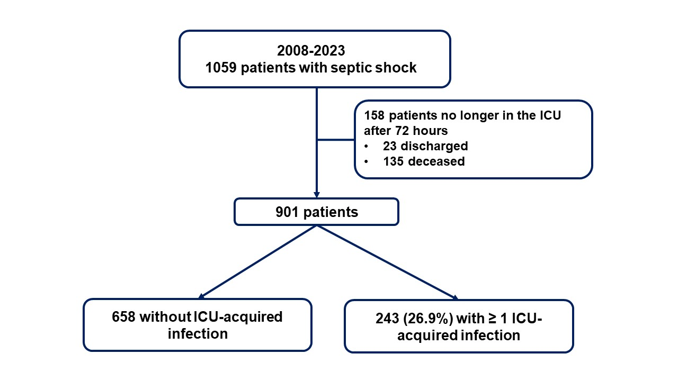

Figure S1: Flowchart of the study

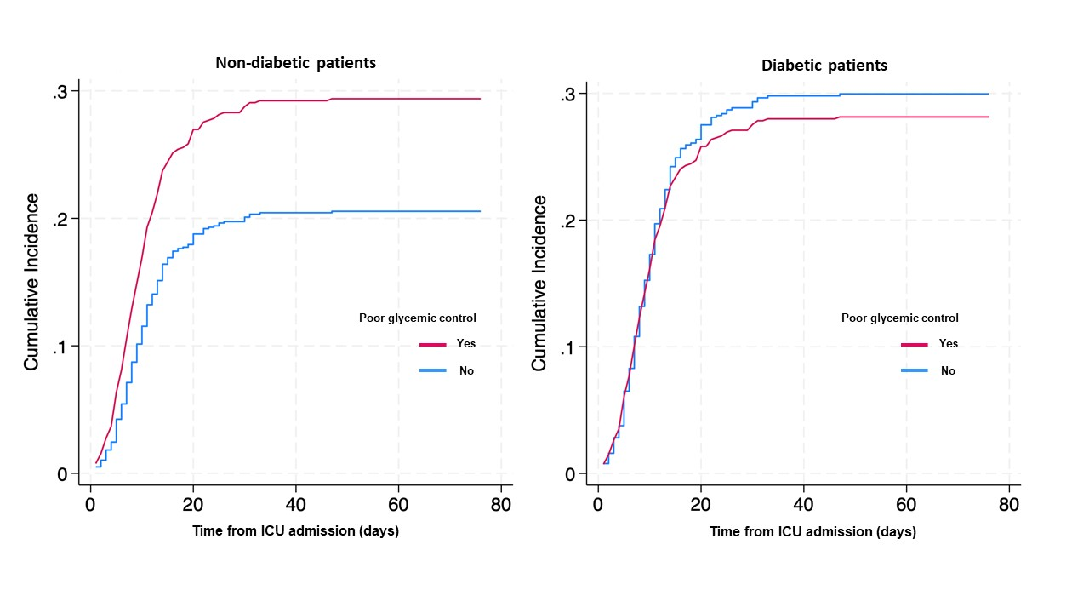

Figure S2: Cumulative incidences of ICU-acquired infections in non-diabetic (n=701) and diabetic (n=200) patients according to 72-hour glycemic control.
Poor glycemic control was defined by blood glucose level > 8 mmol/L for more than 20% of time. Curves were built through a multivariate competing-risk analysis taking into account the competitive risks of death and ICU discharge and adjusted on the following variables: age. admission SOFA score. pneumonia on admission, intubation on a given day, presence of intravascular central venous, arterial or dialysis catheters on a given day, transfusion of blood products on a given day, daily caloric intake.

