SUPPLEMENTARY MATERIAL

Physiological comparison of noninvasive ventilation and CPAP on inspiratory efforts after extubation in critically ill patients with morbid obesity

Martin Mahul, Mathieu Capdevila, Fabrice Galia, Audrey De Jong, Samir Jaber

Table of contents

- Table S1: Individual characteristics of the patients
- Table S2: Friedman test results for indices of inspiratory effort.
- Table S3: Pairwise Wilcoxon signed-rank tests with Holm correction for inspiratory effort indices.
- Figure S1: Flow chart of the study
- Figure S2: Individual and mean changes in Respiratory rate
- Figure S3: Individual and mean changes in Respiratory rate over tidal volume (RR/VT).

Table S1. Individual characteristics of the patients
Patient | Sex | Age | SAPSII | Height  (cm) | Weight  (kg) | BMI  (kg/m²) | Underlying  diseases | Etiology of respiratory failure | ETT  (mm) | MV before extubation  (days) | PSV level before extubation  (cmH2O) | PEEP before extubation  (cmH2O) | Extubation Failure | Outcome (D/S)
1 | F | 85 | 68 | 163 | 115 | 43 | NIDDM | Pneumonia | 7.5 | 4 | 15 | 7 | N | S
2 | M | 64 | 50 | 170 | 130 | 44 | NIDDM | Pancreatitis | 8 | 3 | 12 | 8 | N | S
3 | F | 59 | 60 | 155 | 95 | 39 | None | Peritonitis | 7.5 | 3 | 12 | 8 | N | S
4 | F | 49 | 66 | 160 | 174 | 67 | COPD, OSA | Sepsis | 7.5 | 6 | 10 | 10 | N | S
5 | F | 25 | 29 | 172 | 145 | 49 | None | Asthma | 7.5 | 1 | 10 | 8 | N | S
6 | F | 54 | 19 | 153 | 121 | 51 | Asthma, HTN | Postoperative | 7.5 | 1 | 10 | 8 | N | S
7 | M | 37 | 54 | 180 | 130 | 40 | None | Pancreatitis | 8 | 14 | 8 | 10 | N | S
8 | F | 78 | 90 | 155 | 87 | 36 | None | Bowel obstruction | 7.5 | 4 | 8 | 5 | N | S
9 | F | 49 | 78 | 167 | 112 | 41 | Asthma, OSA | Peritonitis | 7.5 | 30 | 8 | 5 | N | S
10 | F | 73 | 77 | 150 | 93 | 41 | CHF, AF | Septic shock | 7.5 | 4 | 12 | 6 | N | D
11 | F | 50 | 45 | 162 | 94 | 36 | None | Necrotizing Fasciitis | 7.5 | 2 | 9 | 7 | N | S
12 | M | 63 | 64 | 175 | 180 | 56 | NIDDM, HTN | Small bowel bleeding | 7.5 | 1 | 8 | 10 | N | S
13 | F | 43 | 48 | 155 | 105 | 43 | OSA | Pneumonia | 7.5 | 3 | 12 | 7 | N | S
14 | F | 77 | 41 | 155 | 84 | 36 | NIDDM, HTN | Pancreatitis | 7.5 | 7 | 9 | 7 | Y | S
15 | F | 50 | 64 | 164 | 124 | 46 | OSA | Postoperative | 7.5 | 8 | 14 | 8 | N | S
Overall | 80%  F | 54  [49-68] | 60  [46-67] | 162  [155-168] | 115  [94-130] | 43  [39-47] | . | . | 87%  7.5 | 4  [2-6] | 10  [8-12] | 8  [7-8] | 93%  N | 93%  S

Continuous variables are presented as median [interquartile range] and categorical variables as number (percentage).
Definition of abbreviations: AF: Atrial Fibrillation, BMI: Body Mass Index; CHF: Chronic Heart Failure, COPD: Chronic Obstructive Pulmonary Disease, D: Deceased; ETT: Endotracheal Tube Internal Diameter; F: female; M: male; HTN: Hypertension; MV: Mechanical Ventilation; NIDDM: Non Insulin Dependent Diabetes Mellitus; OSA: Obstructive Sleep Apnoea, PEEP: Positive End Expiratory Pressure; PSV: Pressure Support Ventilation; SAPS II Simplified Acute Physiology Score II (2); S: Survived. All postoperative cases occurred after abdominal surgery, and all episodes of pancreatitis were acute.
Table S2: Friedman test results for indices of inspiratory effort.

Inspiratory effort indice | Friedman test: χ²(2) | p-value
WOB (J/min) | 28.1 | 7.8 × 10⁻⁷
WOB (J/L) | 30.0 | 3.1 × 10⁻⁷
Swing Pdi | 28.1 | 7.8 × 10⁻⁷
Swing Pes | 29.5 | 3.9 × 10⁻⁷
PTPdi | 30.0 | 3.1 × 10⁻⁷
PTPes | 30.0 | 3.1 × 10⁻⁷

Table S3. Pairwise Wilcoxon signed-rank tests with Holm correction for inspiratory effort indices.

Inspiratory effort indice | Comparison | Raw p-value | Holm-adjusted p-value | Significant
WOB (J/min) | O₂ vs CPAP | 0.00012 | 0.00018 | Yes
WOB (J/min) | O₂ vs PSV-PEEP | 0.00006 | 0.00018 | Yes
WOB (J/min) | CPAP vs PSV-PEEP | 0.00006 | 0.00018 | Yes
WOB (J/L) | O₂ vs CPAP | 0.00006 | 0.00018 | Yes
WOB (J/L) | O₂ vs PSV-PEEP | 0.00006 | 0.00018 | Yes
WOB (J/L) | CPAP vs PSV-PEEP | 0.00006 | 0.00018 | Yes
Swing Pdi | O₂ vs CPAP | 0.00006 | 0.00018 | Yes
Swing Pdi | O₂ vs PSV-PEEP | 0.00006 | 0.00018 | Yes
Swing Pdi | CPAP vs PSV-PEEP | 0.00012 | 0.00018 | Yes
Swing Pes | O₂ vs CPAP | 0.00006 | 0.00018 | Yes
Swing Pes | O₂ vs PSV-PEEP | 0.00006 | 0.00018 | Yes
Swing Pes | CPAP vs PSV-PEEP | 0.00097 | 0.00097 | Yes
PTPdi | O₂ vs CPAP | 0.00006 | 0.00018 | Yes
PTPdi | O₂ vs PSV-PEEP | 0.00006 | 0.00018 | Yes
PTPdi | CPAP vs PSV-PEEP | 0.00006 | 0.00018 | Yes
PTPes | O₂ vs CPAP | 0.00006 | 0.00018 | Yes
PTPes | O₂ vs PSV-PEEP | 0.00006 | 0.00018 | Yes
PTPes | CPAP vs PSV-PEEP | 0.00006 | 0.00018 | Yes

Figure S1: Flow chart of the study
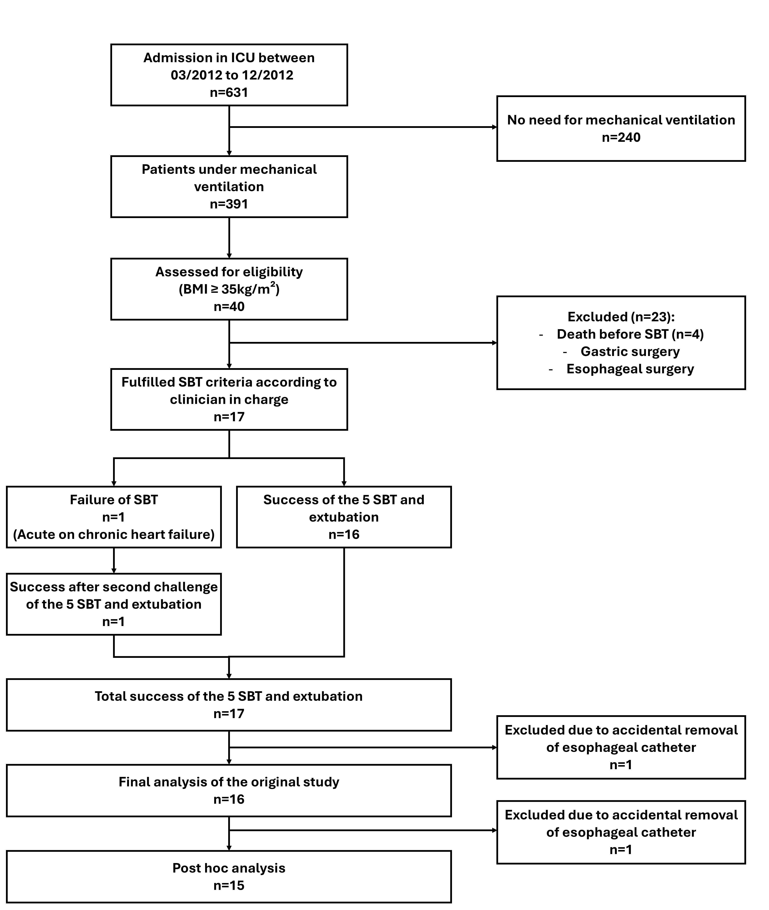

Figure S2: Individual and mean changes in Respiratory rate. * p< 0.05

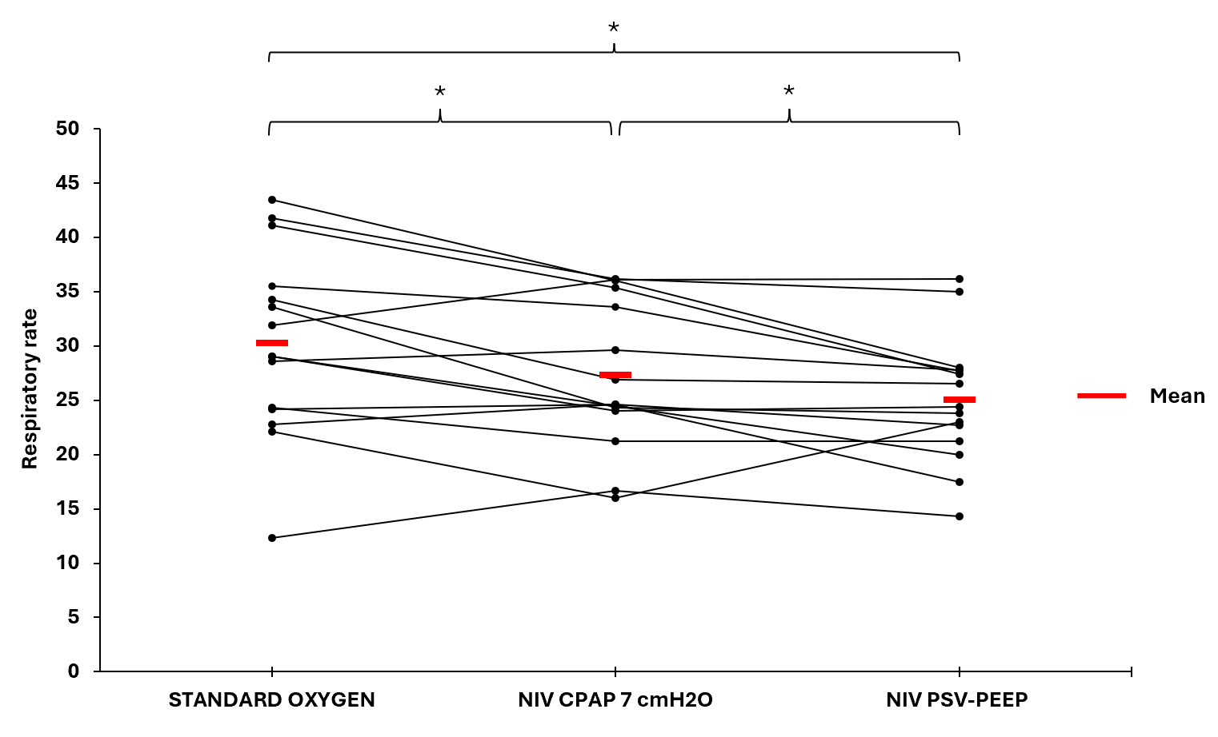

Figure S3: Individual and mean changes in Respiratory rate over tidal volume (RR/VT). * p< 0.05

