Online Resource A
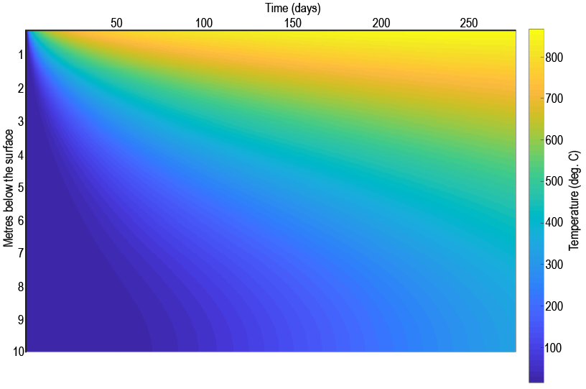
Raw, continuous lava flow-substrate heat transfer results from when lava first inundates the location of interest through to nine months after the end of the emplacement period.

