Cost-benefit analysis for evacuation decision-support: challenges and possible solutions for applications in areas of distributed volcanism

A.J. Wild, M.S. Bebbington, J.M. Lindsay, N.I. Deligne
Supplementary Material
This file contains the outputs of the spatial vent likelihood for the 0.5, 0.2 to 0.8, 0.1 to 0.9 and 0 to 1 interval sets for Node 4 monitoring component weights for the Bayesian Event Tree for Eruption Forecasting, implemented for the Auckland Volcanic Field (BETEF_AVF). Additionally, the Bayesian Event Tree for Short-term Volcanic Hazard implemented for the Auckland Volcanic Field (BETVHst_AVF) for 0.2 to 0.8 and 0 to 1 interval sets for Node 4 monitoring component weights.

BETEF_AVF Node 4: Spatial vent likelihood
This section presents the absolute probabilities of an eruption at a location, i.e., Node 4, from BETEF_AVF for the Node 4 monitoring component weights for the Birkenhead scenario for 0.5 (Figure 1), 0.2 to 0.8 (Figure 2), 0.1 to 0.9 (Figure 3) and 0 to 1 (Figure 4). Outputs are at a 0.25km² resolution.

Evacuation Zone using cost-benefit analysis
This section presents the spatial probability of volcanic hazard impact at a location with the 0.2 to 0.8 and 0 to 1 interval sets for Node 4 monitoring component, with evacuation zones defined with each of the four presented CBA thresholds in Figures 5 and 6 respectively. This follows the same approach as explained in the main paper.

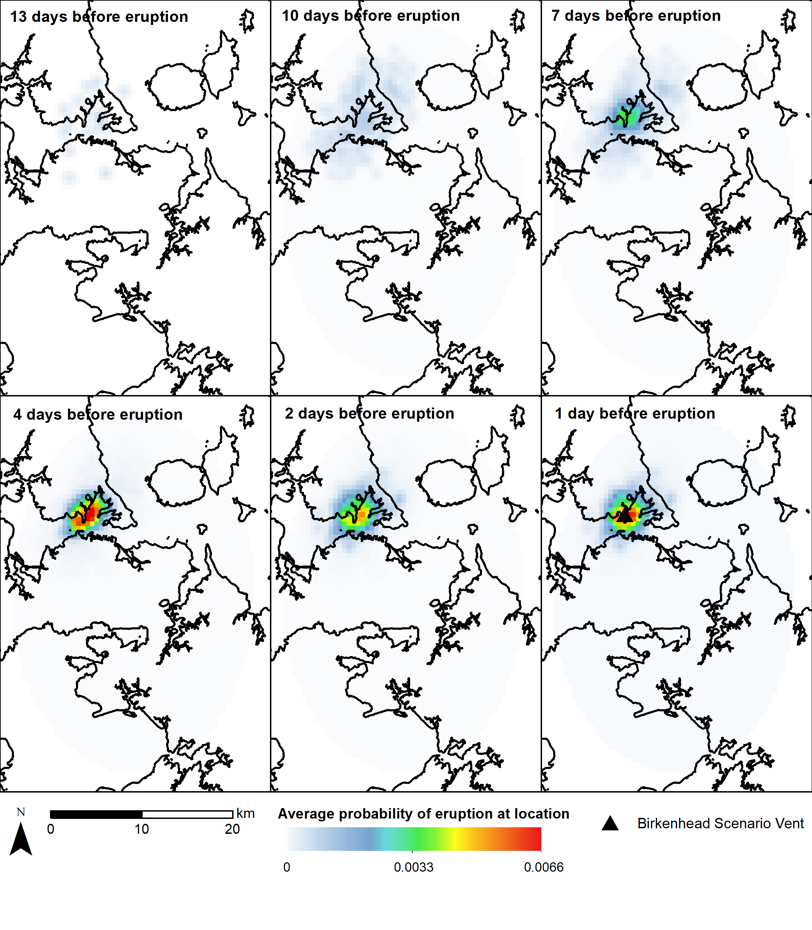
Figure 1 Spatial distribution of absolute eruption probabilities for the Birkenhead scenario from BETEF_AVF for selected days leading up to the eruption with weight of the monitoring component of 0.5

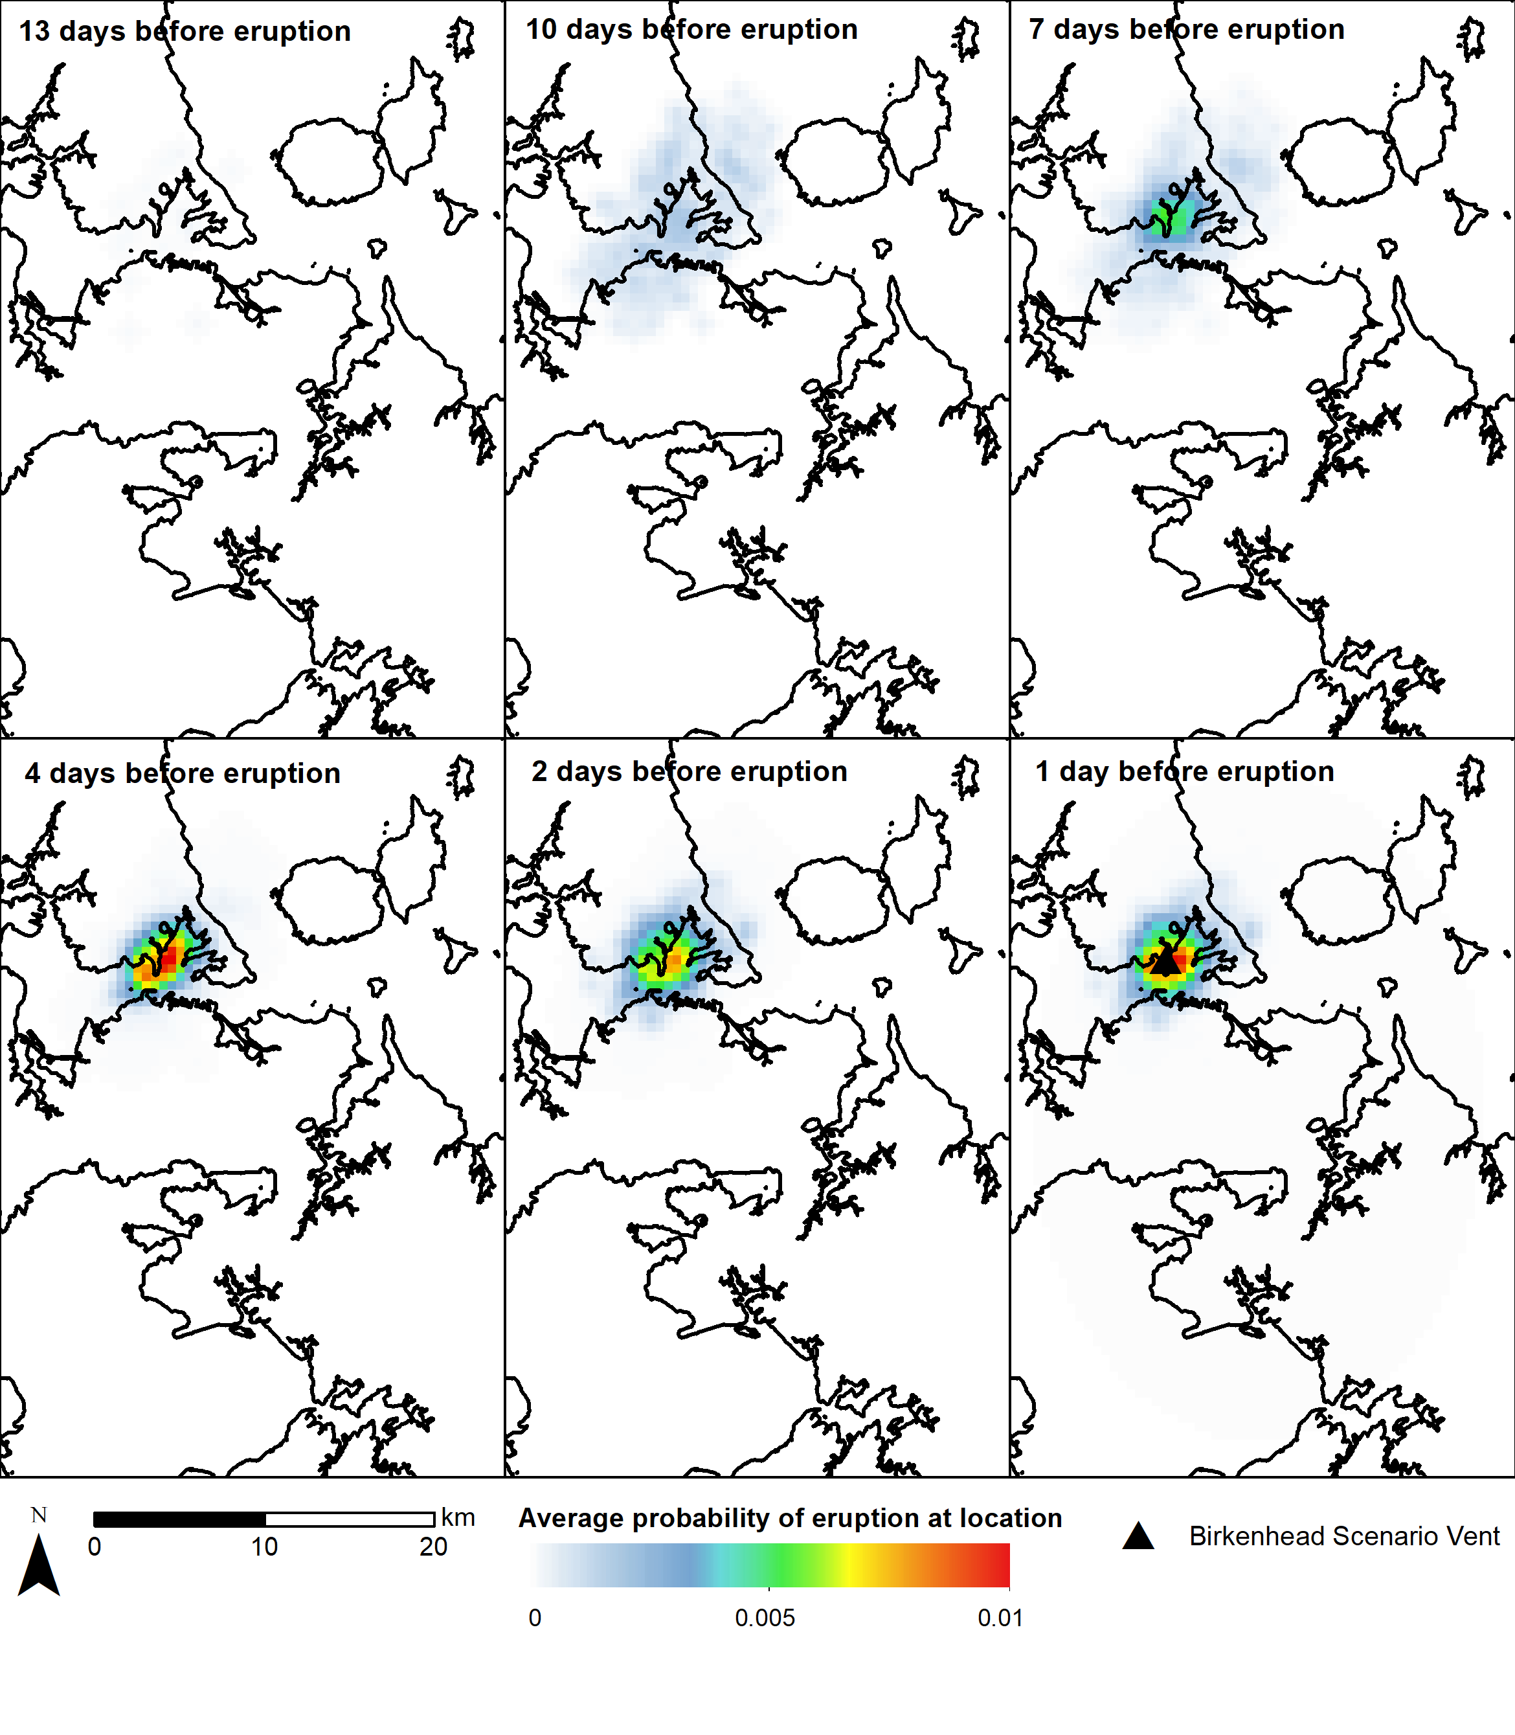

Figure 2 Spatial distribution of absolute eruption probabilities for the Birkenhead scenario from BETEF_AVF for selected days leading up to the eruption with weight of the monitoring component range of 0.2 to 0.8
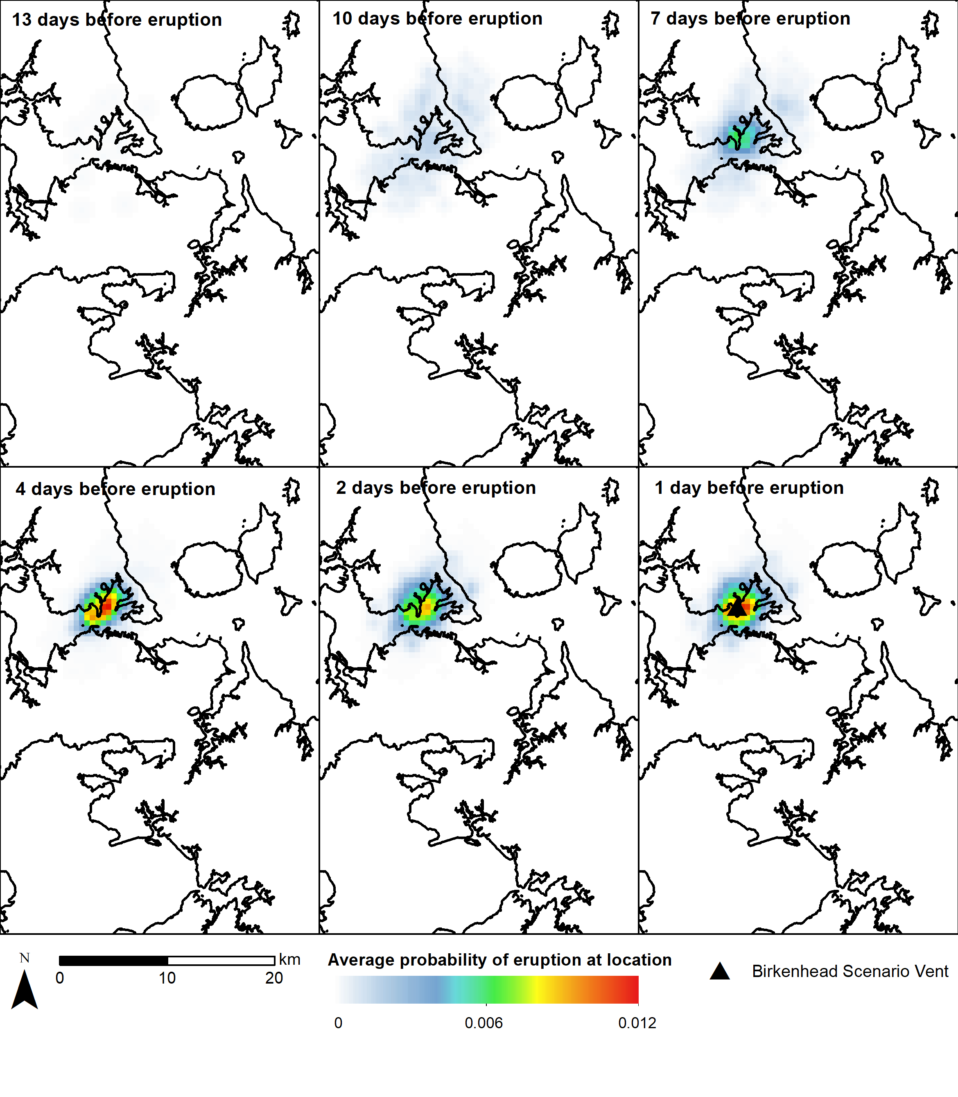
Figure 3 Spatial distribution of absolute eruption probabilities for the Birkenhead scenario from BETEF_AVF for selected days leading up to the eruption with weight of the monitoring component range of 0.1 to 0.9

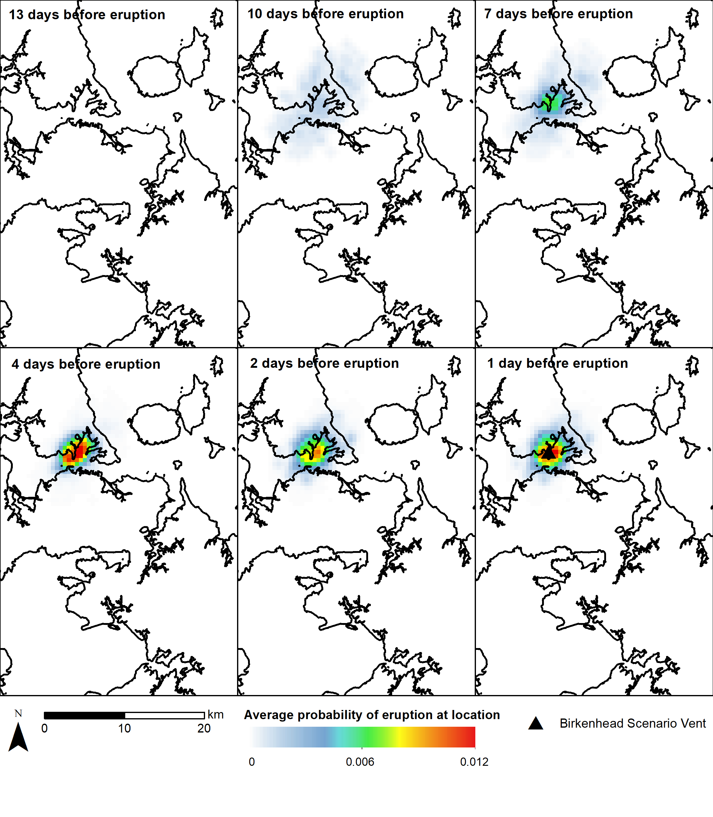

Figure 4 Spatial distribution of absolute eruption probabilities for the Birkenhead scenario from BETEF_AVF for selected days leading up to the eruption with weight of the monitoring component range of 0 to 1

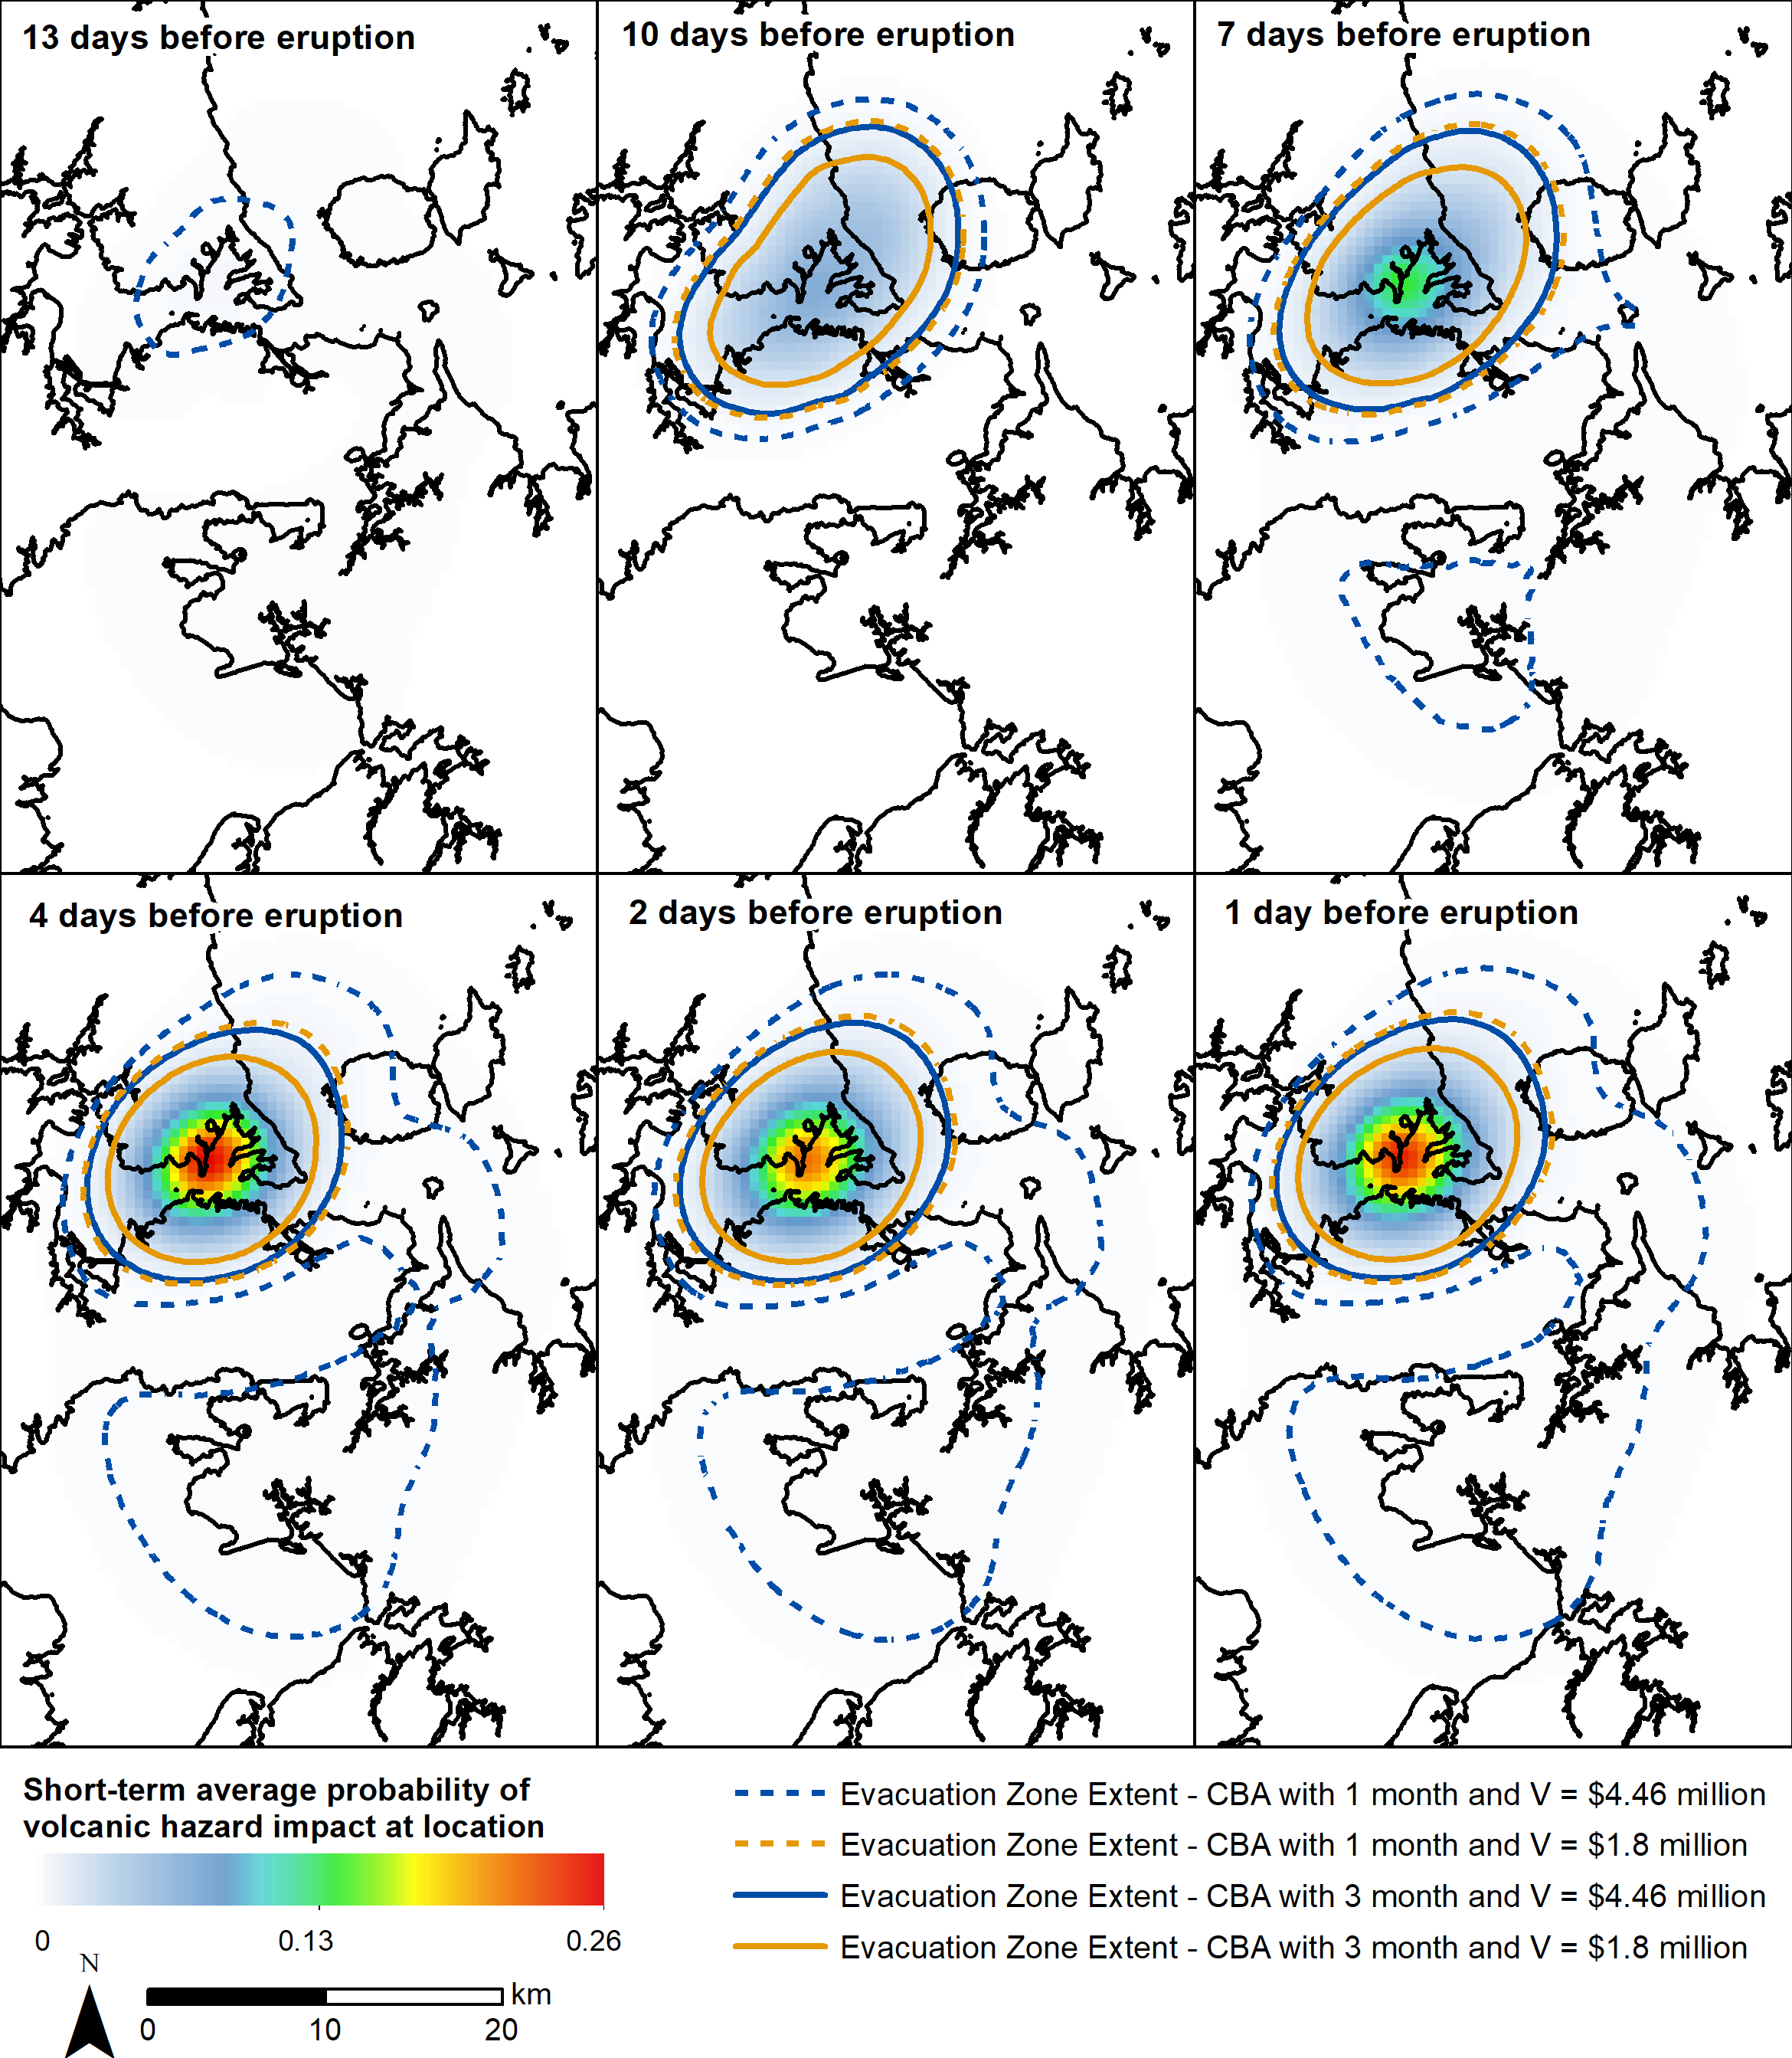

Figure 5 Evacuation zones defined for each of the CBA approaches using the spatial distribution of the absolute short-term average probability of volcanic hazard impact at a location from BETVHst_AVF where the Node 4 weight of the monitoring component transitions from 0.2 to 0.8 for selected days leading up to the eruption in the Birkenhead scenario.

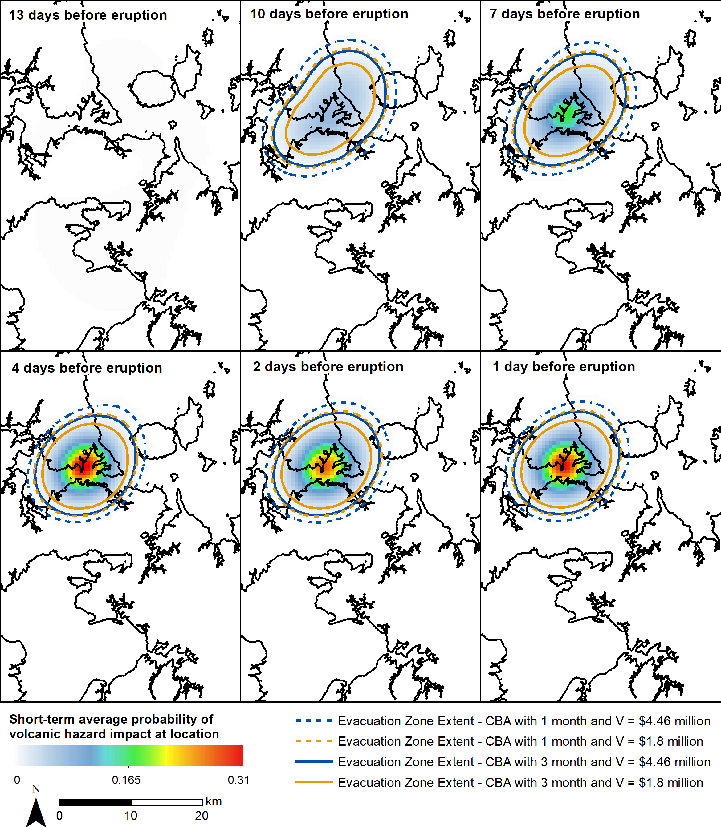

Figure 6 Evacuation zones defined for each of the CBA approaches using the spatial distribution of the absolute short-term average probability of volcanic hazard impact at a location from BETVHst_AVF where the Node 4 weight of the monitoring component transitions from 0 to 1 for selected days leading up to the eruption in the Birkenhead scenario.

References
Wild AJ, Bebbington MS, Lindsay JM. Short-Term Eruption Forecasting for Crisis Decision-Support in the Auckland Volcanic Field, New Zealand. Front. Earth Sci. 2022 May 24;10:893882.

