Supporting Information

The Validation of Quality Attributes in Primary Human Hepatocytes Standard

Zhaoliang Peng^{1†}, Jiaying Wu^{2†$}, Xi Zhang³, Xinyang Jia³, Zhitao Wu^{1,3}, Hao Dai², Da Huang^{2$}, Xin Cheng^{2*}, Guoyu Pan^{1,3*}, Ruimin Huang^{1,3*}

†These authors contributed equally to this work.

*Correspondence
Xin Cheng, Center for Excellence in Molecular Cell Science, Chinese Academy of Sciences, 320 Yueyang Road, Shanghai 200031, China. Email: xcheng@sibcb.ac.cn
Guoyu Pan, Shanghai Institute of Materia Medica, Chinese Academy of Sciences, 555 Zuchongzhi Road, Shanghai 201203, China. Email: gypan@simm.ac.cn
Ruimin Huang, Shanghai Institute of Materia Medica, Chinese Academy of Sciences, 555 Zuchongzhi Road, Shanghai 201203, China. Email: rmhuang@simm.ac.cn

Table S1. The microorganisms report of PHHs from the manufacturers
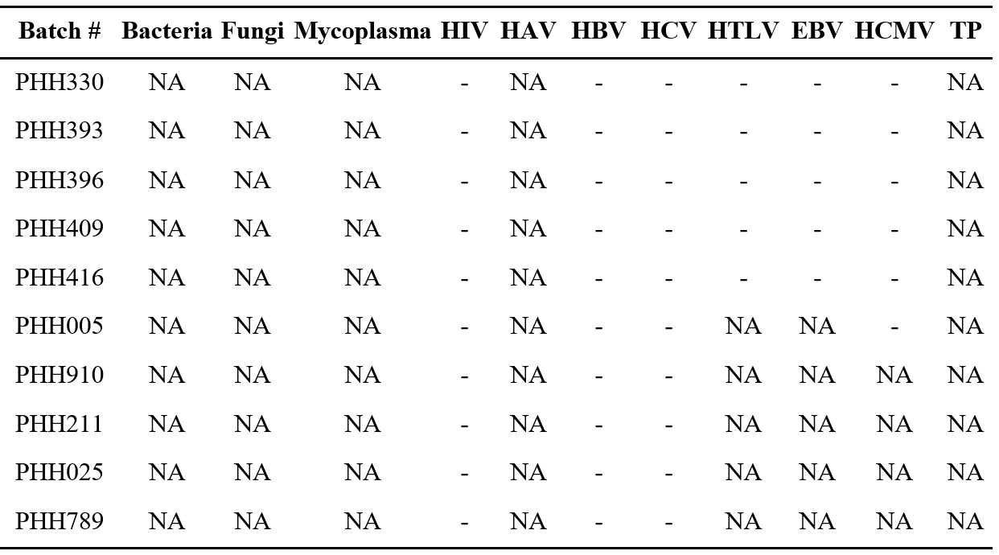
HIV: Human Immunodeficiency Virus;
HAV: Hepatitis A Virus;
HBV: Hepatitis B Virus;
HCV: Hepatitis C Virus;
HTLV: Human T-lymphotropic Virus;
EBV: Epstein-Barr Virus;
HCMV: Human Cytomegalovirus;
TP: Treponema Pallidum;
-: not detected;
NA: not applicable.

Table S2. Percentage of ALB⁺ or HNF4A⁺ cells in PHHs by flow cytometry
 | PHH330 | PHH409 | PHH416 | PHH211 | PHH025 | PHH789
ALB⁺ (%) | 72.2 | 94.9 | 95.4 | 49.4 | 98.0 | 98.9
HNF4A⁺ (%) | 49.4 | 91.4 | 90.9 | 37.7 | 78.5 | 70.2

Table S3. Normalized secreted ALB by ELISA (ng/24 hr/10⁶ cells)
 | PHH330 | PHH409 | PHH416 | PHH211 | PHH025 | PHH789
Mean ± SD | 762.7 ± 174.1 | 6957.7 ± 2440.5 | 4076.1 ± 422.5 | 2358.7 ± 742.6 | 4122.0 ± 955.2 | 2792.5 ± 774.9
SD, standard deviation; n=3.

Table S4. Substrate clearance rates dependent on CYP450 enzymes in six PHHs (μL//hr/10⁶ cells)
Enzyme | Substrate  (Concentration µM) | PHH330 | PHH409 | PHH416 | PHH211 | PHH025 | PHH789
CYP1A2 | Phenacetin (1.0) | 92.5 ± 23.2 | 117.5 ± 7.0 | 0.0 | 208.8 ± 14.1 | 72.4 ± 26.0 | 112.3 ± 22.4
CYP2B6 | Bupropion (1.0) | 146.8 ± 24.3 | 185.9 ± 24.1 | 200.2 ± 32.8 | 286.6 ± 17.8 | 370.6 ± 19.9 | 476.8 ± 48.2
CYP2C9 | Diclofenac (1.0) | 78.6 ± 18.9 | 162.7 ± 15.1 | 236.5 ± 17.5 | 170.7 ± 8.0 | 86.1 ± 19.9 | 246.7 ± 10.4
CYP2C19 | Mephenytoin (1.0) | 0.0 | 0.0 | 0.0 | 34.8 ± 8.6 | 48.4 ± 2.8 | 255.1 ± 64.6
CYP2D6 | Dextromethorphan (1.0) | 72.1 ± 46.7 | 273.8 ± 41.0 | 566.6 ± 21.7 | 238.4 ± 18.0 | 437.6 ± 14.4 | 902.9 ± 125.6
CYP3A4 | Testosterone (1.0) | 970.6 ± 134.4 | 1377.8 ± 58.4 | 1127.9 ± 16.4 | 1354.0 ± 67.0 | 802.7 ± 70.8 | 1981.0 ± 314.7
Data: mean ± standard deviation; n=3.

Table S5. Metabolite formation rates dependent on CYP450 enzymes in six PHHs (pmol/hr/10⁶ cells)
Enzyme | Metabolite | PHH330 | PHH409 | PHH416 | PHH211 | PHH025 | PHH789
CYP1A2 | 4-Acetamidophenol | 74.2 ± 6.4 | 353.0 ± 14.2 | 33.9 ± 5.6 | 317.0 ± 41.8 | 0.0 | 152.2 ± 2.8
CYP2B6 | 4-Hydroxybupropion | 769.5 ± 174.4 | 370.7 ± 41.8 | 236.4 ± 11.6 | 431.4 ± 37.8 | 26.7 ± 0.6 | 485.2 ± 19.3
CYP2C9 | 4'-Hydroxydiclofenac | 102.7 ± 17.7 | 433.2 ± 43.3 | 129.9 ± 5.9 | 137.0 ± 7.4 | 0.0 | 744.7 ± 50.4
CYP2C19 | 4-Hydroxymephenytoin | 0.0 | 0.0 | 15.2 ± 0.1 | 32.7 ± 8.4 | 0.0 | 211.7 ± 16.4
CYP2D6 | Dextrorphan | 67.7 ± 6.3 | 398.2 ± 3.7 | 849.9 ± 46.9 | 478.2 ± 33.7 | 197.8 ± 20.3 | 330.0 ± 2.8
CYP3A4 | 6β-hydroxytestosterone | 2008.6 ± 147.9 | 420.5 ± 45.6 | 234.8 ± 38.3 | 479.2 ± 54.1 | 0.0 | 985.8 ± 21.3
Data: mean ± standard deviation; n=3.

Table S6. Detection parameters in LC-MS for CYP450-related drug-metabolizing function and bile secretion index
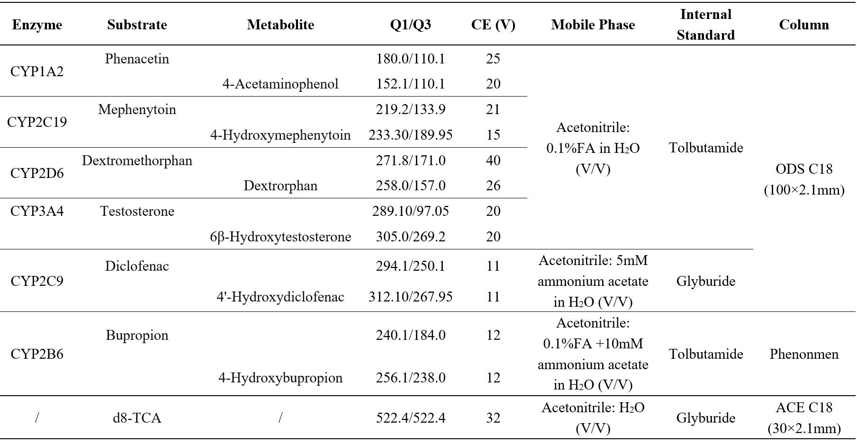

Table S7. Bile secretion index (BEI) in PHHs by LC-MS
 | PHH393 | PHH396 | PHH416 | PHH005 | PHH910
BEI (%) | 27.2 | 27.5 | 25.7 | 62.0 | 59.0

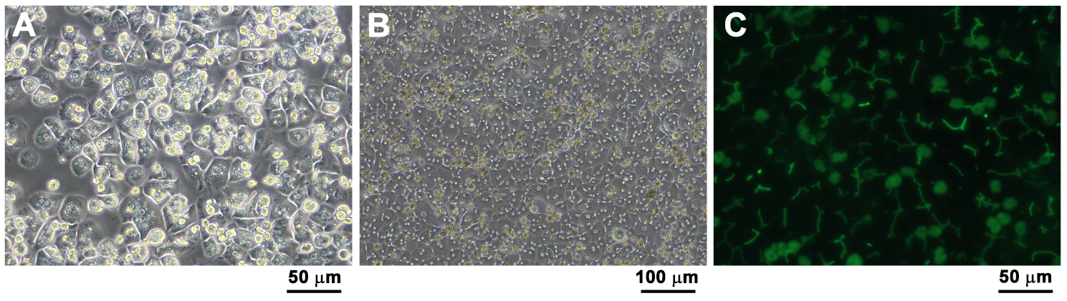
Fig. S1 Representative graphs of PHHs (Batch: PHH005). A Photograph of PHHs four hours after plating in 2D-culture condition. B Photograph of PHHs five days after plating in sandwich-culture condition. C The formation of bile canaliculi networks in polarized hepatocytes were visualized by fluorescence from CDFDA (5-(and-6)-carboxy-2′, 7′-dichlorofluorescein diacetate).

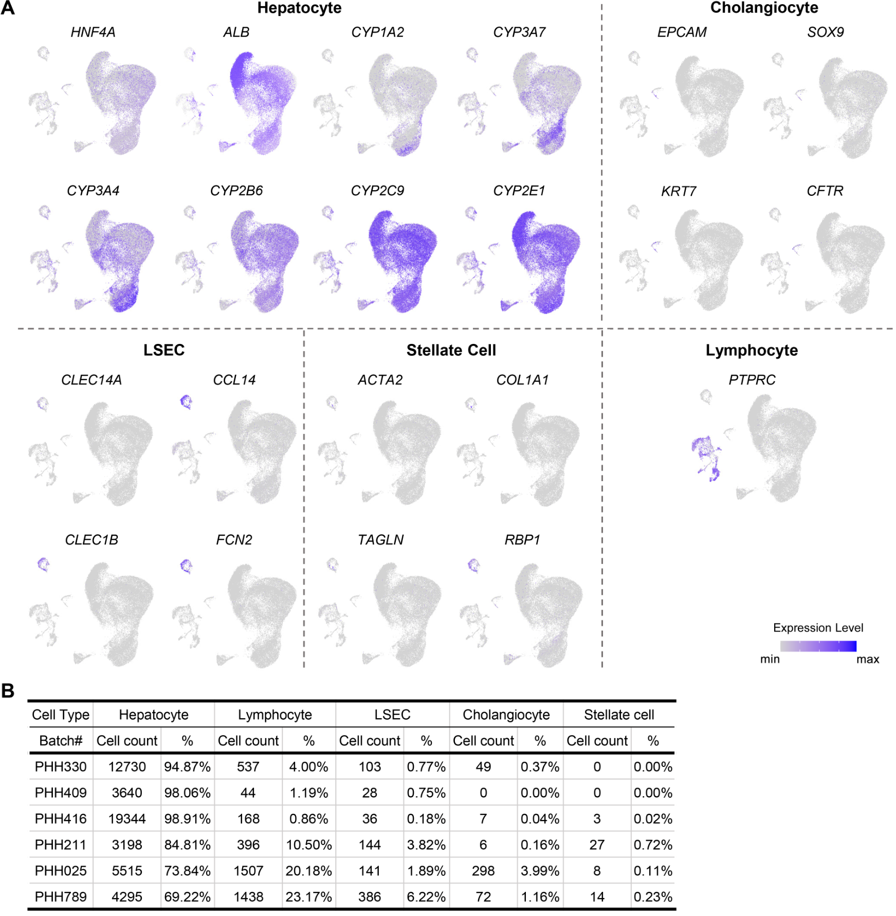
Fig. S2 Identification and distribution of different cell types in six PHHs. A Dot plots showing the expression levels of indicated marker genes for different cell types in UMAP clustering. B Cell counts and proportions of different cell types in six PHHs.

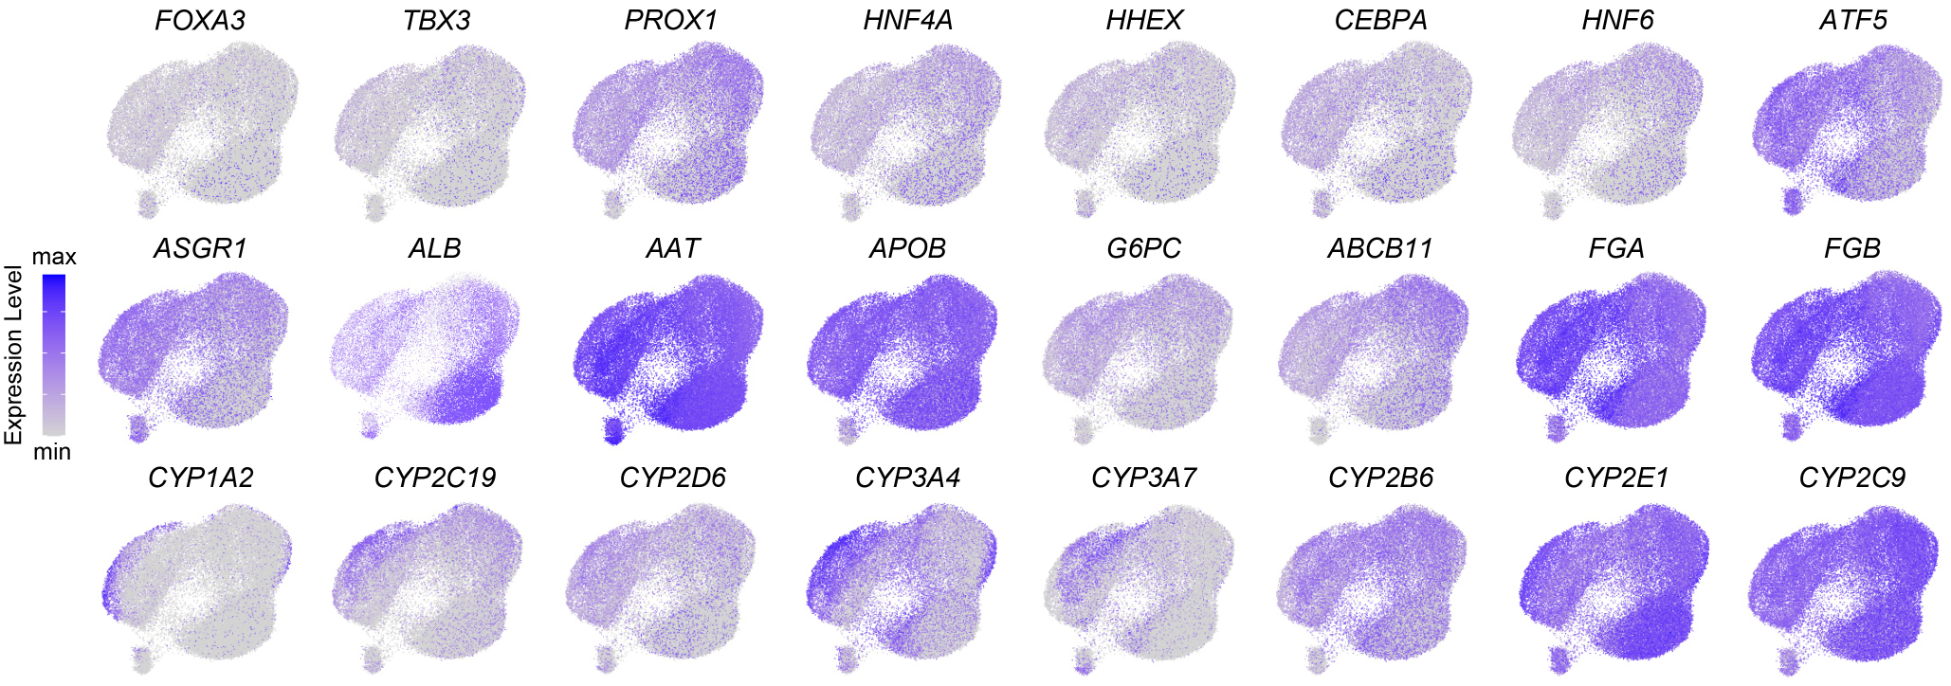
Fig. S3 Dot plots showing the expression levels of hepatic marker genes for hepatocyte population in UMAP clustering.

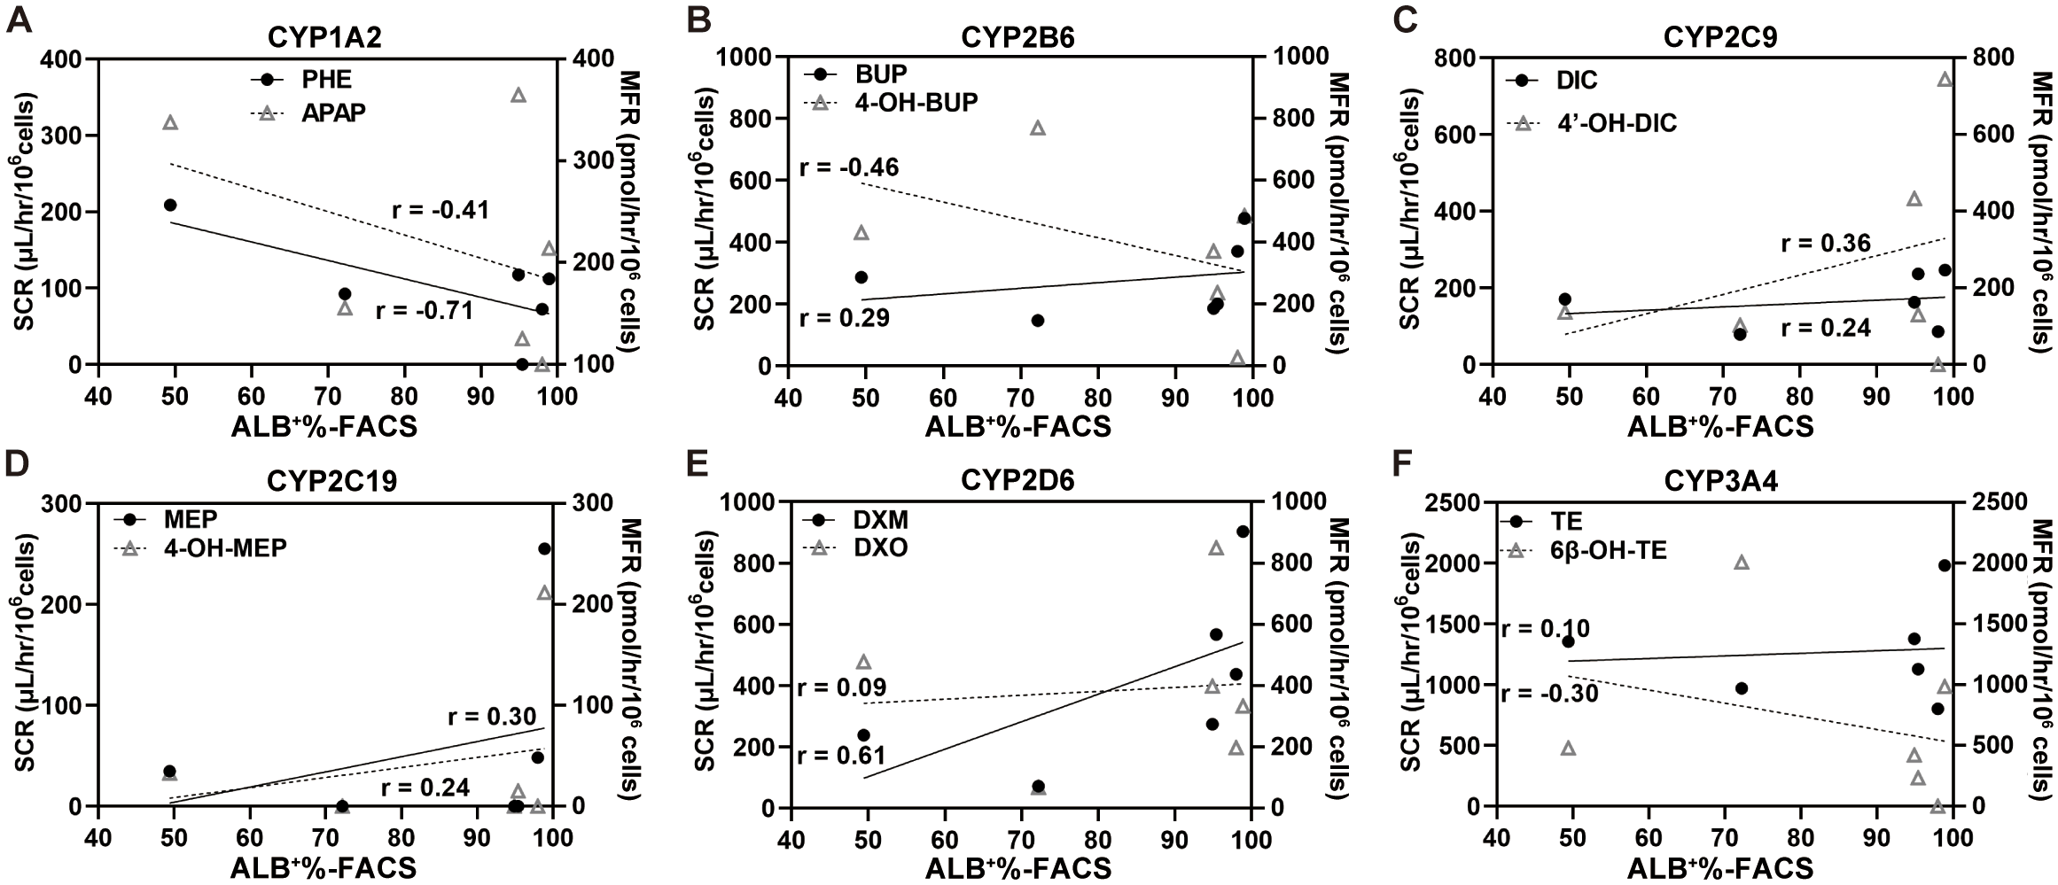
Fig. S4 Correlations between ALB⁺% by FACS and the corresponding substrate clearance rates (SCR; solid dot or solid line) or metabolite formation rates (MFR; hollow triangle or dotted line) in six PHHs. r, Pearson correlation coefficient.

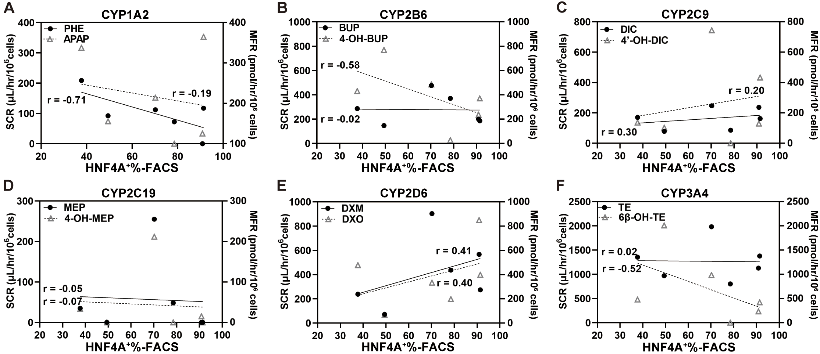
Fig. S5 Correlations between HNF4A⁺% by FACS and the corresponding substrate clearance rates (SCR; solid dot or solid line) or metabolite formation rates (MFR; hollow triangle or dotted line) in six PHHs. r, Pearson correlation coefficient.

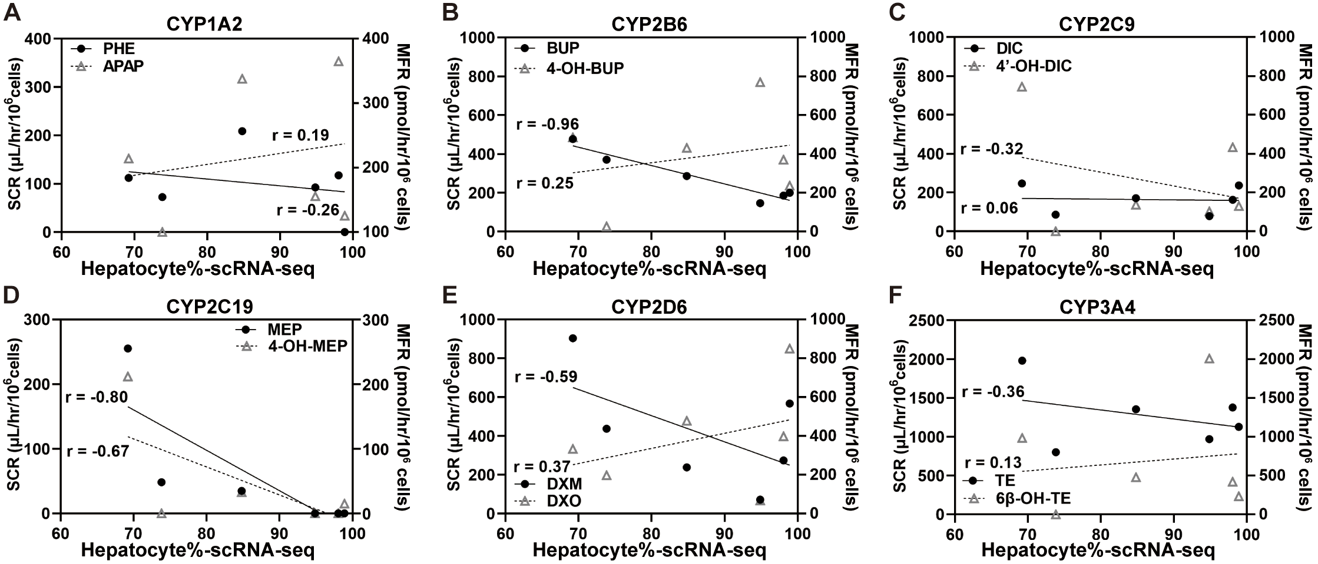
Fig. S6 Correlations between hepatocyte% by scRNA-seq and the corresponding substrate clearance rates (SCR; solid dot or solid line) or metabolite formation rates (MFR; hollow triangle or dotted line) in six PHHs. r, Pearson correlation coefficient.

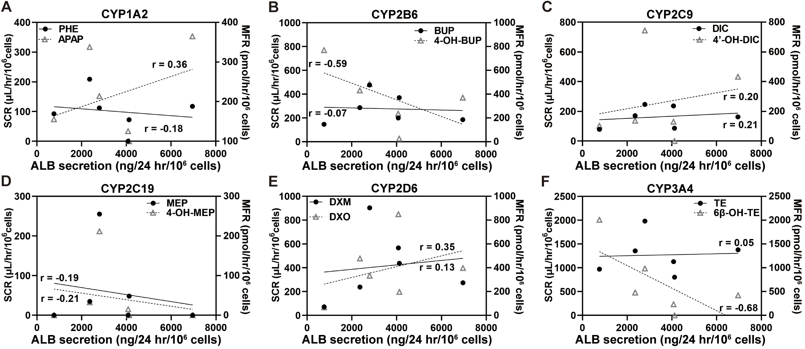
Fig. S7 Correlations between secreted ALB level by ELISA and the corresponding substrate clearance rates (SCR; solid dot or solid line) or metabolite formation rates (MFR; hollow triangle or dotted line) in six PHHs. r, Pearson correlation coefficient.

