Additional File 1 / Appendix 1: Stakeholder Maps
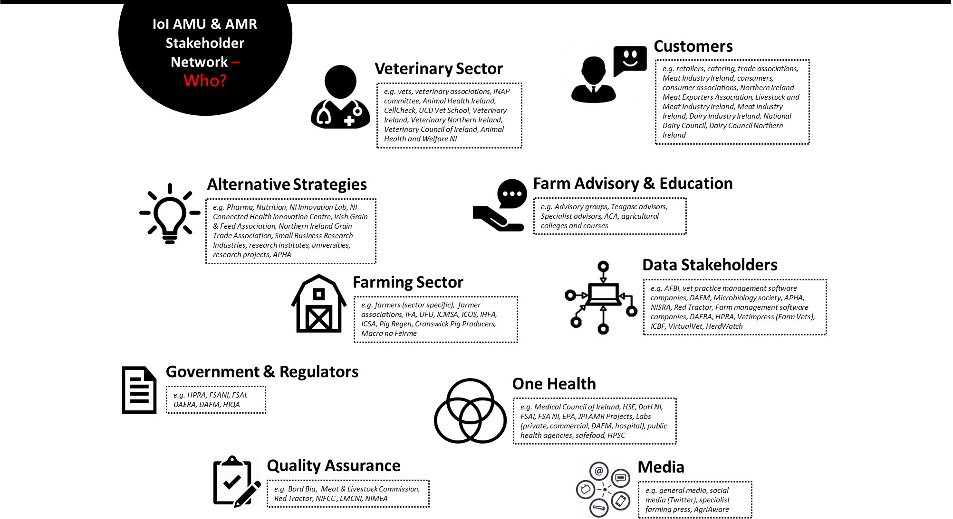
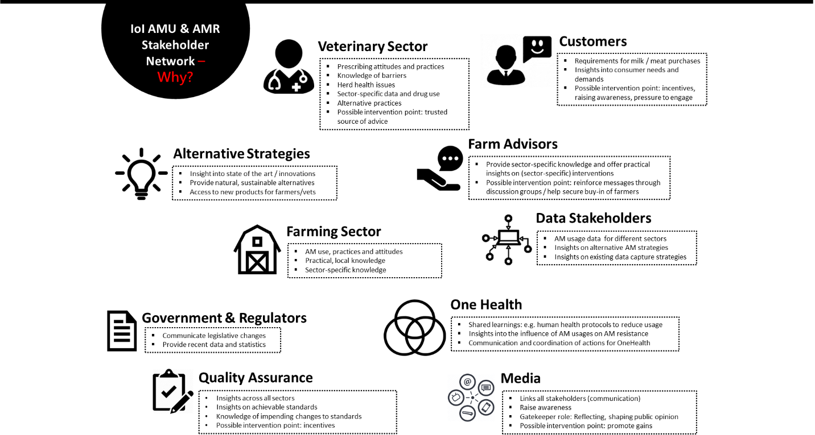
Figure A1: Stakeholder Maps produced through participatory workshops identifying relevant stakeholders interested in AMU and AMR on the island of Ireland

