Supplementary material
Table S1 – Summary statistics of the time interval (in days) between assessments in the same farms
Time interval between assessments | Minimum | Median | Mean | Maximum
First to second | 60 | 444 | 550.2 | 1599
Second to third | 122 | 381 | 426.4 | 937
Third to fourth | 134 | 357 | 373.6 | 827
Fourth to fifth | 184 | 328 | 346.5 | 607
Fifth to sixth | 184 | 184 | 184 | 184
All time intervals – all farms | 60 | 388 | 473.2 | 1599
All time intervals – cohort of 183 farms | 98 | 384 | 473.5 | 1485

Table S2 – Summary of the mean differences and Turkey post hoc p value (p) of the combined scores over the years Year comparison | External |  | Internal |  | Overall
 | Mean difference | p | Mean difference | p | Mean difference | p
2020-2019 | 5.15 | <0.0001 | 8.00 | 0.001 | 6.60 | <0.0001
2021-2019 | 5.98 | <0.0001 | 8.22 | 0.0004 | 7.14 | <0.0001
2022-2019 | 6.97 | <0.0001 | 9.51 | <0.0001 | 8.24 | <0.0001
2023-2019 | 7.30 | <0.0001 | 10.28 | <0.0001 | 8.82 | <0.0001
2021-2020 | 0.83 | 0.825 | 0.22 | 0.999 | 0.55 | 0.987
2022-2020 | 1.82 | 0.073 | 1.51 | 0.869 | 1.64 | 0.444
2023-2020 | 2.15 | 0.022 | 2.28 | 0.607 | 2.22 | 0.164
2022-2021 | 0.99 | 0.580 | 1.30 | 0.908 | 1.09 | 0.765
2023-2021 | 1.32 | 0.300 | 2.06 | 0.655 | 1.67 | 0.391
2023-2022 | 0.33 | 0.979 | 0.76 | 0.977 | 0.58 | 0.952

Table S3 – Summary statistics of the biosecurity scores for all farms assessed in 2023 (268 farms)
Biosecurity subcategory | Minimum | Q1 | Median score | Mean | Q3 | Maximum
Internal
A. Disease management | 0 | 80 | 100 | 86 | 100 | 100
B. Farrowing unit and suckling period | 21 | 50 | 64 | 63 | 79 | 100
C. Nursery unit | 21 | 57 | 71 | 66 | 71 | 100
D. Fattening unit | 0 | 57 | 79 | 75 | 93 | 100
E. Measures between compartments and the use of equipment | 18 | 46 | 57 | 62 | 71 | 100
F. Cleaning and disinfection | 0 | 45 | 65 | 63 | 95 | 100
External
A. Purchase of animals and semen | 0 | 92 | 100 | 94 | 100 | 100
B. Transport of animals, removal of manure/dead animals | 43 | 81 | 86 | 86 | 90 | 100
C. Feed, water and equipment supply | 17 | 40 | 53 | 53 | 57 | 100
D. Personnel and visitors | 12 | 65 | 76 | 78 | 94 | 100
E. Vermin and bird control | 20 | 70 | 90 | 84 | 100 | 100
F. Environment and region | 30 | 100 | 100 | 93 | 100 | 100

Table S4 – Median of the biosecurity scores for all farms assessed during the study period per farm type
Year of assessment | Biosecurity | Finisher farms | Farrow-to-finisher farms | Farrow-to-weaner farms | Weaner-to-finisher farms
2018 | Overall | 68 | 62.5 | 75 | -
2018 | External | 70.5 | 75 | 75 | -
2018 | Internal | 64.5 | 52 | 69 | -
2019 | Overall | 77 | 62.5 | 72 | 59
2019 | External | 74.5 | 75 | 81 | 69
2019 | Internal | 81.5 | 50 | 64 | 48
2020 | Overall | 76 | 71 | 75 | 71
2020 | External | 79 | 81 | 86 | 82
2020 | Internal | 76 | 61 | 66 | 64
2021 | Overall | 78 | 72 | 72.5 | 71
2021 | External | 82 | 81 | 83.5 | 81
2021 | Internal | 76 | 62 | 63 | 64
2022 | Overall | 76 | 74 | 74.5 | 70
2022 | External | 80 | 84 | 85 | 81
2022 | Internal | 71 | 65 | 66 | 64
2023 | Overall | 78 | 73.5 | 79 | 70
2023 | External | 81 | 84 | 83 | 79.5
2023 | Internal | 74 | 64 | 75 | 63.5

Table S5 – Median of the biosecurity scores for last three most assessments (presented in chronological order (A, B, C)) for the cohort of farms with at least three assessments during the study period per farm type
Assessment | Biosecurity | Finisher farms | Farrow-to-finisher farms | Farrow-to-weaner farms | Weaner-to-finisher farms
A | Overall | 75 | 70 | 74.5 | 70
A | External | 81 | 80 | 81 | 81
A | Internal | 74 | 60 | 65 | 64
B | Overall | 77.5 | 72 | 74.5 | 70
B | External | 81.5 | 84 | 82.5 | 82
B | Internal | 71.5 | 63 | 67 | 64
C | Overall | 79 | 73 | 78 | 71
C | External | 82 | 84 | 83 | 81
C | Internal | 77 | 62 | 74.5 | 66

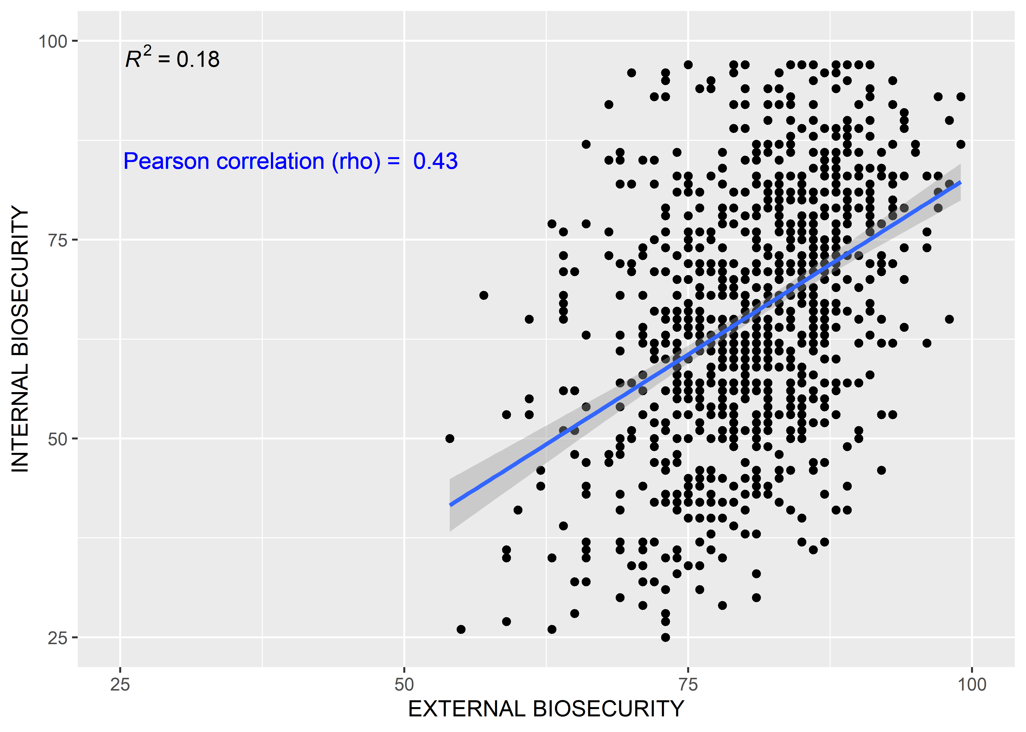
Figure S1: Distribution of the scores per farm for external and internal biosecurity for all biosecurity surveys for all 393 farms that were assessed at least once, including fitted line, coefficient of determination (R²) and correlation coefficient.

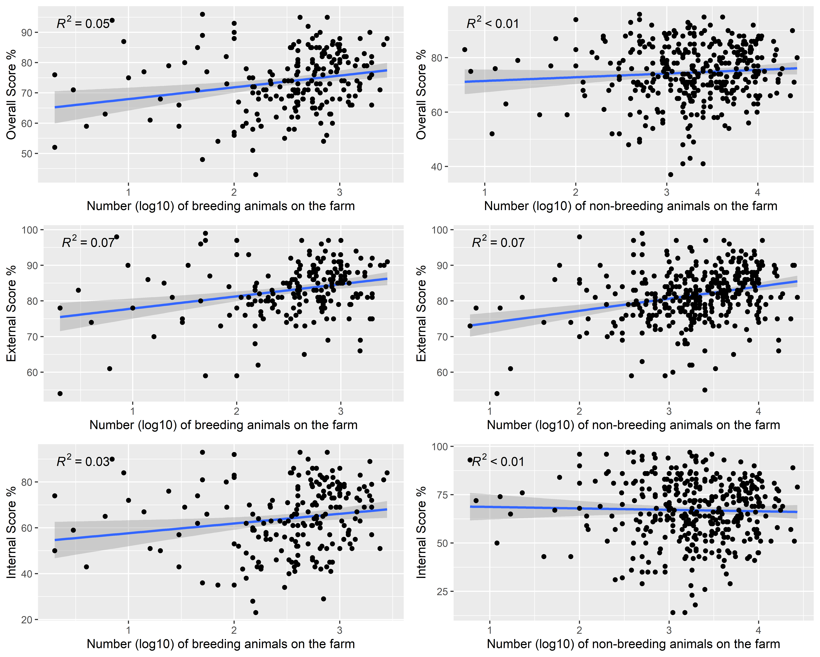
Figure S2: Biosecurity scores (overall (first row), external (second row) and internal (third row)) by size of the farm in log10 scale (breeding animals left panel, non-breeding animals right panel).

