Additional file 1 for:

Rheological Properties of Cells Measured by Optical Tweezers
Yareni A. Ayala^{1,2,§}, Bruno Pontes^{1,§}, Diney S. Ether^{1,2}, Luis B. Pires^{1,2}, Glauber R. de S. Araujo³, Susana Frases³, Luciana F. Romão⁴, Marcos Farina¹, Vivaldo Moura-Neto⁵, Nathan B. Viana^{1,2,*} and H. Moysés Nussenzveig^{1,2}

¹LPO-COPEA, Instituto de Ciências Biomédicas, Universidade Federal do Rio de Janeiro, RJ, 21941-902, Brazil.
²Instituto de Física, Universidade Federal do Rio de Janeiro, RJ, 21941-972, Brazil.
³Laboratório de Ultraestrutura Celular Hertha Meyer, Instituto de Biofisica Carlos Chagas Filho, Universidade Federal do Rio de Janeiro, RJ, 21941-902, Brazil.
⁴Universidade Federal do Rio de Janeiro – Pólo de Xerém, Duque de Caxias, RJ, 25245-390, Brazil.
⁵Instituto Estadual do Cérebro Paulo Niemeyer, Rio de Janeiro, RJ, 20231-092, Brazil.

* Corresponding author

§ Yareni Ayala and Bruno Pontes contributed equally to this work.

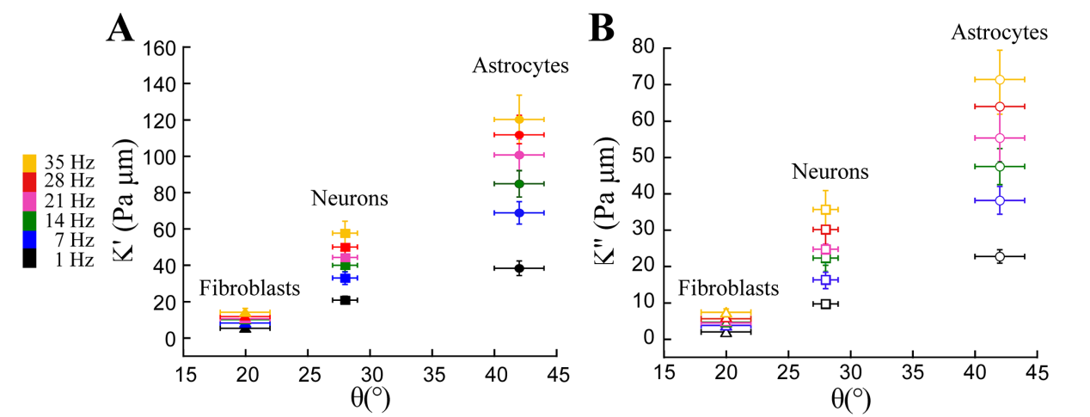
Figure S1: (A) Plot of $K^{'}$$K_{C}^{*}=K^{'}+iK^{''}$ values measured for fibroblasts, neurons, and astrocytes vs immersion angle θ for the different frequencies probed in this work. (B) Similar plot for $K^{''}$ values. All error bars represent the standard error of the means.

