Appendix 2
Risk of bias

Review authors’ judgements about each risk of bias item presented as percentages for all included studies.
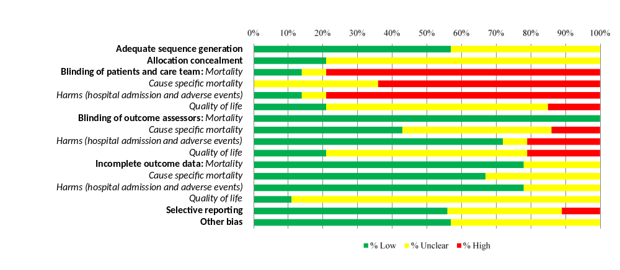
9/14 RCTs (RCTs that contributed aggregate data) were used to assess risk of bias from incomplete outcome data and selective outcome reporting. For all other risk of bias domains all 14 RCTs were used.

Review authors’ judgements about each risk of bias item presented for all the included studies

Study | Selection bias |  | Performance bias |  |  |  | Detection bias |  |  |  | Attrition bias |  |  |  | Reporting bias | Other bias
Study |  |  | Blinding of participants and personnel |  |  |  | Blinding of outcome assessment |  |  |  | Incomplete outcome data§ |  |  |  | Selective reporting§ | Other sources of bias
Study | Random sequence generation | Allocation concealment | All-cause mortality | Cause specific mortality* | Harms** | Quality of life | All-cause mortality | Cause specific mortality* | Harms** | Quality of life | All-cause mortality | Cause specific mortality* | Harms** | Quality of life | Selective reporting§ | Other sources of bias
Anguita [20] | Unclear | Unclear | High | High | High | Unclear | Low | High | High | Unclear | - | - | - | - | - | Low
Northstar [27] | Low | Unclear | High | High | High | High | Low | Low | Low | High | - | - | - | - | - | Unclear
Shochat [32]  Published as abstract only | Unclear | Unclear | Unclear | Unclear | Unclear | Unclear | Low | Unclear | Unclear | Unclear | - | - | - | - | - | Unclear
Starbrite [31] | Low | Low | High | Unclear | High | Unclear | Low | Unclear | High | Unclear | - | - | - | - | - | Low
Upstep [24] | Low | Unclear | High | High | High | Unclear | Low | Low | Low | Unclear | - | - | - | - | - | Unclear
Christchurch Pilot [29] | Unclear | Unclear | Low | Unclear | Low | Low | Low | Unclear | Low | Low | Low | Unclear | Low | Unclear | Unclear | Low
Time-CHF* [26, 33] | Low | Low | High | High | High | Low | Low | Low | Low | Low | Low | Low | Low | Unclear | Low | Low
Berger [21] | Low | Low | High | Unclear | High | Unclear | Low | Unclear | Low | Unclear | Unclear | Unclear | Unclear | Unclear | Unclear | Low
Prima [22] | Unclear | Unclear | High | High | High | Unclear | Low | Low | Low | High | Low | Low | Low | Unclear | Low | Low
Signal-HF [25] | Unclear | Unclear | High | High | High | Unclear | Low | High | High | Unclear | Low | Low | Low | Unclear | High | Unclear
Battlescarred [28] | Low | Unclear | Low | Unclear | Low | Low | Low | Unclear | Low | Low | Unclear | Unclear | Unclear | Unclear | Low | Low
Stars-BNP [23] | Unclear | Unclear | High | High | High | Unclear | Low | Unclear | Low | Unclear | Low | Low | Low | Unclear | Unclear | Unclear
Protect [30] | Low | Unclear | High | High | High | High | Low | Low | Low | High | Low | Low | Low | Low | Low | Unclear
Guide-IT [11] | Low | Unclear | High | High | High | Unclear | Low | Low | Low | Unclear | Low | Low | Low | Unclear | Low | Low
§ Only trials that provided aggregate data were assessed for risk of bias from incomplete outcome data and selective outcome reporting
*Death related to HF and death from any cardiovascular cause **All-cause hospital admission, hospital admission for HF, other serious adverse events

