Additional file 5. Sensitivity Analyses

Sensitivity Analysis for Gestational Age in Studies Evaluating CRP in the Diagnosis of HCA/Funisitis.

All included studies

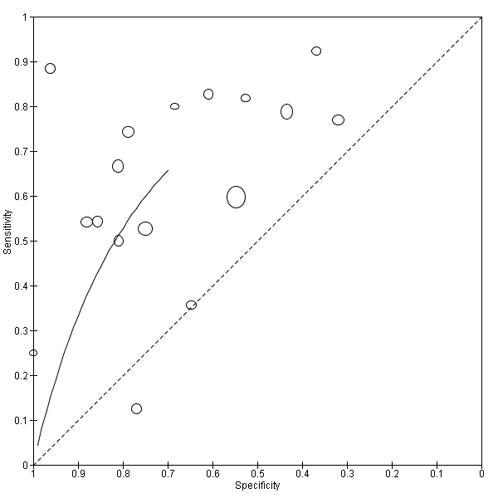

Studies without early (<24 weeks) gestations.
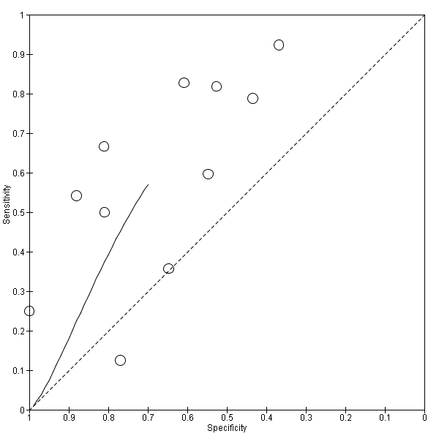

Sensitivity Analysis for Applicability Concerns in Patient Selection in Studies Evaluating CRP in the Diagnosis of HCA/Funisitis.

All included studies

Studies with low applicability concerns in patient selection.
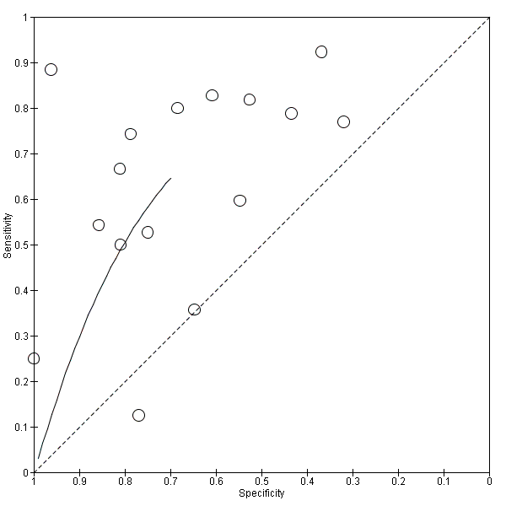

Sensitivity Analysis for Year of Publication in Studies Evaluating CRP in the Diagnosis of HCA/Funisitis.

All included studies
Studies published within 20 years of the review search date. 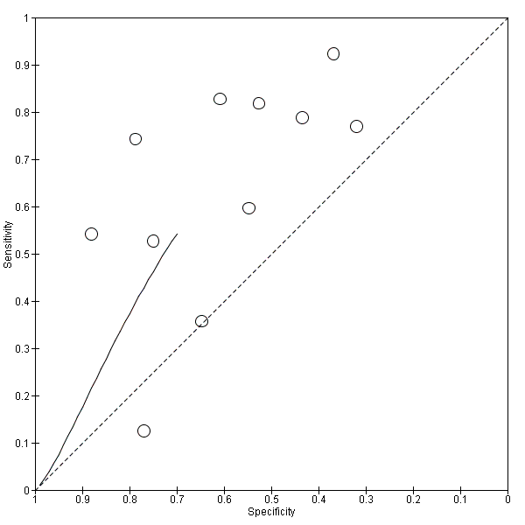

Sensitivity Analysis for Gestational Age in Studies Evaluating PCT in the Diagnosis of HCA/Funisitis.

All included studies

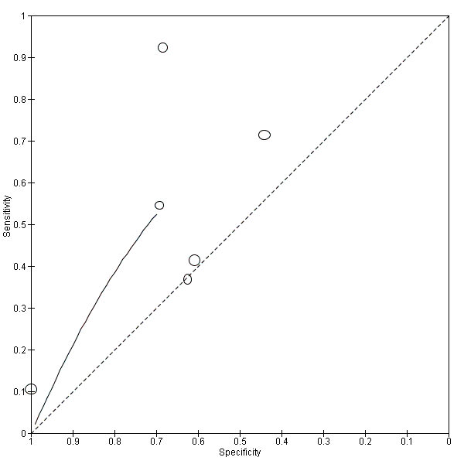

Studies without early (<24 weeks) gestations.
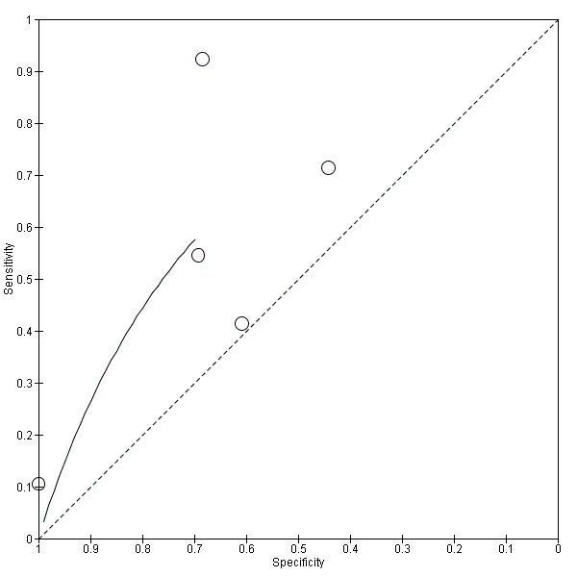

Sensitivity Analysis for Applicability Concerns in Patient Selection in Studies Evaluating PCT in the Diagnosis of HCA/Funisitis.

All Included Studies

Studies with low applicability concernsin Patient selection
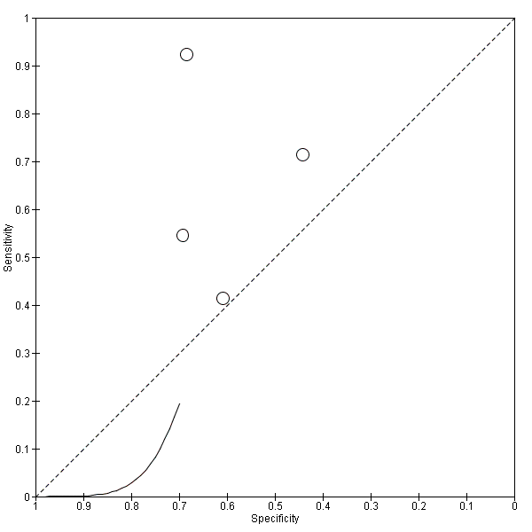

Sensitivity Analysis for Gestational Age in Studies Evaluating IL6 in the Diagnosis of HCA/Funisitis.

All Included Studies

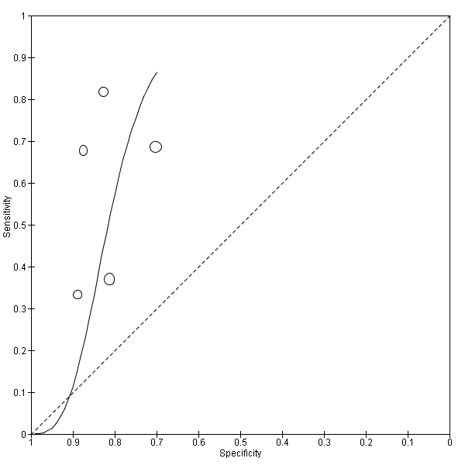

Studies without early (<24 weeks) gestations.
