Additional file 4. Heterogeneity Assessments
- Heterogeneity Assessments for Index Test C-Reactive Protein
  - Assay type
Standardisation for CRP assays which was first performed in 1993¹³² was taken as the proxy for CRP assays before standardisation and after standardisation. The -2 log likelihoods of the 2 plots were compared with the ᵪ² test yielding a p value of <0.001.

SROC Plots Comparing Studies Evaluating CRP in the Diagnosis of HCA and/or Funisitis, Subgroups: Assays Performed Before and After 1993.
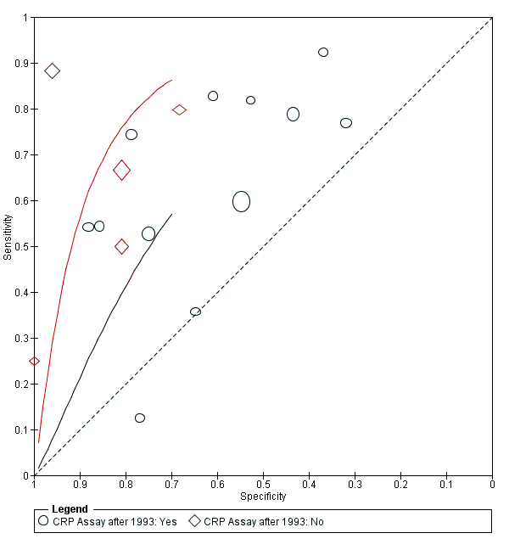

  - Pre-specified cut-off
Studies were grouped according to whether the cut-off used was pre-specified or whether it was determined from the study data. The -2 log likelihoods of the 2 plots were compared with the ᵪ² test, p=0.003, indicating evidence for a difference in the two plots.

SROC Plots Comparing Studies Evaluating CRP in the Diagnosis of HCA and/or Funisitis, Subgroups: Pre-specified cut-off or not.
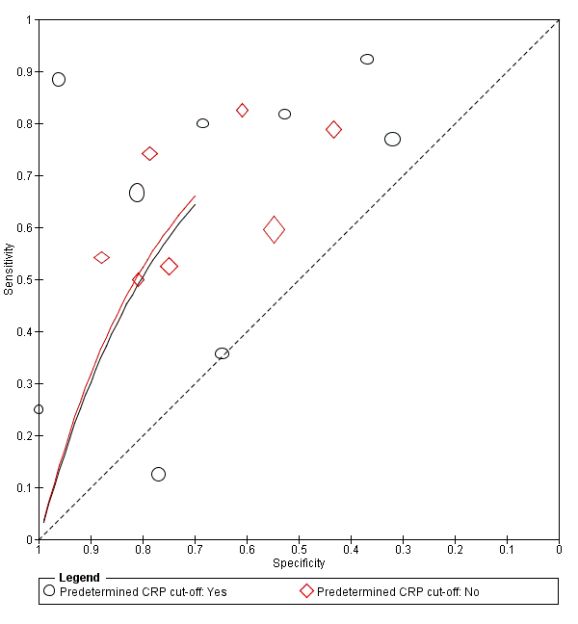

  - Interval from sampling to delivery
Studies were grouped according to sampling time with an interval of 72hours between sampling and delivery as the cut-off. The -2 log likelihoods of the 2 plots were compared with the ᵪ² test. P<0.001 indicating that the 2 plots are different.

SROC Plots comparing Studies Evaluating CRP in the Diagnosis of HCA and/or Funisitis, Subgroups: Appropriate Sample Interval* or Not
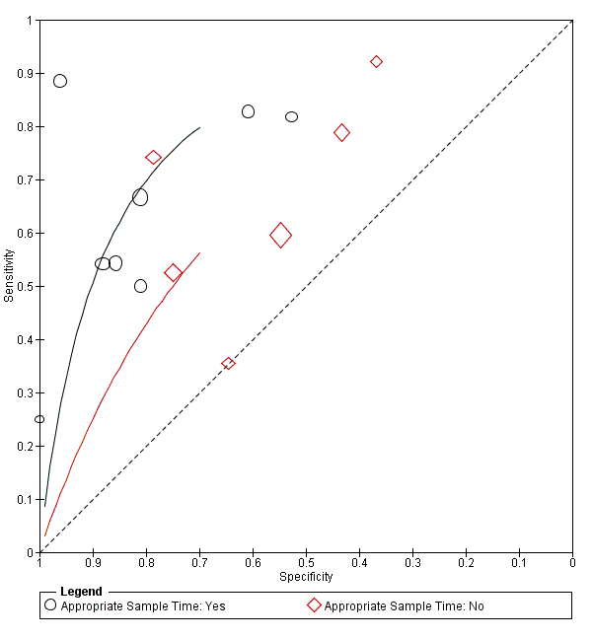

*Appropriate sample time - ≤72hours

  - Risk of Bias in Patient Selection
The judgements on risk of bias in the patient selection domain of the QUADAS-2¹⁰² tool were used to classify studies into 2 subgroups: high risk and low risk. The -2 log likelihoods of the 2 plots were compared with the ᵪ² test. P<0.001 indicating evidence for a difference in the 2 plots.

SROC Plots comparing Studies Evaluating CRP in the Diagnosis of HCA and/or Funisitis, Subgroups: Low Risk and High Risk of Bias in the Patient Selection Domain
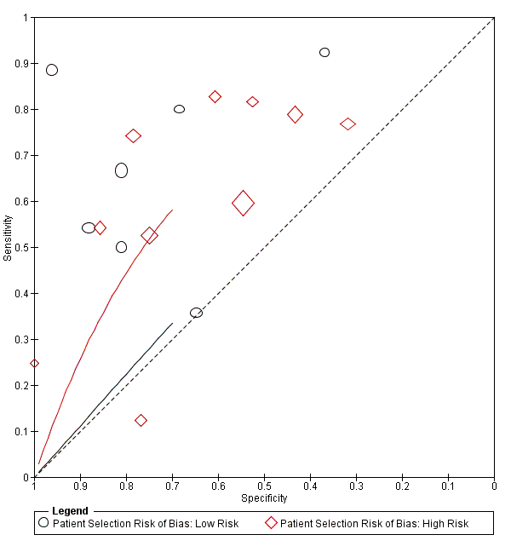
- Heterogeneity Assessments for Index Test Procalcitonin
  - Pre-specified cut-off
Studies were grouped according to whether the cut-off used was pre-specified or whether it was determined from the study data. The -2 log likelihoods of the 2 plots were compared with the ᵪ² test, p=0.026, indicating evidence for a difference in the two plots.

SROC Plots Comparing Studies Evaluating PCT in the Diagnosis of HCA and/or Funisitis, Subgroups: Pre-specified cut-off or not.
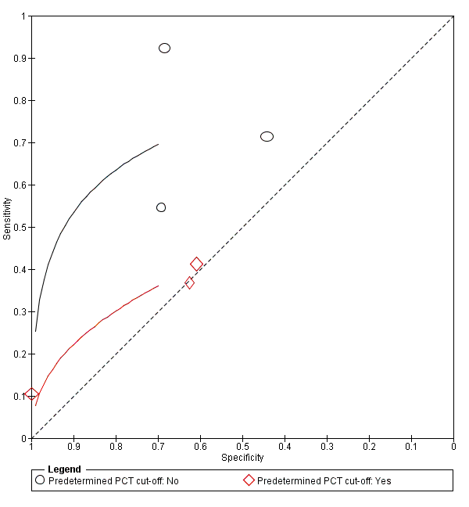

  - Interval from sampling to delivery
Studies were grouped according to sampling time with an interval of 72hours between sampling and delivery as the cut-off. The -2 log likelihoods of the 2 plots were compared with the ᵪ² test. P=0.178 indicating no evidence that the 2 plots are different.

SROC Plots comparing Studies Evaluating PCT in the Diagnosis of HCA and/or Funisitis, Subgroups: Appropriate Sample Interval* or Not
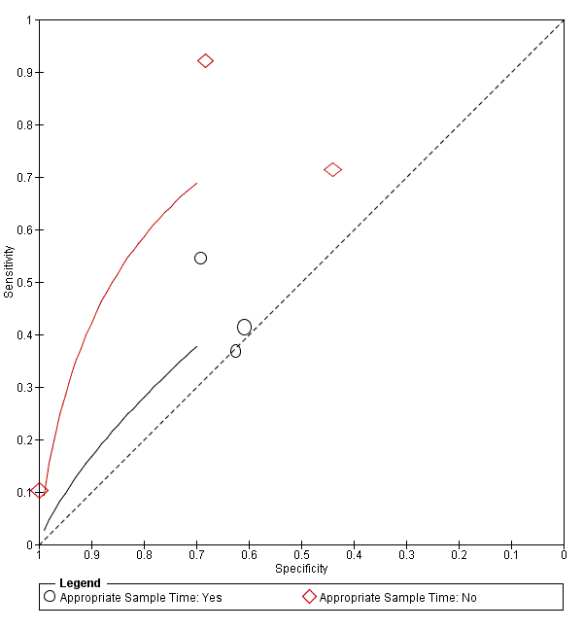

*Appropriate sample time - ≤72hours

  - Risk of Bias in Patient Selection
The judgements on risk of bias in the patient selection domain of the QUADAS-2¹⁰² tool were used to classify studies into 2 subgroups: high risk and low risk. The -2 log likelihoods of the 2 plots were compared with the ᵪ² test. P<0.001 indicating evidence for a difference in the 2 plots.

SROC Plots comparing Studies Evaluating PCT in the Diagnosis of HCA and/or Funisitis, Subgroups: Low Risk and High Risk of Bias in the Patient Selection Domain
- Heterogeneity Assessments for Index Test Interleukin 6
  - Predetermined cut-off

This was not assessed as one of the subgroups (Predetermined cut-off =Yes) had only 1 study.
  - Interval from sampling to delivery
Studies were grouped according to sampling time with an interval of 72hours between sampling and delivery as the cut-off. The -2 log likelihoods of the 2 plots were compared with the ᵪ² test. P<0.001 indicating evidence that the 2 plots are different.

SROC Plots comparing Studies Evaluating IL6 in the Diagnosis of HCA and/or Funisitis, Subgroups: Appropriate Sample Interval* or Not
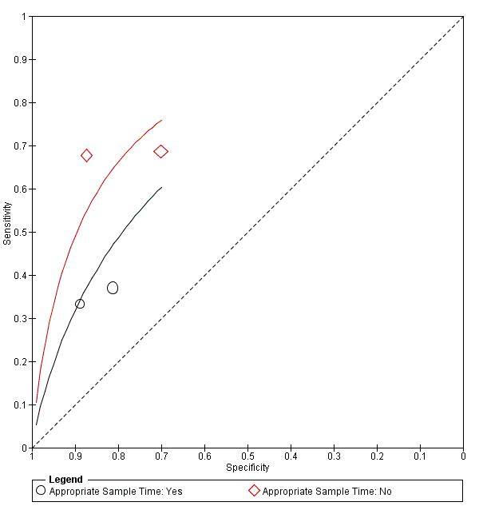
*Appropriate sample time - ≤72hours
  - Risk of Bias in Patient Selection

This was not assessed as one of the subgroups (Risk of bias =High) had only 1 study.

