Supplemental Figure 1.
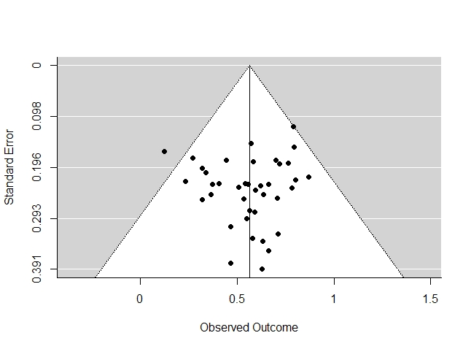
Effect Sizes for Mean Proportions of Opioids Leftover
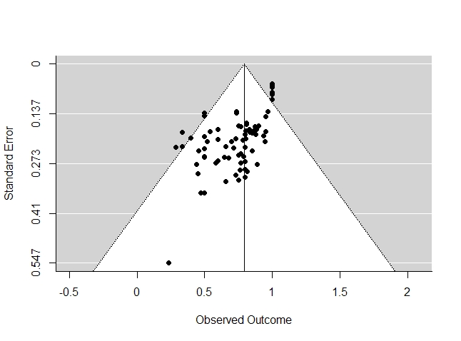
Effect Sizes for Median Proportions of Opioids Leftover

