Additional File 5
Risk of Bias Assessment
Table 8

JBI Critical Appraisal Checklist for Case Series
JBI checklist questions | Ferrari et al. 2011  (82) | Prechtl et al. 1993 (84) | %
Were there clear criteria for inclusion in the case series? | Yes | Uncertain | 50.0
Was the condition measured in a standard, reliable way for all participants included in the case series? | Uncertain | Uncertain | 0.0
Were valid methods used for identification of the condition for all participants included in the case series? | Yes | Yes | 100.0
Did the case series have consecutive inclusion of participants? | Uncertain | Uncertain | 0.0
Did the case series have complete inclusion of participants? | Uncertain | Uncertain | 0.0
Was there clear reporting of the demographics of the participants in the study? | Yes | Yes | 100.0
Was there clear reporting of clinical information of the participants? | Yes | Yes | 100.0
Were the outcomes or follow up results of cases clearly reported? | Yes | Yes | 100.0
Was there clear reporting of the presenting site(s)/clinic(s) demographic information? | Yes | Yes | 100.0
Was statistical analysis appropriate? | Yes | Yes | 100.0

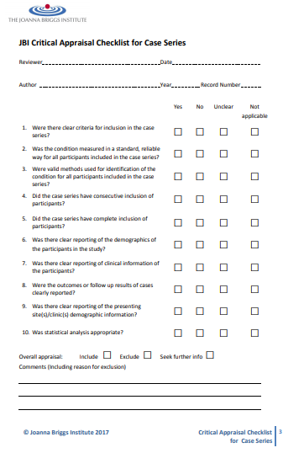
Table 9

JBI Critical Appraisal Checklist for Cohort Studies
JBI checklist questions | Glass et al. 2011  (83) |  | %
Were the two groups similar and recruited from the same population? | Yes |  | 100.0
Were the exposures measured similarly to assign people to both exposed and  unexposed groups? | Yes |  | 100.0
Was the exposure measured in a valid and reliable way? | Yes |  | 100.0
Were confounding factors identified? | Yes |  | 100.0
Were strategies to deal with confounding factors stated? | Yes |  | 100.0
Were the groups/participants free of the outcome at the start of the study (or at the  moment of exposure)? | Yes |  | 100.0
Were the outcomes measured in a valid and reliable way? | Yes |  | 100.0
Was the follow up time reported and sufficient to be long enough for outcomes to occur? | Yes |  | 100.0
Was follow up complete, and if not, were the reasons to loss to follow up described  and explored?  Were strategies to address incomplete follow up utilized? | Yes  Unclear |  | 100.0  50.0
Was statistical analysis appropriate? | Yes |  | 100.0

