Gender:
proportion 95%-CI %W(fixed) %W(random) gender
Cappucio et al. 2004 0.2987 [0.2534; 0.3471] 1.8 3.2 male
Escalona et al. 2004 0.2763 [0.2225; 0.3353] 1.1 3.1 male
Addo et al. 2006 0.2430 [0.1653; 0.3354] 0.4 2.8 male
Burket 2006 0.3939 [0.2758; 0.5219] 0.3 2.7 male
Agyeman et al. 2006 0.3012 [0.2660; 0.3383] 3.0 3.3 male
Addo et al. 2009 0.3171 [0.2804; 0.3555] 2.9 3.3 male
Koopman 2012 0.2562 [0.2178; 0.2978] 2.0 3.3 male
Minicuci 2014 0.5149 [0.4945; 0.5353] 12.9 3.4 male
Awuah et al. 2014 0.3100 [0.2604; 0.3631] 1.5 3.2 male
Obirikorang et al. 2015 0.4615 [0.4052; 0.5186] 1.7 3.2 male
Osman 2017 0.5778 [0.4898; 0.6622] 0.7 3.0 male
Lamptey et al. 2017 0.3306 [0.2988; 0.3635] 4.1 3.3 male
Gomez-Olive et al. 2017 0.2410 [0.2136; 0.2700] 3.7 3.3 male
Dosoo et al. 2019 0.2735 [0.2462; 0.3022] 4.4 3.3 male
Anto et al. 2020 0.3871 [0.3453; 0.4302] 2.7 3.3 male
Cappucio et al. 2004 0.2803 [0.2454; 0.3172] 2.8 3.3 female
Escalona et al. 2004 0.2610 [0.2152; 0.3110] 1.4 3.2 female
Addo et al. 2006 0.2588 [0.2062; 0.3172] 1.1 3.1 female
Burket 2006 0.3077 [0.2475; 0.3731] 1.0 3.1 female
Agyeman et al. 2006 0.2795 [0.2484; 0.3123] 3.5 3.3 female
Hill et al. 2007 0.4021 [0.3756; 0.4290] 7.0 3.4 female
Addo et al. 2009 0.2800 [0.2365; 0.3268] 1.8 3.2 female
Koopman 2012 0.2252 [0.1872; 0.2670] 1.7 3.2 female
Minicuci 2014 0.5072 [0.4868; 0.5274] 13.1 3.4 female
Awuah et al. 2014 0.2571 [0.2142; 0.3039] 1.6 3.2 female
Obirikorang et al. 2015 0.2500 [0.2061; 0.2981] 1.5 3.2 female
Osman 2017 0.5245 [0.4625; 0.5860] 1.5 3.2 female
Lamptey et al. 2017 0.3202 [0.2966; 0.3445] 7.2 3.4 female
Gomez-Olive et al. 2017 0.2484 [0.2227; 0.2754] 4.4 3.3 female
Acheampong et al. 2019 0.3380 [0.2752; 0.4053] 1.1 3.1 female
Dosoo et al. 2019 0.2303 [0.2095; 0.2521] 6.0 3.4 female

Number of studies combined: k = 31

proportion 95%-CI
Fixed effect model 0.3535 [0.3469; 0.3601]
Random effects model 0.3219 [0.2853; 0.3608]

Quantifying heterogeneity:
tau^2 = 0.2288 [0.1131; 0.3590]; tau = 0.4784 [0.3363; 0.5991];
I^2 = 97.0% [96.4%; 97.5%]; H = 5.79 [5.28; 6.35]

Quantifying residual heterogeneity:
I^2 = 97.1% [96.5%; 97.6%]; H = 5.84 [5.32; 6.42]

Test of heterogeneity:
Q d.f. p-value
1006.02 30 < 0.0001

Results for subgroups (fixed effect model):
k proportion 95%-CI Q I^2
gender = male 15 0.3688 [0.3586; 0.3791] 425.94 96.7%
gender = female 16 0.3419 [0.3333; 0.3507] 564.73 97.3%

Test for subgroup differences (fixed effect model):
Q d.f. p-value
Between groups 15.34 1 < 0.0001
Within groups 990.67 29 < 0.0001

Results for subgroups (random effects model):
k proportion 95%-CI tau^2 tau
gender = male 15 0.3399 [0.2848; 0.3996] 0.2414 0.4913
gender = female 16 0.3058 [0.2562; 0.3604] 0.2411 0.4910

Test for subgroup differences (random effects model):
Q d.f. p-value
Between groups 0.74 1 0.3902

Details on meta-analytical method:
- Inverse variance method
- DerSimonian-Laird estimator for tau^2
- Jackson method for confidence interval of tau^2 and tau
- Logit transformation
- Clopper-Pearson confidence interval for individual studies

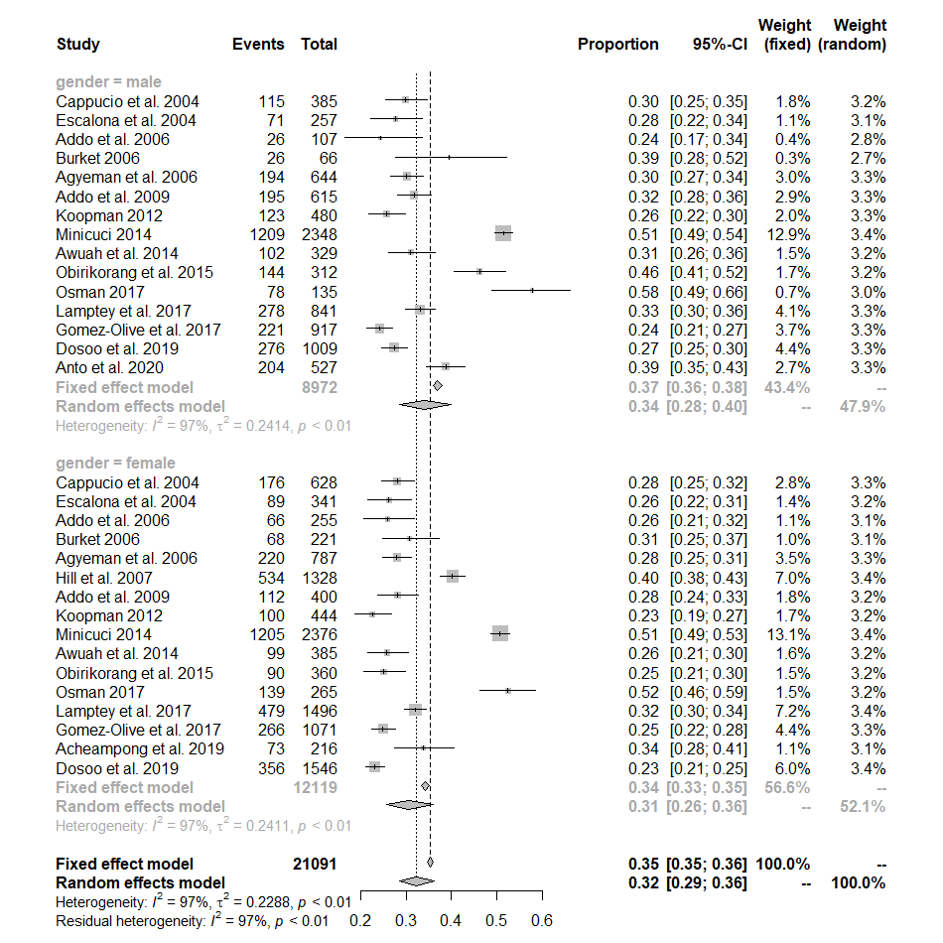

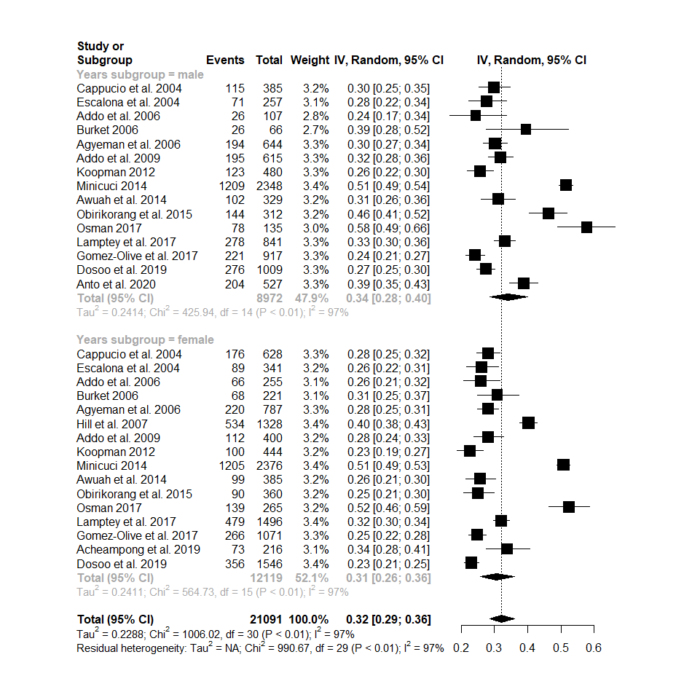

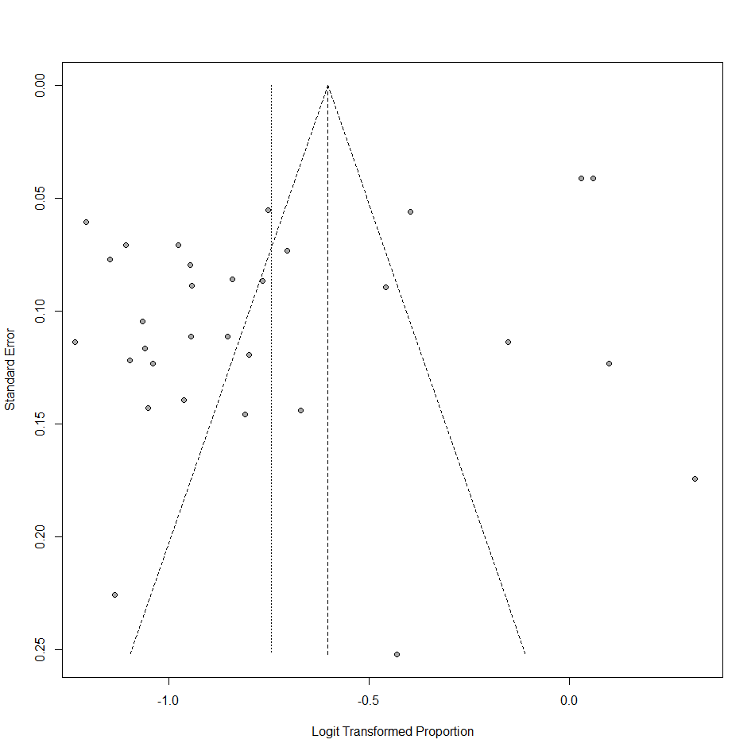

Population:
proportion 95%-CI %W(fixed) %W(random) population
Cappucio et al. 2004 0.2873 [0.2596; 0.3162] 3.2 4.2 mixed
Escalona et al. 2004 0.2676 [0.2325; 0.3050] 1.8 4.2 urban
Addo et al. 2006 0.2541 [0.2101; 0.3023] 1.1 4.1 rural
Burket 2006 0.3275 [0.2735; 0.3851] 1.0 4.1 rural
Agyeman et al. 2006 0.2942 [0.2707; 0.3186] 4.6 4.2 mixed
Hill et al. 2007 0.4021 [0.3756; 0.4290] 4.9 4.3 urban
Addo et al. 2009 0.3025 [0.2743; 0.3318] 3.3 4.2 urban
Kunutsor & Powles 2009 0.1934 [0.1618; 0.2281] 1.4 4.1 rural
Koopman 2012 0.2413 [0.2141; 0.2703] 2.6 4.2 rural
Williams et al. 2013 0.4471 [0.3991; 0.4957] 1.6 4.2 rural
Minicuci 2014 0.5110 [0.4966; 0.5254] 18.2 4.3 mixed
Awuah et al. 2014 0.2829 [0.2501; 0.3175] 2.2 4.2 mixed
Obirikorang et al. 2015 0.3482 [0.3122; 0.3856] 2.4 4.2 mixed
Stringhini et al. 2016 0.0454 [0.0279; 0.0692] 0.3 3.6 rural
Nuertey 2017 0.4780 [0.4632; 0.4927] 17.2 4.3 mixed
Osman 2017 0.5425 [0.4923; 0.5921] 1.5 4.1 mixed
Lamptey et al. 2017 0.3239 [0.3050; 0.3433] 7.9 4.3 urban
Agyeman et al. 2017 0.2176 [0.1929; 0.2439] 2.7 4.2 rural
Agyeman et al. 2017 0.2533 [0.2311; 0.2765] 4.2 4.2 urban
Gomez-Olive et al. 2017 0.2450 [0.2262; 0.2645] 5.7 4.3 rural
Acheampong et al. 2019 0.3380 [0.2752; 0.4053] 0.7 4.0 urban
Dosoo et al. 2019 0.2810 [0.2637; 0.2989] 8.0 4.3 urban
Anto et al. 2020 0.3871 [0.3453; 0.4302] 1.9 4.2 urban
Duah et al. 2013 0.2709 [0.2338; 0.3105] 1.6 4.2 rural

Number of studies combined: k = 24

proportion 95%-CI
Fixed effect model 0.3631 [0.3575; 0.3687]
Random effects model 0.3028 [0.2612; 0.3478]

Quantifying heterogeneity:
tau^2 = 0.2551 [0.1526; 0.5665]; tau = 0.5050 [0.3906; 0.7527];
I^2 = 98.5% [98.2%; 98.7%]; H = 8.15 [7.49; 8.87]

Quantifying residual heterogeneity:
I^2 = 97.1% [96.4%; 97.7%]; H = 5.89 [5.28; 6.57]

Test of heterogeneity:
Q d.f. p-value
1527.27 23 < 0.0001

Results for subgroups (fixed effect model):
k proportion 95%-CI Q I^2
population = mixed 7 0.4448 [0.4363; 0.4534] 440.97 98.6%
population = urban 8 0.3130 [0.3039; 0.3222] 105.91 93.4%
population = rural 9 0.2522 [0.2415; 0.2631] 181.35 95.6%

Test for subgroup differences (fixed effect model):
Q d.f. p-value
Between groups 799.04 2 < 0.0001
Within groups 728.23 21 < 0.0001

Results for subgroups (random effects model):
k proportion 95%-CI tau^2 tau
population = mixed 7 0.3873 [0.3135; 0.4667] 0.1880 0.4335
population = urban 8 0.3167 [0.2805; 0.3553] 0.0563 0.2372
population = rural 9 0.2335 [0.1861; 0.2887] 0.1796 0.4238

Test for subgroup differences (random effects model):
Q d.f. p-value
Between groups 11.39 2 0.0034

Details on meta-analytical method:
- Inverse variance method
- DerSimonian-Laird estimator for tau^2
- Jackson method for confidence interval of tau^2 and tau
- Logit transformation
- Clopper-Pearson confidence interval for individual studies

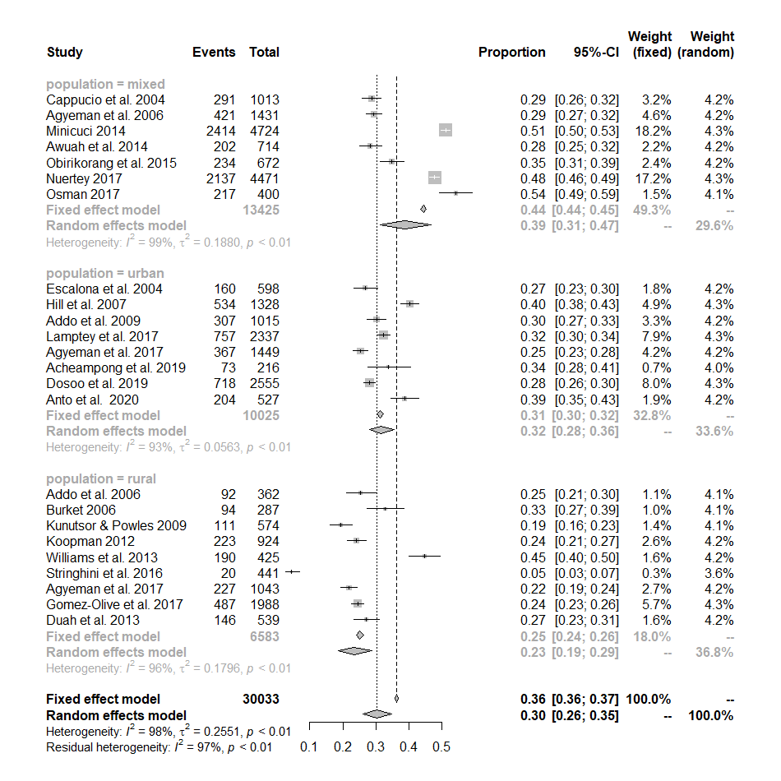

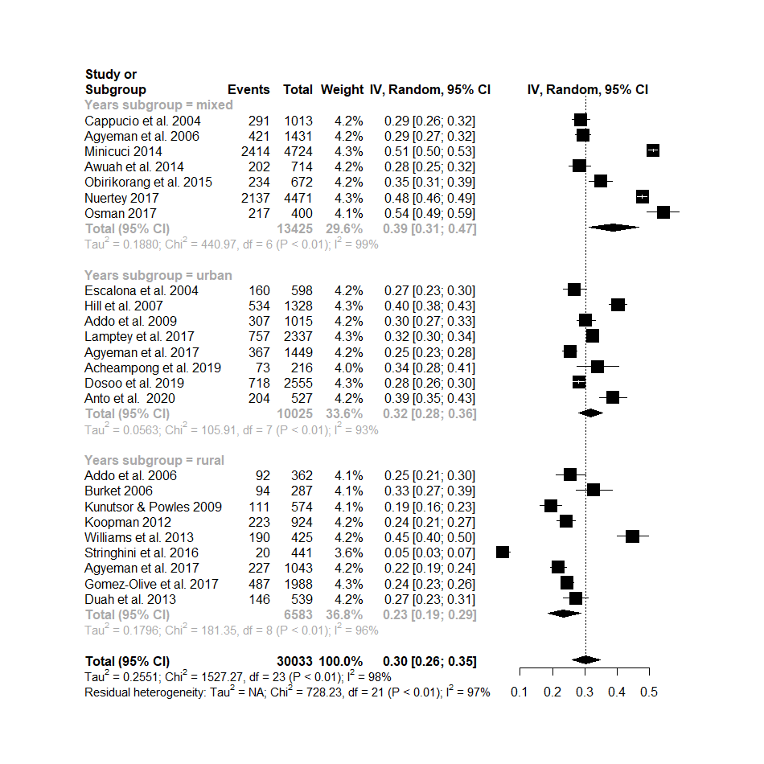

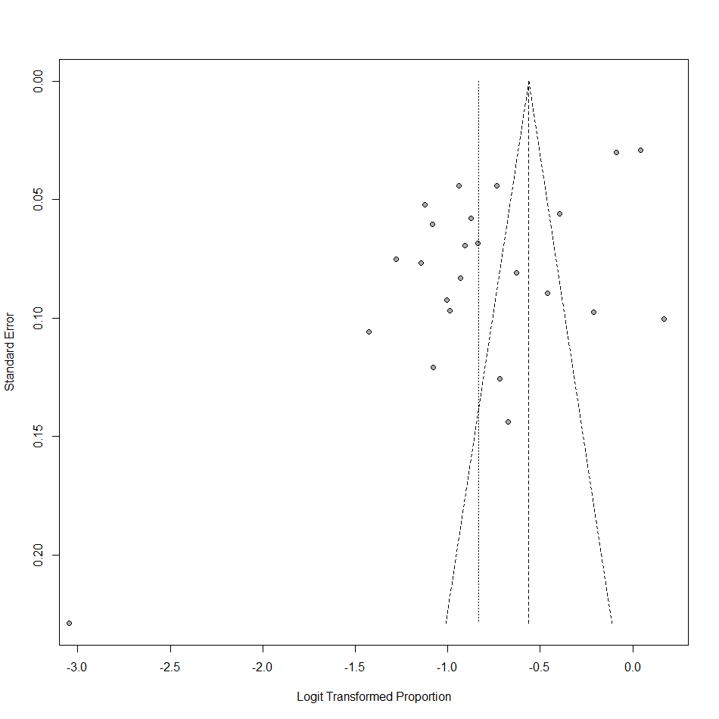

Region:

proportion 95%-CI %W(fixed) %W(random) region
Cappucio et al. 2004 0.2873 [0.2596; 0.3162] 3.4 4.6 AR
Escalona et al. 2004 0.2676 [0.2325; 0.3050] 1.9 4.6 GA
Addo et al. 2006 0.2541 [0.2101; 0.3023] 1.1 4.4 GA
Burket 2006 0.3275 [0.2735; 0.3851] 1.0 4.4 VR
Agyeman et al. 2006 0.2942 [0.2707; 0.3186] 4.9 4.6 AR
Hill et al. 2007 0.4021 [0.3756; 0.4290] 5.3 4.7 GA
Addo et al. 2009 0.3025 [0.2743; 0.3318] 3.5 4.6 GA
Kunutsor & Powles 2009 0.1934 [0.1618; 0.2281] 1.5 4.5 UE
Koopman 2012 0.2413 [0.2141; 0.2703] 2.8 4.6 UE
Williams et al. 2013 0.4471 [0.3991; 0.4957] 1.7 4.5 AR
Minicuci 2014 0.5110 [0.4966; 0.5254] 19.5 4.7 nationwide
Awuah et al. 2014 0.2829 [0.2501; 0.3175] 2.4 4.6 GA
Obirikorang et al. 2015 0.3482 [0.3122; 0.3856] 2.5 4.6 AR
Stringhini et al. 2016 0.0454 [0.0279; 0.0692] 0.3 3.9 AR
Nuertey 2017 0.4780 [0.4632; 0.4927] 18.5 4.7 nationwide
Osman 2017 0.5425 [0.4923; 0.5921] 1.6 4.5 AR
Lamptey et al. 2017 0.3239 [0.3050; 0.3433] 8.5 4.7 ER
Gomez-Olive et al. 2017 0.2450 [0.2262; 0.2645] 6.1 4.7 UE
Acheampong et al. 2019 0.3380 [0.2752; 0.4053] 0.8 4.3 GA
Dosoo et al. 2019 0.2810 [0.2637; 0.2989] 8.5 4.7 BE
Duah et al. 2013 0.2709 [0.2338; 0.3105] 1.8 4.5 AR
Anto et al. 2020 0.3871 [0.3453; 0.4302] 2.1 4.6 nationwide

Number of studies combined: k = 22

proportion 95%-CI
Fixed effect model 0.3735 [0.3676; 0.3794]
Random effects model 0.3097 [0.2665; 0.3564]

Quantifying heterogeneity:
tau^2 = 0.2452 [0.1504; 0.5998]; tau = 0.4952 [0.3878; 0.7744];
I^2 = 98.4% [98.1%; 98.7%]; H = 8.02 [7.33; 8.77]

Quantifying residual heterogeneity:
I^2 = 95.8% [94.3%; 96.9%]; H = 4.86 [4.18; 5.65]

Test of heterogeneity:
Q d.f. p-value
1349.98 21 < 0.0001

Results for subgroups (fixed effect model):
k proportion 95%-CI Q I^2
region = AR 7 0.3268 [0.3133; 0.3407] 232.76 97.4%
region = GA 5 0.3328 [0.3165; 0.3494] 57.85 93.1%
region = VR 1 0.3275 [0.2757; 0.3839] 0.00 --
region = GA 1 0.3025 [0.2750; 0.3314] 0.00 --
region = UE 3 0.2361 [0.2223; 0.2505] 6.78 70.5%
region = nationwide 3 0.4893 [0.4793; 0.4992] 32.91 93.9%
region = ER 1 0.3239 [0.3052; 0.3432] 0.00 --
region = BE 1 0.2810 [0.2639; 0.2988] 0.00 --

Test for subgroup differences (fixed effect model):
Q d.f. p-value
Between groups 1019.67 7 < 0.0001
Within groups 330.30 14 < 0.0001

Results for subgroups (random effects model):
k proportion 95%-CI tau^2 tau
region = AR 7 0.2916 [0.2156; 0.3813] 0.2844 0.5333
region = GA 5 0.3073 [0.2467; 0.3753] 0.1093 0.3307
region = VR 1 0.3275 [0.2757; 0.3839] -- --
region = GA 1 0.3025 [0.2750; 0.3314] -- --
region = UE 3 0.2293 [0.2025; 0.2585] 0.0136 0.1166
region = nationwide 3 0.4641 [0.4190; 0.5098] 0.0233 0.1527
region = ER 1 0.3239 [0.3052; 0.3432] -- --
region = BE 1 0.2810 [0.2639; 0.2988] -- --

Test for subgroup differences (random effects model):
Q d.f. p-value
Between groups 87.68 7 < 0.0001

Details on meta-analytical method:
- Inverse variance method
- DerSimonian-Laird estimator for tau^2
- Jackson method for confidence interval of tau^2 and tau
- Logit transformation
- Clopper-Pearson confidence interval for individual studies

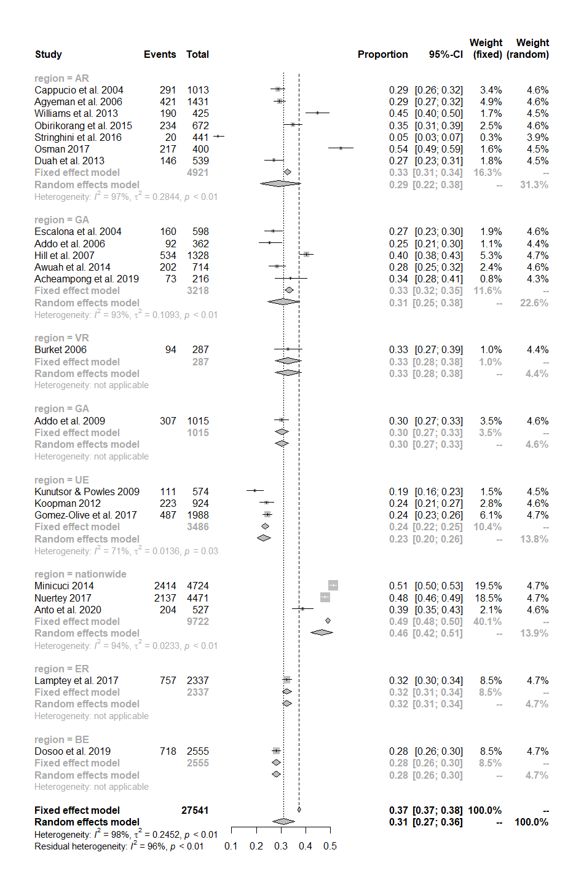

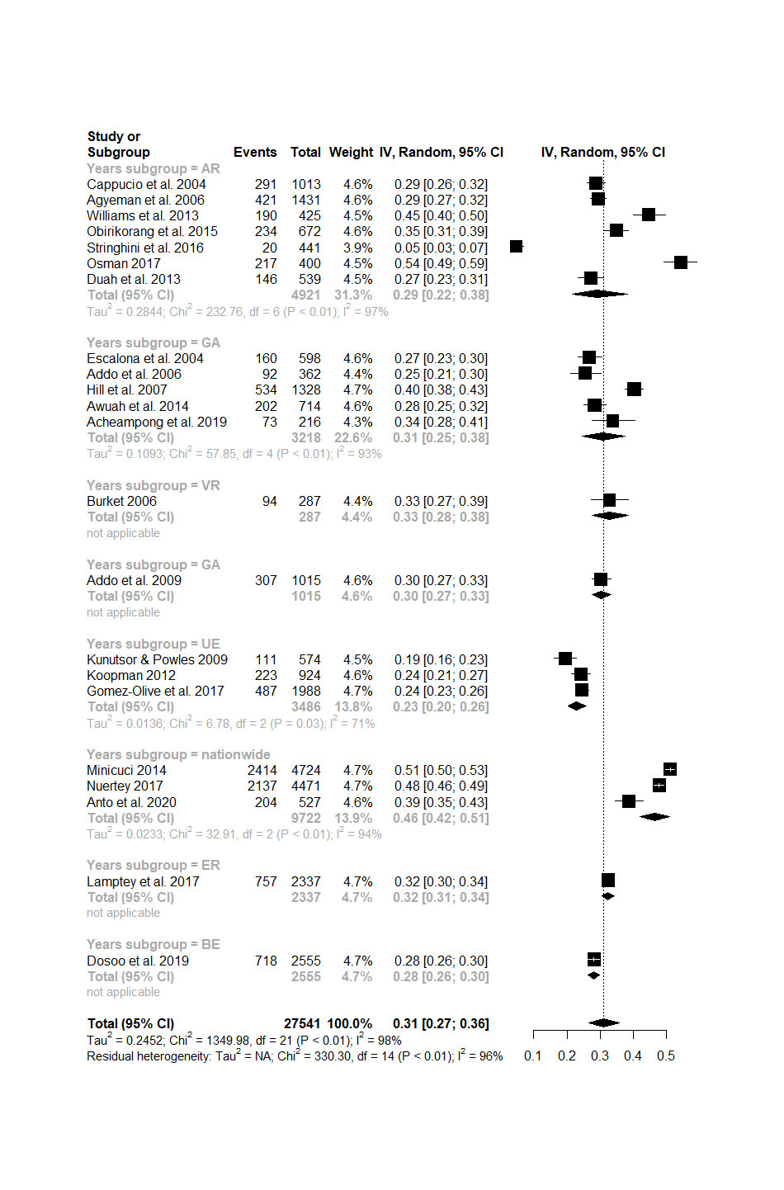
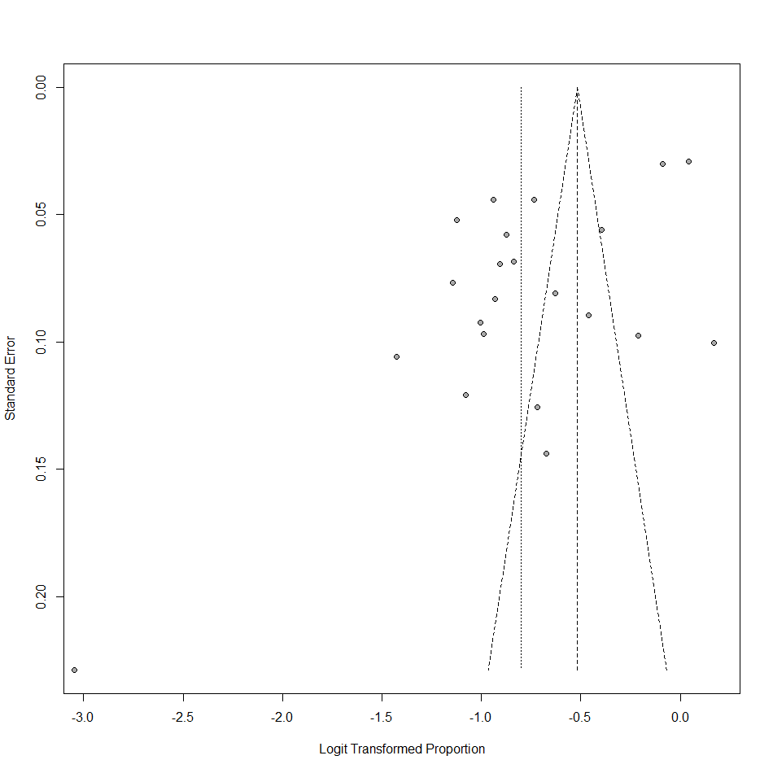

Geographical Belt:
proportion 95%-CI %W(fixed) %W(random) geographical_belt
Cappucio et al. 2004 0.2873 [0.2596; 0.3162] 3.5 4.8 middle
Escalona et al. 2004 0.2676 [0.2325; 0.3050] 2.0 4.8 southern
Addo et al. 2006 0.2541 [0.2101; 0.3023] 1.2 4.7 southern
Burket 2006 0.3275 [0.2735; 0.3851] 1.1 4.6 middle
Agyeman et al. 2006 0.2942 [0.2707; 0.3186] 5.0 4.9 middle
Hill et al. 2007 0.4021 [0.3756; 0.4290] 5.4 4.9 southern
Addo et al. 2009 0.3025 [0.2743; 0.3318] 3.6 4.8 southern
Kunutsor & Powles 2009 0.1934 [0.1618; 0.2281] 1.5 4.7 northern
Koopman 2012 0.2413 [0.2141; 0.2703] 2.9 4.8 northern
Williams et al. 2013 0.4471 [0.3991; 0.4957] 1.8 4.8 middle
Minicuci 2014 0.5110 [0.4966; 0.5254] 20.0 4.9 nationwide
Awuah et al. 2014 0.2829 [0.2501; 0.3175] 2.4 4.8 southern
Obirikorang et al. 2015 0.3482 [0.3122; 0.3856] 2.6 4.8 middle
Stringhini et al. 2016 0.0454 [0.0279; 0.0692] 0.3 4.1 middle
Nuertey 2017 0.4780 [0.4632; 0.4927] 18.9 4.9 nationwide
Osman 2017 0.5425 [0.4923; 0.5921] 1.7 4.7 middle
Lamptey et al. 2017 0.3239 [0.3050; 0.3433] 8.7 4.9 middle
Gomez-Olive et al. 2017 0.2450 [0.2262; 0.2645] 6.2 4.9 northern
Acheampong et al. 2019 0.3380 [0.2752; 0.4053] 0.8 4.6 southern
Dosoo et al. 2019 0.2810 [0.2637; 0.2989] 8.7 4.9 middle
Duah et al. 2013 0.2709 [0.2338; 0.3105] 1.8 4.8 middle

Number of studies combined: k = 21

proportion 95%-CI
Fixed effect model 0.3732 [0.3672; 0.3792]
Random effects model 0.3061 [0.2618; 0.3543]

Quantifying heterogeneity:
tau^2 = 0.2516 [0.1535; 0.6348]; tau = 0.5016 [0.3918; 0.7968];
I^2 = 98.5% [98.2%; 98.8%]; H = 8.21 [7.51; 8.99]

Quantifying residual heterogeneity:
I^2 = 94.8% [93.1%; 96.1%]; H = 4.39 [3.80; 5.08]

Test of heterogeneity:
Q d.f. p-value
1349.55 20 < 0.0001

Results for subgroups (fixed effect model):
k proportion 95%-CI Q I^2
geographical_belt = middle 10 0.3144 [0.3052; 0.3238] 250.37 96.4%
geographical_belt = southern 6 0.3255 [0.3114; 0.3399] 61.05 91.8%
geographical_belt = northern 3 0.2361 [0.2223; 0.2505] 6.78 70.5%
geographical_belt = nationwide 2 0.4949 [0.4847; 0.5052] 10.03 90.0%

Test for subgroup differences (fixed effect model):
Q d.f. p-value
Between groups 1021.31 3 < 0.0001
Within groups 328.23 17 < 0.0001

Results for subgroups (random effects model):
k proportion 95%-CI tau^2 tau
geographical_belt = middle 10 0.3016 [0.2535; 0.3543] 0.1394 0.3733
geographical_belt = southern 6 0.3067 [0.2584; 0.3596] 0.0795 0.2820
geographical_belt = northern 3 0.2293 [0.2025; 0.2585] 0.0136 0.1166
geographical_belt = nationwide 2 0.4945 [0.4622; 0.5269] 0.0079 0.0887

Test for subgroup differences (random effects model):
Q d.f. p-value
Between groups 140.65 3 < 0.0001

Details on meta-analytical method:
- Inverse variance method
- DerSimonian-Laird estimator for tau^2
- Jackson method for confidence interval of tau^2 and tau
- Logit transformation
- Clopper-Pearson confidence interval for individual studies

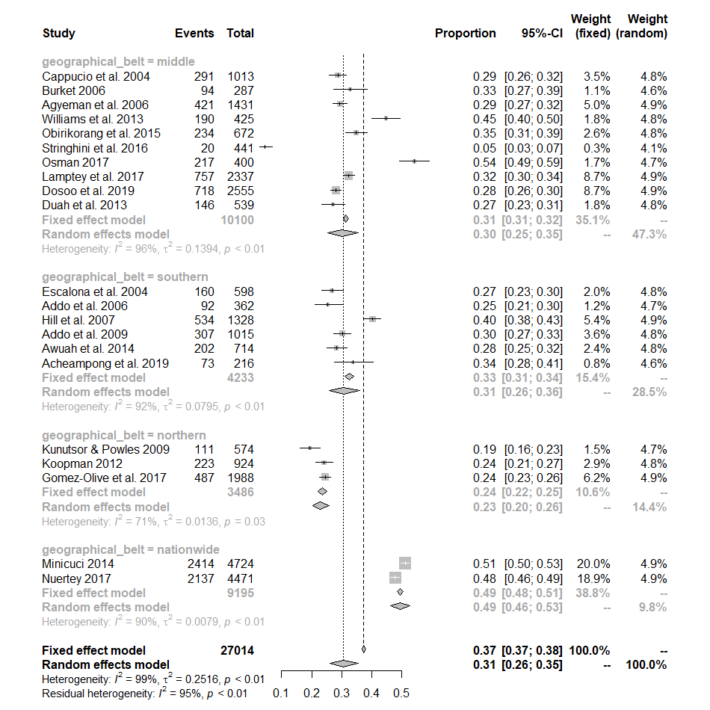

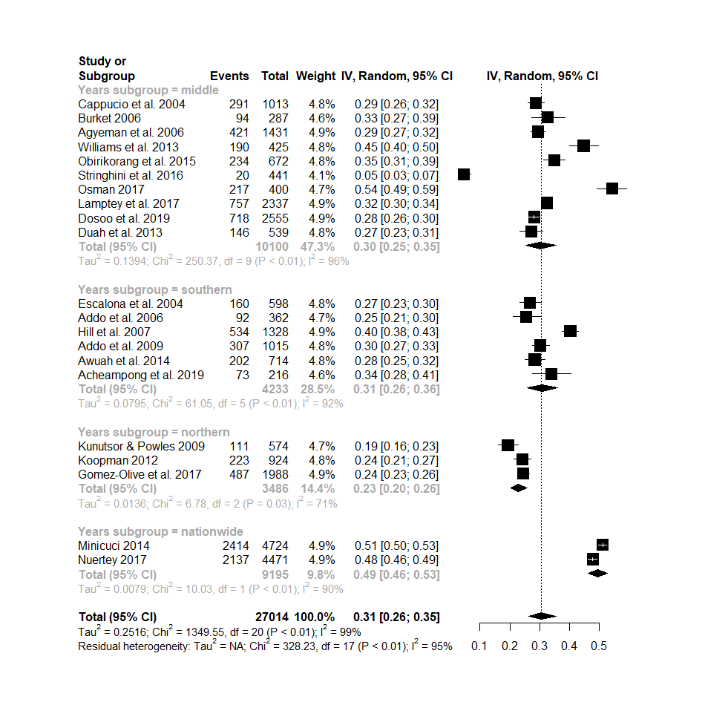

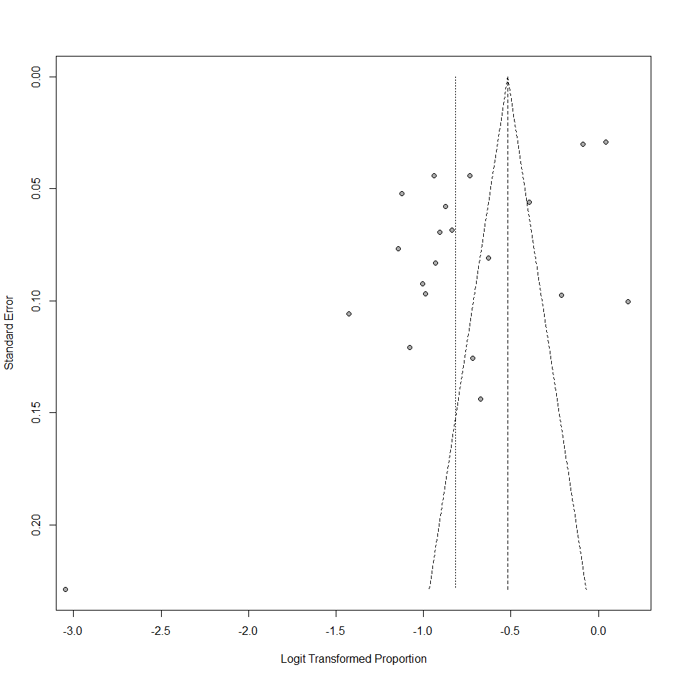

Year:

proportion 95%-CI %W(fixed) %W(random) year_of_study
Cappucio et al. 2004 0.2873 [0.2596; 0.3162] 3.4 4.6 before 2010
Escalona et al. 2004 0.2676 [0.2325; 0.3050] 1.9 4.6 before 2010
Addo et al. 2006 0.2541 [0.2101; 0.3023] 1.1 4.4 before 2010
Burket 2006 0.3275 [0.2735; 0.3851] 1.0 4.4 before 2010
Agyeman et al. 2006 0.2942 [0.2707; 0.3186] 4.9 4.6 before 2010
Hill et al. 2007 0.4021 [0.3756; 0.4290] 5.3 4.7 before 2010
Addo et al. 2009 0.3025 [0.2743; 0.3318] 3.5 4.6 before 2010
Kunutsor & Powles 2009 0.1934 [0.1618; 0.2281] 1.5 4.5 before 2010
Koopman 2012 0.2413 [0.2141; 0.2703] 2.8 4.6 before 2010
Williams et al. 2013 0.4471 [0.3991; 0.4957] 1.7 4.5 before 2010
Minicuci 2014 0.5110 [0.4966; 0.5254] 19.5 4.7 before 2010
Awuah et al. 2014 0.2829 [0.2501; 0.3175] 2.4 4.6 after 2010
Obirikorang et al. 2015 0.3482 [0.3122; 0.3856] 2.5 4.6 after 2010
Stringhini et al. 2016 0.0454 [0.0279; 0.0692] 0.3 3.9 after 2010
Nuertey 2017 0.4780 [0.4632; 0.4927] 18.5 4.7 after 2010
Osman 2017 0.5425 [0.4923; 0.5921] 1.6 4.5 after 2010
Lamptey et al. 2017 0.3239 [0.3050; 0.3433] 8.5 4.7 after 2010
Gomez-Olive et al. 2017 0.2450 [0.2262; 0.2645] 6.1 4.7 after 2010
Acheampong et al. 2019 0.3380 [0.2752; 0.4053] 0.8 4.3 after 2010
Dosoo et al. 2019 0.2810 [0.2637; 0.2989] 8.5 4.7 after 2010
Anto et al. 2020 0.3871 [0.3453; 0.4302] 2.1 4.6 after 2010
Duah et al. 2013 0.2709 [0.2338; 0.3105] 1.8 4.5 after 2010

Number of studies combined: k = 22

proportion 95%-CI
Fixed effect model 0.3735 [0.3676; 0.3794]
Random effects model 0.3097 [0.2665; 0.3564]

Quantifying heterogeneity:
tau^2 = 0.2452 [0.1504; 0.5998]; tau = 0.4952 [0.3878; 0.7744];
I^2 = 98.4% [98.1%; 98.7%]; H = 8.02 [7.33; 8.77]

Quantifying residual heterogeneity:
I^2 = 98.5% [98.2%; 98.7%]; H = 8.15 [7.44; 8.92]

Test of heterogeneity:
Q d.f. p-value
1349.98 21 < 0.0001

Results for subgroups (fixed effect model):
k proportion 95%-CI Q I^2
year_of_study = before 2010 11 0.3886 [0.3799; 0.3974] 659.45 98.5%
year_of_study = after 2010 11 0.3603 [0.3524; 0.3683] 668.63 98.5%

Test for subgroup differences (fixed effect model):
Q d.f. p-value
Between groups 21.90 1 < 0.0001
Within groups 1328.08 20 < 0.0001

Results for subgroups (random effects model):
k proportion 95%-CI tau^2 tau
year_of_study = before 2010 11 0.3153 [0.2498; 0.3890] 0.2931 0.5414
year_of_study = after 2010 11 0.3038 [0.2435; 0.3716] 0.2547 0.5047

Test for subgroup differences (random effects model):
Q d.f. p-value
Between groups 0.06 1 0.8125

Details on meta-analytical method:
- Inverse variance method
- DerSimonian-Laird estimator for tau^2
- Jackson method for confidence interval of tau^2 and tau
- Logit transformation
- Clopper-Pearson confidence interval for individual studies

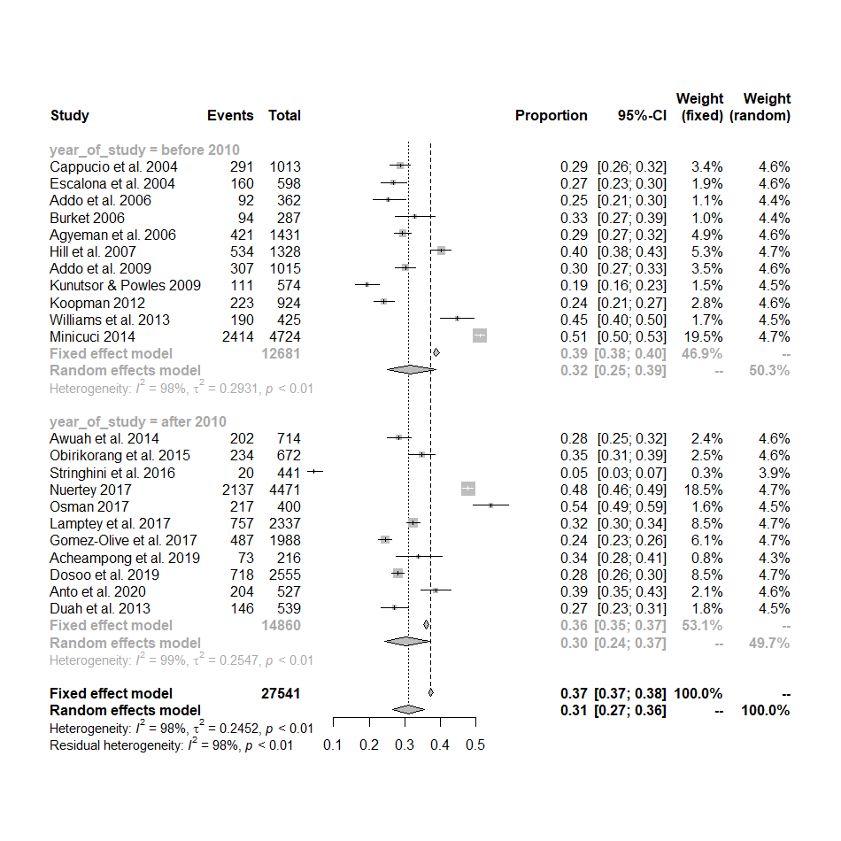

Device:

proportion 95%-CI %W(fixed) %W(random) bp_device
Cappucio et al. 2004 0.2873 [0.2596; 0.3162] 3.2 4.2 electronic
Escalona et al. 2004 0.2676 [0.2325; 0.3050] 1.8 4.2 manual
Addo et al. 2006 0.2541 [0.2101; 0.3023] 1.1 4.1 manual
Burket 2006 0.3275 [0.2735; 0.3851] 1.0 4.1 manual
Agyeman et al. 2006 0.2942 [0.2707; 0.3186] 4.6 4.2 electronic
Hill et al. 2007 0.4021 [0.3756; 0.4290] 4.9 4.3 manual
Addo et al. 2009 0.3025 [0.2743; 0.3318] 3.3 4.2 electronic
Kunutsor & Powles 2009 0.1934 [0.1618; 0.2281] 1.4 4.1 electronic
Koopman 2012 0.2413 [0.2141; 0.2703] 2.6 4.2 manual
Williams et al. 2013 0.4471 [0.3991; 0.4957] 1.6 4.2 manual
Minicuci 2014 0.5110 [0.4966; 0.5254] 18.2 4.3 electronic
Awuah et al. 2014 0.2829 [0.2501; 0.3175] 2.2 4.2 electronic
Obirikorang et al. 2015 0.3482 [0.3122; 0.3856] 2.4 4.2 electronic
Stringhini et al. 2016 0.0454 [0.0279; 0.0692] 0.3 3.6 electronic
Nuertey 2017 0.4780 [0.4632; 0.4927] 17.2 4.3 electronic
Osman 2017 0.5425 [0.4923; 0.5921] 1.5 4.1 electronic
Lamptey et al. 2017 0.3239 [0.3050; 0.3433] 7.9 4.3 electronic
Agyeman et al. 2017 0.2176 [0.1929; 0.2439] 2.7 4.2 electronic
Agyeman et al. 2017 0.2533 [0.2311; 0.2765] 4.2 4.2 electronic
Gomez-Olive et al. 2017 0.2450 [0.2262; 0.2645] 5.7 4.3 electronic
Acheampong et al. 2019 0.3380 [0.2752; 0.4053] 0.7 4.0 manual
Dosoo et al. 2019 0.2810 [0.2637; 0.2989] 8.0 4.3 electronic
Anto et al. 2020 0.3871 [0.3453; 0.4302] 1.9 4.2 electronic
Duah et al., 2013 0.2709 [0.2338; 0.3105] 1.6 4.2 electronic

Number of studies combined: k = 24

proportion 95%-CI
Fixed effect model 0.3631 [0.3575; 0.3687]
Random effects model 0.3028 [0.2612; 0.3478]

Quantifying heterogeneity:
tau^2 = 0.2551 [0.1526; 0.5665]; tau = 0.5050 [0.3906; 0.7527];
I^2 = 98.5% [98.2%; 98.7%]; H = 8.15 [7.49; 8.87]

Quantifying residual heterogeneity:
I^2 = 98.5% [98.3%; 98.8%]; H = 8.29 [7.61; 9.03]

Test of heterogeneity:
Q d.f. p-value
1527.27 23 < 0.0001

Results for subgroups (fixed effect model):
k proportion 95%-CI Q I^2
bp_device = electronic 17 0.3677 [0.3616; 0.3738] 1402.39 98.9%
bp_device = manual 7 0.3346 [0.3201; 0.3493] 108.59 94.5%

Test for subgroup differences (fixed effect model):
Q d.f. p-value
Between groups 16.29 1 < 0.0001
Within groups 1510.98 22 < 0.0001

Results for subgroups (random effects model):
k proportion 95%-CI tau^2 tau
bp_device = electronic 17 0.2950 [0.2448; 0.3506] 0.2805 0.5296
bp_device = manual 7 0.3217 [0.2613; 0.3887] 0.1457 0.3817

Test for subgroup differences (random effects model):
Q d.f. p-value
Between groups 0.40 1 0.5272

Details on meta-analytical method:
- Inverse variance method
- DerSimonian-Laird estimator for tau^2
- Jackson method for confidence interval of tau^2 and tau
- Logit transformation
- Clopper-Pearson confidence interval for individual studies

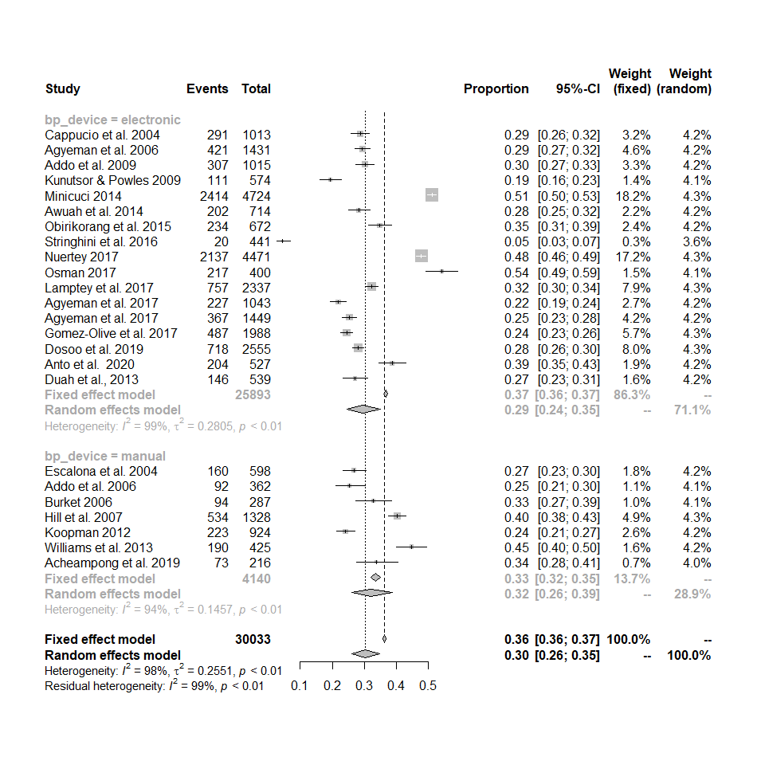

Earliest_year_of_sampling:

proportion 95%-CI %W(fixed) %W(random) Earliest_year_of_sampling
Cappucio et al. 2004 0.2873 [0.2596; 0.3162] 3.4 4.6 2000-2005
Escalona et al. 2004 0.2676 [0.2325; 0.3050] 1.9 4.6 2000-2005
Addo et al. 2006 0.2541 [0.2101; 0.3023] 1.1 4.4 2000-2005
Burket 2006 0.3275 [0.2735; 0.3851] 1.0 4.4 2000-2005
Agyeman et al. 2006 0.2942 [0.2707; 0.3186] 4.9 4.6 2000-2005
Hill et al. 2007 0.4021 [0.3756; 0.4290] 5.3 4.7 2000-2005
Addo et al. 2009 0.3025 [0.2743; 0.3318] 3.5 4.6 2006-2010
Kunutsor & Powles 2009 0.1934 [0.1618; 0.2281] 1.5 4.5 2006-2010
Koopman 2012 0.2413 [0.2141; 0.2703] 2.8 4.6 2006-2010
Williams et al. 2013 0.4471 [0.3991; 0.4957] 1.7 4.5 2011-2015
Minicuci 2014 0.5110 [0.4966; 0.5254] 19.5 4.7 2006-2010
Awuah et al. 2014 0.2829 [0.2501; 0.3175] 2.4 4.6 2011-2015
Obirikorang et al. 2015 0.3482 [0.3122; 0.3856] 2.5 4.6 2011-2015
Stringhini et al. 2016 0.0454 [0.0279; 0.0692] 0.3 3.9 2011-2015
Nuertey 2017 0.4780 [0.4632; 0.4927] 18.5 4.7 2011-2015
Osman 2017 0.5425 [0.4923; 0.5921] 1.6 4.5 2016-2020
Lamptey et al. 2017 0.3239 [0.3050; 0.3433] 8.5 4.7 2011-2015
Gomez-Olive et al. 2017 0.2450 [0.2262; 0.2645] 6.1 4.7 2011-2015
Acheampong et al. 2019 0.3380 [0.2752; 0.4053] 0.8 4.3 2016-2020
Dosoo et al. 2019 0.2810 [0.2637; 0.2989] 8.5 4.7 2016-2020
Anto et al. 2020 0.3871 [0.3453; 0.4302] 2.1 4.6 2011-2015
Duah et al. 2013 0.2709 [0.2338; 0.3105] 1.8 4.5 2006-2010

Number of studies combined: k = 22

proportion 95%-CI
Fixed effect model 0.3735 [0.3676; 0.3794]
Random effects model 0.3097 [0.2665; 0.3564]

Quantifying heterogeneity:
tau^2 = 0.2452 [0.1504; 0.5998]; tau = 0.4952 [0.3878; 0.7744];
I^2 = 98.4% [98.1%; 98.7%]; H = 8.02 [7.33; 8.77]

Quantifying residual heterogeneity:
I^2 = 98.5% [98.1%; 98.7%]; H = 8.09 [7.35; 8.90]

Test of heterogeneity:
Q d.f. p-value
1349.98 21 < 0.0001

Results for subgroups (fixed effect model):
k proportion 95%-CI Q I^2
Earliest_year_of_sampling = 2000-2005 6 0.3192 [0.3064; 0.3324] 64.79 92.3%
Earliest_year_of_sampling = 2006-2010 5 0.4219 [0.4106; 0.4334] 486.33 99.2%
Earliest_year_of_sampling = 2011-2015 8 0.3788 [0.3697; 0.3880] 523.48 98.7%
Earliest_year_of_sampling = 2016-2020 3 0.3199 [0.3036; 0.3367] 102.91 98.1%

Test for subgroup differences (fixed effect model):
Q d.f. p-value
Between groups 172.46 3 < 0.0001
Within groups 1177.51 18 < 0.0001

Results for subgroups (random effects model):
k proportion 95%-CI tau^2 tau
Earliest_year_of_sampling = 2000-2005 6 0.3047 [0.2590; 0.3545] 0.0716 0.2677
Earliest_year_of_sampling = 2006-2010 5 0.2957 [0.1812; 0.4433] 0.5274 0.7262
Earliest_year_of_sampling = 2011-2015 8 0.2964 [0.2252; 0.3791] 0.2765 0.5259
Earliest_year_of_sampling = 2016-2020 3 0.3818 [0.2281; 0.5634] 0.4135 0.6430

Test for subgroup differences (random effects model):
Q d.f. p-value
Between groups 0.89 3 0.8287

Details on meta-analytical method:
- Inverse variance method
- DerSimonian-Laird estimator for tau^2
- Jackson method for confidence interval of tau^2 and tau
- Logit transformation
- Clopper-Pearson confidence interval for individual studies

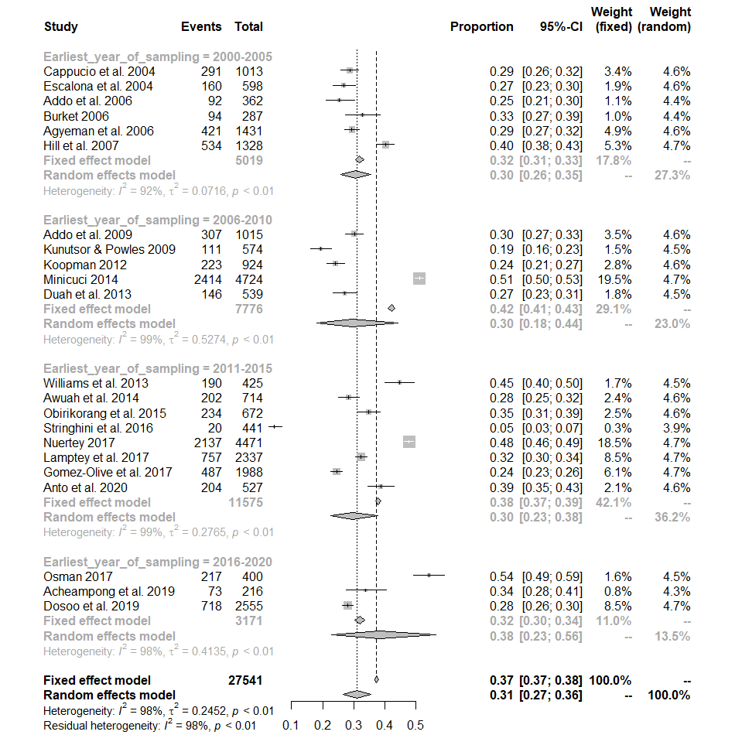

Year_of_publication:
proportion 95%-CI %W(fixed) %W(random) Year_of_publication
Cappucio et al. 2004 0.2873 [0.2596; 0.3162] 3.4 4.6 2000-2005
Escalona et al. 2004 0.2676 [0.2325; 0.3050] 1.9 4.6 2000-2005
Addo et al. 2006 0.2541 [0.2101; 0.3023] 1.1 4.4 2006-2010
Burket 2006 0.3275 [0.2735; 0.3851] 1.0 4.4 2006-2010
Agyeman et al. 2006 0.2942 [0.2707; 0.3186] 4.9 4.6 2006-2010
Hill et al. 2007 0.4021 [0.3756; 0.4290] 5.3 4.7 2006-2010
Addo et al. 2009 0.3025 [0.2743; 0.3318] 3.5 4.6 2006-2010
Kunutsor & Powles 2009 0.1934 [0.1618; 0.2281] 1.5 4.5 2006-2010
Koopman 2012 0.2413 [0.2141; 0.2703] 2.8 4.6 2010-2015
Duah et al. 2013 0.2709 [0.2338; 0.3105] 1.8 4.5 2010-2015
Williams et al. 2013 0.4471 [0.3991; 0.4957] 1.7 4.5 2010-2015
Minicuci 2014 0.5110 [0.4966; 0.5254] 19.5 4.7 2010-2015
Awuah et al. 2014 0.2829 [0.2501; 0.3175] 2.4 4.6 2010-2015
Obirikorang et al. 2015 0.3482 [0.3122; 0.3856] 2.5 4.6 2010-2015
Stringhini et al. 2016 0.0454 [0.0279; 0.0692] 0.3 3.9 2016-2020
Nuertey 2017 0.4780 [0.4632; 0.4927] 18.5 4.7 2016-2020
Osman 2017 0.5425 [0.4923; 0.5921] 1.6 4.5 2016-2020
Lamptey et al. 2017 0.3239 [0.3050; 0.3433] 8.5 4.7 2016-2020
Gomez-Olive et al. 2017 0.2450 [0.2262; 0.2645] 6.1 4.7 2016-2020
Acheampong et al. 2019 0.3380 [0.2752; 0.4053] 0.8 4.3 2016-2020
Dosoo et al. 2019 0.2810 [0.2637; 0.2989] 8.5 4.7 2016-2020
Anto et al. 2020 0.3871 [0.3453; 0.4302] 2.1 4.6 2016-2020

Number of studies combined: k = 22

proportion 95%-CI
Fixed effect model 0.3735 [0.3676; 0.3794]
Random effects model 0.3097 [0.2665; 0.3564]

Quantifying heterogeneity:
tau^2 = 0.2452 [0.1504; 0.5998]; tau = 0.4952 [0.3878; 0.7744];
I^2 = 98.4% [98.1%; 98.7%]; H = 8.02 [7.33; 8.77]

Quantifying residual heterogeneity:
I^2 = 98.4% [98.0%; 98.7%]; H = 7.84 [7.11; 8.65]

Test of heterogeneity:
Q d.f. p-value
1349.98 21 < 0.0001

Results for subgroups (fixed effect model):
k proportion 95%-CI Q I^2
Year_of_publication = 2000-2005 2 0.2801 [0.2587; 0.3025] 0.72 0.0%
Year_of_publication = 2006-2010 6 0.3159 [0.3030; 0.3291] 94.09 94.7%
Year_of_publication = 2010-2015 6 0.4332 [0.4220; 0.4444] 384.14 98.7%
Year_of_publication = 2016-2020 8 0.3689 [0.3603; 0.3776] 627.55 98.9%

Test for subgroup differences (fixed effect model):
Q d.f. p-value
Between groups 243.48 3 < 0.0001
Within groups 1106.50 18 < 0.0001

Results for subgroups (random effects model):
k proportion 95%-CI tau^2 tau
Year_of_publication = 2000-2005 2 0.2801 [0.2587; 0.3025] 0 0
Year_of_publication = 2006-2010 6 0.2927 [0.2391; 0.3527] 0.1098 0.3313
Year_of_publication = 2010-2015 6 0.3448 [0.2450; 0.4605] 0.3585 0.5988
Year_of_publication = 2016-2020 8 0.3043 [0.2298; 0.3908] 0.2938 0.5420

Test for subgroup differences (random effects model):
Q d.f. p-value
Between groups 1.76 3 0.6241

Details on meta-analytical method:
- Inverse variance method
- DerSimonian-Laird estimator for tau^2
- Jackson method for confidence interval of tau^2 and tau
- Logit transformation
- Clopper-Pearson confidence interval for individual studies

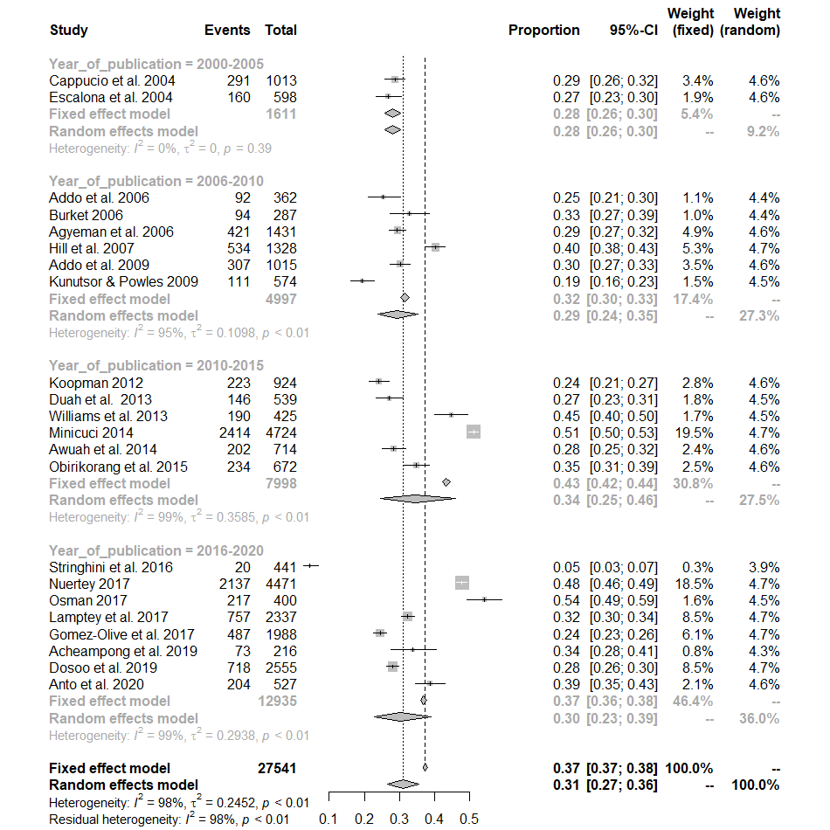

Age:

proportion 95%-CI %W(fixed) %W(random) age
Cappucio et al. 2004 0.2873 [0.2596; 0.3162] 3.4 4.6 general population
Escalona et al. 2004 0.2676 [0.2325; 0.3050] 1.9 4.6 general population
Addo et al. 2006 0.2541 [0.2101; 0.3023] 1.1 4.4 general population
Burket 2006 0.3275 [0.2735; 0.3851] 1.0 4.4 general population
Agyeman et al. 2006 0.2942 [0.2707; 0.3186] 4.9 4.6 general population
Hill et al. 2007 0.4021 [0.3756; 0.4290] 5.3 4.7 general population
Addo et al. 2009 0.3025 [0.2743; 0.3318] 3.5 4.6 general population
Kunutsor & Powles 2009 0.1934 [0.1618; 0.2281] 1.5 4.5 general population
Koopman 2012 0.2413 [0.2141; 0.2703] 2.8 4.6 adults
Williams et al. 2013 0.4471 [0.3991; 0.4957] 1.7 4.5 adults
Minicuci 2014 0.5110 [0.4966; 0.5254] 19.5 4.7 adults
Awuah et al. 2014 0.2829 [0.2501; 0.3175] 2.4 4.6 general population
Obirikorang et al. 2015 0.3482 [0.3122; 0.3856] 2.5 4.6 general population
Stringhini et al. 2016 0.0454 [0.0279; 0.0692] 0.3 3.9 general population
Nuertey 2017 0.4780 [0.4632; 0.4927] 18.5 4.7 adults
Osman 2017 0.5425 [0.4923; 0.5921] 1.6 4.5 adults
Lamptey et al. 2017 0.3239 [0.3050; 0.3433] 8.5 4.7 general population
Gomez-Olive et al. 2017 0.2450 [0.2262; 0.2645] 6.1 4.7 general population
Acheampong et al. 2019 0.3380 [0.2752; 0.4053] 0.8 4.3 general population
Dosoo et al. 2019 0.2810 [0.2637; 0.2989] 8.5 4.7 general population
Anto et al. 2020 0.3871 [0.3453; 0.4302] 2.1 4.6 adults
Duah et al. 2013 0.2709 [0.2338; 0.3105] 1.8 4.5 general popilation

Number of studies combined: k = 22

proportion 95%-CI
Fixed effect model 0.3735 [0.3676; 0.3794]
Random effects model 0.3097 [0.2665; 0.3564]

Quantifying heterogeneity:
tau^2 = 0.2452 [0.1504; 0.5998]; tau = 0.4952 [0.3878; 0.7744];
I^2 = 98.4% [98.1%; 98.7%]; H = 8.02 [7.33; 8.77]

Quantifying residual heterogeneity:
I^2 = 96.0% [94.9%; 96.9%]; H = 5.02 [4.42; 5.70]

Test of heterogeneity:
Q d.f. p-value
1349.98 21 < 0.0001

Results for subgroups (fixed effect model):
k proportion 95%-CI Q I^2
age = general population 16 0.2953 [0.2882; 0.3025] 245.73 93.9%
age = adults 6 0.4729 [0.4637; 0.4822] 234.07 97.9%

Test for subgroup differences (fixed effect model):
Q d.f. p-value
Between groups 870.18 1 < 0.0001
Within groups 479.80 20 < 0.0001

Results for subgroups (random effects model):
k proportion 95%-CI tau^2 tau
age = general population 16 0.2741 [0.2461; 0.3040] 0.0789 0.2808
age = adults 6 0.4303 [0.3612; 0.5023] 0.1254 0.3541

Test for subgroup differences (random effects model):
Q d.f. p-value
Between groups 17.57 1 < 0.0001

Details on meta-analytical method:
- Inverse variance method
- DerSimonian-Laird estimator for tau^2
- Jackson method for confidence interval of tau^2 and tau
- Logit transformation
- Clopper-Pearson confidence interval for individual studies
>

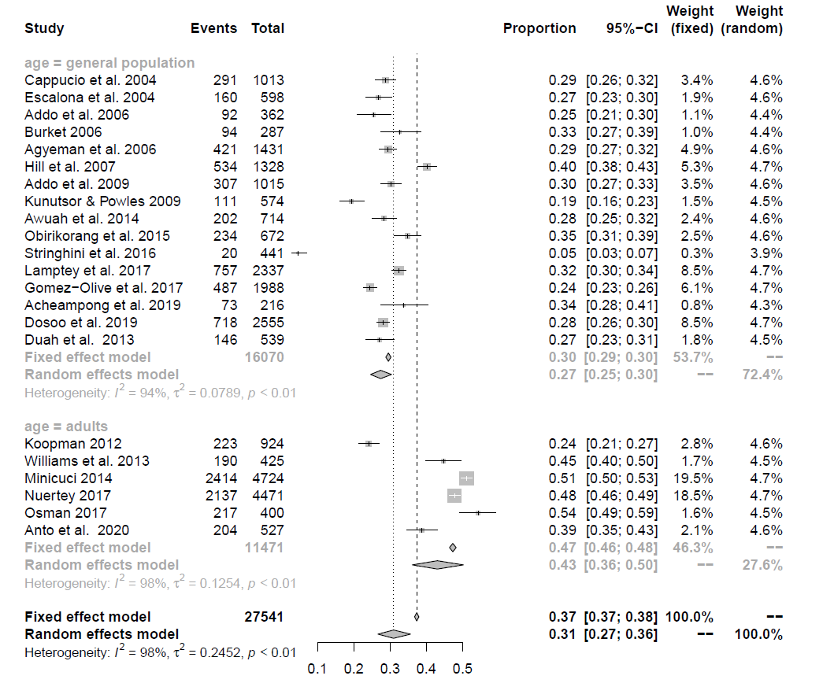

Composite:

proportion 95%-CI %W(fixed) %W(random)
Cappucio et al. 2004 0.2870 [0.2600; 0.3156] 3.2 4.2
Escalona et al. 2004 0.2680 [0.2340; 0.3049] 1.8 4.2
Addo et al. 2006 0.2540 [0.2118; 0.3014] 1.1 4.1
Burket 2006 0.3280 [0.2762; 0.3844] 1.0 4.1
Agyeman et al. 2006 0.2940 [0.2710; 0.3181] 4.6 4.2
Hill et al. 2007 0.4020 [0.3759; 0.4286] 4.9 4.3
Addo et al. 2009 0.3020 [0.2745; 0.3310] 3.3 4.2
Kunutsor & Powles 2009 0.1930 [0.1627; 0.2273] 1.4 4.1
Koopman 2012 0.2410 [0.2145; 0.2696] 2.6 4.2
Williams et al. 2013 0.4470 [0.4004; 0.4946] 1.6 4.2
Minicuci 2014 0.5110 [0.4967; 0.5252] 18.2 4.3
Awuah et al. 2014 0.2830 [0.2512; 0.3172] 2.2 4.2
Obirikorang et al. 2015 0.3480 [0.3129; 0.3848] 2.3 4.2
Stringhini et al. 2016 0.0450 [0.0292; 0.0688] 0.3 3.6
Nuertey 2017 0.4780 [0.4634; 0.4927] 17.2 4.3
Osman 2017 0.5430 [0.4939; 0.5913] 1.5 4.1
Lamptey et al. 2017 0.3240 [0.3053; 0.3433] 7.9 4.3
Gomez-Olive et al. 2017 0.2450 [0.2266; 0.2644] 5.7 4.3
Acheampong et al. 2019 0.3380 [0.2781; 0.4037] 0.7 4.0
Dosoo et al. 2019 0.2810 [0.2639; 0.2988] 8.0 4.3
Agyeman et al. 2017 0.2180 [0.1940; 0.2441] 2.7 4.2
Agyeman et al. 2017 0.2530 [0.2313; 0.2760] 4.2 4.2
Anto et al. 2020 0.3871 [0.3464; 0.4294] 1.9 4.2
Duah et al. 2013 0.2709 [0.2350; 0.3100] 1.6 4.2

Number of studies combined: k = 24

proportion 95%-CI
Fixed effect model 0.3630 [0.3574; 0.3687]
Random effects model 0.3027 [0.2612; 0.3477]

Quantifying heterogeneity:
tau^2 = 0.2553 [0.1528; 0.5675]; tau = 0.5052 [0.3909; 0.7533];
I^2 = 98.5% [98.2%; 98.7%]; H = 8.15 [7.49; 8.87]

Test of heterogeneity:
Q d.f. p-value
1528.28 23 < 0.0001

Details on meta-analytical method:
- Inverse variance method
- DerSimonian-Laird estimator for tau^2
- Jackson method for confidence interval of tau^2 and tau
- Logit transformation
- Normal approximation confidence interval for individual studies

