Additional file 6: Risk of bias

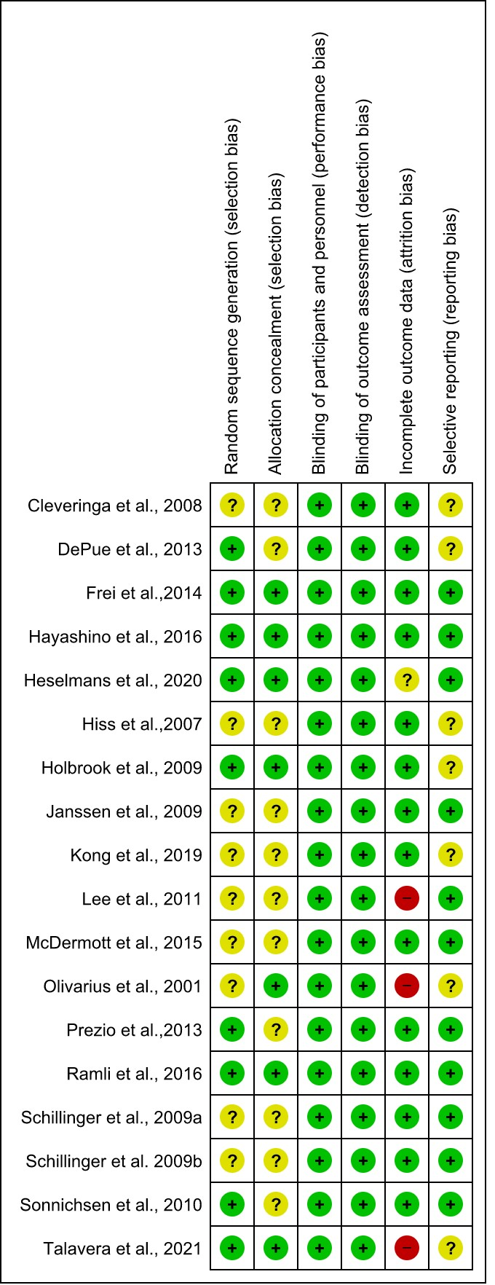

(i) Risk of bias summary

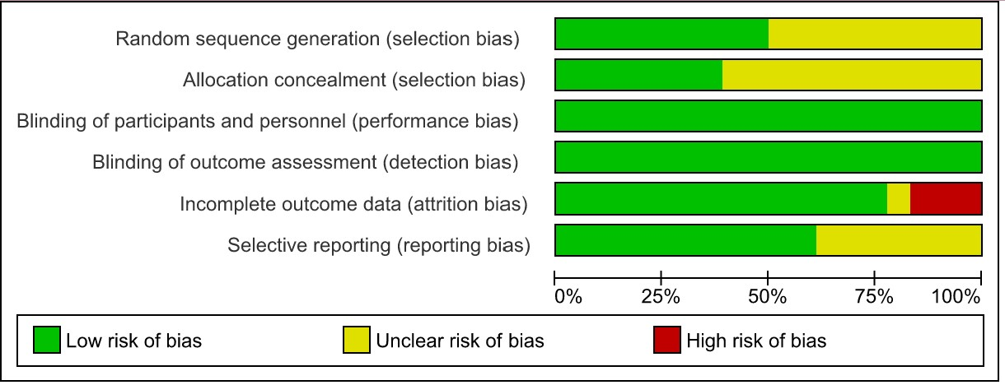

(ii) Risk of bias graph

