Supplementary file 7: Subgroup analyses, Diabetes distress

When assessing diabetes distress, test for subgroup difference showed evidence of a difference when comparing type of diabetes (p=0.02) with a neutral effect of the experimental intervention in participants with type 1 diabetes and a negative effect in participants with type 2 diabetes; Guided self-determination method compared to self-determination theory-based interventions (p=0.007) showing benefits of guided self-determination and harms of self-determination based interventions; type of therapy (individual compared to group (p=0.004) showing harms of individual therapy compared to benefits of group therapy. We found no evidence of a difference when comparing adolescents to adults (p=0.15), length of intervention (p=0.14), or type of control intervention (standard care compared to waitlist design compared to attention control) (p=0.05).

We were not able to perform any of the remaining pre-planned subgroup analyses [1] due to lack of relevant data.

Participants:
- Type of diabetes: Type 1 diabetes compared to type 2 diabetes
Primary outcome: Diabetes distress
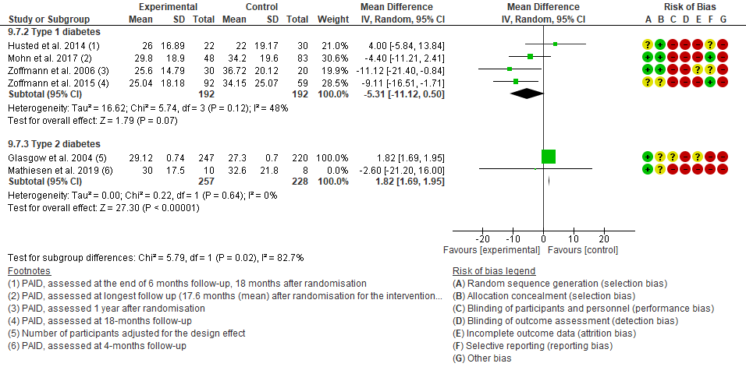
- Socioeconomic status (Low compared to high socioeconomic status). Not possible to conduct due to sparse data.
- Number of comorbidities. Not possible to conduct due to sparse data.

- Effect in men compared to women. Not possible to conduct due to sparse data.

- Effect in adolescents (13-18 years) compared to adults (> 18 years):

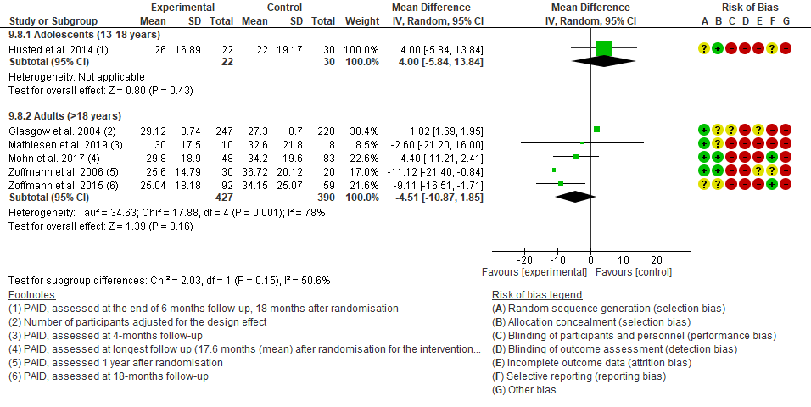

Intervention:
6. Trials investigating self-determination theory-based interventions compared to guided self-determination method.

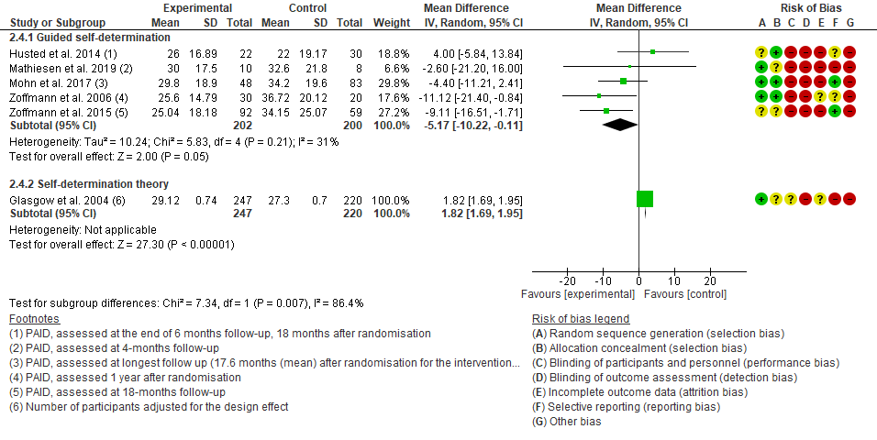
- 7. Interventions above or below the mean difference in intervention length. The mean difference of the four trials reporting on quality of life was 228 days (range 98-608). Not possible to conduct due to sparse data.

8. Individual compared to group interventions:

