Additional tables and figures for Systematic Review on Interventions for Postpartum Anaemia

Additional Figure 1: Forest Plot of sensitivity analysis excluding off-protocol RBC-T for comparison of IV-iron vs. oral iron: Hb concentration longest follow-up (g/dL)

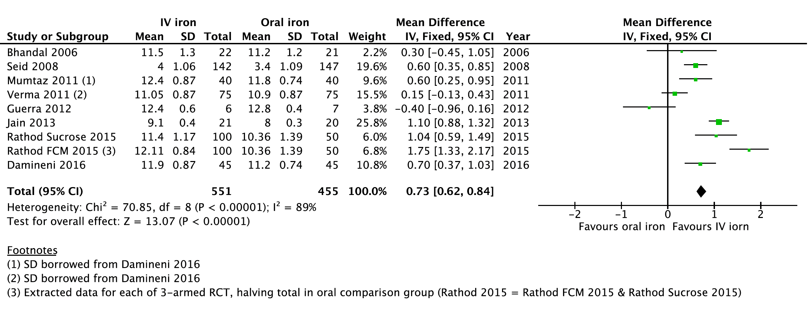

Additional Figure 2: Forest Plot of subgroup analysis of high and low dose IV-iron for comparison of IV-iron vs. oral iron Hb concentration (g/dL) longest follow-up

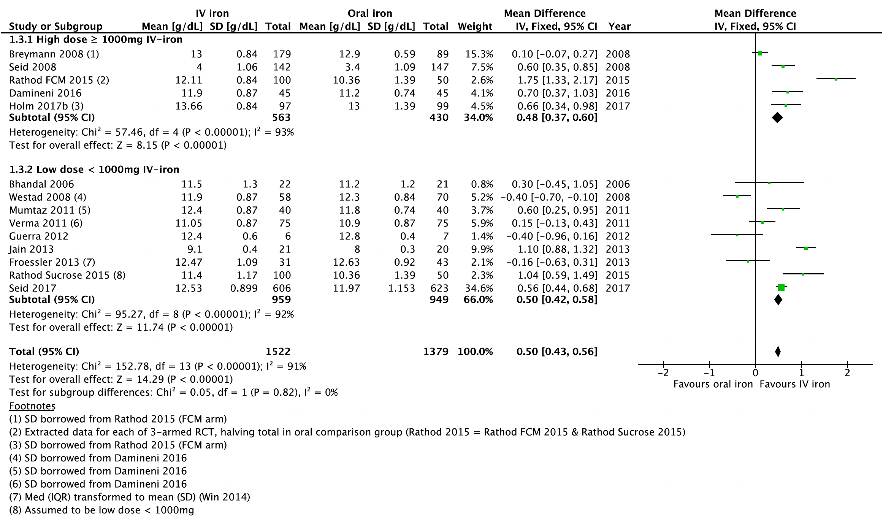

Additional Figure 3: Forest Plot of baseline Hb concentration subgroup for comparison of IV-iron vs. oral iron Hb concentration (g/dL) longest follow-up

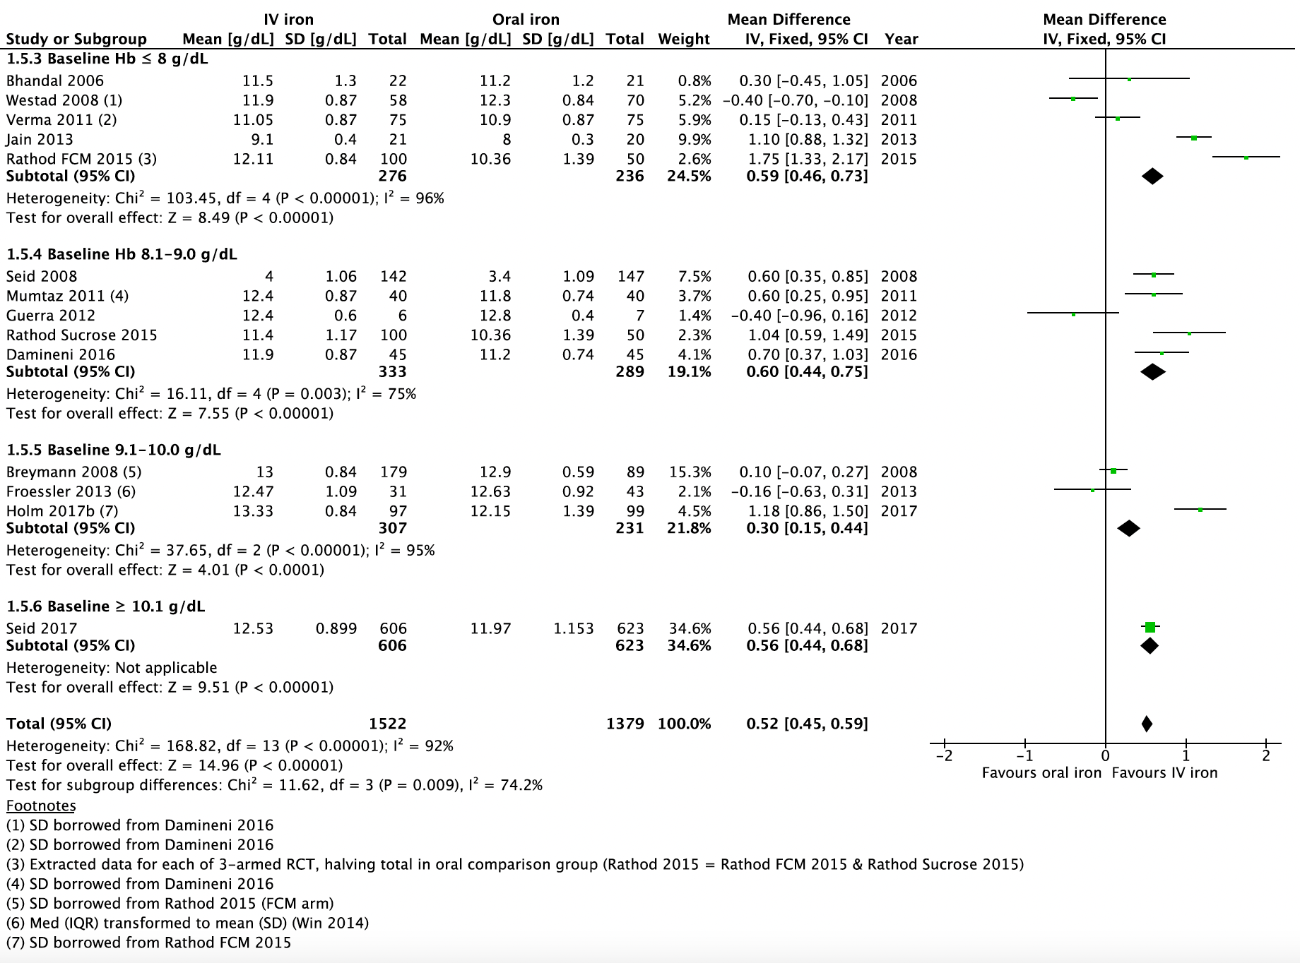

Additional File Figure 4: Forest Plot of baseline Hb subgroup and sensitivity analysis (less studies with RBC-T) for comparison of IV-iron vs. oral iron Hb concentration (g/dL) longest follow-up

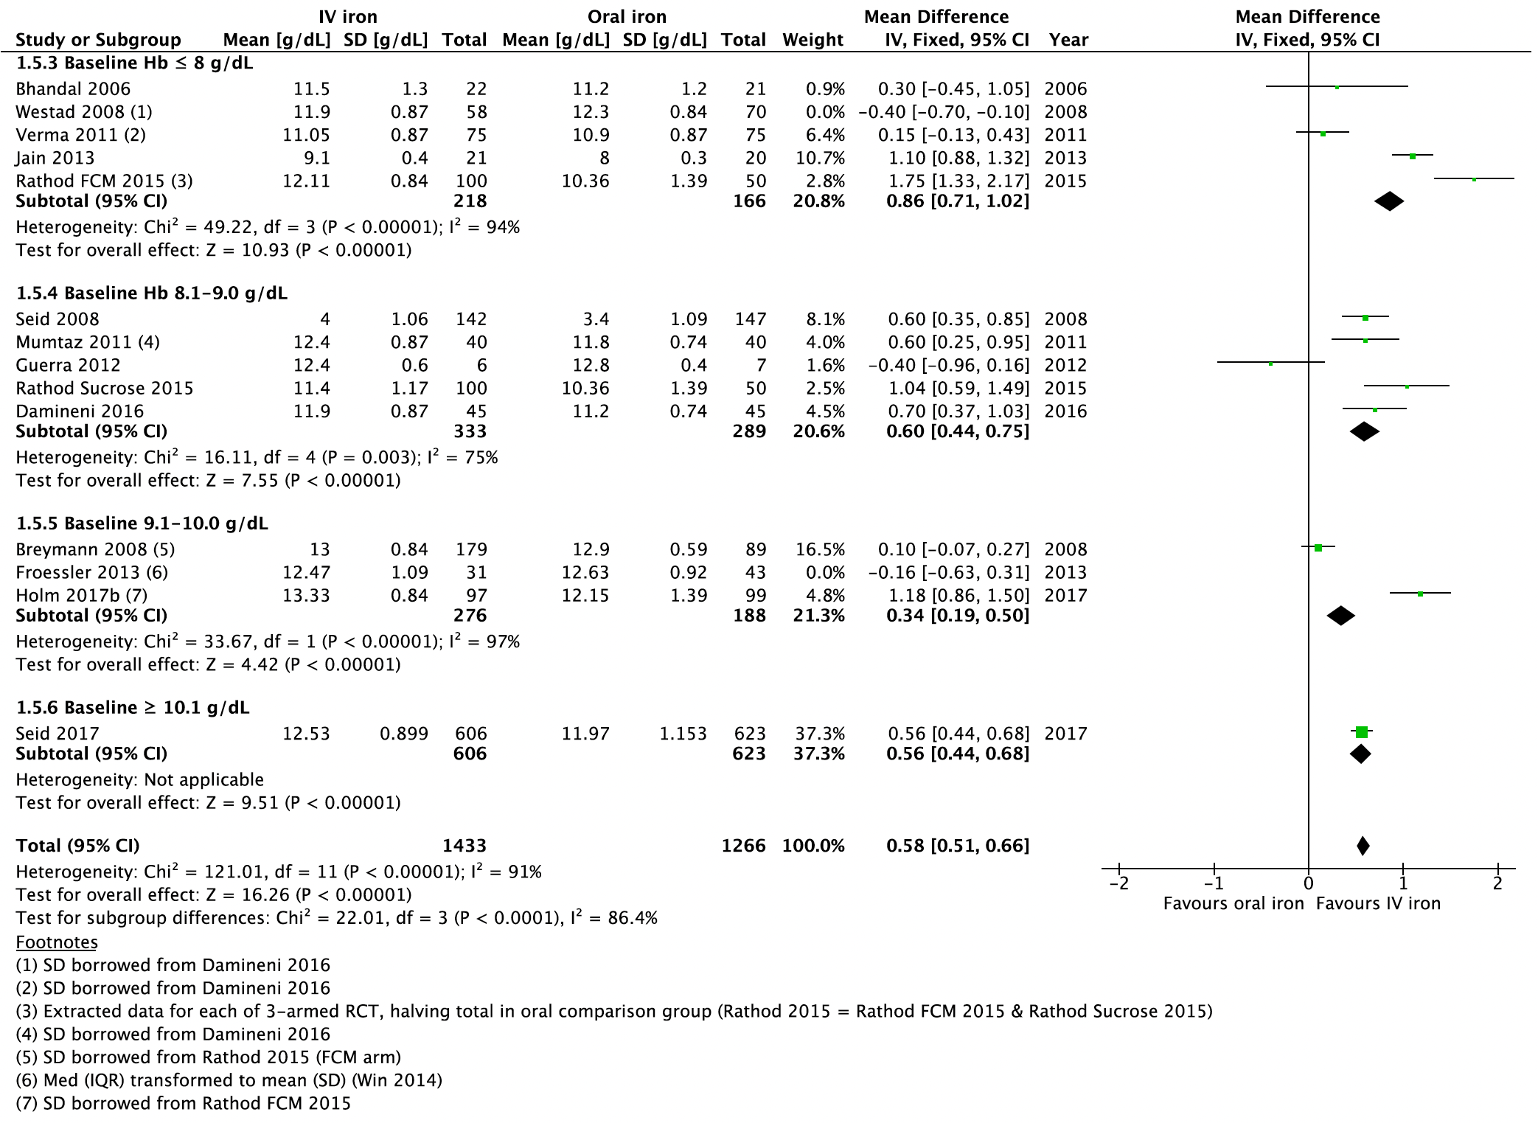

Additional Figure 5: Funnel Plot for comparison of IV iron vs. oral iron: Hb concentration at longest follow-up (g/dL)

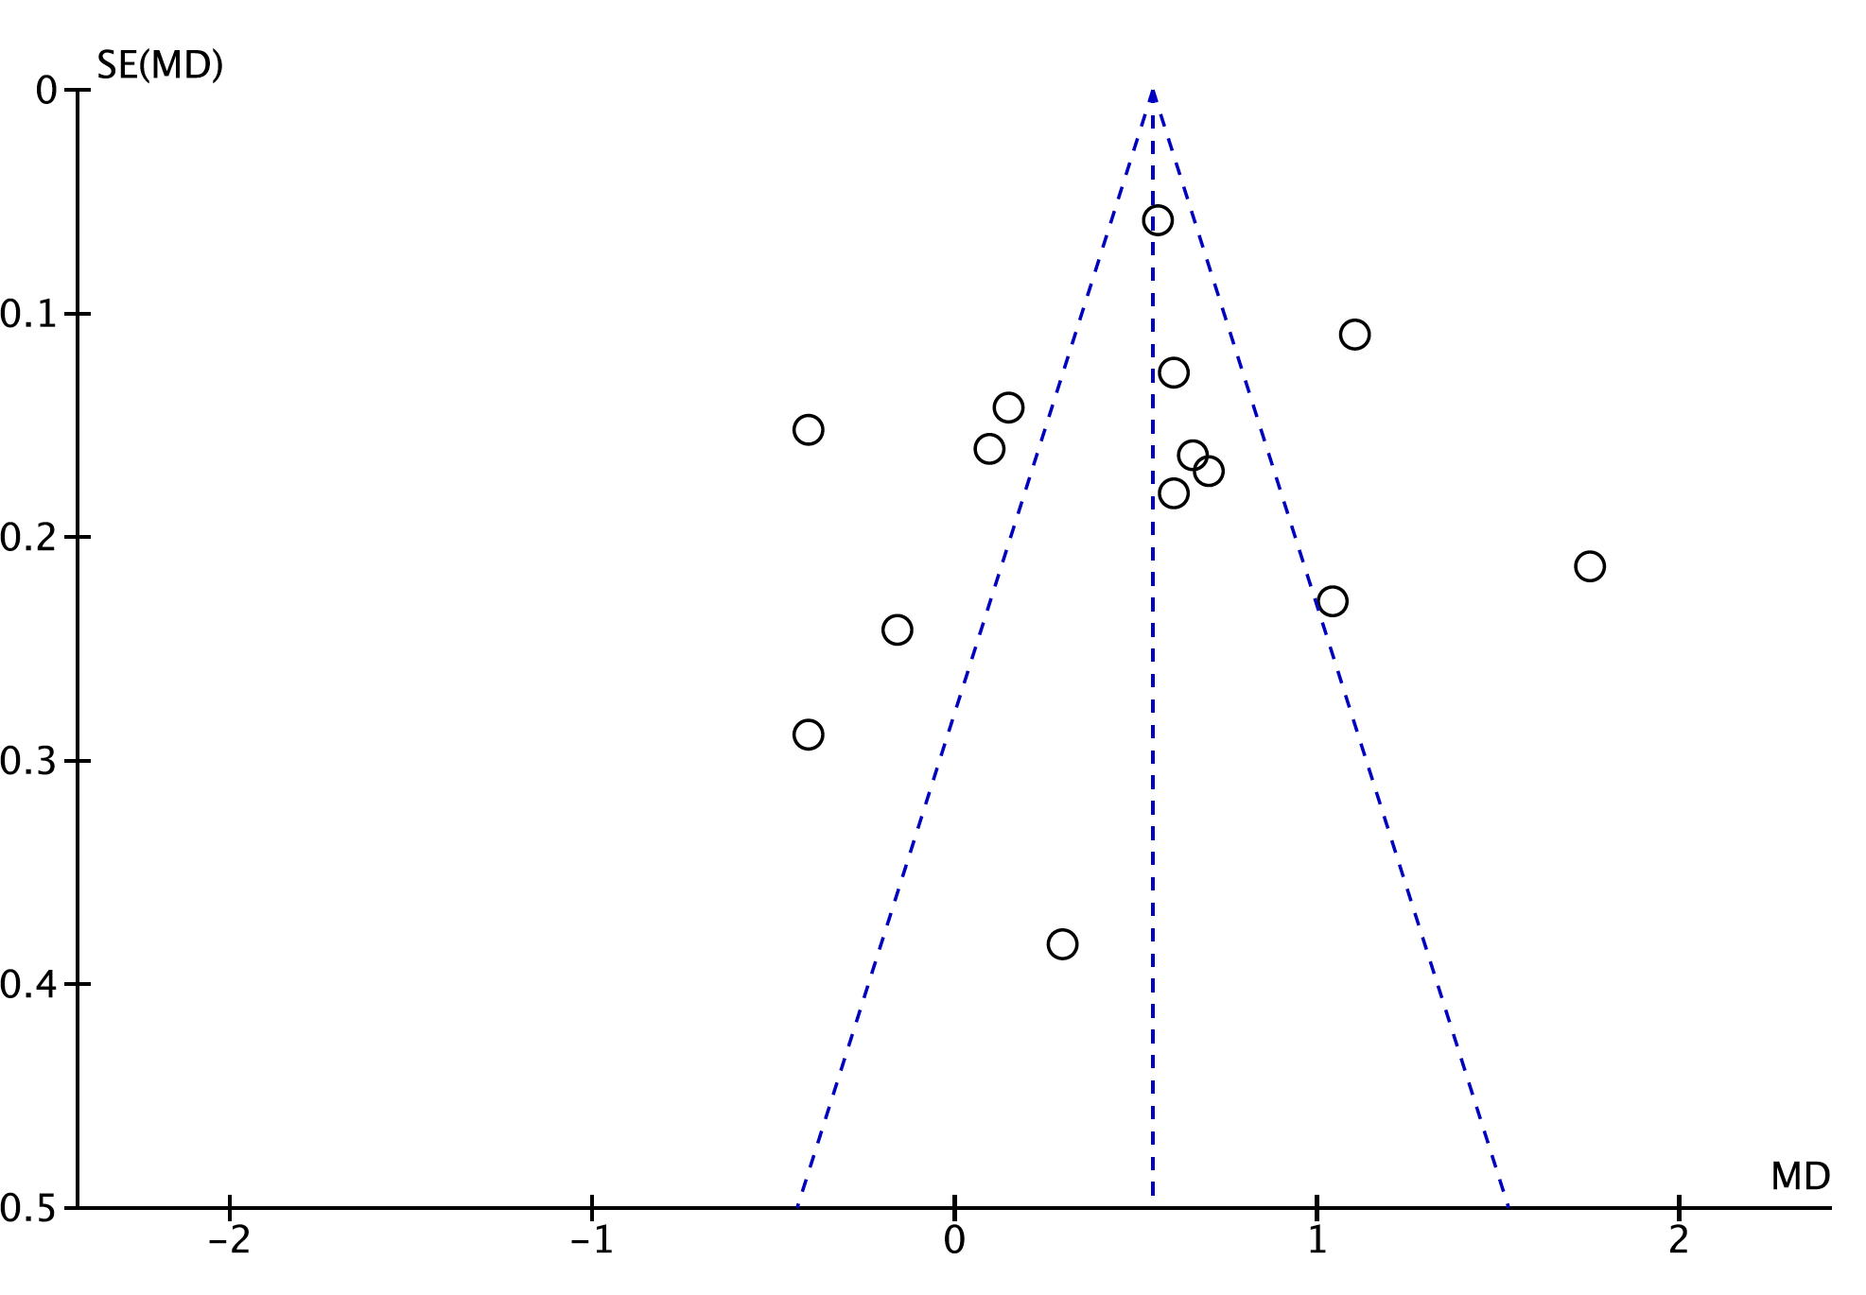

Additional File Figure 6: Forest Plot of total drug-related adverse effects for comparison of IV-iron vs. oral iron

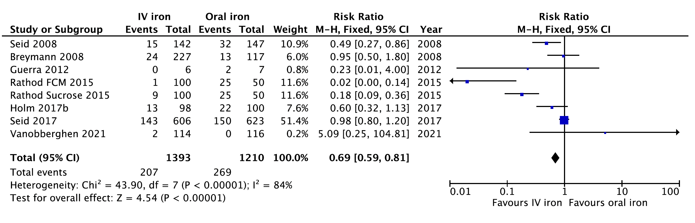

Additional Figure 7: Forest Plot of all gastrointestinal disorders for comparison of IV-iron vs. oral iron

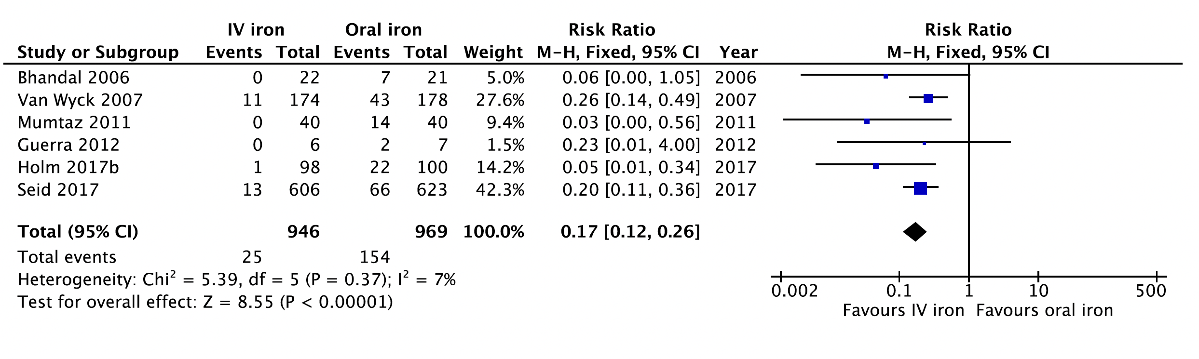

Additional Figure 8: Forest Plot of gastrointestinal disorders combined for comparison of IV-iron vs. oral iron

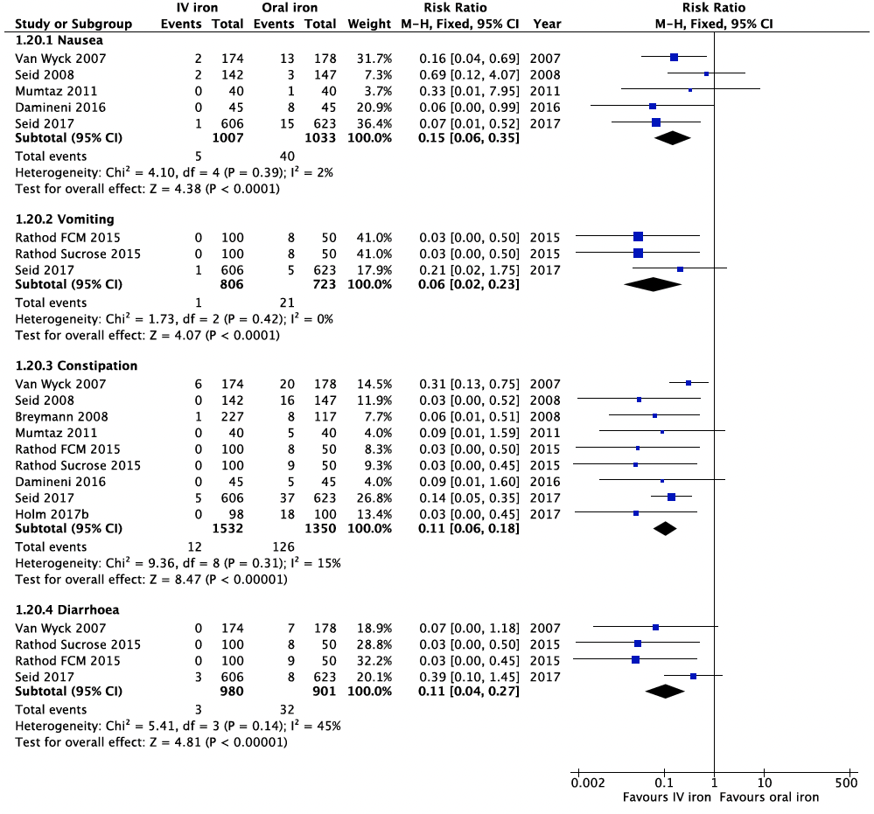

Additional Figure 9: Forest Plot of generalized (systemic) adverse effects for comparison of IV-iron vs. oral iron
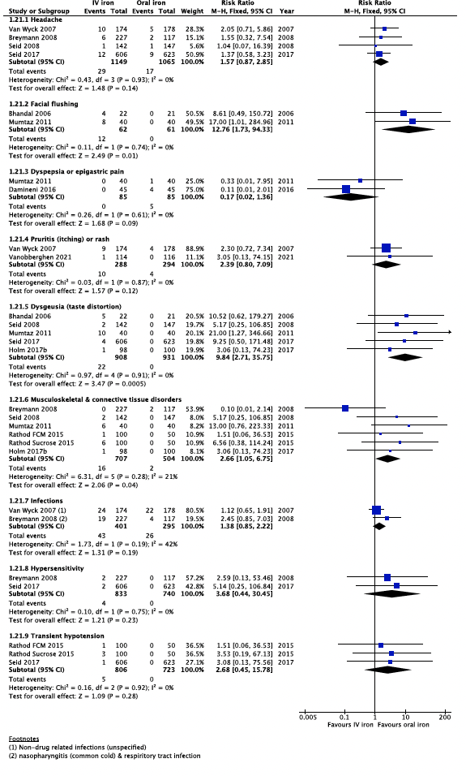

Additional Figure 10: Forest Plot of all injection site disorders for comparison of IV-iron vs. oral

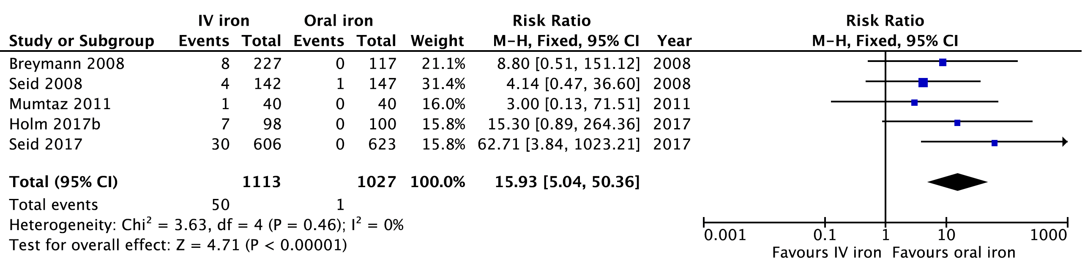

Additional Figure 11: Forest Plot of biochemical outcomes for comparison of IV-iron vs. oral iron

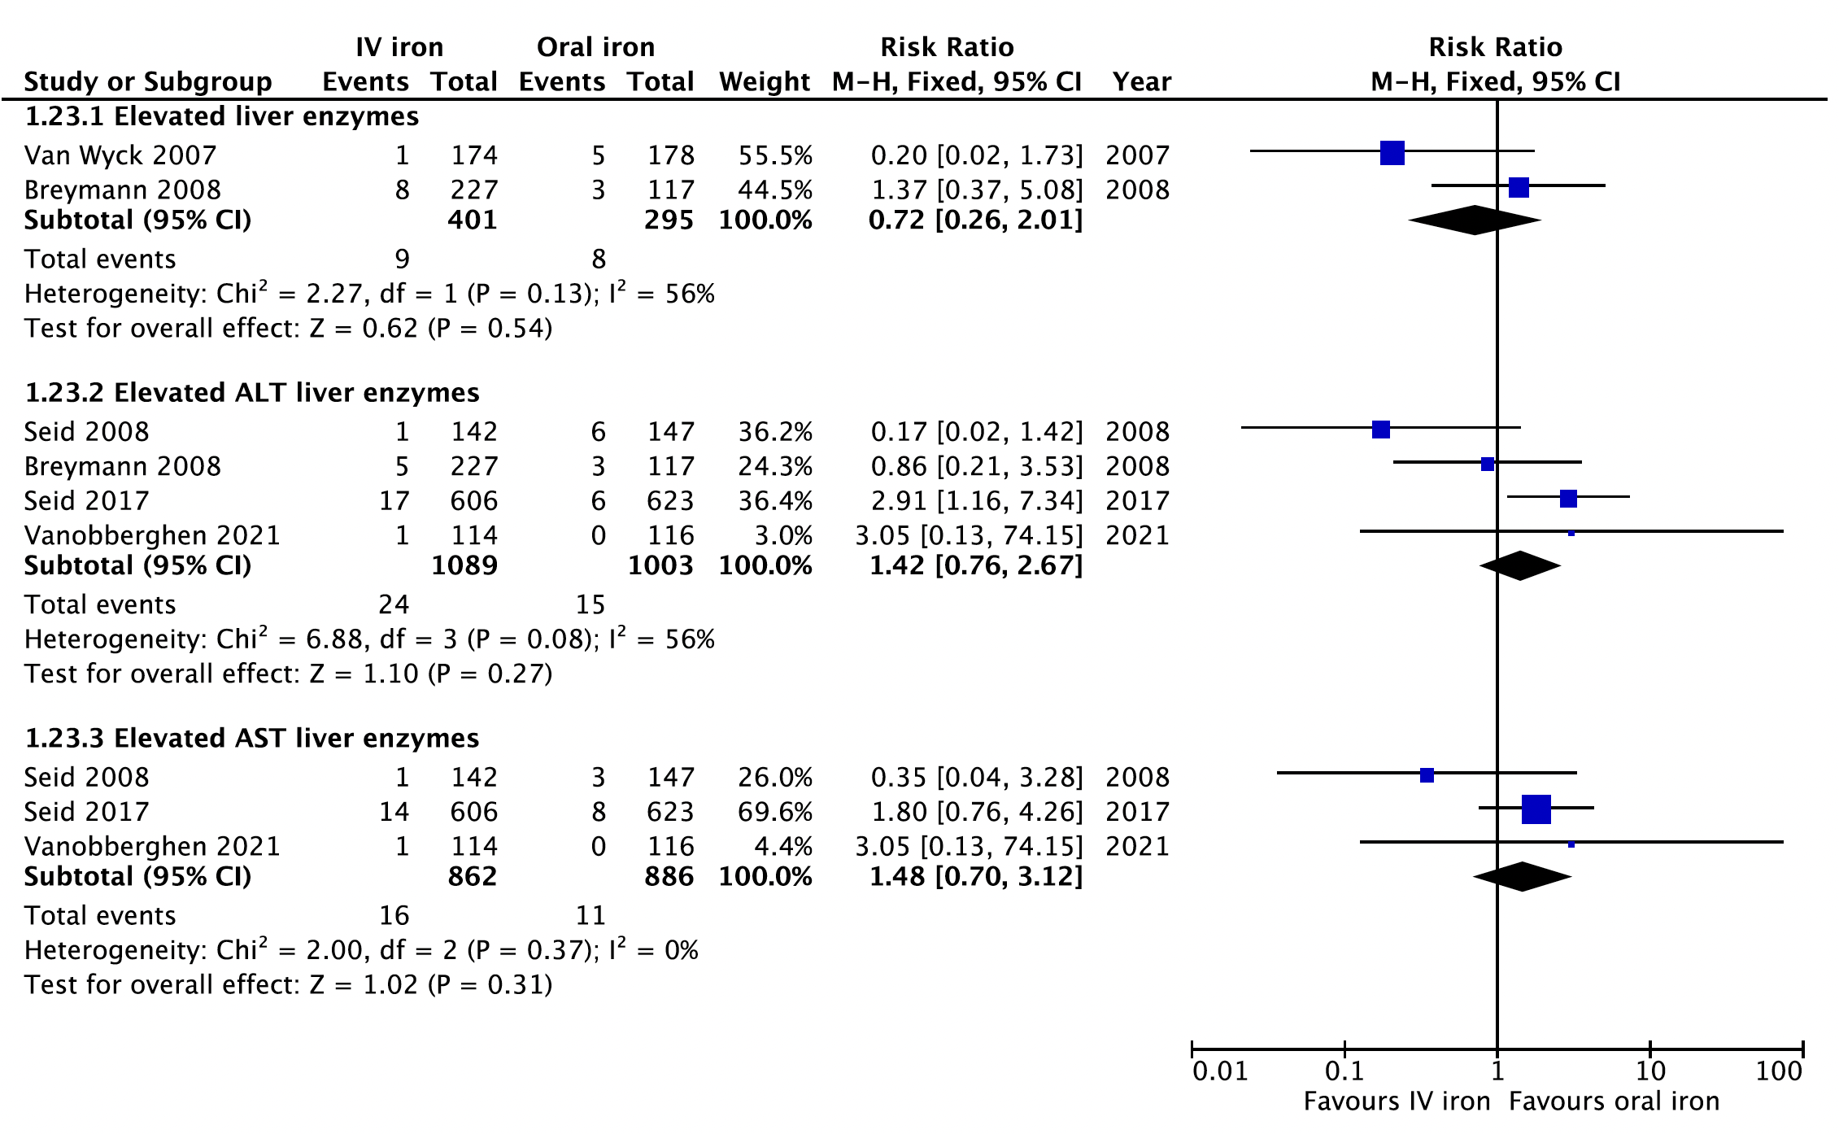

Additional Figure 12: Forest Plot of hypophosphataemia for comparison of IV-iron vs. oral iron

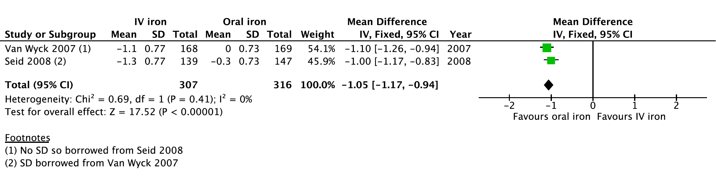

Additional File Appendix 2.

MEDLINE (Ovid)
- Postpartum Period/
- puerperal disorders/
- (postpartum or post partum or postnatal* or puerper*).ti,ab.
- 1 or 2 or 3
- Anemia/
- Anemia, Iron-deficiency/
- Postpartum Hemorrhage/
- (anaemia or anemia or anaemic or anemic or postpartum hemorrhage or haemorrhage or iron-deficien*).ti,ab.
- 5 or 6 or 7 or 8
- 4 and 9
- Iron/
- Ferric Compounds/
- Ferrous Compounds/
- Hematinics/ or iron-dextran complex/
- (iron or ferric compounds or ferrous or carboxymaltose or ferinject or iron-sucrose or venofer or isomaltoside or monofer or iron polymaltose or maltofer).ti,ab.
- Erythrocyte Transfusion/
- (erythrocyte transfusion or red blood cells or blood transfusion or allogenic).ti,ab.
- 11 or 12 or 13 or 14 or 15 or 16 or 17
- Administration, intravenous/ or infusion, intravenous/ or injections, intravenous/
- (intravenous administration or infusion* or injection*).mp.
- 19 or 20
- 18 and 21
- Randomized Controlled Trials as Topic/
- Controlled clinical trial.mp
- (randomi?ed controlled trial or clinical trial or random* or placebo).ti,ab.
- 23 or 24 or 25
- 10 and 22 and 26

