Supplementary Online Content

PRISMA Checklist

eTable 1. Complete search algorithm used in pubmed, embase and cochrane search.

eTable 2. Quality assessment of included studies with the Newcastle–Ottawa Scale.

eFigure 1. Funnel plots for outcomes after intravenous thrombolysis in acute ischemic stroke patients with prestroke disability. (a: good clinical outcome at 90 days; b: Successful reperfusion; c: mortality at 90 days; d: symptomatic intracranial hemorrhage). 3-month good clinical outcome defined as an modified Rankin Scores of 0-2, successful reperfusion defined as thrombolysis in cerebral infarction scores of 2b to 3.

 PRISMA 2020 Checklist
Section and Topic | Item# | Checklist item | where item  is reported
TITLE
Title | 1 | Identify the report as a systematic review. | Page1
ABSTRACT
Abstract | 2 | See the PRISMA 2020 for Abstracts checklist. | Page1-2
INTRODUCTION
Rationale | 3 | Describe the rationale for the review in the context of existing knowledge. | Page3
Objectives | 4 | Provide an explicit statement of the objective (s) or question (s) the review addresses. | Page3
METHODS
Eligibility criteria | 5 | Specify the inclusion and exclusion criteria for the review and how studies were grouped for the syntheses. | Page4
Information sources | 6 | Specify all databases, registers, websites, organisations, reference lists and other sources searched or consulted to identify studies. Specify the date when each source was last searched or consulted. | Page4
Search strategy | 7 | Present the full search strategies for all databases, registers and websites, including any filters and limits used. | Page4
Selection process | 8 | Specify the methods used to decide whether a study met the inclusion criteria of the review, including how many reviewers screened each record and each report retrieved, whether they worked independently, and if applicable, details of automation tools used in the process. | Page4
Data collection process | 9 | Specify the methods used to collect data from reports, including how many reviewers collected data from each report, whether they worked independently, any processes for obtaining or confirming data from study investigators, and if applicable, details of automation tools used in the process. | Page5
Data items | 10a | List and define all outcomes for which data were sought. Specify whether all results that were compatible with each outcome domain in each study were sought (e.g. for all measures, time points, analyses), and if not, the methods used to decide which results to collect. | Page4-5
Data items | 10b | List and define all other variables for which data were sought (e.g. participant and intervention characteristics, funding sources). Describe any assumptions made about any missing or unclear information. | Page4-5
Study risk of bias  assessment | 11 | Specify the methods used to assess risk of bias in the included studies, including details of the tool(s) used, how many reviewers assessed each study and whether they worked independently, and if applicable, details of automation tools used in the process. | Page5
Effect measures | 12 | Specify for each outcome the effect measure(s) (e.g. risk ratio, mean difference) used in the synthesis or presentation of results. | Page5
Synthesis methods | 13a | Describe the processes used to decide which studies were eligible for each synthesis (e.g. tabulating the study intervention characteristics and comparing against the planned groups for each synthesis (item #5)). | Page5
Synthesis methods | 13b | Describe any methods required to prepare the data for presentation or synthesis, such as handling of missing summary statistics, or data conversions. | Page5
Synthesis methods | 13c | Describe any methods used to tabulate or visually display results of individual studies and syntheses. | Page5
Synthesis methods | 13d | Describe any methods used to synthesize results and provide a rationale for the choice(s). If meta-analysis was performed, describe the model(s), method(s) to identify the presence and extent of statistical heterogeneity, and software package(s) used. | Page5
Synthesis methods | 13e | Describe any methods used to explore possible causes of heterogeneity among study results (e.g. subgroup analysis, meta-regression). | Page5
Synthesis methods | 13f | Describe any sensitivity analyses conducted to assess robustness of the synthesized results. | Page5
Reporting bias  assessment | 14 | Describe any methods used to assess risk of bias due to missing results in a synthesis (arising from reporting biases). | Page5
Certainty assessment | 15 | Describe any methods used to assess certainty (or confidence) in the body of evidence for an outcome. | Page5
RESULTS
Study selection | 16a | Describe the results of the search and selection process, from the number of records identified in the search to the number of studies included in the review, ideally using a flow diagram. | Page5-6
Study selection | 16b | Cite studies that might appear to meet the inclusion criteria, but which were excluded, and explain why they were excluded. | Page5-6
Study characteristics | 17 | Cite each included study and present its characteristics. | Page6
Risk of bias in studies | 18 | Present assessments of risk of bias for each included study. | Page6
Results of individual  studies | 19 | For all outcomes, present, for each study: (a) summary statistics for each group (where appropriate) and (b) an effect estimate and its precision (e.g. confidence/credible interval), ideally using structured tables or plots. | Page6
Results of syntheses | 20a | For each synthesis, briefly summarise the characteristics and risk of bias among contributing studies. | Page6
Results of syntheses | 20b | Present results of all statistical syntheses conducted. If meta-analysis was done, present for each the summary estimate and its precision (e.g. confidence/credible interval) and measures of statistical heterogeneity. If comparing groups, describe the direction of the effect. | Page6
Results of syntheses | 20c | Present results of all investigations of possible causes of heterogeneity among study results. | Page6
Results of syntheses | 20d | Present results of all sensitivity analyses conducted to assess the robustness of the synthesized results. | Page6
Reporting biases | 21 | Present assessments of risk of bias due to missing results (arising from reporting biases) for each synthesis assessed. | Page6
Certainty of evidence | 22 | Present assessments of certainty (or confidence) in the body of evidence for each outcome assessed. | Page6
DISCUSSION
Discussion | 23a | Provide a general interpretation of the results in the context of other evidence. | Page7-8
 | 23b | Discuss any limitations of the evidence included in the review. | Page8-9
 | 23c | Discuss any limitations of the review processes used. | Page8-9
 | 23d | Discuss implications of the results for practice, policy, and future research. | Page8
OTHER INFORMATION
Registration and  protocol | 24a | Provide registration information for the review, including register name and registration number, or state that the review was not registered. | Page4
 | 24b | Indicate where the review protocol can be accessed, or state that a protocol was not prepared. | Page4
 | 24c | Describe and explain any amendments to information provided at registration or in the protocol. | Page4
Support | 25 | Describe sources of financial or non-financial support for the review, and the role of the funders or sponsors in the review. | Not applicable
Competing interests | 26 | Declare any competing interests of review authors. | Page9
Availability of data,  code and other  materials | 27 | Report which of the following are publicly available and where they can be found: template data collection forms; data extracted from included studies; data used for all analyses; analytic code; any other materials used in the review. | Page4

eTable 1. Complete search algorithm used in pubmed, embase and cochrane search.
Database | search strategies
PubMed: | 1. Stroke [MeSH Terms]  2. Brain Ischemia [MeSH Terms]  3. Intracranial Embolism and Thrombosis [MeSH Terms]  4. (stroke* or AIS or apople*) [Title/Abstract]  5. ((intracranial or carotid arter* or brain or cerebr*) and (isch*emi* or embolism or thrombosis or obstruct* or occlus* or block* or infarct* or clot*)) [Title/Abstract]  6. (cerebrovascular or cerebral arter*) and (accident or event* or disorder* or disease*) [Title/Abstract]  7. (anterior circulation or ACA) [Title/Abstract]  8. (large vessel occlusion* or large arter* occlusion* or LVO) [Title/Abstract]  9. or 1-8  10. (Atrial Fibrillation OR Auricular fibrillation* OR AF OR AFib) [Title/Abstract]  11. Thrombectomy [MeSH Terms]  12. Embolectomy [MeSH Terms]  13. (mechanical or endovascular) and (thromb* or embol*)[Title/Abstract]  14. (thrombectomy or embolectomy or EVT or MT) [Title/Abstract]  15. (bridg* or endovascular) and (therapy or treatment or intervention) [Title/Abstract]  16. ((clot* or thromb* or embol* or stent*) and (retriev* or disruption* or fragmentation)) [Title/Abstract]  17. (stent-retriever or aspiration or solitaire or trevo or preset or catch) [Title/Abstract]  18. or 11-17  19. (Fibrinolysin or Plasminogen or plasminogen activators or Thrombolytic Therapy or Fibrinolysis or Thrombosis/drug therapy or Thromboembolism/drug therapy or Intracranial Thrombosis/drug therapy or Intracranial Embolism/drug therapy or Intracranial Embolism and Thrombosis/drug therapy) [MeSH Terms]  20 (Fibrogammin or Thrombolysin or Plasmin or plasminogen activator* or Thrombolys* or Thrombolytic or Fibrinolytic or alteplase or tPA or t-PA or rtPA or rt-PA or Tenecteplase or TNK-tPA) [Title/Abstract]  21. or 19-20  22. 9 and 10 and 18 and 21
Embase: | 1. 'brain infarction'/exp or 'brain infarction'/exp or 'cerebrovascular accident'/exp or 'occlusive cerebrovascular disease'/exp  2. 'stroke*':ab,ti or 'AIS':ab,ti or 'apople*':ab,ti  3. ('intracranial':ab,ti or 'carotid arter*':ab,ti or 'brain':ab,ti or 'cerebr*':ab,ti) and ('isch*emi*':ab,ti or 'embolism':ab,ti or 'thrombosis':ab,ti or 'obstruct*':ab,ti or 'occlus*':ab,ti or ' block*':ab,ti or 'infarct*':ab,ti or 'clot*':ab,ti)  4. ('cerebrovascular':ab,ti or 'cerebral arter*':ab,ti) and ('accident':ab,ti or 'event*':ab,ti or 'disorder*':ab,ti or 'disease*':ab,ti)  5. 'large vessel occlusion*':ab,ti or 'large arter* occlusion*':ab,ti or 'anterior circulation occlusion*':ab,ti or 'LVO':ab,ti  6. or 1-5  7. 'Atrial Fibrillation':ab,ti or 'AF':ab,ti or 'AFib':ab,ti  8. 'thrombectomy'/exp or 'embolectomy'/exp  9. 'thrombectomy':ab,ti or 'embolectomy':ab,ti  10. ('mechanical':ab,ti or 'endovascular':ab,ti) and ('thromb*':ab,ti or 'embol*':ab,ti)  11.('bridg*':ab,ti or 'endovascular':ab,ti) and ('therapy':ab,ti or 'treatment':ab,ti or 'intervention':ab,ti)  12.'stent-retriever':ab,ti or 'aspiration':ab,ti or 'solitaire':ab,ti or 'trevo':ab,ti or 'preset':ab,ti or 'catch':ab,ti  13. or 8-12  14. 'plasmin'/exp or 'plasminogen'/exp or 'plasminogen activator'/exp or 'fibrinolytic therapy'/exp or 'fibrinolysis'/exp  15. 'fibrinolysin':ab,ti or 'fibrogammin':ab,ti or 'thrombolysin':ab,ti or 'plasmin':ab,ti or 'plasminogen activator*':ab,ti or 'thrombolys*':ab,ti or 'thrombolytic':ab,ti or 'fibrinolytic':ab,ti or 'thrombosis/drug therapy':ab,ti or 'thromboembolism/drug therapy':ab,ti or 'intracranial thrombosis/drug therapy':ab,ti or 'intracranial embolism/drug therapy':ab,ti or 'intracranial embolism thrombosis/drug therapy':ab,ti  16. 'alteplase':ab,ti or 'tpa':ab,ti or 't pa':ab,ti or 'rtpa':ab,ti or 'rt pa':ab,ti or 'Tenecteplase':ab,ti or 'TNK-tPA':ab,ti  17. 14-16  18. 6 and 7 and 13 and 17
Cochrane | 1. MeSH descriptor: [Stroke] explode all trees  2. "Cerebrovascular event" or Stroke or apoplex or CVA or "cerebrovascular accident" or "brain vascular accident" or "brain isch*" or "brain infarc*" or "cerebral infarc$" or "cerebral isch$" or ”large vessel occlusion” or "intracranial isch*" or "intracranial infarction" or "intracranial vessel occlusion" or "brain vessel occlusion"  3. 1 or 2  4. MeSH descriptor: [Thrombectomy] explode all trees  5. Thrombectomy or thrombectomie$ or mechanical or endovascular or embolectomy  or "intracranial intervention" or Stent-retriever or stentretriever or preset or solitaire or  trevo or catch  6. 4 or 5  7. MeSH descriptor:Atrial Fibrillation  (Atrial Fibrillation OR Auricular fibrillation* OR AF OR AFib) [All Fields]  8. (thrombolysis OR tPA OR tissue plasminogen activator)[All Fields]  9. 3 and 6 and 7 and 8

eTable 2. Quality assessment of included studies with the Newcastle–Ottawa Scale.
Reference | Selection | Comparability | Outcome | Overall score
Loo et al,2023 | *** | * | ** | 6/9
Lin et al, 2023 | **** | * | *** | 8/9
Cao et al, 2022 | *** | ** | ** | 7/9
Akbik et al, 2022 | *** | * | ** | 6/9
Mujanovic et al, 2022 | *** | * | *** | 7/9
Chen et al, 2022 | *** | * | ** | 6/9
Yaghi et al, 2021 | *** | * | ** | 6/9
Chalos et al, 2019 | **** | * | ** | 7/9
Overall Score | 26/32 | 9/16 | 18/24 | 53/72

eFigure 1. Funnel plots for outcomes after intravenous thrombolysis in acute ischemic stroke patients with prestroke disability. (a: good clinical outcome at 90 days; b: Successful reperfusion; c: mortality at 90 days; d: symptomatic intracranial hemorrhage)
a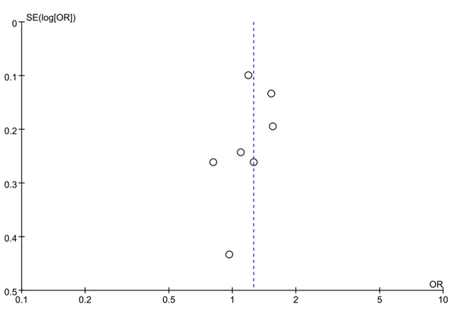b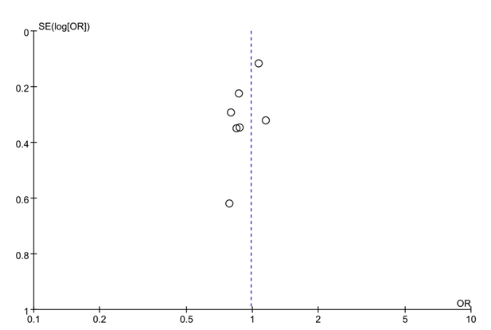
c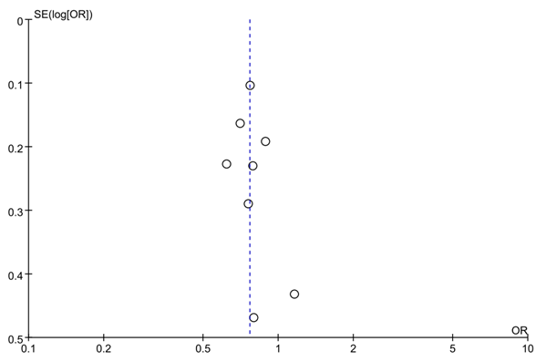d