Additional file 6
Data synthesis

Table of Contents
Bibliographic characteristics 2
PICO 3
Population 3
Intervention 4
Comparison 5
Outcome 5
Outcome strength of evidence 7
Dissemination data from Cochrane website 9
Dissemination: clinical guidelines 11
Dissemination Altmetric data 12
Weighing of Altmetric data 12
Dissemination online sources 13
Dissemination all mentions 15
Dissemination Altmetric Score 18
Regression analysis 23
Variable distribution 23
Variables in regression n=87 28
Binary logistic regression analysis n=87 30
Sensitivity analysis: Binary logistic regression analysis n=84 32

Bibliographic characteristics

Statistics
 |  | publication year | 3b Region of corresponding author | 6 Review type | meta analysis performed yes vs. no | primary studies in review
N | Valid | 100 | 100 | 100 | 100 | 100
N | Missing | 0 | 0 | 0 | 0 | 0
Minimum |  | 2005 |  |  |  | 1
Maximum |  | 2023 |  |  |  | 132

3b Region of corresponding author
 |  | Frequency | Percent | Valid Percent | Cumulative Percent
Valid | Africa | 2 | 2.0 | 2.0 | 2.0
Valid | Asia | 3 | 3.0 | 3.0 | 5.0
Valid | Australia | 21 | 21.0 | 21.0 | 26.0
Valid | Europe | 61 | 61.0 | 61.0 | 87.0
Valid | North America | 13 | 13.0 | 13.0 | 100.0
Valid | Total | 100 | 100.0 | 100.0

6 Review type
 |  | Frequency | Percent | Valid Percent | Cumulative Percent
Valid | overview of reviews | 1 | 1.0 | 1.0 | 1.0
Valid | rapid review | 2 | 2.0 | 2.0 | 3.0
Valid | systematic review | 97 | 97.0 | 97.0 | 100.0
Valid | Total | 100 | 100.0 | 100.0

meta analysis performed yes vs. no
 |  | Frequency | Percent | Valid Percent | Cumulative Percent
Valid | no | 31 | 31.0 | 31.0 | 31.0
Valid | yes | 69 | 69.0 | 69.0 | 100.0
Valid | Total | 100 | 100.0 | 100.0

PICO

Population
Population by type | n studies
consumers (clients, patients or carers) | 86
healthcare professionals | 16

Population by age if consumers | n studies
any adults or children | 44
only adults | 36
only children | 6
sum | 86

Population by health if consumers (clients, patients or carers) | n studies
any clinical or healthy | 16
only healthy | 2
only clinical | 68
sum | 86

Disease group or clinical focus if healthy | n studies
brain | 34
any disease | 16
respiratory | 13
other in <10 reviews | 23
genitourinary | 9
cardiovascular | 4
endocrine | 3
gastrointestinal | 3
genetic | 2
cancer | 1
infectious | 1
NA (only healthcare professionals) | 14
sum | 100

Intervention
0b Intervention
 |  | Frequency | Percent | Valid Percent | Cumulative Percent
Valid | multiple | 75 | 75.0 | 75.0 | 75.0
Valid | single | 25 | 25.0 | 25.0 | 100.0
Valid | Total | 100 | 100.0 | 100.0

0c Digital Intervention
 |  | Frequency | Percent | Valid Percent | Cumulative Percent
Valid | All digital | 62 | 62.0 | 62.0 | 62.0
Valid | mixed | 38 | 38.0 | 38.0 | 100.0
Valid | Total | 100 | 100.0 | 100.0

15 Intervention type (based on Item 13)
 |  | Frequency | Percent | Valid Percent | Cumulative Percent
Valid | any | 70 | 70.0 | 70.0 | 70.0
Valid | mobile | 21 | 21.0 | 21.0 | 91.0
Valid | not mobile | 9 | 9.0 | 9.0 | 100.0
Valid | Total | 100 | 100.0 | 100.0

16b Digital device type (based on Item 16a)
 |  | Frequency | Percent | Valid Percent | Cumulative Percent
Valid | any | 73 | 73.0 | 73.0 | 73.0
Valid | computer | 9 | 9.0 | 9.0 | 82.0
Valid | mobile phone | 12 | 12.0 | 12.0 | 94.0
Valid | mobile phone, computer | 1 | 1.0 | 1.0 | 95.0
Valid | mobile phone, tablet | 2 | 2.0 | 2.0 | 97.0
Valid | mobile phone, tablet, personal digital assistant | 1 | 1.0 | 1.0 | 98.0
Valid | tablet | 1 | 1.0 | 1.0 | 99.0
Valid | wearable | 1 | 1.0 | 1.0 | 100.0
Valid | Total | 100 | 100.0 | 100.0

Comparison

18 Comparison
type (based on Item 17, at least one comparison= digital)
 |  | Frequency | Percent | Valid Percent | Cumulative Percent
Valid | digital | 40 | 40.0 | 40.0 | 40.0
Valid | no comparison | 3 | 3.0 | 3.0 | 43.0
Valid | not digital | 57 | 57.0 | 57.0 | 100.0
Valid | Total | 100 | 100.0 | 100.0

Outcome
Health focus | n studies
treatment | 56
health promotion and disease prevention | 27
management | 17
sum | 100

Outcome focus |  | n studies
treatment | therapy | 17
treatment | disease management or monitoring | 23
treatment | adherence | 9
treatment | rehabilitation | 7
treatment | sum | 56
health promotion and disease prevention | health education | 17
health promotion and disease prevention | lifestyle monitoring | 10
health promotion and disease prevention | sum | 27
management | support systems | 11
management | medical training | 3
management | patient management via electronic health records | 3
management | sum | 17

21b Health focus (based on Item 21a)
 |  | Frequency | Percent | Valid Percent | Cumulative Percent
Valid | health promotion and disease prevention | 27 | 100.0 | 100.0 | 100.0

health focus health promotion and disease prevention
 |  | Frequency | Percent | Valid Percent | Cumulative Percent
Valid | any | 5 | 18.5 | 18.5 | 18.5
Valid | cardiovascular | 1 | 3.7 | 3.7 | 22.2
Valid | cholecystectomy | 1 | 3.7 | 3.7 | 25.9
Valid | chronic disease | 1 | 3.7 | 3.7 | 29.6
Valid | chronic kidney disease | 1 | 3.7 | 3.7 | 33.3
Valid | dementia | 1 | 3.7 | 3.7 | 37.0
Valid | immunization | 1 | 3.7 | 3.7 | 40.7
Valid | obesity | 1 | 3.7 | 3.7 | 44.4
Valid | pain | 1 | 3.7 | 3.7 | 48.1
Valid | reproductive | 7 | 25.9 | 25.9 | 74.1
Valid | social isolation | 1 | 3.7 | 3.7 | 77.8
Valid | stress | 2 | 7.4 | 7.4 | 85.2
Valid | substance misuse | 4 | 14.8 | 14.8 | 100.0
Valid | Total | 27 | 100.0 | 100.0

Outcome strength of evidence

Statistics
 |  | outcomes rated | outcomes strong | outcome moderate | outcome low | outcome very low
N | Valid | 100 | 87 | 87 | 87 | 87
N | Missing | 0 | 13 | 13 | 13 | 13

outcomes rated
 |  | Frequency | Percent | Valid Percent | Cumulative Percent
Valid | no | 13 | 13.0 | 13.0 | 13.0
Valid | yes | 87 | 87.0 | 87.0 | 100.0
Valid | Total | 100 | 100.0 | 100.0

outcomes strong
 |  | Frequency | Percent | Valid Percent | Cumulative Percent
Valid | no | 77 | 77.0 | 88.5 | 88.5
Valid | yes | 10 | 10.0 | 11.5 | 100.0
Valid | Total | 87 | 87.0 | 100.0
Missing | -99 | 13 | 13.0
Total |  | 100 | 100.0

outcome moderate
 |  | Frequency | Percent | Valid Percent | Cumulative Percent
Valid | no | 42 | 42.0 | 48.3 | 48.3
Valid | yes | 45 | 45.0 | 51.7 | 100.0
Valid | Total | 87 | 87.0 | 100.0
Missing | -99 | 13 | 13.0
Total |  | 100 | 100.0

outcome low
 |  | Frequency | Percent | Valid Percent | Cumulative Percent
Valid | no | 16 | 16.0 | 18.4 | 18.4
Valid | yes | 71 | 71.0 | 81.6 | 100.0
Valid | Total | 87 | 87.0 | 100.0
Missing | -99 | 13 | 13.0
Total |  | 100 | 100.0

outcome very low
 |  | Frequency | Percent | Valid Percent | Cumulative Percent
Valid | no | 29 | 29.0 | 33.3 | 33.3
Valid | yes | 58 | 58.0 | 66.7 | 100.0
Valid | Total | 87 | 87.0 | 100.0
Missing | -99 | 13 | 13.0
Total |  | 100 | 100.0

Statistics
 |  | 22 Number of quantitative rated outcomes (based on Summary of findings) | 22a Number of outcomes with strong/high evidence (based on Item 22) | 22b Number of outcomes with moderate evidence (based on Item 22) | 22c Number of outcomes with low evidence (based on Item 22) | 22d Number of outcomes with very low evidence (based on Item 22)
N | Valid | 100 | 87 | 87 | 87 | 87
N | Missing | 0 | 13 | 13 | 13 | 13
Mean |  | 7.67 | .25 | 1.95 | 3.43 | 3.18
Median |  | 6.00 | .00 | 1.00 | 3.00 | 2.00
Mode |  | 0 | 0 | 0 | 3 | 0
Std. Deviation |  | 7.107 | .892 | 3.114 | 3.633 | 4.334
Minimum |  | 0 | 0 | 0 | 0 | 0
Maximum |  | 48 | 6 | 20 | 23 | 19
Sum |  | 767 | 22 | 170 | 298 | 277

Dissemination data from Cochrane website

23 PLS included (from Cochrane Website)
 |  | Frequency | Percent | Valid Percent | Cumulative Percent
Valid | yes | 100 | 100.0 | 100.0 | 100.0

24 PLS OA (from Cochrane Website)
 |  | Frequency | Percent | Valid Percent | Cumulative Percent
Valid | yes | 100 | 100.0 | 100.0 | 100.0

25 PLS type (from Cochrane Website)
 |  | Frequency | Percent | Valid Percent | Cumulative Percent
Valid | text-based | 100 | 100.0 | 100.0 | 100.0

26 PLS translation (from Cochrane Website)
 |  | Frequency | Percent | Valid Percent | Cumulative Percent
Valid | yes | 100 | 100.0 | 100.0 | 100.0

28 PLS language number
 |  | Frequency | Percent | Valid Percent | Cumulative Percent
Valid | 3 | 10 | 10.0 | 10.0 | 10.0
Valid | 4 | 10 | 10.0 | 10.0 | 20.0
Valid | 5 | 9 | 9.0 | 9.0 | 29.0
Valid | 6 | 7 | 7.0 | 7.0 | 36.0
Valid | 7 | 4 | 4.0 | 4.0 | 40.0
Valid | 8 | 7 | 7.0 | 7.0 | 47.0
Valid | 9 | 18 | 18.0 | 18.0 | 65.0
Valid | 10 | 14 | 14.0 | 14.0 | 79.0
Valid | 11 | 7 | 7.0 | 7.0 | 86.0
Valid | 12 | 5 | 5.0 | 5.0 | 91.0
Valid | 13 | 5 | 5.0 | 5.0 | 96.0
Valid | 14 | 4 | 4.0 | 4.0 | 100.0
Valid | Total | 100 | 100.0 | 100.0

Languages PLS | n studies
NA | 0
English | 100
German | 54
Spanish | 100
Arabic | 72
French | 88
Croatian | 33
Japanese | 51
South Korean | 24
Malay | 69
Thai | 25
Tamil | 8
Polish | 27
Portuguese | 13
Russian | 52
simple Chinese | 45
traditional Chinese | 40
Total languages | 801

Dissemination: clinical guidelines

Statistics
30q guidelines (based on Item 30)
N | Valid | 100
N | Missing | 0
Mean |  | 2.11
Median |  | 1.00
Mode |  | 0
Std. Deviation |  | 3.168
Minimum |  | 0
Maximum |  | 18
Sum |  | 211

30q
Reviews cited in clinical guidelines
(based on Item 30)
 |  | Frequency | Percent | Valid Percent | Cumulative Percent
Valid | 0 | 40 | 40.0 | 40.0 | 40.0
Valid | 1 | 19 | 19.0 | 19.0 | 59.0
Valid | 2 | 15 | 15.0 | 15.0 | 74.0
Valid | 3 | 8 | 8.0 | 8.0 | 82.0
Valid | 4 | 3 | 3.0 | 3.0 | 85.0
Valid | 5 | 2 | 2.0 | 2.0 | 87.0
Valid | 6 | 3 | 3.0 | 3.0 | 90.0
Valid | 7 | 4 | 4.0 | 4.0 | 94.0
Valid | 8 | 2 | 2.0 | 2.0 | 96.0
Valid | 11 | 1 | 1.0 | 1.0 | 97.0
Valid | 12 | 1 | 1.0 | 1.0 | 98.0
Valid | 13 | 1 | 1.0 | 1.0 | 99.0
Valid | 18 | 1 | 1.0 | 1.0 | 100.0
Valid | Total | 100 | 100.0 | 100.0

Dissemination Altmetric data

Weighing of Altmetric data
https://help.altmetric.com/support/solutions/articles/6000232839-how-are-outputs-scored.
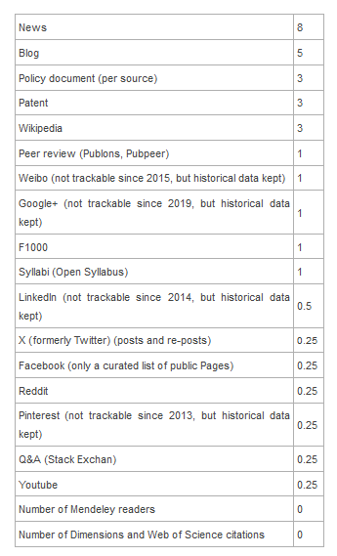

Dissemination online sources

Number | Type of channel | n studies
1 | Twitter | 99
2 | Facebook | 69
3 | Blogs | 48
4 | Policy sources | 40
5 | News | 33
6 | Wikipedia | 30
7 | Google+ | 6
8 | Youtube | 3
9 | Patent | 1
10 | Peer-reviews | 0
11 | Weibo | 0
12 | Syllabi | 0
13 | F1000 | 0
14 | LinkedIn | 0
15 | Reddit | 0
16 | Q&A | 0
17 | Pinterest | 0
 | Total | 329

Twitter
 |  | Frequency | Percent | Valid Percent | Cumulative Percent
Valid | 0 | 1 | 1.0 | 1.0 | 1.0
Valid | 1 | 99 | 99.0 | 99.0 | 100.0
Valid | Total | 100 | 100.0 | 100.0

Facebook
 |  | Frequency | Percent | Valid Percent | Cumulative Percent
Valid | 0 | 31 | 31.0 | 31.0 | 31.0
Valid | 1 | 69 | 69.0 | 69.0 | 100.0
Valid | Total | 100 | 100.0 | 100.0

blogs
 |  | Frequency | Percent | Valid Percent | Cumulative Percent
Valid | 0 | 52 | 52.0 | 52.0 | 52.0
Valid | 1 | 48 | 48.0 | 48.0 | 100.0
Valid | Total | 100 | 100.0 | 100.0

policy
 |  | Frequency | Percent | Valid Percent | Cumulative Percent
Valid | 0 | 60 | 60.0 | 60.0 | 60.0
Valid | 1 | 40 | 40.0 | 40.0 | 100.0
Valid | Total | 100 | 100.0 | 100.0

news
 |  | Frequency | Percent | Valid Percent | Cumulative Percent
Valid | 0 | 67 | 67.0 | 67.0 | 67.0
Valid | 1 | 33 | 33.0 | 33.0 | 100.0
Valid | Total | 100 | 100.0 | 100.0

Wikipedia
 |  | Frequency | Percent | Valid Percent | Cumulative Percent
Valid | 0 | 70 | 70.0 | 70.0 | 70.0
Valid | 1 | 30 | 30.0 | 30.0 | 100.0
Valid | Total | 100 | 100.0 | 100.0

Google_plus
 |  | Frequency | Percent | Valid Percent | Cumulative Percent
Valid | 0 | 94 | 94.0 | 94.0 | 94.0
Valid | 1 | 6 | 6.0 | 6.0 | 100.0
Valid | Total | 100 | 100.0 | 100.0

Youtube
 |  | Frequency | Percent | Valid Percent | Cumulative Percent
Valid | 0 | 97 | 97.0 | 97.0 | 97.0
Valid | 1 | 3 | 3.0 | 3.0 | 100.0
Valid | Total | 100 | 100.0 | 100.0

patents
 |  | Frequency | Percent | Valid Percent | Cumulative Percent
Valid | 0 | 99 | 99.0 | 99.0 | 99.0
Valid | 1 | 1 | 1.0 | 1.0 | 100.0
Valid | Total | 100 | 100.0 | 100.0

Dissemination all mentions

Statistics
Altmetric_all_posts
N | Valid | 100
N | Missing | 0
Mean |  | 46.61
Median |  | 34.00
Mode |  | 15
Std. Deviation |  | 48.489
Minimum |  | 1
Maximum |  | 271
Sum |  | 4661

Altmetric_all_posts
 |  | Frequency | Percent | Valid Percent | Cumulative Percent
Valid | 1 | 1 | 1.0 | 1.0 | 1.0
Valid | 2 | 3 | 3.0 | 3.0 | 4.0
Valid | 3 | 1 | 1.0 | 1.0 | 5.0
Valid | 4 | 2 | 2.0 | 2.0 | 7.0
Valid | 5 | 1 | 1.0 | 1.0 | 8.0
Valid | 6 | 4 | 4.0 | 4.0 | 12.0
Valid | 7 | 2 | 2.0 | 2.0 | 14.0
Valid | 9 | 1 | 1.0 | 1.0 | 15.0
Valid | 10 | 2 | 2.0 | 2.0 | 17.0
Valid | 11 | 1 | 1.0 | 1.0 | 18.0
Valid | 12 | 3 | 3.0 | 3.0 | 21.0
Valid | 13 | 1 | 1.0 | 1.0 | 22.0
Valid | 14 | 3 | 3.0 | 3.0 | 25.0
Valid | 15 | 6 | 6.0 | 6.0 | 31.0
Valid | 17 | 1 | 1.0 | 1.0 | 32.0
Valid | 19 | 1 | 1.0 | 1.0 | 33.0
Valid | 21 | 1 | 1.0 | 1.0 | 34.0
Valid | 22 | 3 | 3.0 | 3.0 | 37.0
Valid | 23 | 2 | 2.0 | 2.0 | 39.0
Valid | 26 | 1 | 1.0 | 1.0 | 40.0
Valid | 27 | 1 | 1.0 | 1.0 | 41.0
Valid | 28 | 2 | 2.0 | 2.0 | 43.0
Valid | 29 | 1 | 1.0 | 1.0 | 44.0
Valid | 30 | 1 | 1.0 | 1.0 | 45.0
Valid | 31 | 1 | 1.0 | 1.0 | 46.0
Valid | 32 | 1 | 1.0 | 1.0 | 47.0
Valid | 33 | 1 | 1.0 | 1.0 | 48.0
Valid | 34 | 5 | 5.0 | 5.0 | 53.0
Valid | 35 | 1 | 1.0 | 1.0 | 54.0
Valid | 36 | 1 | 1.0 | 1.0 | 55.0
Valid | 39 | 2 | 2.0 | 2.0 | 57.0
Valid | 41 | 2 | 2.0 | 2.0 | 59.0
Valid | 42 | 2 | 2.0 | 2.0 | 61.0
Valid | 44 | 1 | 1.0 | 1.0 | 62.0
Valid | 46 | 2 | 2.0 | 2.0 | 64.0
Valid | 47 | 3 | 3.0 | 3.0 | 67.0
Valid | 48 | 1 | 1.0 | 1.0 | 68.0
Valid | 50 | 1 | 1.0 | 1.0 | 69.0
Valid | 51 | 1 | 1.0 | 1.0 | 70.0
Valid | 53 | 2 | 2.0 | 2.0 | 72.0
Valid | 54 | 1 | 1.0 | 1.0 | 73.0
Valid | 55 | 1 | 1.0 | 1.0 | 74.0
Valid | 56 | 1 | 1.0 | 1.0 | 75.0
Valid | 58 | 1 | 1.0 | 1.0 | 76.0
Valid | 59 | 1 | 1.0 | 1.0 | 77.0
Valid | 60 | 1 | 1.0 | 1.0 | 78.0
Valid | 64 | 1 | 1.0 | 1.0 | 79.0
Valid | 67 | 1 | 1.0 | 1.0 | 80.0
Valid | 69 | 1 | 1.0 | 1.0 | 81.0
Valid | 70 | 1 | 1.0 | 1.0 | 82.0
Valid | 72 | 1 | 1.0 | 1.0 | 83.0
Valid | 78 | 1 | 1.0 | 1.0 | 84.0
Valid | 80 | 1 | 1.0 | 1.0 | 85.0
Valid | 82 | 1 | 1.0 | 1.0 | 86.0
Valid | 87 | 1 | 1.0 | 1.0 | 87.0
Valid | 93 | 1 | 1.0 | 1.0 | 88.0
Valid | 100 | 1 | 1.0 | 1.0 | 89.0
Valid | 110 | 2 | 2.0 | 2.0 | 91.0
Valid | 111 | 1 | 1.0 | 1.0 | 92.0
Valid | 129 | 1 | 1.0 | 1.0 | 93.0
Valid | 133 | 1 | 1.0 | 1.0 | 94.0
Valid | 134 | 1 | 1.0 | 1.0 | 95.0
Valid | 148 | 1 | 1.0 | 1.0 | 96.0
Valid | 152 | 1 | 1.0 | 1.0 | 97.0
Valid | 166 | 1 | 1.0 | 1.0 | 98.0
Valid | 261 | 1 | 1.0 | 1.0 | 99.0
Valid | 271 | 1 | 1.0 | 1.0 | 100.0
Valid | Total | 100 | 100.0 | 100.0

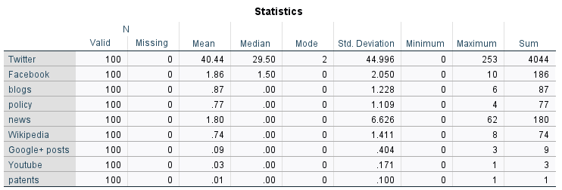

Dissemination Altmetric Score
Statistics
 |  |  |  | 29 Altmetric score (from Cochrane Website) |  |  |  | Altmetric score in the top of all research outputs %
N | Valid |  |  | 100 |  |  |  | 90
N | Missing |  |  | 0 |  |  |  | 10
Mean |  |  |  | 48.38 |  |  |  | 14.11
Median |  |  |  | 28.50 |  |  |  | 5.00
Mode |  |  |  | 4ª |  |  |  | 5
Std. Deviation |  |  |  | 67.344 |  |  |  | 10.016
Minimum |  |  |  | 1 |  |  |  | 5
Maximum |  |  |  | 553 |  |  |  | 25
a. Multiple modes exist. The smallest value is shown
29 Altmetric score (from Cochrane Website)
 |  |  | Frequency |  |  | Percent |  |  | Valid Percent |  |  | Cumulative Percent
Valid | 1 |  | 3 |  |  | 3.0 |  |  | 3.0 |  |  | 3.0
Valid | 3 |  | 2 |  |  | 2.0 |  |  | 2.0 |  |  | 5.0
Valid | 4 |  | 4 |  |  | 4.0 |  |  | 4.0 |  |  | 9.0
Valid | 6 |  | 1 |  |  | 1.0 |  |  | 1.0 |  |  | 10.0
Valid | 7 |  | 1 |  |  | 1.0 |  |  | 1.0 |  |  | 11.0
Valid | 8 |  | 2 |  |  | 2.0 |  |  | 2.0 |  |  | 13.0
Valid | 9 |  | 1 |  |  | 1.0 |  |  | 1.0 |  |  | 14.0
Valid | 10 |  | 4 |  |  | 4.0 |  |  | 4.0 |  |  | 18.0
Valid | 11 |  | 2 |  |  | 2.0 |  |  | 2.0 |  |  | 20.0
Valid | 12 |  | 1 |  |  | 1.0 |  |  | 1.0 |  |  | 21.0
Valid | 13 |  | 3 |  |  | 3.0 |  |  | 3.0 |  |  | 24.0
Valid | 14 |  | 1 |  |  | 1.0 |  |  | 1.0 |  |  | 25.0
Valid | 15 |  | 1 |  |  | 1.0 |  |  | 1.0 |  |  | 26.0
Valid | 17 |  | 2 |  |  | 2.0 |  |  | 2.0 |  |  | 28.0
Valid | 19 |  | 3 |  |  | 3.0 |  |  | 3.0 |  |  | 31.0
Valid | 20 |  | 2 |  |  | 2.0 |  |  | 2.0 |  |  | 33.0
Valid | 21 |  | 2 |  |  | 2.0 |  |  | 2.0 |  |  | 35.0
Valid | 22 |  | 3 |  |  | 3.0 |  |  | 3.0 |  |  | 38.0
Valid | 23 |  | 3 |  |  | 3.0 |  |  | 3.0 |  |  | 41.0
Valid | 24 |  | 1 |  |  | 1.0 |  |  | 1.0 |  |  | 42.0
Valid | 26 |  | 3 |  |  | 3.0 |  |  | 3.0 |  |  | 45.0
Valid | 27 |  | 4 |  |  | 4.0 |  |  | 4.0 |  |  | 49.0
Valid | 28 |  | 1 |  |  | 1.0 |  |  | 1.0 |  |  | 50.0
Valid | 29 |  | 1 |  |  | 1.0 |  |  | 1.0 |  |  | 51.0
Valid | 30 |  | 1 |  |  | 1.0 |  |  | 1.0 |  |  | 52.0
Valid | 31 |  | 1 |  |  | 1.0 |  |  | 1.0 |  |  | 53.0
Valid | 33 |  | 2 |  |  | 2.0 |  |  | 2.0 |  |  | 55.0
Valid | 34 |  | 2 |  |  | 2.0 |  |  | 2.0 |  |  | 57.0
Valid | 35 |  | 1 |  |  | 1.0 |  |  | 1.0 |  |  | 58.0
Valid | 36 |  | 3 |  |  | 3.0 |  |  | 3.0 |  |  | 61.0
Valid | 37 |  | 2 |  |  | 2.0 |  |  | 2.0 |  |  | 63.0
Valid | 38 |  | 2 |  |  | 2.0 |  |  | 2.0 |  |  | 65.0
Valid | 41 |  | 3 |  |  | 3.0 |  |  | 3.0 |  |  | 68.0
Valid | 43 |  | 1 |  |  | 1.0 |  |  | 1.0 |  |  | 69.0
Valid | 45 |  | 2 |  |  | 2.0 |  |  | 2.0 |  |  | 71.0
Valid | 46 |  | 1 |  |  | 1.0 |  |  | 1.0 |  |  | 72.0
Valid | 47 |  | 1 |  |  | 1.0 |  |  | 1.0 |  |  | 73.0
Valid | 50 |  | 1 |  |  | 1.0 |  |  | 1.0 |  |  | 74.0
Valid | 56 |  | 2 |  |  | 2.0 |  |  | 2.0 |  |  | 76.0
Valid | 61 |  | 1 |  |  | 1.0 |  |  | 1.0 |  |  | 77.0
Valid | 64 |  | 1 |  |  | 1.0 |  |  | 1.0 |  |  | 78.0
Valid | 66 |  | 1 |  |  | 1.0 |  |  | 1.0 |  |  | 79.0
Valid | 70 |  | 1 |  |  | 1.0 |  |  | 1.0 |  |  | 80.0
Valid | 72 |  | 1 |  |  | 1.0 |  |  | 1.0 |  |  | 81.0
Valid | 73 |  | 1 |  |  | 1.0 |  |  | 1.0 |  |  | 82.0
Valid | 75 |  | 1 |  |  | 1.0 |  |  | 1.0 |  |  | 83.0
Valid | 77 |  | 2 |  |  | 2.0 |  |  | 2.0 |  |  | 85.0
Valid | 85 |  | 1 |  |  | 1.0 |  |  | 1.0 |  |  | 86.0
Valid | 90 |  | 1 |  |  | 1.0 |  |  | 1.0 |  |  | 87.0
Valid | 95 |  | 1 |  |  | 1.0 |  |  | 1.0 |  |  | 88.0
Valid | 96 |  | 1 |  |  | 1.0 |  |  | 1.0 |  |  | 89.0
Valid | 101 |  | 1 |  |  | 1.0 |  |  | 1.0 |  |  | 90.0
Valid | 111 |  | 1 |  |  | 1.0 |  |  | 1.0 |  |  | 91.0
Valid | 134 |  | 1 |  |  | 1.0 |  |  | 1.0 |  |  | 92.0
Valid | 137 |  | 1 |  |  | 1.0 |  |  | 1.0 |  |  | 93.0
Valid | 139 |  | 1 |  |  | 1.0 |  |  | 1.0 |  |  | 94.0
Valid | 142 |  | 1 |  |  | 1.0 |  |  | 1.0 |  |  | 95.0
Valid | 147 |  | 1 |  |  | 1.0 |  |  | 1.0 |  |  | 96.0
Valid | 150 |  | 1 |  |  | 1.0 |  |  | 1.0 |  |  | 97.0
Valid | 207 |  | 1 |  |  | 1.0 |  |  | 1.0 |  |  | 98.0
Valid | 237 |  | 1 |  |  | 1.0 |  |  | 1.0 |  |  | 99.0
Valid | 553 |  | 1 |  |  | 1.0 |  |  | 1.0 |  |  | 100.0
Valid | Total |  | 100 |  |  | 100.0 |  |  | 100.0
Altmetric score in the top of all research outputs %
 |  |  |  |  | Frequency |  | Percent |  |  | Valid Percent |  |  | Cumulative Percent
Valid |  | 5 |  |  | 49 |  | 49.0 |  |  | 54.4 |  |  | 54.4
 |  | 25 |  |  | 41 |  | 41.0 |  |  | 45.6 |  |  | 100.0
 |  | Total |  |  | 90 |  | 90.0 |  |  | 100.0
Missing |  | System |  |  | 10 |  | 10.0
Total |  |  |  |  | 100 |  | 100.0

Case Summariesª
 |  | 29 Altmetric score (from Cochrane Website) | Altmetric score in the top of all research outputs %
1 |  | 1 | .
2 |  | 1 | .
3 |  | 1 | .
4 |  | 3 | .
5 |  | 3 | .
6 |  | 4 | .
7 |  | 4 | .
8 |  | 4 | .
9 |  | 4 | .
10 |  | 6 | .
11 |  | 7 | 25
12 |  | 8 | 25
13 |  | 8 | 25
14 |  | 9 | 25
15 |  | 10 | 25
16 |  | 10 | 25
17 |  | 10 | 25
18 |  | 10 | 25
19 |  | 11 | 25
20 |  | 11 | 25
21 |  | 12 | 25
22 |  | 13 | 25
23 |  | 13 | 25
24 |  | 13 | 25
25 |  | 14 | 25
26 |  | 15 | 25
27 |  | 17 | 25
28 |  | 17 | 25
29 |  | 19 | 25
30 |  | 19 | 25
31 |  | 19 | 25
32 |  | 20 | 25
33 |  | 20 | 25
34 |  | 21 | 25
35 |  | 21 | 25
36 |  | 22 | 25
37 |  | 22 | 25
38 |  | 22 | 25
39 |  | 23 | 25
40 |  | 23 | 25
41 |  | 23 | 25
42 |  | 24 | 25
43 |  | 26 | 25
44 |  | 26 | 25
45 |  | 26 | 25
46 |  | 27 | 25
47 |  | 27 | 25
48 |  | 27 | 25
49 |  | 27 | 25
50 |  | 28 | 25
51 |  | 29 | 25
52 |  | 30 | 5
53 |  | 31 | 5
54 |  | 33 | 5
55 |  | 33 | 5
56 |  | 34 | 5
57 |  | 34 | 5
58 |  | 35 | 5
59 |  | 36 | 5
60 |  | 36 | 5
61 |  | 36 | 5
62 |  | 37 | 5
63 |  | 37 | 5
64 |  | 38 | 5
65 |  | 38 | 5
66 |  | 41 | 5
67 |  | 41 | 5
68 |  | 41 | 5
69 |  | 43 | 5
70 |  | 45 | 5
71 |  | 45 | 5
72 |  | 46 | 5
73 |  | 47 | 5
74 |  | 50 | 5
75 |  | 56 | 5
76 |  | 56 | 5
77 |  | 61 | 5
78 |  | 64 | 5
79 |  | 66 | 5
80 |  | 70 | 5
81 |  | 72 | 5
82 |  | 73 | 5
83 |  | 75 | 5
84 |  | 77 | 5
85 |  | 77 | 5
86 |  | 85 | 5
87 |  | 90 | 5
88 |  | 95 | 5
89 |  | 96 | 5
90 |  | 101 | 5
91 |  | 111 | 5
92 |  | 134 | 5
93 |  | 137 | 5
94 |  | 139 | 5
95 |  | 142 | 5
96 |  | 147 | 5
97 |  | 150 | 5
98 |  | 207 | 5
99 |  | 237 | 5
100 |  | 553 | 5
Total | N | 100 | 90
a. Limited to first 100 cases.

Regression analysis

Variable distribution
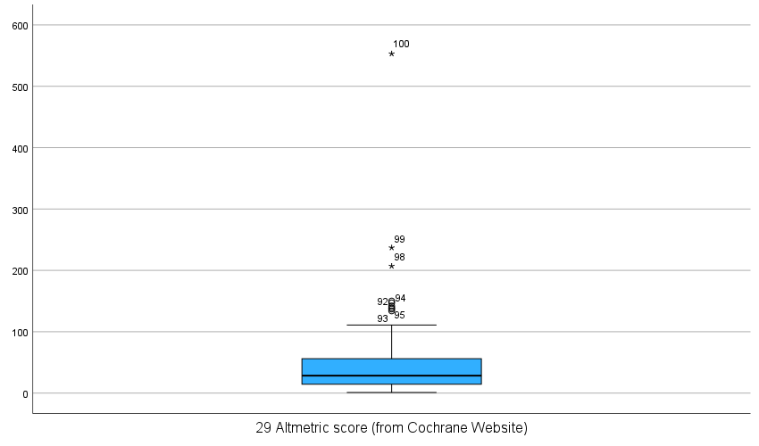

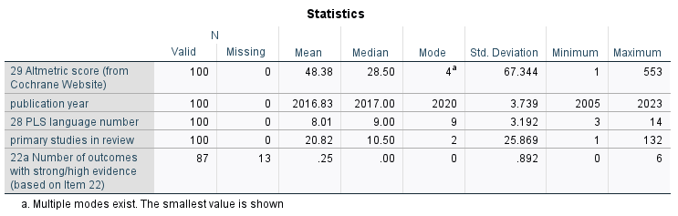

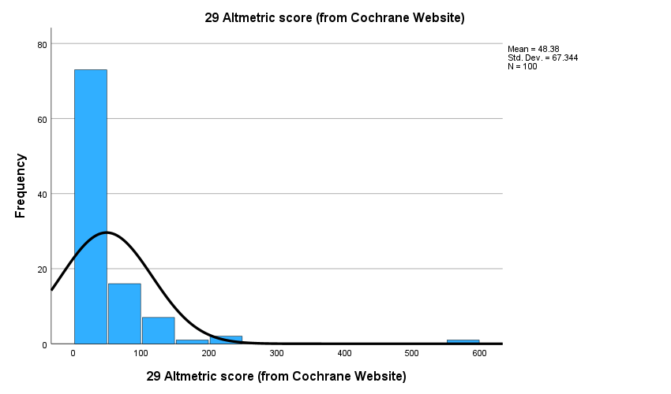

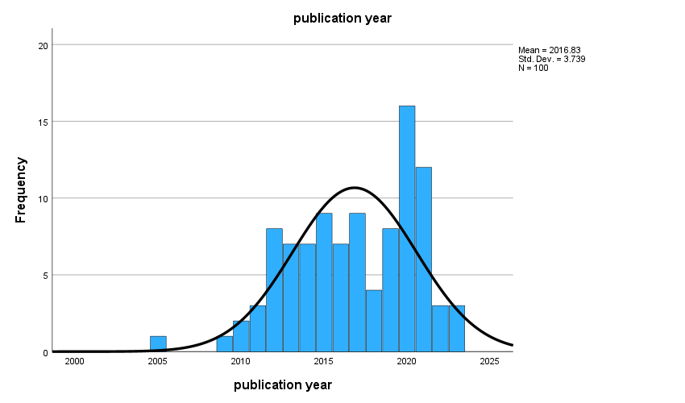

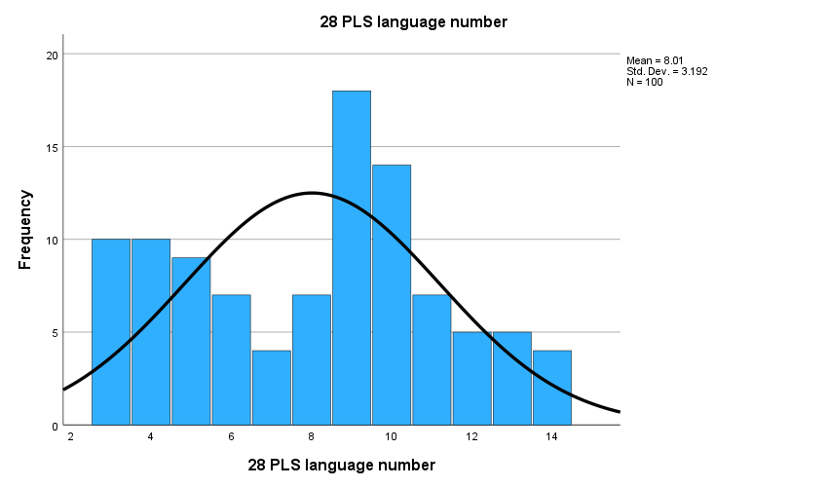

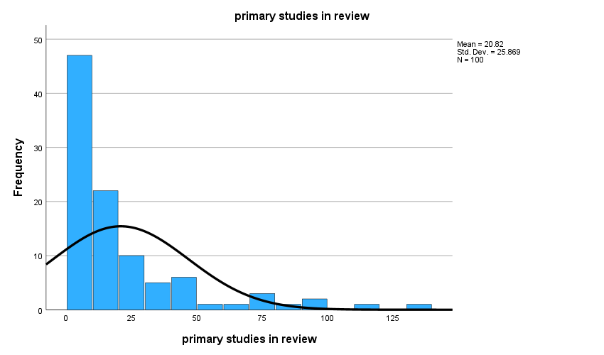

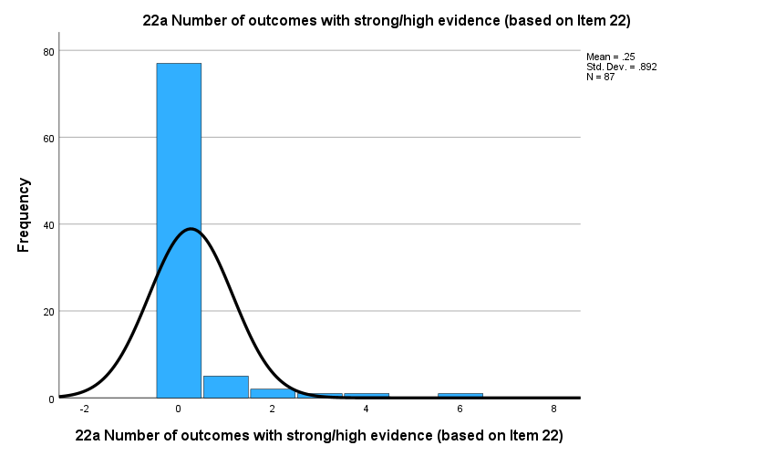

Altmetric Score high vs. low (R)
 |  | Frequency | Percent | Valid Percent | Cumulative Percent
Valid | low < top 25% | 51 | 51.0 | 51.0 | 51.0
Valid | high top 5% | 49 | 49.0 | 49.0 | 100.0
Valid | Total | 100 | 100.0 | 100.0

primary studies many vs. few (R)
 |  | Frequency | Percent | Valid Percent | Cumulative Percent
Valid | few (1-10) | 50 | 50.0 | 50.0 | 50.0
Valid | many (11-132) | 50 | 50.0 | 50.0 | 100.0
Valid | Total | 100 | 100.0 | 100.0

meta analysis performed yes vs. no (R)
 |  | Frequency | Percent | Valid Percent | Cumulative Percent
Valid | no | 31 | 31.0 | 31.0 | 31.0
Valid | yes | 69 | 69.0 | 69.0 | 100.0
Valid | Total | 100 | 100.0 | 100.0

outcomes high-moderate vs. low-very low (R)
 |  | Frequency | Percent | Valid Percent | Cumulative Percent
Valid | no | 41 | 41.0 | 47.1 | 47.1
Valid | yes | 46 | 46.0 | 52.9 | 100.0
Valid | Total | 87 | 87.0 | 100.0
Missing | -99 | 13 | 13.0
Total |  | 100 | 100.0

Variables in regression n=87

13 reviews without strength of evidence rating excluded

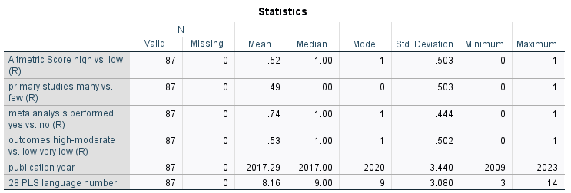

Altmetric Score high vs. low (R)
 |  | Frequency | Percent | Valid Percent | Cumulative Percent
Valid | low < top 25% | 42 | 48.3 | 48.3 | 48.3
Valid | high top 5% | 45 | 51.7 | 51.7 | 100.0
Valid | Total | 87 | 100.0 | 100.0

primary studies many vs. few (R)
 |  | Frequency | Percent | Valid Percent | Cumulative Percent
Valid | few (1-10) | 44 | 50.6 | 50.6 | 50.6
Valid | many (11-132) | 43 | 49.4 | 49.4 | 100.0
Valid | Total | 87 | 100.0 | 100.0

meta analysis performed yes vs. no (R)
 |  | Frequency | Percent | Valid Percent | Cumulative Percent
Valid | no | 23 | 26.4 | 26.4 | 26.4
Valid | yes | 64 | 73.6 | 73.6 | 100.0
Valid | Total | 87 | 100.0 | 100.0

outcomes high-moderate vs. low-very low (R)
 |  | Frequency | Percent | Valid Percent | Cumulative Percent
Valid | no | 41 | 47.1 | 47.1 | 47.1
Valid | yes | 46 | 52.9 | 52.9 | 100.0
Valid | Total | 87 | 100.0 | 100.0

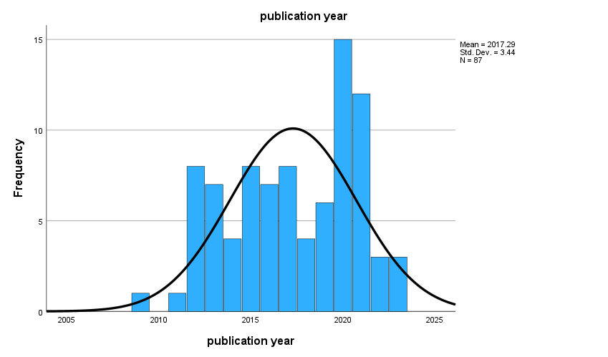
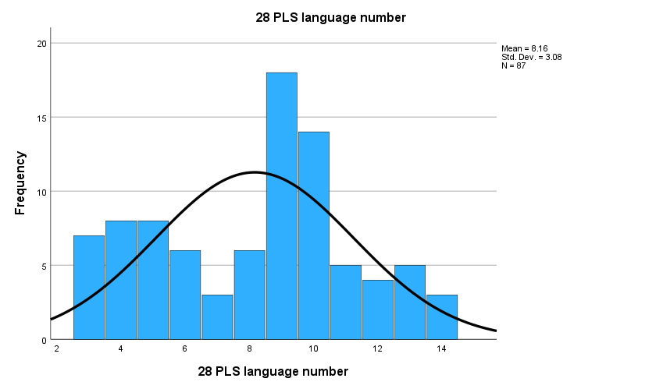

Binary logistic regression analysis n=87

Case Processing Summary
Unweighted Casesª |  | N | Percent
Selected Cases | Included in Analysis | 87 | 87.0
Selected Cases | Missing Cases | 13 | 13.0
Selected Cases | Total | 100 | 100.0
Unselected Cases |  | 0 | .0
Total |  | 100 | 100.0
a. If weight is in effect, see classification table for the total number of cases.

Dependent Variable Encoding
Original Value | Internal Value
low < top 25% | 0
high top 5% | 1

Omnibus Tests of Model Coefficients
 |  | Chi-square | df | Sig.
Step 1 | Step | 12.837 | 5 | .025
Step 1 | Block | 12.837 | 5 | .025
Step 1 | Model | 12.837 | 5 | .025

Model Summary
Step | -2 Log likelihood | Cox & Snell R Square | Nagelkerke R Square
1 | 107.667ª | .137 | .183
a. Estimation terminated at iteration number 5 because parameter estimates changed by less than .001.

Hosmer and Lemeshow Test
Step | Chi-square | df | Sig.
1 | 6.306 | 8 | .613

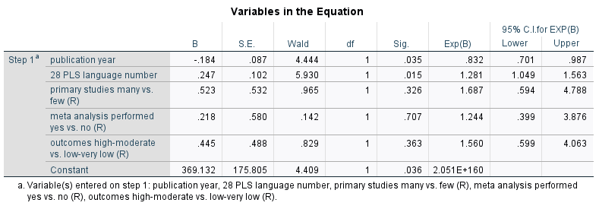

Sensitivity analysis: Binary logistic regression analysis n=84

Three reviews with the highest Altmetric Scores of >150 removed from the analysis.

Case Processing Summary
Unweighted Casesª |  | N | Percent
Selected Cases | Included in Analysis | 84 | 100.0
Selected Cases | Missing Cases | 0 | .0
Selected Cases | Total | 84 | 100.0
Unselected Cases |  | 0 | .0
Total |  | 84 | 100.0
a. If weight is in effect, see classification table for the total number of cases.

Omnibus Tests of Model Coefficients
 |  | Chi-square | df | Sig.
Step 1 | Step | 11.354 | 5 | .045
Step 1 | Block | 11.354 | 5 | .045
Step 1 | Model | 11.354 | 5 | .045

Model Summary
Step | -2 Log likelihood | Cox & Snell R Square | Nagelkerke R Square
1 | 105.095ª | .126 | .169
a. Estimation terminated at iteration number 5 because parameter estimates changed by less than .001.

Hosmer and Lemeshow Test
Step | Chi-square | df | Sig.
1 | 6.266 | 8 | .618

