Appendix A Search syntax for PubMed
("Aged"[MeSH Terms] OR "aged, 80 and over"[MeSH Terms] OR "elder*"[Title/Abstract] OR "older people"[Title/Abstract] OR "older adult*"[Title/Abstract] OR "senior*"[Title/Abstract] OR "retire*"[Title/Abstract] OR "geriatric*"[Title/Abstract]) AND ("Nursing Home"[Title/Abstract] OR "Nursing Homes"[MeSH Terms]) AND ("Frailty"[Title/Abstract] OR "Frailty"[MeSH Terms])
English language 2010-2022.
576 results.

The following resulted in 893 articles
("Aged"[MeSH Terms] OR "aged, 80 and over"[MeSH Terms] OR "elder*"[Title/Abstract] OR "older people"[Title/Abstract] OR "older adult*"[Title/Abstract] OR "senior*"[Title/Abstract] OR "retire*"[Title/Abstract] OR "geriatric*"[Title/Abstract]) AND ("Nursing Home"[Title/Abstract] OR "Nursing Homes"[MeSH Terms]) AND ("Frailty"[Title/Abstract] OR "Frailty"[MeSH Terms] OR “Frail Elderly”[MeSH Terms])

Frailty major mesh resulted in 750 articles
("Aged"[MeSH Terms] OR "aged, 80 and over"[MeSH Terms] OR "elder*"[Title/Abstract] OR "older people"[Title/Abstract] OR "older adult*"[Title/Abstract] OR "senior*"[Title/Abstract] OR "retire*"[Title/Abstract] OR "geriatric*"[Title/Abstract]) AND ("Nursing Home"[Title/Abstract] OR "Nursing Homes"[MeSH Terms]) AND ("Frailty"[Title/Abstract] OR "Frailty"[MaJR] OR "Frail Elderly"[MaJR])

Major mesh for nursing homes
("Aged"[MeSH Terms] OR "aged, 80 and over"[MeSH Terms] OR "elder*"[Title/Abstract] OR "older people"[Title/Abstract] OR "older adult*"[Title/Abstract] OR "senior*"[Title/Abstract] OR "retire*"[Title/Abstract] OR "geriatric*"[Title/Abstract]) AND ("Nursing Home"[Title/Abstract] OR "Nursing Homes"[MaJR] OR "Homes for the Aged"[ MaJR] OR "Long-Term Care"[ MaJR] OR "Residential Facilities"[MaJR])

majr Aged
(("Aged"[MaJR] OR "aged, 80 and over"[MaJR] OR "elder*"[Title/Abstract] OR "older people"[Title/Abstract] OR "older adult*"[Title/Abstract] OR "senior*"[Title/Abstract] OR "retire*"[Title/Abstract] OR "geriatric*"[Title/Abstract]) AND ("Nursing Home"[Title/Abstract] OR "Nursing Homes"[MeSH Major Topic] OR "Homes for the Aged"[MeSH Major Topic] OR "Long-Term Care"[MeSH Major Topic] OR "Residential Facilities"[MeSH Major Topic])) AND ((2010:2022[pdat]) AND (english[Filter]))

Residential Facilities
Long-term care facilities which provide supervision and assistance in activities of daily living with medical and nursing services when required.
Year introduced: 1968

Homes for the Aged
Geriatric long-term care facilities which provide supervision and assistance in activities of daily living with medical and nursing services when required.
Year introduced: 1968

Long-Term Care
Care over an extended period, usually for a chronic condition or disability, requiring periodic, intermittent, or continuous care.
Year introduced: 1992

Nursing Homes
Facilities which provide nursing supervision and limited medical care to persons who do not require hospitalization.
PubMed search builder options

Final Search

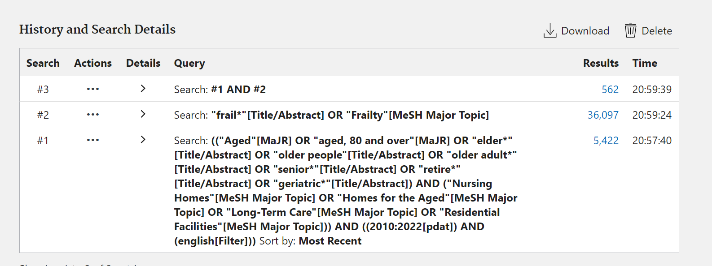

#1. Aged [MaJR]
#2. “aged 80 and over” [MaJR]
#3. ”elder*”[Title/Abstract]
#4. “older people*”[Title/Abstract]
#5. ”older adult*”[Title/Abstract]
#6. “senior*”[Title/Abstract]
#7. “retire*”[Title/Abstract]
#8. ”geriatric*”[Title/Abstract]
#9. #1 OR #2 OR #3 OR #4 OR #5 OR #6 OR #7 OR #8
#10. “frail*”[Title/Abstract]
#11. “Frailty”[MaJR]
#12. #10 OR #11
#13. “Nursing homes”[MaJR]
#14. “Homes for the Aged” [MaJR]
#15. “Long-Term Care” [MaJR]
#16. “Residential Facilities” [MaJR]
#17. #13 OR #14 OR #15 OR #16
#18. #9 AND #12 AND #17
#19. Limit #18 to English language
#20. Limit #19 to 2010-2022

