Supplementary 2: funnel plot and Egger’s regression test

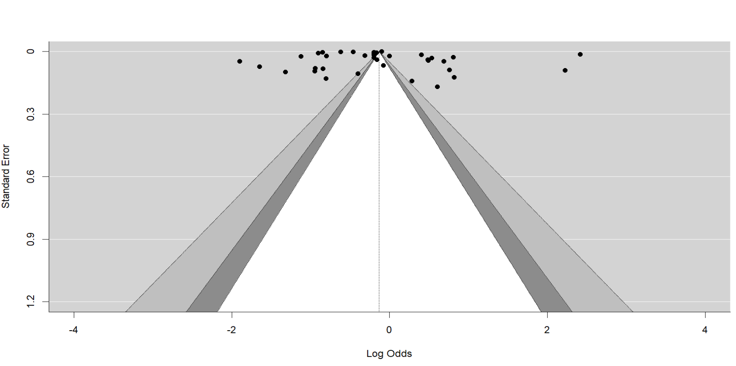
Fig S6: Funnel plot for overall inappropriate antibiotic prescription rate

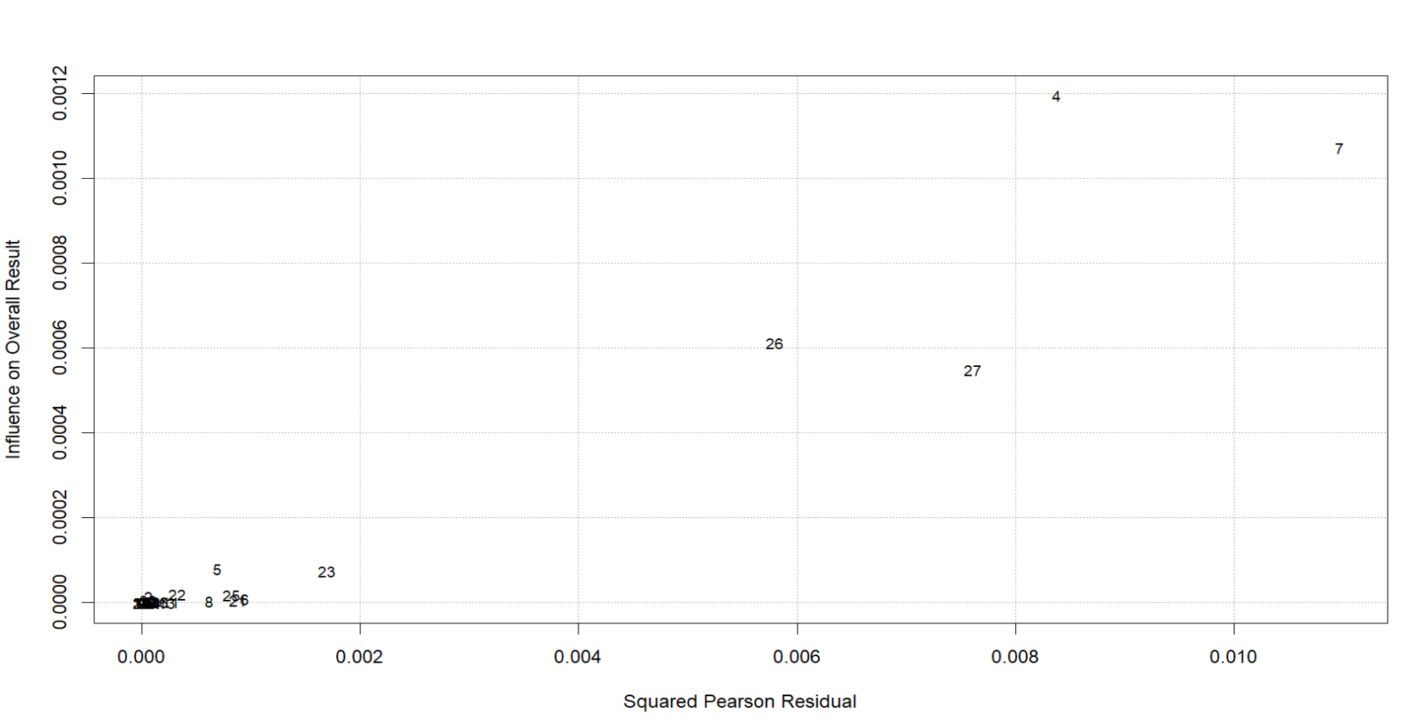
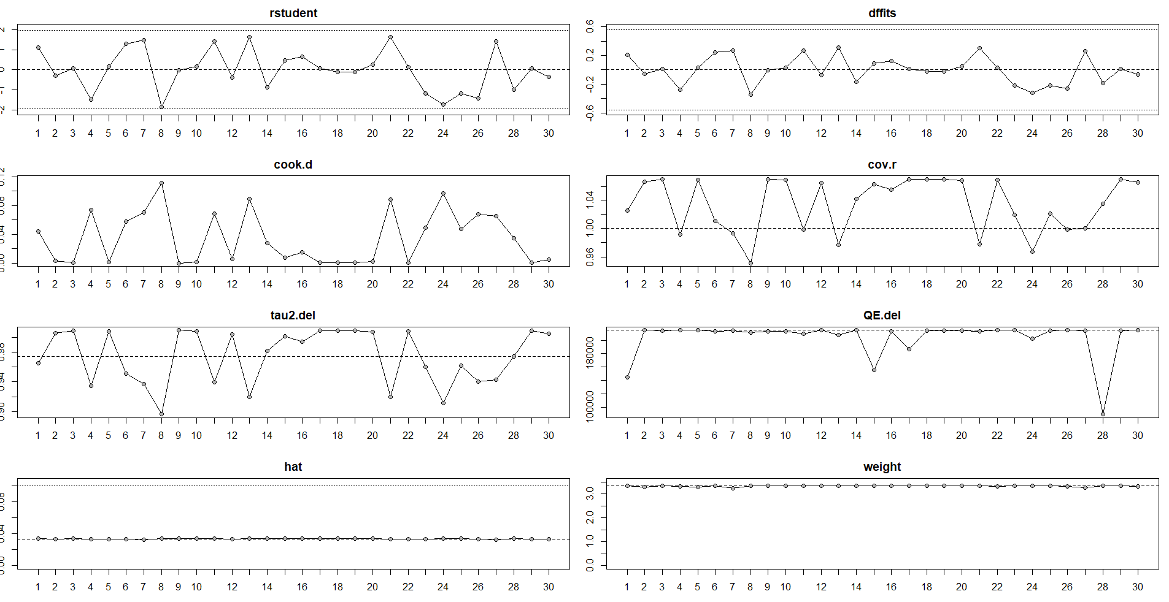
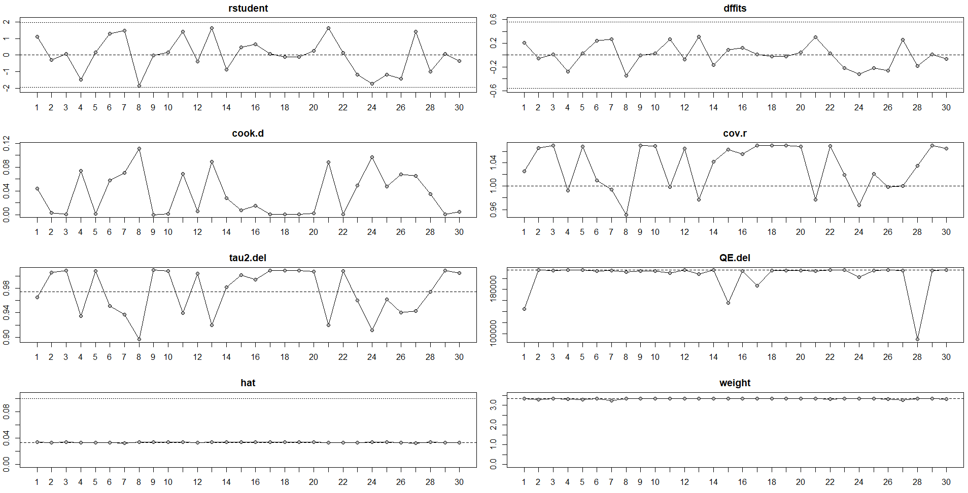
Fig S7. Identification of outliers and influencer studies for antibiotic prescription rate.

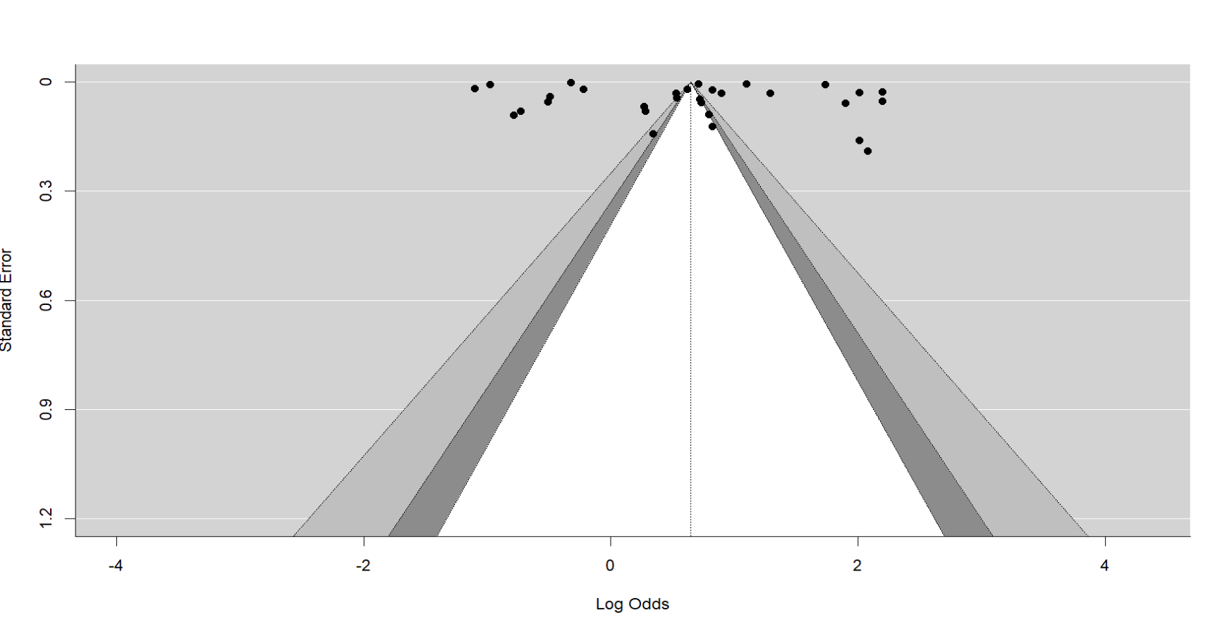
Fig S8: Funnel plot for overall antibiotic prescription rate
Egger’s regression test for antibiotic prescription rate
Test for Funnel Plot Asymmetry: t = 1.1293, df = 28, p = 0.2684
Limit Estimate (as sei -> 0): b = 0.4098 (CI: -0.1553, 0.9750)

