Supplementary material
Table S1- PRISMA 2020 checklist statement: an updated guideline for reporting systematic reviews.
Section and Topic | Item # | Checklist item | Location where item is reported
TITLE
Title | 1 | Identify the report as a systematic review. | P. 1
ABSTRACT
Abstract | 2 | See PRISMA 2020 for the Abstracts checklist. | P. 1
INTRODUCTION
Rationale | 3 | Describe the rationale for the review in the context of existing knowledge. | P. 3-5
Objectives | 4 | Provide an explicit statement of the objective(s) or question(s) the review addresses. | P. 5
METHODS
Eligibility criteria | 5 | Specify the inclusion and exclusion criteria for the review and how studies were grouped for the syntheses. | P. 6
Information sources | 6 | Specify all databases, registers, websites, organizations, reference lists and other sources searched or consulted to identify studies; specify the date when each source was last searched or consulted. | P. 5
Search strategy | 7 | Present the full search strategies for all databases, registers and websites, including any filters and limits used. | P. 5
Selection process | 8 | Specify the methods used to decide whether the study met the inclusion criteria of the review, including how many reviewers screened each record and each report retrieved, whether they worked independently, and if applicable, details of automation tools used in the process. | P. 6
Data collection process | 9 | Specify the methods used to collect data from reports, including how many reviewers collected data from each report, whether they worked independently, any processes for obtaining or confirming data from study investigators, and if applicable, details of automation tools used in the process. | P. 6
Data items | 10a | List and define all outcomes for which data were sought. Specify whether all results that were compatible with each outcome domain in each study were sought (e.g., for all measures, time points, and analyses), and if not, the methods used to decide which results to collect. | P. 7
Data items | 10b | List and define all other variables for which data were sought (e.g., participant and intervention characteristics, funding sources); describe any assumptions made about any missing or unclear information. | P. 7
Study risk of bias assessment | 11 | Specify the methods used to assess risk of bias in the included studies, including details of the tool(s) used, how many reviewers assessed each study and whether they worked independently, and if applicable, details of automation tools used in the process. | P. 7-8
Effect measures | 12 | Specify for each outcome the effect measure(s) (e.g., risk ratio and mean difference) used in the synthesis or presentation of results. | P. 7-8
Synthesis methods | 13a | Describe the processes used to decide which studies were eligible for each synthesis (e.g. tabulating the study intervention characteristics and comparing against the planned groups for each synthesis (item #5)). | P. 6-8
Synthesis methods | 13b | Describe any methods required to prepare the data for presentation or synthesis, such as handling of missing summary statistics, or data conversions. | P. 7-8
Synthesis methods | 13c | Describe any methods used to tabulate or visually display results of individual studies and syntheses. | P. 7-8
Synthesis methods | 13d | Describe any methods used to synthesize results and provide a rationale for the choice(s). If a meta-analysis was performed, describe the model(s) and/or method(s) to identify the presence and extent of statistical heterogeneity and provide the software package(s) used. | P. 7-8
Synthesis methods | 13e | Describe any methods used to explore possible causes of heterogeneity among study results (e.g. subgroup analysis and meta-regression). | P. 7-8
Synthesis methods | 13f | Describe any sensitivity analyses conducted to assess the robustness of the synthesized results. | P. 7-8
Reporting bias assessment | 14 | Describe any methods used to assess the risk of bias due to missing results in a synthesis (arising from reporting biases). | P. 7-8
Certainty assessment | 15 | Describe any methods used to assess certainty (or confidence) in the body of evidence for an outcome. | P. 7-8
RESULTS
Study selection | 16a | Describe the results of the search and selection process, from the number of records identified in the search to the number of studies included in the review, ideally using a flow diagram. | P. 8
Study selection | 16b | Cite studies that might appear to meet the inclusion criteria but that were excluded, and explain why they were excluded. | P. 8
Study characteristics | 17 | Cite each included study and present its characteristics. | P. 9-10
Risk of bias in studies | 18 | Present assessments of risk of bias for each study included. | P. 11
Results of individual studies | 19 | For all outcomes, present, for each study (a) summary statistics for each group (where appropriate) and (b) an effect estimate and its precision (e.g., confidence/credible interval), ideally using structured tables or plots. | P.12-15
Results of syntheses | 20a | For each synthesis, provide a brief summary of the characteristics and risk of bias among contributing studies. | P. 11
Results of syntheses | 20b | Present results of all statistical syntheses conducted. If a meta-analysis was done, present for each the summary estimate and its precision (e.g., confidence/credible interval) and measures of statistical heterogeneity. If comparing groups, describe the direction of the effect. | P. 12-15
Results of syntheses | 20c | Present results of all investigations of possible causes of heterogeneity among study results. | P. 12-15
Results of syntheses | 20d | Present results of all sensitivity analyses conducted to assess the robustness of the synthesized results. | P. 12-15
Reporting biases | 21 | Present assessments of risk of bias due to missing results (arising from reporting biases) for each synthesis assessed. | P. 12-15
Certainty of evidence | 22 | Present assessments of certainty (or confidence) in the body of evidence for each outcome assessed. | P. 12-15
DISCUSSION
Discussion | 23a | Provide a general interpretation of the results in the context of other evidence. | P. 15
Discussion | 23b | Discuss any limitations of the evidence included in the review. | P. 16-17
Discussion | 23c | Discuss any limitations of the review processes used. | P. 18
Discussion | 23d | Discusses implications of the results for practice, policy, and future research. | P. 18
OTHER INFORMATION
Registration and protocol | 24a | Provide registration information for the review, including the register name and registration number, or state that the review was not registered. | P. 5
Registration and protocol | 24b | Indicate where the review protocol can be accessed, or state that the protocol was not prepared. | P. 5
Registration and protocol | 24c | Describe and explain any amendments to information provided at registration or in the protocol. | P. 5
Support | 25 | Describe sources of financial or nonfinancial support for the review and the role of the funders or sponsors in the review. | P. 19
Competing interests | 26 | Declare any competing interests of review authors. | P. 19
Availability of data, code and other materials | 27 | Report which of the following are publicly available and where they can be found: template data collection forms; data extracted from included studies; data used for all analyses; analytical code; and any other materials used in the review. | P. 5
Source: Page MJ, McKenzie JE, Bossuyt PM, Boutron I, Hoffmann TC, Mulrow CD, et al. The PRISMA 2020 statement: an updated guideline for reporting systematic reviews. BMJ 2021;372:n71. doi: 10.1136/bmj.n71
Chart 1. PICOS framework for the systematic review.
PICOS
P | Patients over 18 years old and older with rheumatoid arthritis
I | The use of biosimilar etanercept
C | The use of biologic etanercept
O | To compare the safety, efficacy and immunogenicity of biosimilars with those for biologic etanercept.
S | Phase III randomized clinical trials (RCTs)
Source: Authors' elaboration

Chart 2. Search strategy for the systematic review.
Search strategy
(Etanercept) OR (TNFR-Fc Fusion Protein) OR (Fusion Protein, TNFR-Fc) OR (TNFR Fc Fusion Protein) OR (TNR 001) OR (TNT Receptor Fusion Protein) OR (TNTR-Fc) OR (TNR-001) OR (TNR001) OR (Etanercept-szzs) OR (TNF Receptor Type II-IgG Fusion Protein) OR (TNF Receptor Type II IgG Fusion Protein) OR (Erelzi) OR (Recombinant Human Dimeric TNF Receptor Type II-IgG Fusion Protein) OR (Recombinant Human Dimeric TNF Receptor Type II IgG Fusion Protein) OR (Enbrel)
AND
(Biological Products) OR (Products, Biological) OR (Biological Product) OR (Product, Biological) OR (Biologic Product) OR (Product, Biologic) OR (Biologic Products) OR (Biopharmaceuticals) OR (Biopharmaceutical) OR (Biological) OR (Biologic) OR (Biological Drug) OR (Drug, Biological) OR (Biologic Drugs) OR (Drugs, Biologic) OR (Biological Medicine) OR (Medicine, Biological) OR (Biological Medicines) OR (Medicines, Biological) OR (Biologicals) OR (Biologic Medicines) OR (Medicines, Biologic)
AND
(Biologic Pharmaceuticals) OR (Pharmaceuticals, Biologic) OR (Biologics) OR (Biologic Drug) OR (Drug, Biologic) OR (Biological Drugs) OR (Drugs, Biological) OR (Natural Products) OR (Natural Product) OR (Product, Natural) OR (Biosimilar Pharmaceuticals) OR (Pharmaceuticals, Biosimilar) OR (Subsequent Entry Biologics) OR (Biologics, Subsequent Entry) OR (Follow-on Biologics) OR (Biologics, Follow-on) OR (Follow on Biologics) OR (Biosimilars) OR (Biosimilar)
AND
(Arthritis, Rheumatoid) OR (Rheumatoid Arthritis)
Source: Authors' elaboration
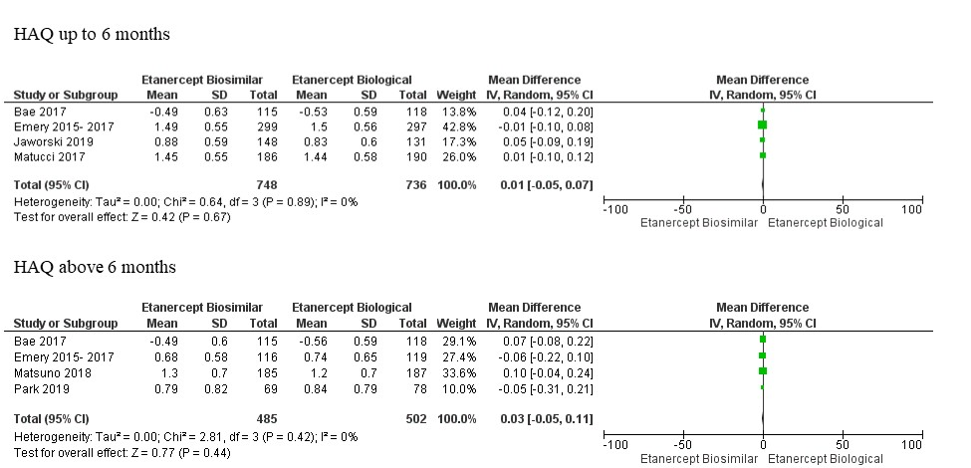
Figure S1. Meta-analyses of HAQ up to and above 6 months.
Source: Authors' elaboration
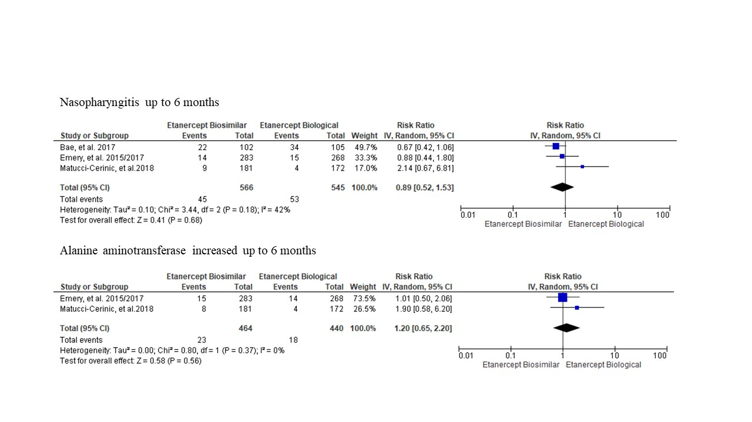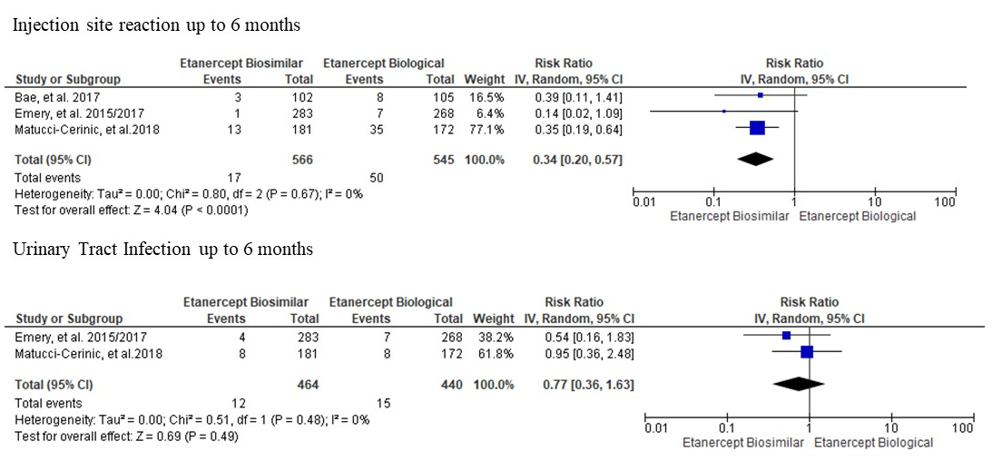
Figure S2. Meta-analyses of non-serious adverse events up to 6 months.
Source: Authors' elaboration
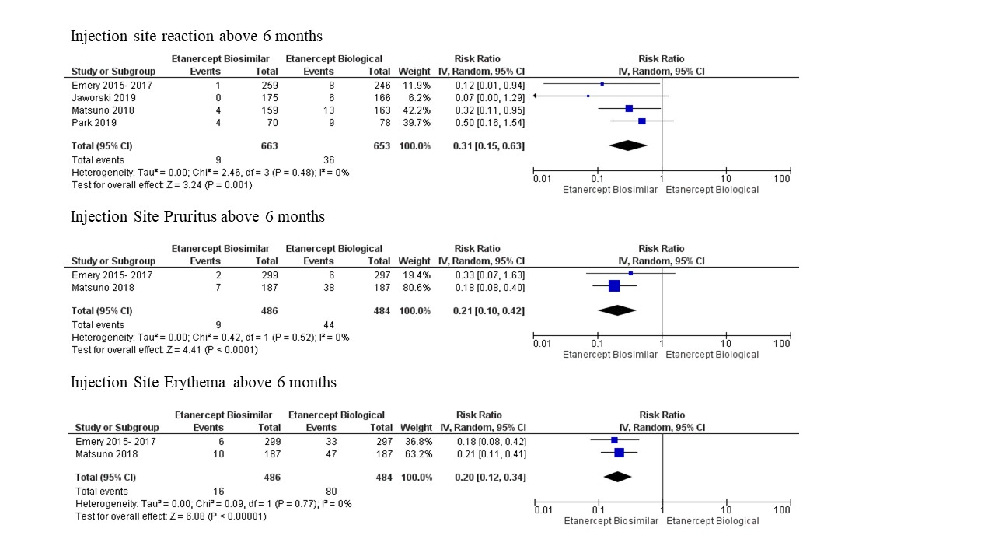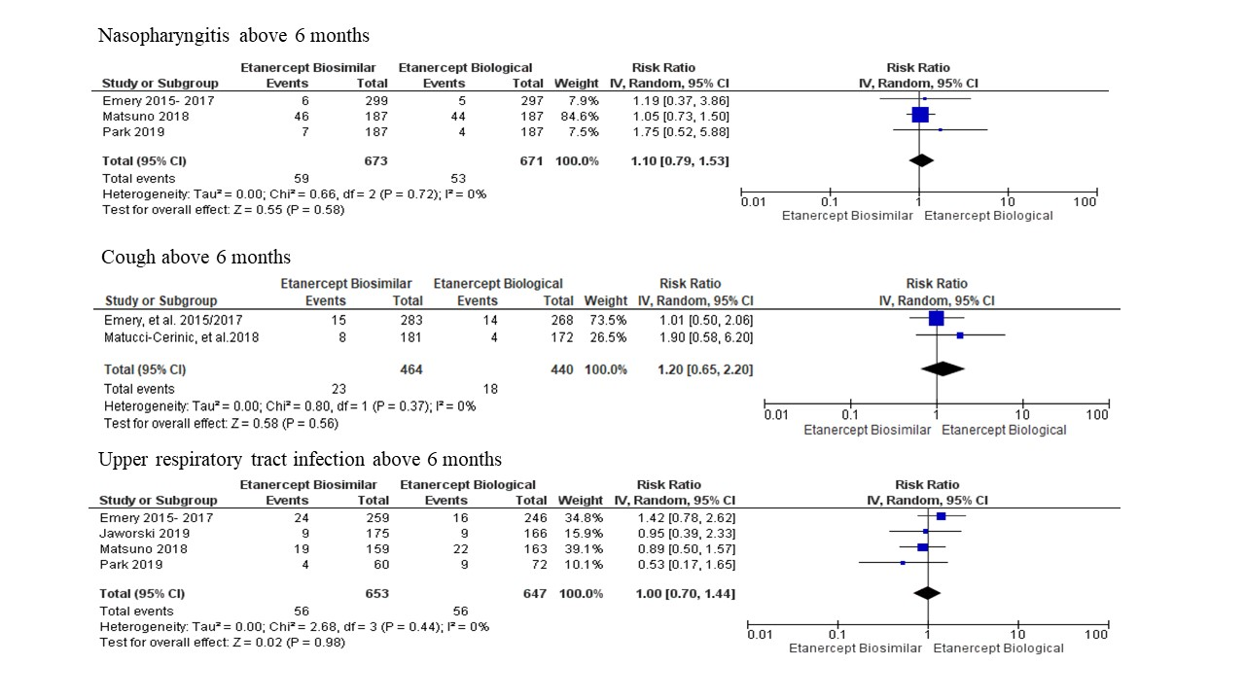
Figure S3. Meta-analyses of non-serious adverse events above 6 months.
Source: Authors' elaboration
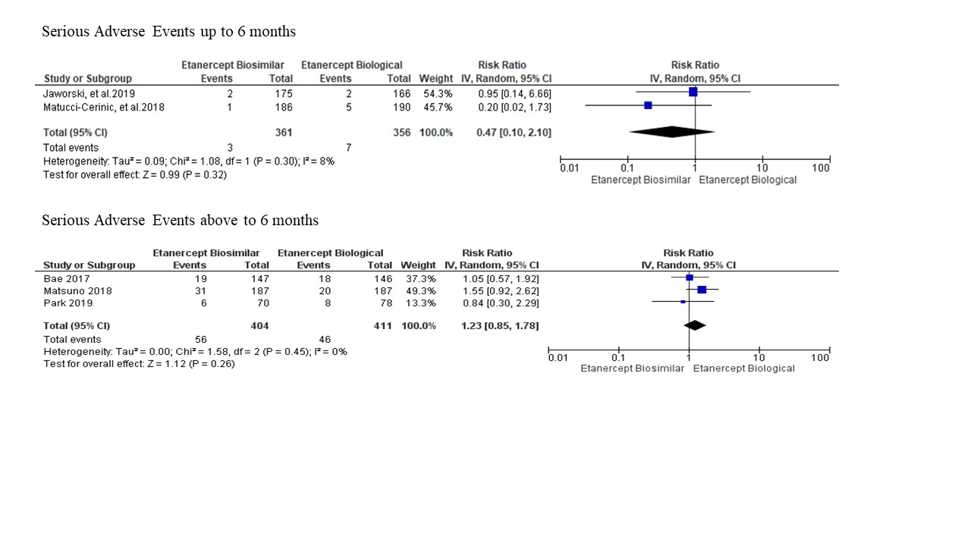
Figure S4. Meta-analyses of serious adverse events up to/over 6 months.
Source: Authors' elaboration
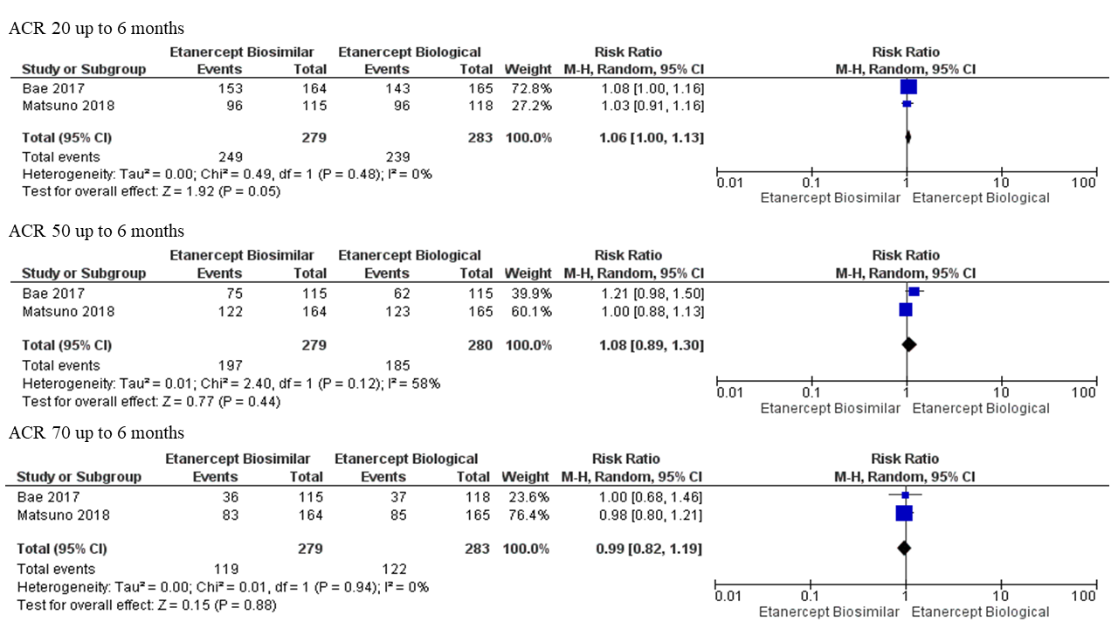
Figure S5. Subgroup meta-analyses for Asian countries of ACR20, ACR50 and ACR70 up to 6 months.
Source: Authors' elaboration

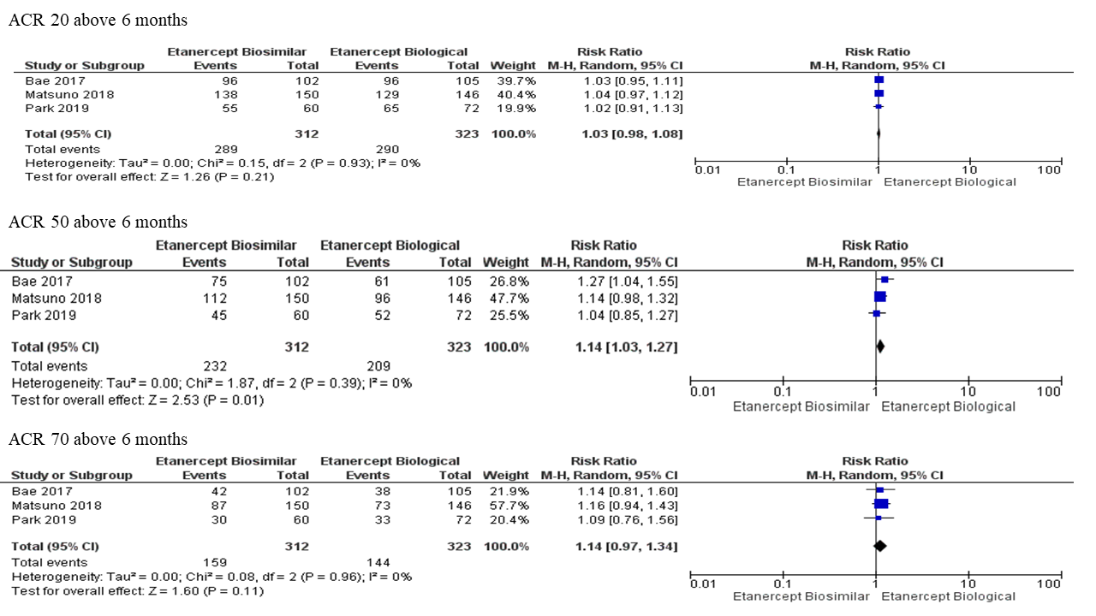
Figure S6. Subgroup meta-analyses for Asian countries of ACR20, ACR50 and ACR70 above 6 months.
Source: Prepared by the authors
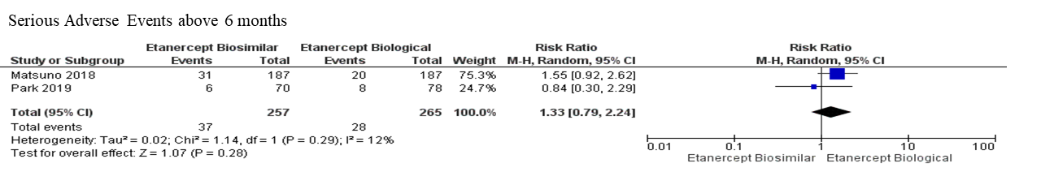
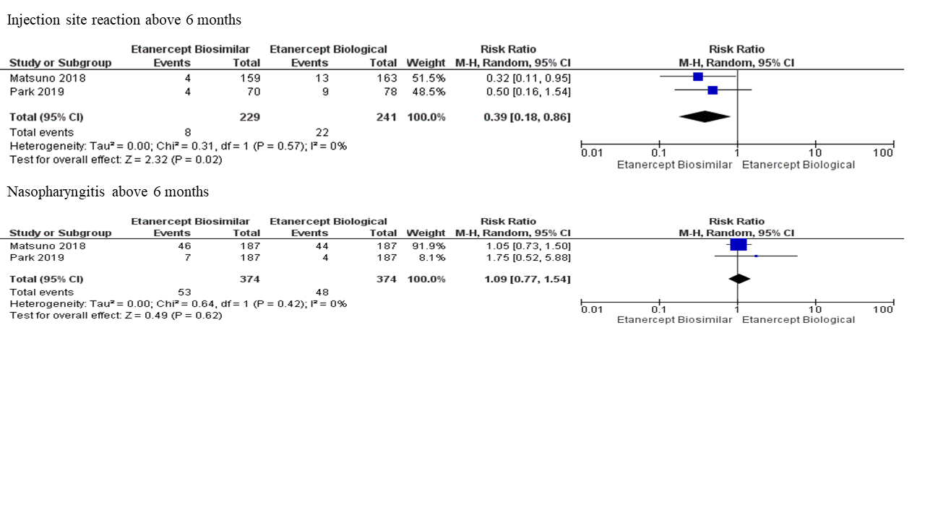

Figure S7. Subgroup meta-analyses for Asian countries of non-serious adverse events and serious adverse above 6 months.
Source: Authors' elaboration

Figure S8. Subgroup meta-analyses for Asian countries of HAQ above 6 months.
Source: Authors' elaboration
Table S2. Grade analyses for the outcomes comparing biosimilar etanercept with biologic etanercept in patients with rheumatoid arthritis.
Certainty assessment |  |  |  |  |  |  | Summary of findings
Participants  (studies)  Follow-up | Risk of bias | Inconsistency | Indirectness | Inaccuracy | Publication bias | Overall certainty of evidence | Study event rates (%) |  | Relative effect  (95% CI)
 |  |  |  |  |  |  | With biologic etanercept | With biosimilar etanercept | Relative effect  (95% CI)
ACR 20
4,198  (6 RCTs) | not serious | serious ª | not serious | not serious | none | ⨁⨁⨁◯  Moderate | 1,184/2,099 (56.4%) | 1,064/2,099 (50.7%) | not estimable
ACR50
4,198  (8 RCTs) | not serious | serious ª | not serious | not serious | none | ⨁⨁⨁◯  Moderate | 1,184/2,099 (56.4%) | 1,064/2,099 (50.7%) | not estimable
ACR70
4,198  (6 RCTs) | not serious | serious ª | not serious | not serious | none | ⨁⨁⨁◯  Moderate | 1,184/2,099 (56.4%) | 1,064/2,099 (50.7%) | not estimable
DAS28
4,198  (6 RCTs) | not serious | not serious | not serious | not serious | none | ⨁⨁⨁⨁  High | 1,184/2,099 (56.4%) | 1,064/2,099 (50.7%) | not estimable
HAQ-DI
4,198  (6 RCTs) | not serious | not serious | not serious | not serious | none | ⨁⨁⨁⨁  High | 1,184/2,099 (56.4%) | 1,064/2,099 (50.7%) | not estimable
ADA - Anti-Drug Antibodies
4,198  (8 RCTs) | not serious | not serious | not serious | not serious | none | ⨁⨁⨁⨁  High | 1,184/2,099 (56.4%) | 1,064/2,099 (50.7%) | not estimable
Injection Site Reaction
2,365  (6 RCTs) | not serious |  | not serious | not serious | not serious |  | none |  | ⨁⨁⨁⨁  High |  | 71/1,186 (5.9865%) |  | 25/1,179 (2.1204%) |  | not estimable
Urinary tract infection
1,348  (3 RCTs) | not serious | not serious |  | not serious | not serious | none |  | ⨁⨁⨁⨁  High |  | 19/677 (2.8%) |  | 25/671 (3.7%) |  | not estimable
Nasopharyngitis
2,274  (6 RCTs) | not serious | not serious |  | not serious | not serious | none |  | ⨁⨁⨁⨁  High |  | 100/1,135 (8.8106%) |  | 103/1,139 (9.0430%) |  | not estimable
Deaths
1,624  (4 RCTs) | not serious | not serious |  | not serious | not serious | none |  | ⨁⨁⨁⨁  High |  | 8/858 (0.9%) |  | 4/766 (0.5%) |  | not estimable
Cough
1,568  (4 RCTs) | not serious | not serious |  | not serious | not serious | none |  | ⨁⨁⨁⨁  High |  | 35/777 (4.5%) |  | 20/791 (2.5%) |  | not estimable
Injection site eruption
925  (2 RCTs) | not serious | not serious |  | not serious | not serious | none |  | ⨁⨁⨁⨁  High |  | 44/455 (9.7%) |  | 9/470 (1.9%) |  | not estimable
Erythema at the injection site
925  (2 RCTs) | not serious | not serious |  | not serious | not serious | none |  | ⨁⨁⨁⨁  High |  | 80/455 (17.6%) |  | 16/470 (3.4%) |  | not estimable
Upper Respiratory Tract Infection
2,320  (6 RCTs) | not serious | not serious |  | not serious | not serious | none |  | ⨁⨁⨁⨁  High |  | 73/1,157 (6.3094%) |  | 70/1,163 (6.0189%) |  | not estimable
Alanine Aminotransferase Augmented
1,303  (3 RCTs) | not serious | not serious |  | not serious | not serious | none |  | ⨁⨁⨁⨁  High |  | 27/648 (4.2%) |  | 30/655 (4.6%) |  | not estimable
Serious Adverse Events
1,532  (5 RCTs) | not serious | not serious ª |  | not serious | not serious | none |  | ⨁⨁⨁⨁  High |  | 53/767 (6.9%) |  | 59/765 (7.7%) |  | not estimable

Explanations
a. The studies up to 6 months showed high heterogeneity; however, studies over 6 months showed low heterogeneity. Thus, we propose that this occurs because the treatment occurred at the beginning of the studies, which lasted for up to 6 months. In studies over 6 months, the samples became more homogeneous.

Table S3. Characterization of positive ADA immunogenicity among patients with rheumatoid arthritis in the ETN (biologic) and biosimilar groups.
Author/Year | ADA positivity in the ETN group | ADA positivity in the biosimilar group
Bae et al.¹ 2017 | 3 | 8
Emery et al. 2015 a 2017²⁻⁴ | 18 | 4
Jaworski et al. 2019 | 11 | 52
Matsuno et al. 2018⁵ | 18 | 3
Matucci-Cerinic et al. 2018⁶ | 49 | 5
Park et al. 2019⁷ | 11 | 2
Total | 110 | 74
Source: Authors' elaboration
Table S4. Characterization of positive neutralizing antibodies in patients with rheumatoid arthritis in the ETN (biologic) and biosimilar groups.
Author/Year | Neutralizing antibody positivity in the ETN group | Neutralizing antibody positivity in the biosimilar group
Bae et al.¹ 2017 | 1 | 3
Emery et al. 2015 a 2017²⁻⁴ | 1 | 1
Jaworski et al. 2019 | 4 | _
Matsuno et al. 2018⁵ | _ | _
Matucci-Cerinic et al. 2018⁶ | 4 | _
Park et al. 2019⁷ | 1 | _
Total | 11 | 4
Source: Authors' elaboration
References
1. Bae SC, Kim J, Choe JY, Park W, Lee SH, Park YB et al. A phase III, multicentre, randomised, double-blind, active-controlled, parallel-group trial comparing safety and efficacy of HD203, with innovator etanercept, in combination with methotrexate, in patients with rheumatoid arthritis: the HERA study. Ann Rheum Dis. 2017 Jan;76(1):65-71. doi: 10.1136/annrheumdis-2015-207613.
2. Emery P, Vencovský J, Sylwestrzak A, Leszczyński P, Porawska W, Baranauskaite A, Tseluyko V et al. A phase III randomised, double-blind, parallel-group study comparing SB4 with etanercept reference product in patients with active rheumatoid arthritis despite methotrexate therapy. Ann Rheum Dis. 2017 Jan;76(1):51-57. doi: 10.1136/annrheumdis-2015-207588.
3. Emery P, Vencovský J, Sylwestrzak A, Leszczynski P, Porawska W, Baranauskaite A, Tseluyko V et al. 52-week results of the phase 3 randomized study comparing SB4 with reference etanercept in patients with active rheumatoid arthritis. Rheumatology (Oxford). 2017 Dec 1;56(12):2093-2101. doi: 10.1093/rheumatology/kex269.
4. Emery P, Vencovský J, Sylwestrzak A, Leszczyński P, Porawska W, Stasiuk B et al. Long-term efficacy and safety in patients with rheumatoid arthritis continuing on SB4 or switching from reference etanercept to SB4. Ann Rheum Dis. 2017 Aug 9;76(12):1986–91. doi: 10.1136/annrheumdis-2017-211591.
5. Jaworski J, Matucci-Cerinic M, Schulze-Koops H, Buch MH, Kucharz EJ, Allanore Y et al. Switch from reference etanercept to SDZ ETN, an etanercept biosimilar, does not impact efficacy, safety, and immunogenicity of etanercept in patients with moderate-to-severe rheumatoid arthritis: 48-week results from the phase III, randomized, double-blind EQUIRA study. Arthritis Res Ther. 2019 May 28;21(1):130. doi: 10.1186/s13075-019-1907-x.
6. Matsuno H, Tomomitsu M, Hagino A, Shin S, Lee J, Song YW. Phase III, multicentre, double-blind, randomised, parallel-group study to evaluate the similarities between LBEC0101 and etanercept reference product in terms of efficacy and safety in patients with active rheumatoid arthritis inadequately responding to methotrexate. Ann Rheum Dis. 2018 Apr;77(4):488-494. doi: 10.1136/annrheumdis-2017-212172.
7. Matucci-Cerinic M, Allanore Y, Kavanaugh A, Buch MH, Schulze-Koops H, Kucharz EJ et al. Efficacy, safety and immunogenicity of GP2015, an etanercept biosimilar, compared with the reference etanercept in patients with moderate-to-severe rheumatoid arthritis: 24-week results from the comparative phase III, randomised, double-blind EQUIRA study. RMD Open. 2018 Nov 14;4(2):e000757. doi: 10.1136/rmdopen-2018-000757.
8. Park MC, Matsuno H, Kim J, Park SH, Lee SH, Park YB. Long-term efficacy, safety and immunogenicity in patients with rheumatoid arthritis continuing on an etanercept biosimilar (LBEC0101) or switching from reference etanercept to LBEC0101: an open-label extension of a phase III multicentre, randomised, double-blind, parallel-group study. Arthritis Res Ther. 2019 May 21;21(1):122. doi: 10.1186/s13075-019-1910-2.

